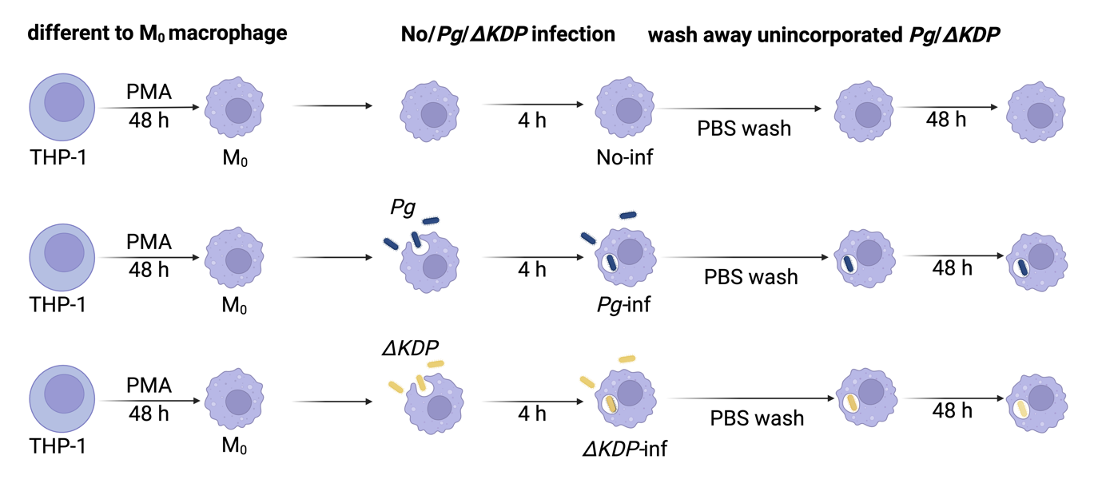

Figure S1. Schedule of cell culture and No-inf, Pg-inf, ΔKDP-inf macrophage establishment.

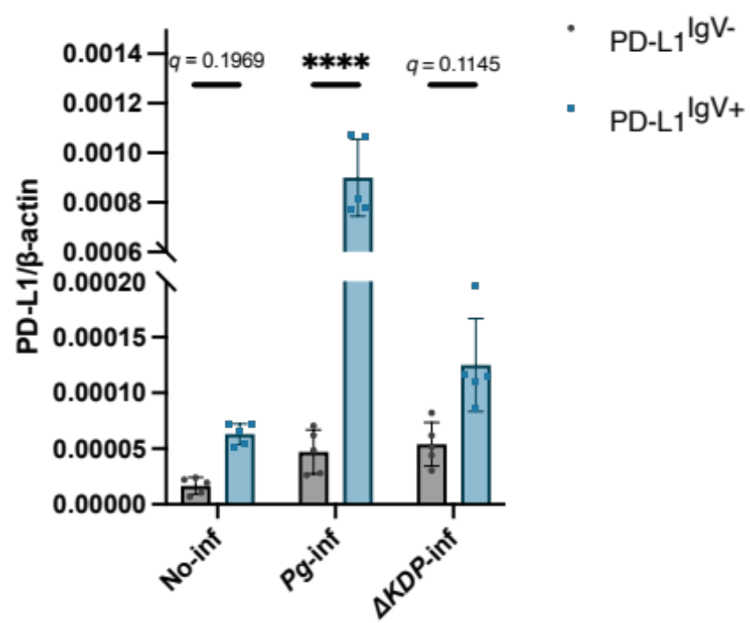

Figure S2. Comparison of expression levels of Functional and Non-functional PD-L1 in No-inf, Pg-inf, and ΔKDP-inf macrophages. ****, q < 0.001.
 | Source of variation | Sum of squares | df | Mean square | F | p- Value | Percentage of total variation
Dependent variable:  PD-L1/β-actin | Interaction (Infection x PD-L1 isoform) | 1.051e-006 | 2 | 5.253e-007 | 124.6 | <0.0001 | 34.25
 | Infection | 1.126e-006 | 2 | 5.629e-007 | 119.8 | <0.0001 | 36.71
 | PD-L1 isoform | 7.837e-007 | 1 | 7.837e-007 | 186.0 | <0.0001 | 25.55
 | Biological Replications | 5.639e-008 | 12 | 4.699e-009 | 1.115 | 0.4267 | 1.839
 | Residual | 5.057e-008 | 12 | 4.214e-009
Note: Two-way analysis of variance.
Abbreviation: df, degrees of freedom.

Table S1. Statistical details for the RT-qPCR results from No-inf, Pg-inf, and ΔKDP-inf macrophages showed in Fig. S2.

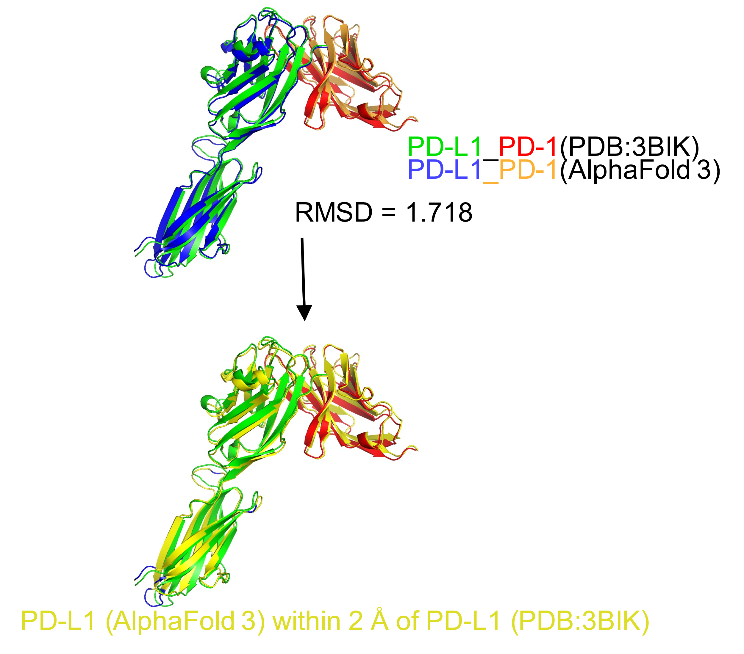

Figure S3. Structural comparison between AlphaFold 3 prediction and PDB 3BIK (the crystal structure of the human PD-L1 and mouse PD-1 protein complex). The RMSD between the two structures is 1.718 Å, with PD-L1 (AlphaFold 3) colored in blue and PD-L1 (PDB:3BIK) in green, and PD-1 (AlphaFold 3) in orange and PD-1 (PDB:3BIK) in red. The bottom image highlights PD-L1 (AlphaFold 3) regions within 2 Å of PD-L1 (PDB:3BIK).

