Supplementary information
Article title: Flow cytometry immune profiling of recurrent and newly diagnosed growth hormone secreting pituitary adenomas: comparison of two clinical cases
Journal name: Endocrine Pathology
Author names: Daria V. Lisina¹, Valeria V. Mazeeva¹, Elena N. Zakharova¹, Alyona V. Sorokina¹, Lilya U. Dzhemileva¹, Andrey Yu. Grigoriev¹, Vilen N. Azizyan¹, Alexandra S. Shutova¹, Ekaterina A. Pigarova¹, Larisa K. Dzeranova¹, Galina A. Melnichenko¹, Sergei A. Rumiantsev¹, Natalia G. Mokrysheva¹, Vladimir P. Chekhonin¹, Marina Yu. Loguinova^{1*}
Affiliations: ¹Endocrinology Research Centre, 117036 Moscow, Russia
*Correspondence: marina.loguinova@mail.ru;

SUPPLEMENTARY
Materials and methods
Sample preparation of peripheral blood and adenoma tissue for flow cytometry
Peripheral blood was drawn from the right forearm vein into a tube containing EDTA as an anticoagulant. The blood was stored at RT until processed. Immunostaining of peripheral blood with antibody mixture was performed before lysis of erythrocytes on the same day.
The adenoma tissue was promptly placed in a chilled medium (DMEM F-12 supplemented with 10% FBS) and kept on ice until sample preparation (typically no later than within two hours). Immediately prior to the preparation of the samples, tissue pieces were washed three times with a cold DMEM F-12 +10% FBS solution in order to remove any residual blood. Subsequently, the samples were diluted in 1 ml of the aforementioned solution and subjected to centrifugation at 300g for 5 minutes at 4°C. The supernatant was then carefully withdrawn, and the pellet was transferred to a small amount of DMEM F-12 +10% FBS (100-200 μl, depending on the size of the sample obtained) in a Petri dish to be quickly and thoroughly dissected with scalpels. Then the sample was immediately transferred into a 15 ml Falcon tube with 400 μl of warm HBSS + 10% FBS + 3 μl of Coll II (100 U/ml) to be additionally digested with collagenase II (Gibco, UK). The suspension of about 500 μl was then carefully mixed and left for 15 minutes in a water bath at 37°C. Next, the dissociation was terminated with 1 ml of HBSS + 10% FBS, followed by centrifugation at 300 g for 7 min at 4°C. Subsequently, the homogenate was passed through a pre-moistened 70 μm sieve into a 15 mL Falcon. The resulting cell suspension was centrifuged at 300g for 7 minutes at 4°C. The supernatant was removed and red blood cells in the cell pellet were lysed in 1 ml lysis buffer (150 mM NH4Cl+ 10 mM NaHCO3 + 0.1 mM EDTA) for 1 min on ice. Then the reaction was stopped with 1 ml of PBS + 10% FBS, and centrifuged under the same conditions. The resulting precipitate was diluted in 1 ml MACS buffer (PBS+ 0.5% BSA+ 2 mM EDTA) and live cells were counted using a TC-20 cell counter (Biorad, USA).
Antibody immunostaining prior to flow cytometric analysis,
Prior to immunostaining, blood samples and adenoma cells were pre-stained with Fixable Viability Stain 620 or 700 (BD Biosciences, USA), which is necessary to assess viable cells. Immunostaining of peripheral blood and pituitary adenoma cells was conducted using several antibody panels:
General Panel №1: CD20-VioBlue (clone REA780, разведение 1:70) / CD45RA-BV480 (clone HI100 , 1:70) / CD8-BV605 (clone 2331 (FUN-1) , 1:100) / CD4-BV786 (clone OKT4, 1:100) / CD56-FITC (B159, 1:50) / CD25-PE (clone M-A251, 1:50) / Fixable viability stain 620 (1:50) /CD16-PerCP-Cy5.5 (clone 3G8, 1:70) / PD-1-PE-Cy7 (clone EH12.2H7, 1:70) / CD127-AF647 (clone HIL-7R-M21, 1:25) / CD3-Alexa Fluor 700 (clone SP34-2, 1:70) / CD45-APC-H7 (clone 2D1, 1:100)
Citotoxic Panel №2: Granzyme B-BV421 (clone GB11, 1:50) / CD38-BV605 (clone HB7, 1:70) / CD45-BV650 (clone HI-30, 1:100) / CD3-FITC (clone OKT3, 1:50) / CD16-PE-CF594 (clone 3G8, 1:70) / Perforin-PerCP-Cy5,5 (clone 569, 1:50) / CD56-PE-Cy7 (clone MEM-188, 1:70) / HLA-DR-APC (clone L243, 1:50) / Fixable viability stain 700 (1:50) / CD8-APC-H7 (clone SK1, 1:70)
Myeloid suppressor Panel №3: CD20-VioBlue (clone REA780, 1:70) / CD45 - BV650 (clone HI-30, 1:100) / CD11b-AF488 (clone ICRF44, 1:50) / CD56-PE-CF594 (clone 3G8, 1:70) / CD15-PerCP-Vio700 (clone VIMC6, 1:70) / CD16-PE-Cy7 (clone MEM-188, 1:70) / HLA-DR-APC (clone L243, 1:50) / CD3-AF700 (clone SP34-2, 1:70) / CD14-APC-H7 (clone M5E2, 1:70)

Macrophages Panel №4: CD14-VioBlue (clone REA599, 1:100) / CD163-BV480 (clone MAC2-158, 1:100) / CD45 - BV650 (clone HI-30, 1:100) / CD11b-AF488 (clone ICRF44, 1:100) / CD80 – PE (clone 2D10, 1:100) / CD206 - BB700 (clone 19.2, 1:50) / CD64 - APC (clone 10.1, 1:50) / Fixable viability stain 700 (1:50)
All antibodies were sourced from BD Biosciences, USA, except for CD20-VioBlue, CD14-VioBlue, CD80-PE, CD15-PerCP-Vio700 (Miltenyi, Germany), PD-1-PE-Cy7, and CD3-FITC (Biolegend, USA), If there were more than one fluorochrome containing Brilliant Violet dyes in a panel antibodies were added to Brilliant Buffer (BD Biosciences, USA) first. The antibody cocktail was added to 50 μl of blood or 100 μl of adenoma cell suspension, thoroughly resuspended, and incubated at 4°C for 30 minutes in the dark. Subsequently, 1 ml of 1X BD FACS Lysing Solution was added to the blood samples with antibody panel №1&3 to lyse red blood cells. Following a 15-minute incubation, the samples were washed from the lysing buffer by centrifugation at 500g for 7 minutes with cytometry buffer (FC buffer, PBS+1% FBS+2mM EDTA). The adenoma cell suspension stained with antibody panels №1, №3, and №4, was not lysed. Instead, it was washed of unbound antibodies using FC buffer (1 ml), at 300g, at 4°C, for 5 minutes. The samples were promptly forwarded for analysis by flow cytometry. Intracellular staining with granzyme B and perforin (in panel №2) was conducted using the CytoFix/CytoPerm kit (BD Biosciences, USA) in accordance with the manufacturer's instructions, with certain modifications. In brief, the cells were resuspended in 250 μl of cold Cytofix/Cytoperm, 1x, and incubated for 15 minutes at 4°C in the dark. Subsequently, the cells were washed in 1 ml of cold Perm/Wash (1x) at 700g for 5 minutes at 4°C. The precipitate was diluted in 100 μl of 1% BSA + 0.3% Triton X-100 in PBS, and antibodies for intracellular staining, perforin and granzyme B, were added. Staining was conducted at 4°C for 30 minutes in the dark. Then, the samples were washed in 1 ml of FC buffer at 700 g for 5 minutes at 4°C. The adenoma samples were resuspended in 200 μl FC-buffer and immediately subjected to analysis on a flow cytometer.
Flow Cytometry
The samples were analyzed using a flow cytometer, specifically BD FACSAria III cell sorter (BD Biosciences), equipped with four lasers (405, 488, 561 & 633 nm). The optimal voltages for each detector were determined through a standard voltage titration procedure, following an analysis of the resolution index (SI) of the signal produced by peripheral blood lymphocytes stained with the antibodies utilized. The voltages at which SI reached its growth plateau as the voltages increased were eventually selected. Subsequently, the reciprocal spillover of fluorochromes was examined at the selected voltages, and the final correction of voltages was conducted to ensure that each fluorochrome was captured to its optimal extent in its specific detector. The instrument status was monitored and validated on a daily basis using BD SC&T calibration particles (BD Biosciences, USA), with verification that the target particle fluorescence intensity values for each channel fell within the specified tolerance range. The final set of voltages was saved as "Application settings" in the BD CS&T module, which automatically maintained a constant difference between the CS&T particle voltages and the selected voltages. This allows for comparative analysis of different samples measured on different days. To calculate spectral compensation, single-color samples were prepared using special anti-mouse Ig-kappa compensation particles (BD compensation beads, BD Biosciences, USA), which were stained with the specific antibodies utilized in the assay. The compensation matrix was calculated automatically using BD FACSDiva BD Biosciences software, Version 9.0.1, and adjusted manually a little if required. The compensation matrices applied to leukocytes circulating in the blood and to infiltrating adenomas from the same patient exhibited slight differences due to the disparate autofluorescence levels of these sample types.
Gating Strategy for the Analysis of Cytometric Data
Gating strategy of the samples stained with antibody cocktail of panel №1 to determine main lymphocyte subpopulations and their subpopulations
We performed the following gating strategy of the samples of blood (Fig. S1) and adenoma (Fig. S2) stained with panel №1 antibody cocktail to identify major lymphocyte subpopulations. At the initial stage of the analysis, we excluded cell aggregates, leaving only single events on FSC-A/FSC-H dot plot (Fig. S1, a1, Fig. S2, a1). Dead cells were removed at FVS-AF700/SSC dot plot (Fig. S1, a2, Fig. S1, a2). We defined the regions of leukocytes in the blood (Fig. S1, a3) and in adenoma samples (Fig. S2, a3) without capturing the area of subcellular debris . Lymphocytes were identified as CD45+SSC^{low} events on CD45/SSC dot plot (Fig. S1, a4, Fig. S2, a4). At the second step we analyzed lymphocytes by expression of lineage markers to identify lymphocyte subpopulations. Thereafter, CD3+ T-cells and CD20+ B-cells were analyzed on CD3-AF700/CD20-VioBlue dot plot (Fig. S1, b1, Fig. S2, b1). Numbers of CD8+ and CD4+ T cells among all lymphocytes were determined on CD3-AF700/CD8-BV605 (Fig. S1, b2, Fig. S2, b2) and CD3-AF700/CD4-BV786 (Fig. S1, b3, Fig. S2, b3) dot plots, respectively. NK cells expressing CD16 and CD56, as well as NKT cells expressing CD3 and either CD16 or CD56 were determined on CD3-AF700/CD16-PerCP-Cy5.5 (Fig. S1, b4, Fig. S2, b4) and CD3-AF700/CD56-FITC (Fig. S1, b5, Fig. S2, b5) dot plots, respectively.
In following steps, we defined individual cell subtypes among major lymphocyte subpopulations. CD3-CD20- cells isolated on CD3-AF700/CD20-VioBlue dot-plot (Fig. S1 b1, Fig. S2, b1) were further analyzed by CD16 and CD56 expression on CD16-PerCP-Cy5.5/CD56-FITC dot-plot (Fig. S1, c1, Fig. S2, c1). Subsequently, different NK cell subtypes were determined such as CD3-CD20-CD16+CD56+ effector NK cells, CD3-CD20-CD16+CD56- lytic NK cells, CD3-CD20-CD16-CD56+ regulatory cytokine-producing NK cells, and CD3-CD20-CD16-CD56- immature NK cells. CD3-CD20+ B cells were further analyzed on CD20-VB/PD-1-PE-Cy7 dot plot to assess the subpopulation of B cells expressing PD-1 (Fig. S1, d1, Fig. S2, d1). CD3+CD20- T cells were displayed on a CD4-BV786/CD8-BV-605 dot plot (Fig. S1, e1, Fig. S2, e1) to calculate four subpopulations of T cells - cytotoxic CD4-CD8+ T cells, CD4+CD8- T helper cells, CD4-CD8- DN (double negative) T cells, and CD4+CD8+ DP (double positive) T cells.
CD3+CD8+ and CD3+CD4+ T cells from all lymphocytes were further evaluated on CD8-BV605/PD-1-PE-Cy7 (Fig. S1, f1, Fig. S2, f1) and CD4-BV786/PD-1-PE-Cy7 (Fig. S1, g1, Fig. S2, g1) dot-plots to assess PD-1+ expressing by T-cell subsets. Additionally, CD3+CD8+ and CD3+CD4+ T cells from all lymphocytes were examined on CD8-BV605/CD45RA-BV480 dot-plots (Fig. S1, f2, Fig. S2, f2) and CD4-BV786/CD45RA-BV480 (Fig. S1, g2, Fig. S2, g2) to assess subpopulations of naive T cells carrying the CD45RA isoform and CD45RA-negative memory cells among CD8+ and CD4+ T cells. Additionally, CD3+CD4+ T cells from all lymphocytes were examined on CD4-BV786/CD25-PE dot plot (Fig. S1, g3, Fig. S2, g3) to identify activated CD4+CD25+ T cells. CD4+CD8- T-helper cells were further analyzed on CD25-PE/CD127-AF-647 dot plot (Fig. S1, h1, Fig. S2, h1) to isolate CD25+CD127- Tregs. Tregs were subsequently analyzed on CD4-BV786/PD-1-PE-Cy7 dot plot (Fig. S1, h2, Fig. S2, h2) to isolate those expressing PD-1, and on CD4-BV786/CD45RA-BV480 dot plot (Fig. S1, h3, Fig. S2, h3) to isolate the two subpopulations of naive (CD45RA+) and memory (CD45RA-) Tregs.

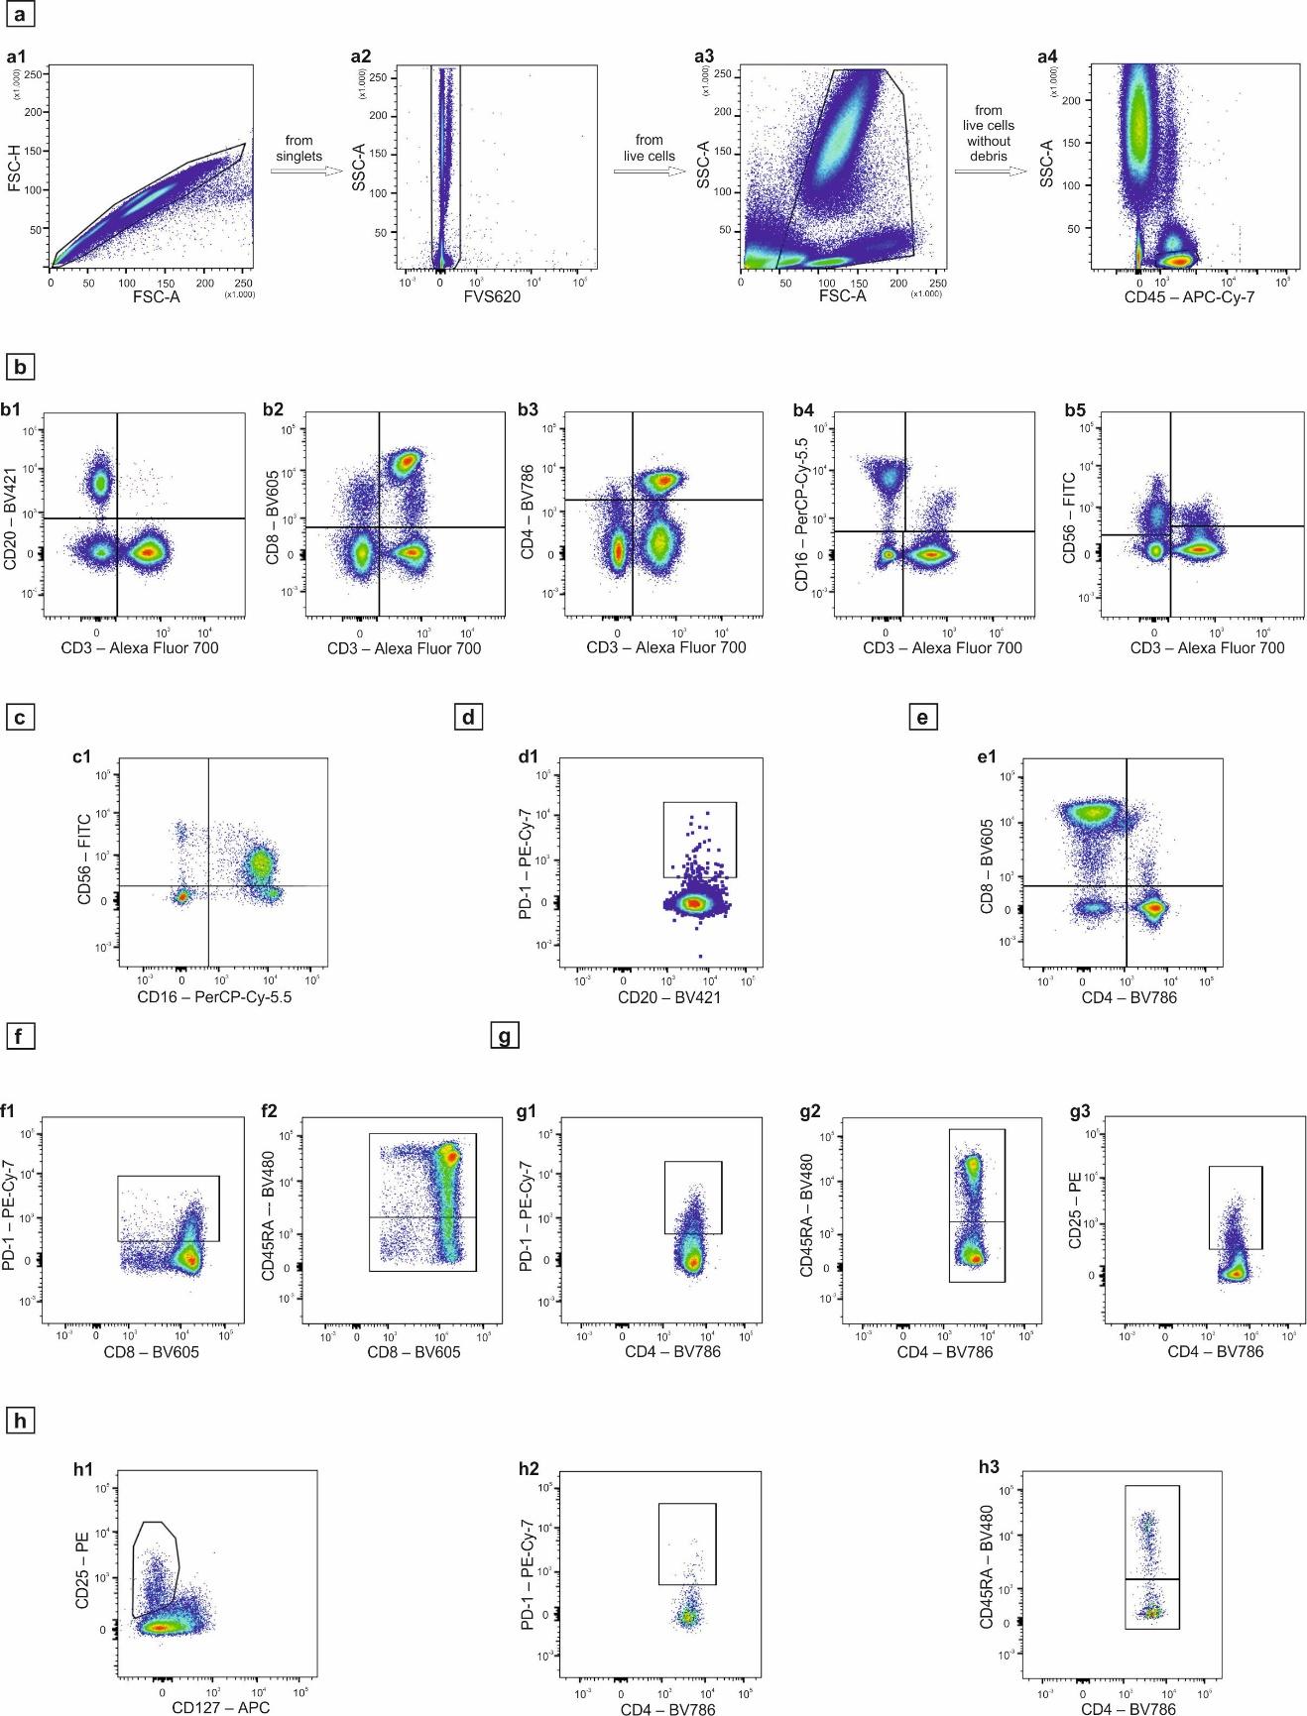
Fig. S1 Gating strategy to identify major lymphocyte subpopulations in blood samples stained with the antibody cocktail from panel №1 (blood of patient R., April 2024 as a representative example). a. Initial strategy of isolating leukocytes (a4) without capturing cell aggregates (a1), dead cells (a2), subcellular debris (a3); b. Determination of major lymphocyte subpopulations using lineage markers: CD3+ T-cells and CD20+ B-cells (b1), CD8+ T-cells (b2), CD4+ T-cells (b3), CD16+ NK and NKT-cells (b4), CD56+ NK and NKT-cells (b5); c. Determination of NK-cell subtypes (c1); d: Analysis of frequency PD-1+ expressing B-cells (d1); e: Analysis of cytotoxic CD4-CD8+ T cells, CD4+CD8- T helper cells, CD4-CD8- DN T cells, and CD4+CD8+ DP T cells among CD3+ T-cells (e1); f: analysis of PD-1 + expression (f1) and naive-memory cells (f2) by CD8+ T-cells; g: analysis of PD-1 + expression (g1), naive-memory cells (g2) and activated CD25+ cells (g3) by CD4+ T-cells; h: Analysis of Tregs - isolation (h1), PD-1 expression (h2), naive/memory Tregs (h3)

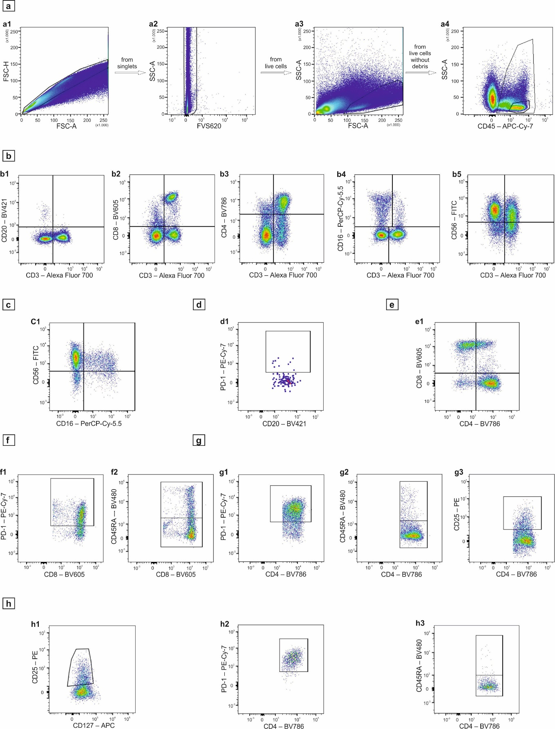
Fig. S2 Gating strategy to identify major lymphocyte subpopulations in adenoma samples stained with the antibody cocktail from panel №1 (adenoma of patient R., April 2024 as a representative example). a. Initial strategy of isolating leukocytes (a4) without capturing cell aggregates (a1), dead cells (a2), subcellular debris (a3); b. Determination of major lymphocyte subpopulations using lineage markers: CD3+ T-cells and CD20+ B-cells (b1), CD8+ T-cells (b2), CD4+ T-cells (b3), CD16+ NK and NKT-cells (b4), CD56+ NK and NKT-cells (b5); c. Determination of NK-cell subtypes (c1); d: Analysis of frequency PD-1+ expressing B-cells (d1); e: Analysis of cytotoxic CD4-CD8+ T cells, CD4+CD8- T helper cells, CD4-CD8- DN T cells, and CD4+CD8+ DP T cells among CD3+ T-cells (e1); f: analysis of PD-1 + expression (f1) and naive-memory cells (f2) by CD8+ T-cells; g: analysis of PD-1 + expression (g1), naive-memory cells (g2) and activated CD25+ cells (g3) by CD4+ T-cells; h: Analysis of Tregs - isolation (h1), PD-1 expression (h2), naive/memory Tregs (h3)

Gating strategy of the samples stained with antibody cocktail of panel №2 to ascertain the cytotoxic potential of CD8+ T cells and NK cells
To evaluate the cytotoxic capacity of CD8+ T cells and NK cells (panel №2) in blood and adenoma, we employed the following gating strategy. As with the gating strategy of panel №1, the first step was to remove aggregates (Fig. S3, a1, Fig. S4, a1), dead cells (Fig. S3, a2, Fig. S4, a2), and subcellular debris (Fig. S3, a3, Fig. S4, a3) that could interfere with the analysis. Eventually, we captured all CD45+ positive leukocytes and among them isolated CD45+ lymphocytes by low SSC (Fig. S3, a4, Fig. S4, a4). To assess the secretion of perforin by CD8+ T cells, CD16+ and CD56+ NK cells, and to calculate the cytotoxicity index, we analyzed all lymphocytes on CD8-APC-H7/Perforin-PerCP-Cy5.5, CD16-PE-CF594/Perforin-PerCP-Cy5.5, and CD56-PE-Cy7/Perforin-PerCP-Cy5.5 dot plots, respectively (Fig. S3, b1-b3 and Fig. S4, b1-b3). Similarly, the production of granzyme B by the same cells was assessed (Fig. S3, b4-b6 and Fig. S4, b4-b6). We calculated the cytotoxicity index (CI), e.g. for perforin-producing CD16+ NK-cells, as the ratio of perforin-producing CD16+ NK-cells to all CD16+ NK-cells, including both perforin-producing and non-producing cells. Thus, CI was calculated as follows: CI = 100% * (Perforin+CD16+)/((Perforin+CD16+) + (Perforin-CD16+)). The proportion of CD8+ T cells (Fig. S3, c1 and Fig. S4, c1) and NK cells (Fig. S3, d1-d2 and Fig. S4, d1-d2) expressing both types of lytic granules, granzyme B and perforin, was determined on Granzyme B-BV421/Perforin-PerCP-Cy5.5 dot plot (Fig. S3, c2, d3 and Fig. S4, c2, d3). CD38 and HLA-DR expression was analyzed both among CD3+ T cells from all lymphocytes (Fig.S3, e1-e2 and Fig. S4, e1-e2) and exclusively on CD8+ T cells (Fig. S3, e3-e4 and Fig. S4, e3-e4). Furthermore, NK cells were examined on the CD8-APC-H7/CD38-BV605 dot plot to analyze CD8+ NK cells expressing or not expressing CD38 (Fig. S3, d4 and Fig. S4, d4).
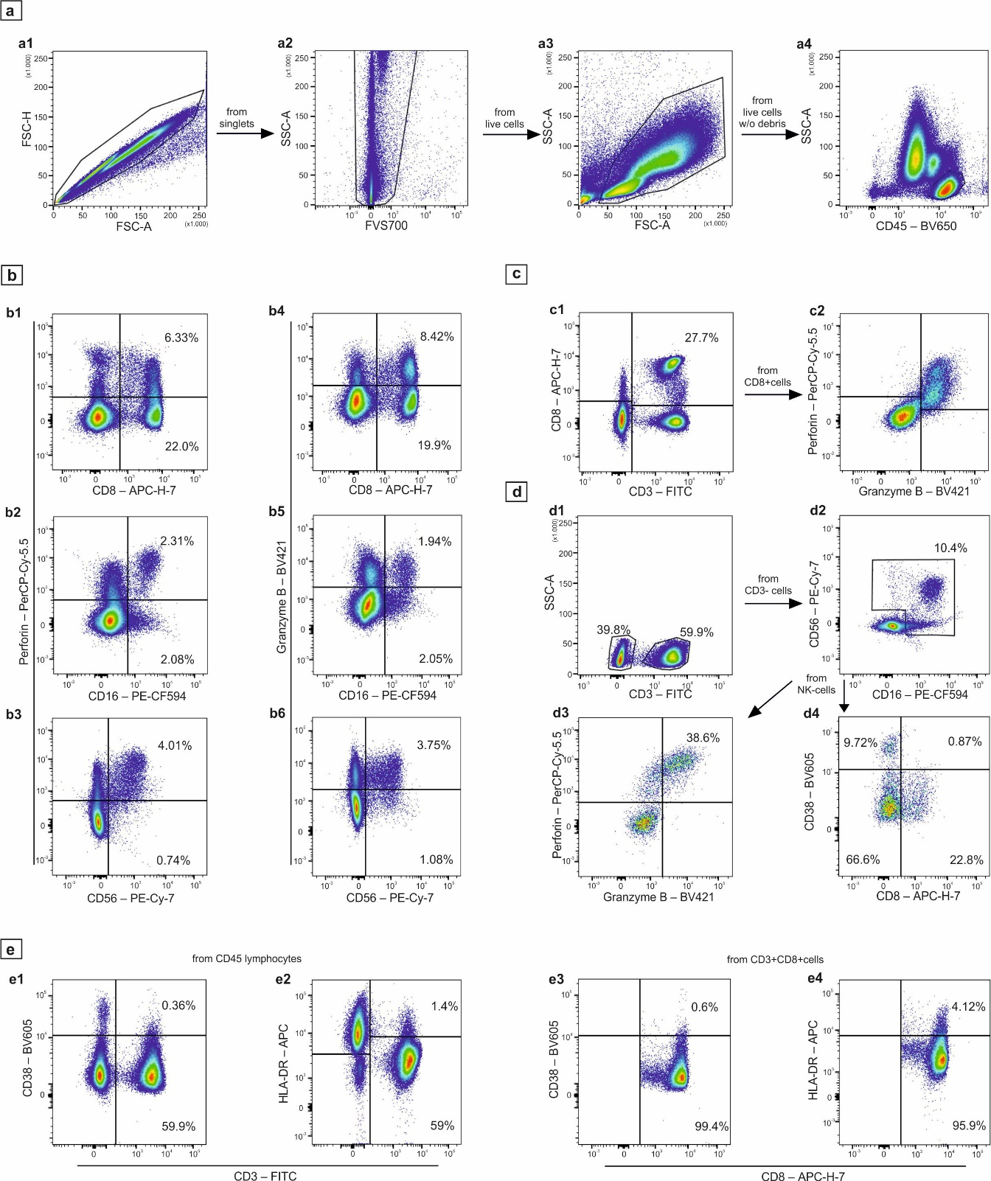
Fig. S3 Gating strategy to evaluate the cytotoxic capacity of CD8+ T cells and NK cells in blood stained with panel №2 antibody cocktail (blood of patient R., October 2023 as a representative example). a. Initial strategy of isolating leukocytes (a4) without capturing cell aggregates (a1), dead cells (a2), subcellular debris (a3); b. Dot plots with all lymphocytes displayed to calculate the cytotoxicity index by perforin production of CD8 T-cells (b1), CD16+ NK-cells (b2), CD56+ NK-cells (b3) and by granzyme B production of CD8 T-cells (b4), CD16+ NK-cells (b5), CD56+ NK-cells (b6); c: Analysis of CD8+ T-cells (c1), expressing simultaneously both types of lytic granules (c2); d: Analysis of NK-cells first isolated as CD3- negative cells (d1) and further selected as CD16+ and/or CD56+ cells (d2), to evaluate NK-cells expressing simultaneously both types of lytic granules (d3) and CD8/CD38 (d4); e: Analysis of CD38 and HLA-DR expression by CD3 T-cells (e1-e2) and by CD8+ T-cells (e3-e4);

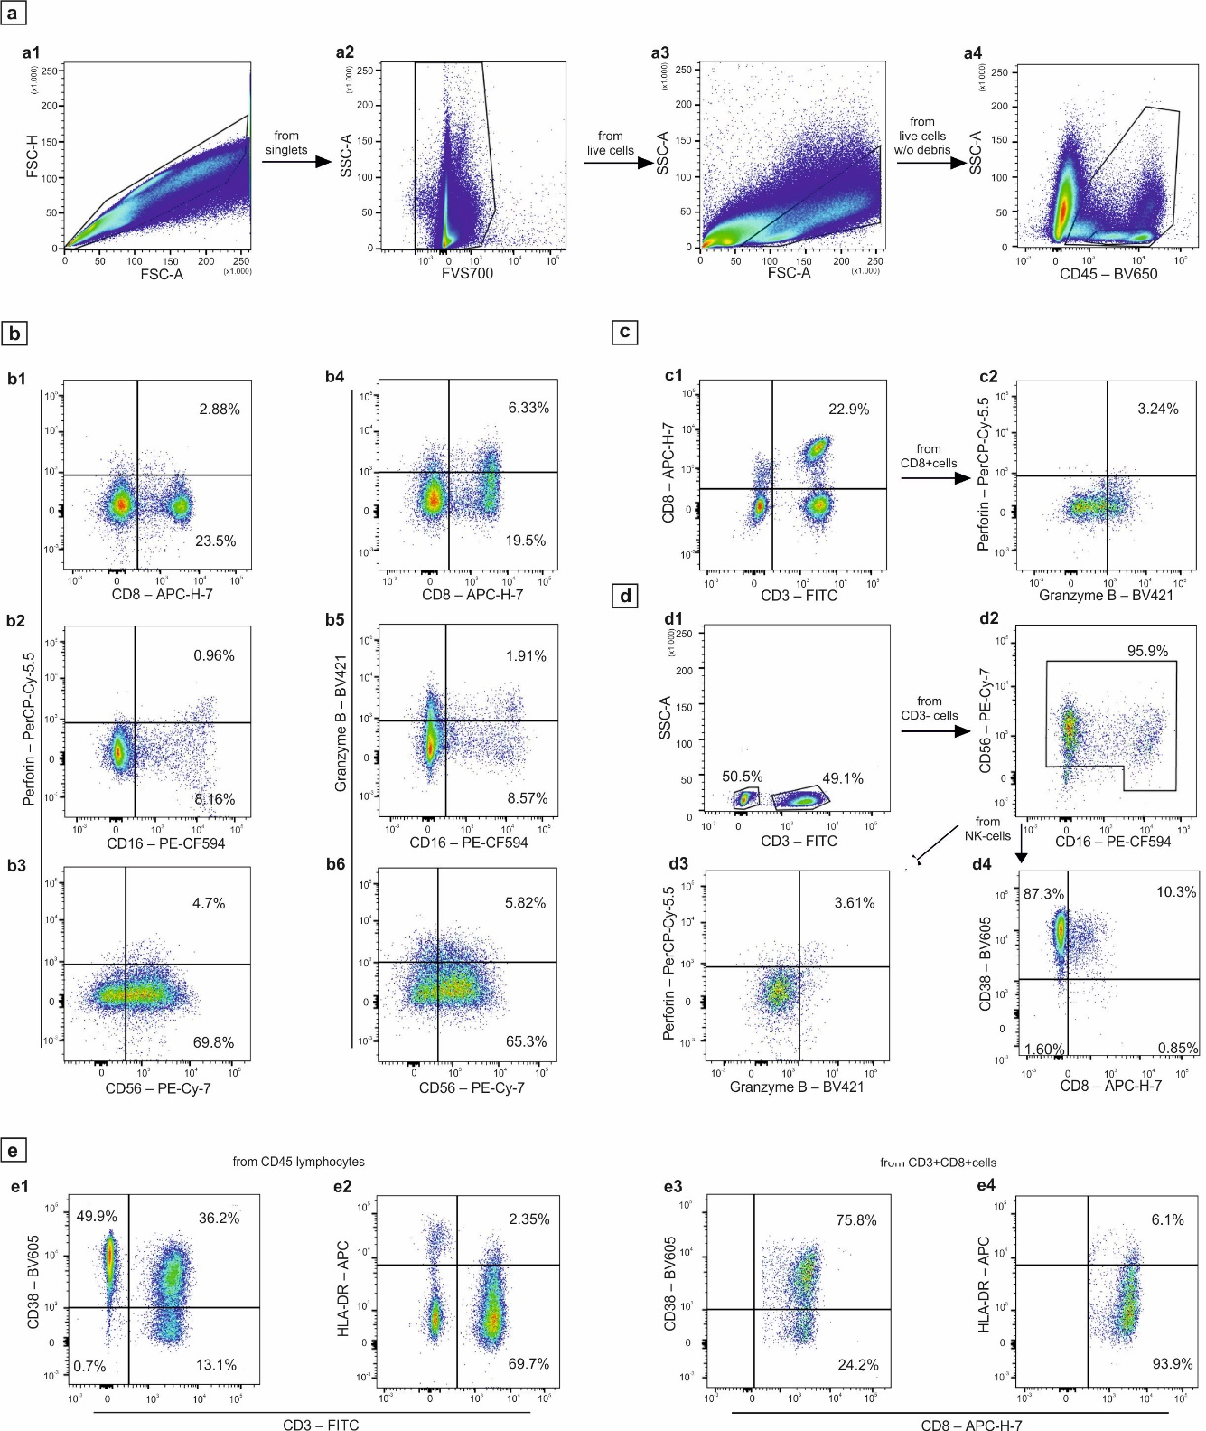
Fig. S4 Gating strategy to evaluate the cytotoxic capacity of CD8+ T cells and NK cells in blood stained with panel №2 antibody cocktail (adenoma of patient R., April 2024 as a representative example). a. Initial strategy of isolating leukocytes (a4) without capturing cell aggregates (a1), dead cells (a2), subcellular debris (a3); b. Dot plots with all lymphocytes displayed to calculate the cytotoxicity index by perforin production of CD8 T-cells (b1), CD16+ NK-cells (b2), CD56+ NK-cells (b3) and by granzyme B production of CD8 T-cells (b4), CD16+ NK-cells (b5), CD56+ NK-cells (b6); c: Analysis of CD8+ T-cells (c1), expressing simultaneously both types of lytic granules (c2); d: Analysis of NK-cells first isolated as CD3- negative cells (d1) and further selected as CD16+ and/or CD56+ cells (d2), to evaluate NK-cells expressing simultaneously both types of lytic granules (d3) and CD8/CD38 (d4); e: Analysis of CD38 and HLA-DR expression by CD3 T-cells (e1-e2) and by CD8+ T-cells (e3-e4);

Gating strategy of the samples stained with antibody cocktail of panel №3 to identify myeloid populations, including myeloid-derived suppressor cells (MDSCs)
The primary objective of analyzing samples stained with panel №3 antibody cocktail was to examine myeloid-derived suppressor cells - PMN-MDSCs, which are characterized by CD11b+CD14-CD15+ phenotype, and M-MDSCs, which are identified by a CD11b+CD14+CD15- phenotype. The gating strategy employed for the analysis of MDSCs found in the blood (Fig. S5) and adenoma (Fig. S6) of patients is outlined below. First, any interfering artifactual events, such as cell aggregates (Fig. S5, a1 and Fig. S6, a1) and subcellular debris (Fig. S5, a2 and Fig. S6, a2), should be removed from the analysis. Then, all CD45+ positive cells should be isolated, excluding the CD45^{low}SSC^{low} region of basophils (Fig. S5, a3 and Fig. S6, a3). Given that MDSCs lack the lineage markers CD3, CD19/20, CD16, CD56, CD14, and CD15 and exhibit absence or low HLA-DR expression, we employed a sequential removal strategy involving the exclusion of various cell lines from CD45+ leukocytes. We first excluded CD3+ T cells on CD3-AF700/SSC dot plot (Fig. S5, b1 and Fig. S6, b1). Subsequently, we removed CD20+ B cells on CD20-VB/SSC among all CD3-luekocytes (Fig. S5, b2 and Fig. S6, b2), followed by CD56+ NK cells removal on CD56-PE-CF594/SSC dot plot (Fig. S5, b3 and Fig. S6, b3). Subsequently, HLA-DR+ monocytes were excluded on HLA-DR-APC/SSC dot plot (Fig. S5, b4 and Fig. S6, b4), while CD16+ neutrophils were removed on CD16-PE-Cy7/SSC dot plot (Fig. S5, b5 and Fig. S6, b5). Eventually, a region of CD11b+ cells was isolated from all Lin- cells on a CD11b-AF488/SSC dot plot (Fig. S5, b6 and Fig. S6, b6), which were then examined on CD15-PerCP-Vio700/CD14-APC-H7 dot plot to identify PMN-MDSCs as CD11b+CD14-CD15+ and M-MDSCs as CD11b+CD14+CD15- events (Fig. S5, b7 and Fig. S6, b7). The relative number of MDSCs among leukocytes was determined by dividing the number of events in MDSCs gate to the total number of events in CD45+ cell gate with multiplying by 100%. This approach allowed for the estimation of the frequency of MDSCs among all blood leukocytes and adenomas.
Additionally, this antibody cocktail can be utilized to analyze lymphocytes (Fig. S5, c1 and Fig. S6, c1) on CD45-BV650/SSC dot plot and the number of CD3+ T cells, CD20+ B cells, and CD3-CD20- NK cells on CD3-AF-700/CD20-VB dot plot (Fig. S5, c2 and Fig. S6, c2). Furthermore, the antibody cocktail can be used to analyze CD3+HLA-DR+ activated T cells on CD3-AF-700/HLA-DR-APC dot plot (Fig. S5, c3 and Fig. S6, c3). Furthermore, NK cells were analyzed for their subpopulation composition on CD16-PE-Cy7/CD56-PE-CF594 dot plot (Fig. S5, c4 and Fig. S6, c4). We estimated the frequency of neutrophils at CD45-BV650/CD16-PE-Cy7 among all leukocytes (Fig. S5, d1 and Fig. S6, d1); Monocytes were determined at CD45-BV650/CD14-APC-H7 among all leukocytes (Fig. S5, e1 and Fig. S6, e1). Further analysis of monocyte subpopulations was performed at HLA-DR-APC/CD11b-AF488 dot plot (Fig. S5, e2 and Fig. S6, e2) to assess subpopulations with high and low HLA-DR expression. Using CD14-APC-H7/CD16-PE-Cy7 dot plot (Fig. S5, e3 and Fig. S6, e3) we assessed the number of classical/intermediate and non-classical frequency of monocytes.
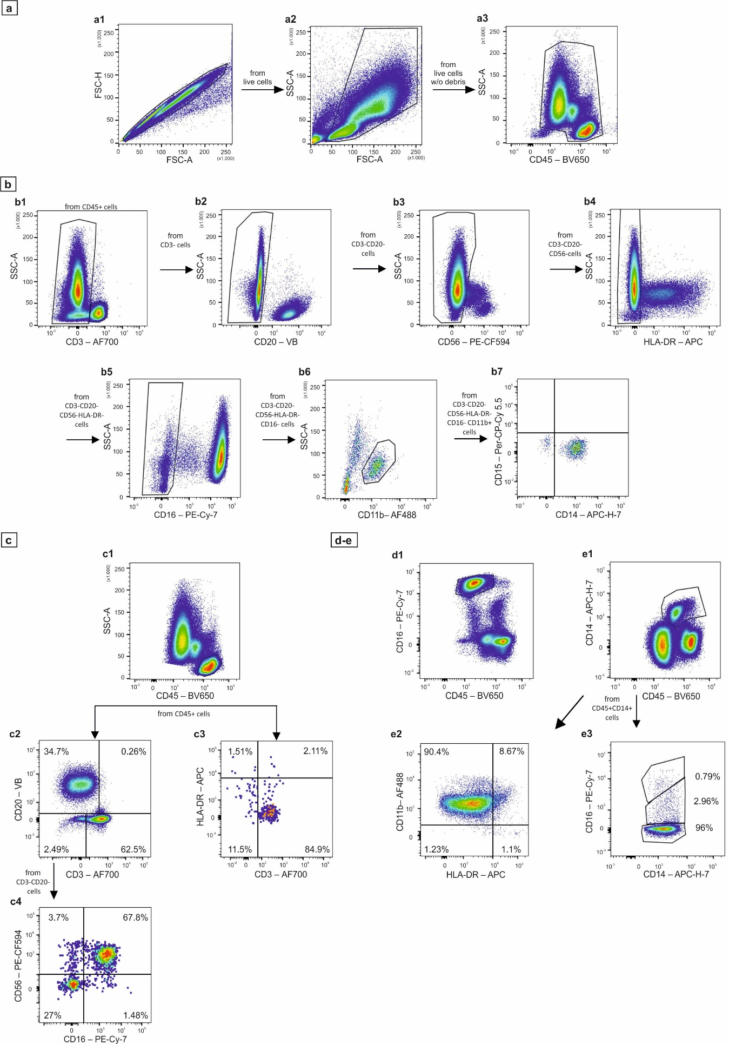
Fig. S5 Gating strategy to evaluate myeloid-derived suppressor cells (MDSCs) in blood stained with panel №3 antibody cocktail (blood of patient R., October 2023 as a representative example). a: Initial clean-up of the data to get rid of cell aggregates (a1) and subcellular debris (a2) as well as CD45^{low}SSC^{low} region of basophils (a3) to capture exclusively CD45+ leukocytes; b: gating strategy of MDSCs isolation through the sequential removal of various cell lineages from CD45+ leukocytes - excluding CD3+ T-cells (b1), CD20+ B-cells (b2), CD56+ cells (b3), HLA-DR expressing cells (b4) and CD16+ cells (b5). Then CD11b+ isolated cells (b6) are examined by CD14 and CD15 expression to identify PMN-MDSCs as CD11b+CD14-CD15+ and M-MDSCs as CD11b+CD14+CD15- events (b7); c: optional analysis of the number of CD45+ lymphocytes (c1), CD3+ T-cells, CD20+ B-cells and CD3-CD20- NK-cells (c2), CD3+HLA-DR+ activated T-cells (c3), and eventually NK-cell subpopulations (c4); d: analysis of CD16+ neutrophils among all leukocytes (d1); e: analysis of CD14+ monocytes among all leukocytes (e1), and monocyte subpopulations expressing HLA-DR (e2) and CD16 (e3);

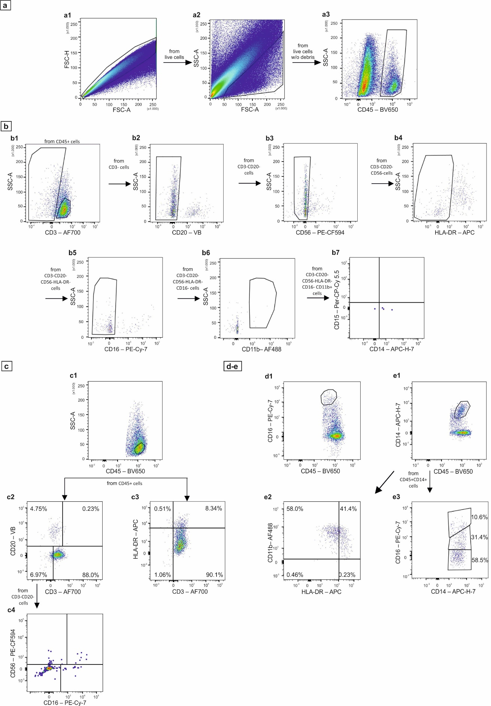
Fig. S6 Gating strategy to evaluate myeloid-derived suppressor cells (MDSCs) in adenoma stained with panel №3 antibody cocktail (adenoma of patient R., October 2023 as a representative example). a: Initial clean-up of the data to get rid of cell aggregates (a1) and subcellular debris (a2) as well as CD45^{low}SSC^{low} region of basophils (a3) to capture exclusively CD45+ leukocytes; b: gating strategy of MDSCs isolation through the sequential removal of various cell lineages from CD45+ leukocytes - excluding CD3+ T-cells (b1), CD20+ B-cells (b2), CD56+ cells (b3), HLA-DR expressing cells (b4) and CD16+ cells (b5). Then CD11b+ isolated cells (b6) are examined by CD14 and CD15 expression to identify PMN-MDSCs as CD11b+CD14-CD15+ and M-MDSCs as CD11b+CD14+CD15- events (b7); c: optional analysis of the number of CD45+ lymphocytes (c1), CD3+ T-cells, CD20+ B-cells and CD3-CD20- NK-cells (c2), CD3+HLA-DR+ activated T-cells (c3), and eventually NK-cell subpopulations (c4); d: analysis of CD16+ neutrophils among all leukocytes (d1); e: analysis of CD14+ monocytes among all leukocytes (e1), and monocyte subpopulations expressing HLA-DR (e2) and CD16 (e3);

Gating strategy of the samples stained with antibody cocktail of panel №4 for macrophage detection
To analyze macrophages, we employed the following gating strategy (Fig. S7): initially, we performed a sequential purification of CD45+ leukocytes from cell aggregates (Fig. S7, a1), dead cells (Fig. S7, a2), and subcellular debris (Fig. S7, a3). Subsequently, we identified CD45+ leukocyte region (Fig. S7, a4). Further, all leukocytes were examined on CD64-APC/CD11b-AF488 dot plot (Fig. S7, b1) to distinguish two subpopulations of cells based on CD64 and CD11b expression levels. CD64^{bright}CD11b^{low} population was identified as macrophages, while CD64^{low}CD11b^{bright} population was designated to be monocytes. All macrophages were displayed on CD206-BB700/CD163-BV480 dot plot (Fig. S7, b2) to isolate double positive CD163+CD206+ M2 macrophages and double negative CD206-CD163- M1 macrophages. We also assessed the expression of CD14 (Fig. S7, b3-b4) in M1 and M2 macrophages, and CD80 (Fig. S7, b5) among M1 macrophages.

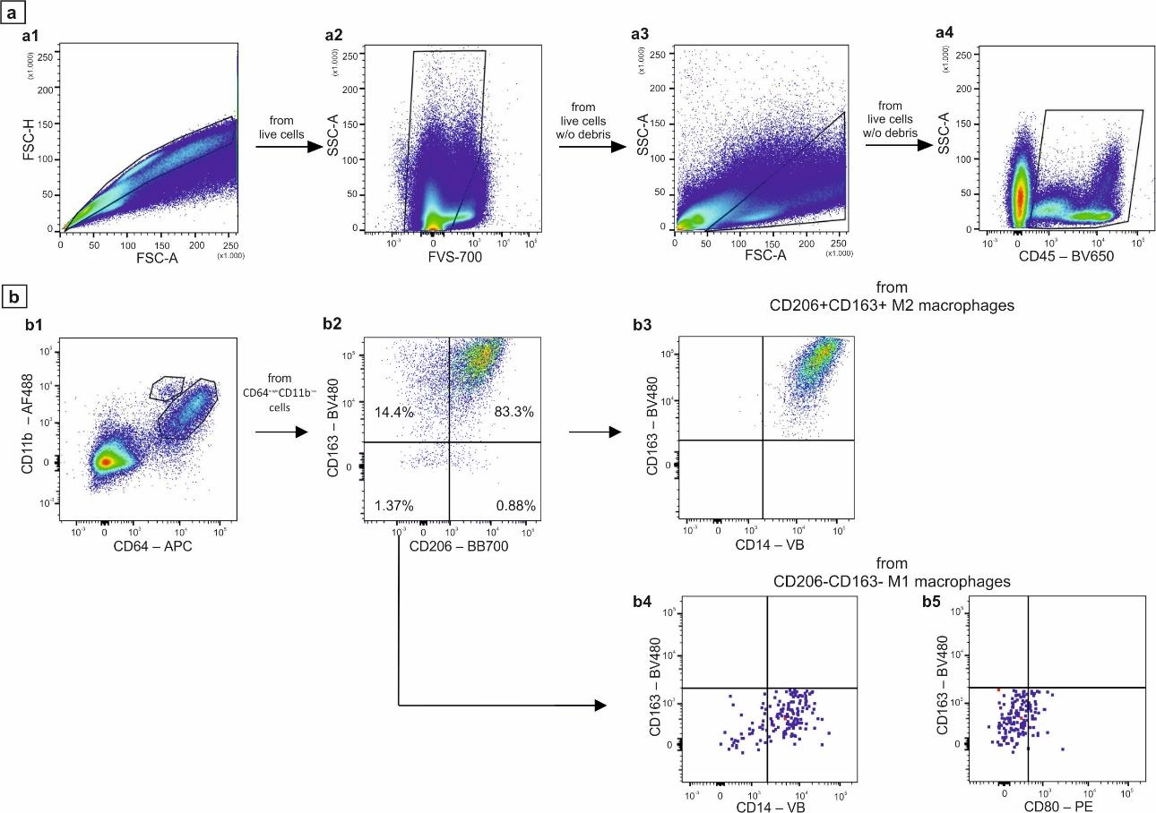
Fig. S7 Gating strategy for estimating the relative numbers of macrophages and monocytes (adenoma of patient R., October 2023 as a representative example). a: initial clean-up of the sample to get rid of cell aggregates (a1), dead cells (a2) and subcellular debris (a3) to determine the region of CD45+ leukocytes (a4); b: identification of macrophages as CD64^{bright}CD11b^{low} population (b1) for further analysis of macrophage M1 and M2 subpopulations (b2). Analysis of CD14 expression (b3-b4) in M1 and M2 macrophages, and CD80 (b5) among M1 macrophages

