Electrochemical Performance of N-doped Graphite @Carbon/ Red Phosphorus Composite for Lithium-Ion Secondary Batteries
MD Rasidul Islam Rocky, Venugopal Nulu*, Keun Yong Sohn*
Department of Nanoscience and Engineering, Center for Nano Manufacturing, Inje University,
197 Inje-ro, Gimhae, Gyeongnam-do 50834, Republic of Korea
* Correspondence to: [ +82-010-8544-0176; ksohn@inje.ac.kr; venungopal@gmail.com]

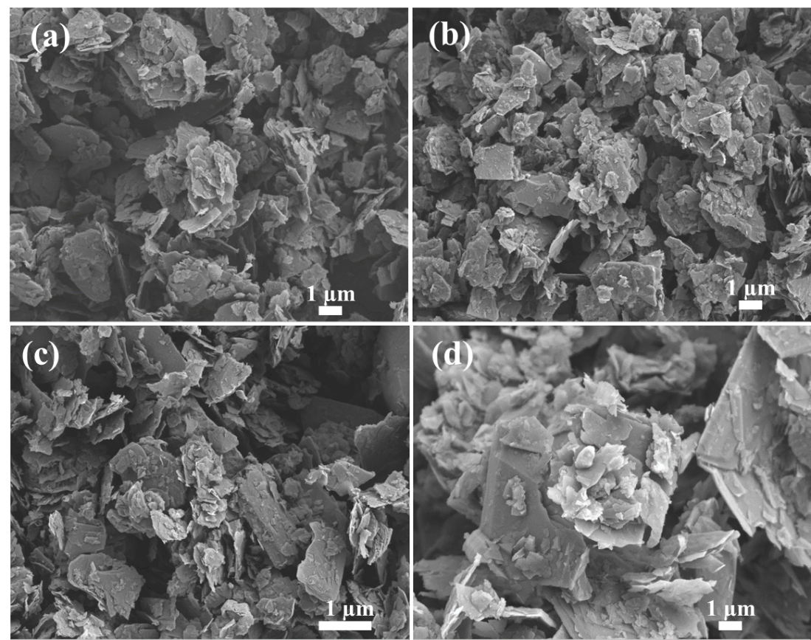

Figure S1. SEM images of (a) NGC; (b) NGC/P1(95:5); (c) NGC/P2(90:10); (c) NGC/P3(85:15)

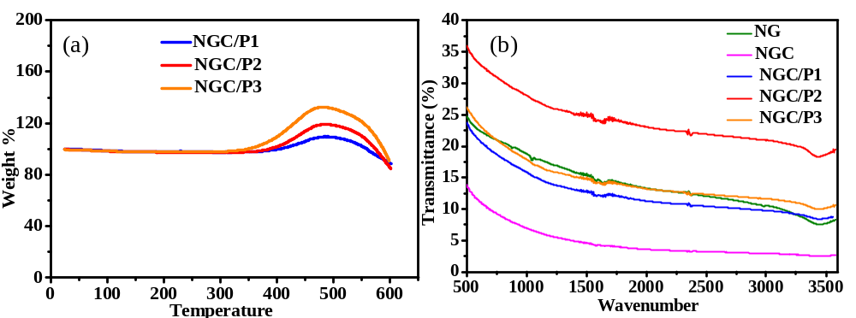

Figure S2. (a) TGA analysis of the composites; (b) FTIR studies of all the samples.

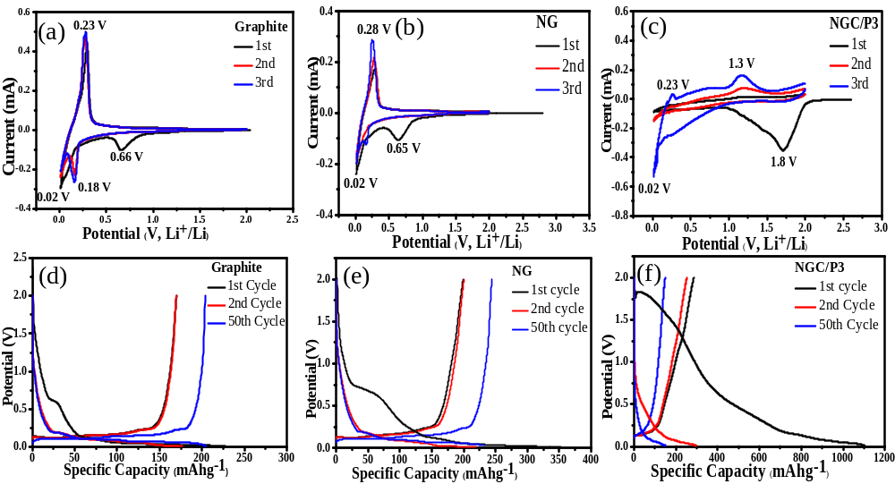
Figure S3: Cyclic voltammograms and charge-discharge curves for the first three cycles of (a, d) G, (b, e) NG, and (c, f) NGC/P3, respectively.
500 nm

Table S1. Comparison of electrochemical performance of our red P-based graphite/carbon hybrid anodes with the literature.
Composite materials |  |  | References
Composite materials | Current density (100 mA g⁻¹); discharge capacity (mAh g⁻¹) after specific number of cycles | Initial specific capacity  (mAh g⁻¹) | References
Nitrogen doped Graphite@Carbon/Red P composite (NGC/P2) | 520, 100 cycles | 1496 | This work
Nitrogen doped Graphite@Carbon/Red P composite (NGC/P1) | 427, 100 cycles | ~970 | This work
Graphene/Graphite Nanosheet Composite | 480, 100 cycles | ~1000 | 1
Ag Nanoparticle-Decorated MoS₂ Nanosheets | 510, 100 cycles  . | 900 | 2
Si-MWNT nanocomposite | 500, 10 cycles | ~1500 | 3
Single-walled carbon Nanotube/Silicon Composites | 50, 50 cycles | ~1400 | 4
Natural-Cellulose-Derived Tin-Nanoparticle/Carbon-Nanofiber Composite | 430, 100 cycles | 580 | 5

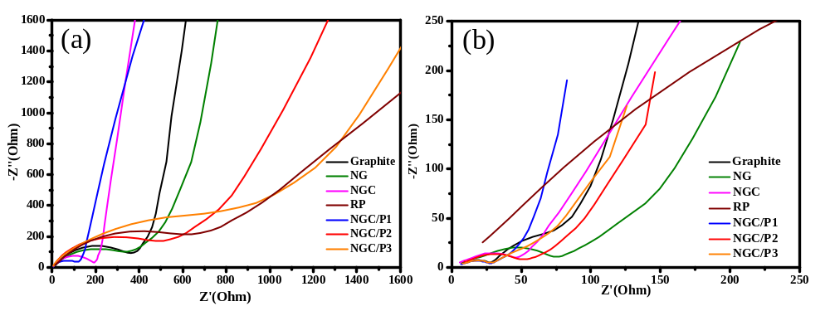

Figure S4. Nyquist plots for G, NG, NGC, NGC/P1, NGC/P2, and NGC/P3, respectively (a) before cycling (b) after ten charge-discharge cycles.

References

- T.P. Nguyen, I.T. Kim, Nanomaterials, 11, 626 (2021).

- Zhu, X.; Yang, C.; Xiao, F.; Wang, J.; Su, X., J. Chem., 39, 683–688 (2015).

3. P. Gao, Y. Nuli, Y. S. He, J. Wang, A. I. Minett, J. Yang, J. Chen, Chem Commun., 46, 48
(2010).

4. J. Y. Eom, H. S. Kwon, ACS Appl Mater Interfaces., 3, 4 (2011).

5. W.Rehman, H. Huang , M. Zain Yousaf , Molecules,28, 2792 (2023).

