Supporting Information

Functionalization of Cellulosic Materials via a Bifunctional Azetidinium Coupler
Yue Suª, Ayodele Fatona^{b}, Erin A.S. Doherty,^{c} Richard J. Riehle,^{c} Sachin Borkar,^{c} Robert H. Pelton^{b} and Jose M. Moran-Mirabal^{a,d,e,}*
ª Department of Chemistry and Chemical Biology, Macmaster University, 1280 Main St. West, Hamilton, ON L8S 4M1, Canada
^{b} Department of Chemical Engineering, McMaster University, 1280 Main St. West, Hamilton, ON L8S 4L7, Canada
^{c} Solenis LLC, 2475 Pinnacle Drive, Wilmington, Delaware, United States of America, 19803
^{d} Centre for Advanced Light Microscopy, McMaster University, 1280 Main St. West, Hamilton, ON L8S 4L7, Canada
^{e} Brockhouse Institute for Materials Research, McMaster University, 1280 Main St. West, Hamilton, ON L8S 4L7, Canada

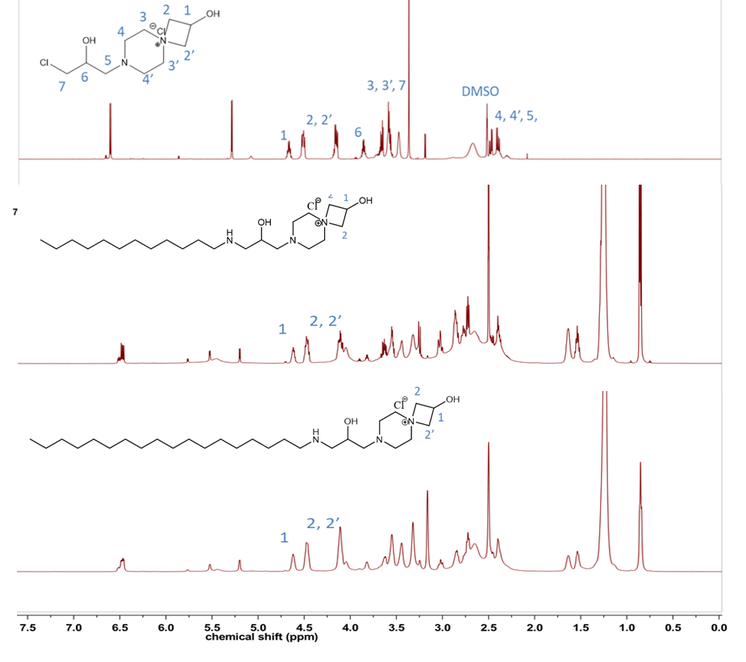
Figure S1. ¹H NMR spectra of bifunctional azetidinium coupler (top), AZE-C12 (middle), and AZE-C18 (bottom).

(a)
(b)
Figure S2. Electrospray ionization mass spectra of (a) AZE-alkyne and (b) AZE-azide derivatives.

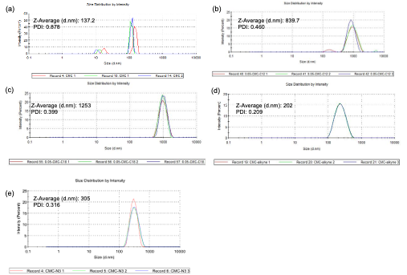Figure S3. DLS of (a) CMC; (b) CMC-AZE-C12; (c) CMC-AZE-C18; (d) CMC-AZE-alkyne; and (e) CMC-AZE-azide polymers. Distributions are representative recordings from n = 3 independently prepared samples.

Figure S4. Dry (blue) and wet strength (purple) of paper sheets made from pulp fibres onto which CMC, CMC-AZE-C12, CMC-AZE-C18, CMC-AZE-alkyne, or CMC-AZE-azide were adsorbed. Numbers presented are means and standard deviations from n = 3 replicate sheets prepared independently.

Figure S5. Calibration curve for FAM-5-azide.

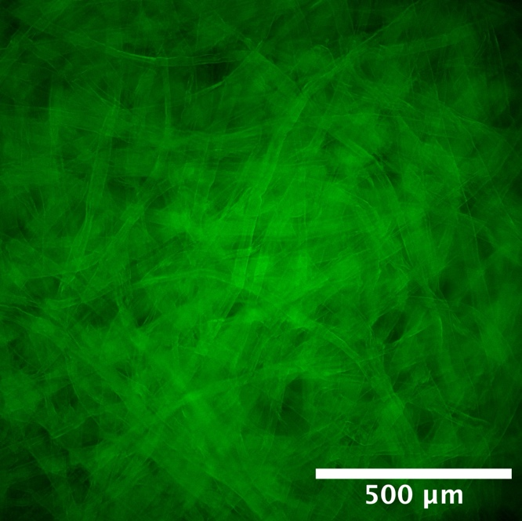

Figure S6. Fluorescence microscopy images of CMC-alkyne modified paper sheets reacted with FAM-azide

