Supplementary Infomation

Figure S1 The image of P. uniflora (A) Flower of P. uniflora. (B) Herbarium of P. uniflora.

Figure S2 Mitogenome structure of P. uniflora accession generated using Bandage software. (A) Draft of the mt genome assembly. (B) Master circular structure of P. uniflora mt genome. (C) Recombinant structure of the mt genome of P. uniflora.

Figure S3 Phylogenetic tree obtained using the maximum likelihood (ML) methods for the 11 Rosaceae species based on 19 conserved mt protein coding genes (PCGs).

Figue S1

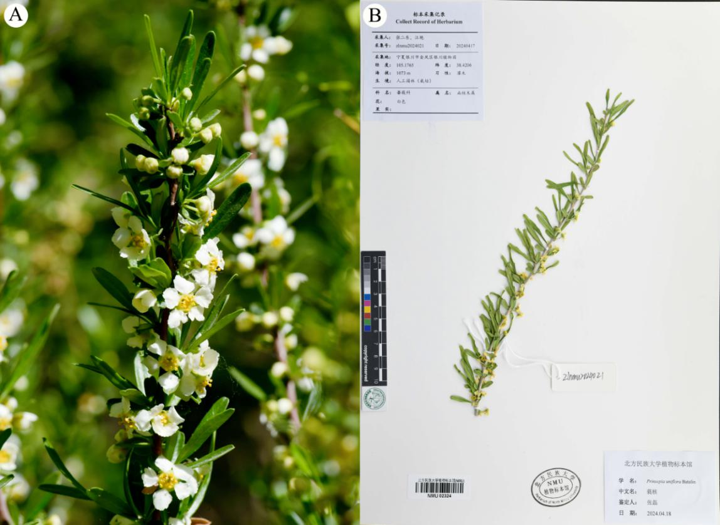

Figue S2

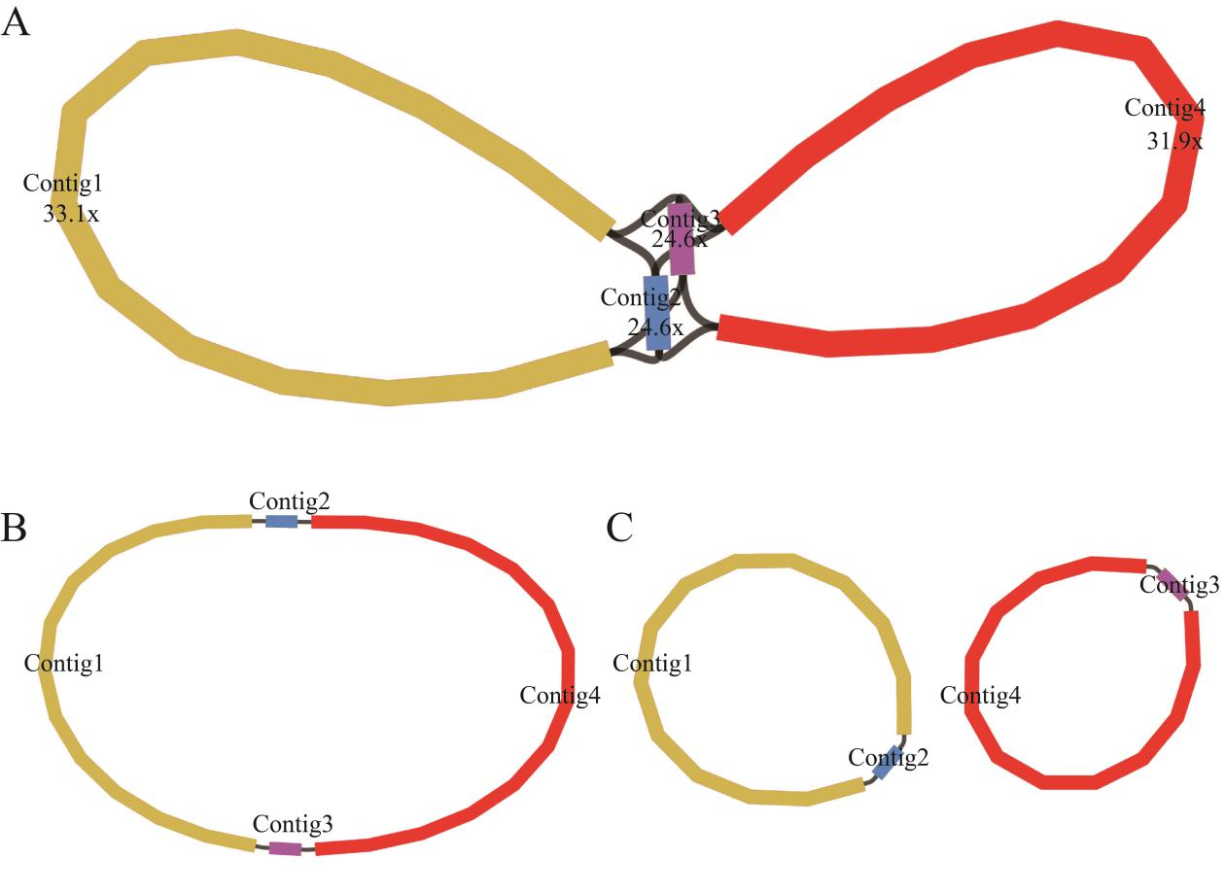

Figue S3

