Current aviation roadmaps are not within planetary boundaries
Supplementary information document
B. Païs^{1*}, A. Gondran², L. Hamelin³, F. Simatos¹
¹Fédération ENAC ISAE-SUPAERO ONERA, Université de Toulouse, France
²ENAC, Université de Toulouse, Toulouse, France
³TBI, Université de Toulouse, CNRS, INRAE, INSA, Toulouse, France
*Corresponding author: bastien.pais@isae.fr
Figures
Figure SI1- Contribution analysis for each AEC and each PB with Remind SSP2-RCP26 2020 technosphere 9
Figure SI2- Contribution analysis for each AEC and each PB with Remind SSP2-RCP26 2050 technosphere 10
Figure SI3- Distribution of biosphere integrity impact in 2050 between the climate change and land occupation drivers 11
Figure SI4- Sensitivity analysis of AESA of aviation scenarios to the choice of IAM-SSP-RCP 12
Figure SI5- Aggregated sensitivity analysis of AESA of aviation scenarios to the choice of IAM-SSP-RCP 13
Figure SI6- Sensitivity analysis of 2050 aviation relative resource needs to the choice of IAM-SSP-RCP 14
Figure SI7- Sensitivity analysis of 2050 aviation absolute resource needs to the choice of IAM-SSP-RCP 15
Figure SI8- Aggregated sensitivity analysis of 2050 aviation relative resource needs to the choice of IAM-SSP-RCP 16
Figure SI9- Resource requirements with CAGR=0% between 2023 and 2050 17
Figure SI10- Resource requirements with CAGR=-3% between 2023 and 2050 18
Figure SI11- Evolution of the energy mix for some institutional and industrial scenarios 19

Tables
Table SI1 – Footprint data for each PB and for each reference country 20
Table SI2 - 2019 trafic by country (domestic + flights departing from the country) 21
Table SI3 - Allocation to the transport sector in the FHN reference countries 22

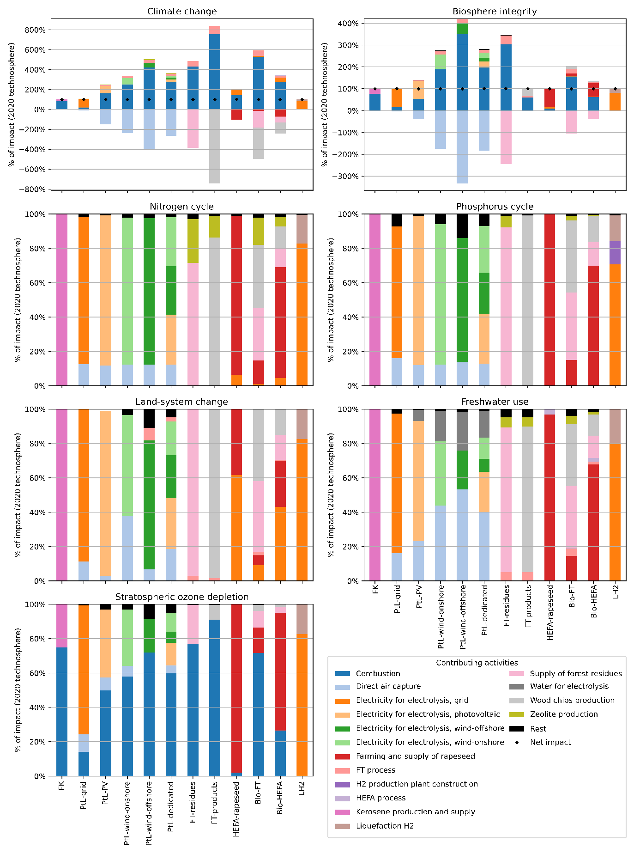
Contribution analysis for each AEC and each PB with Remind SSP2-RCP26 2020 technosphere

Each bar represents an AEC, and each color represents an activity. The results are expressed relative to the total impact. For example, in 2020, approximately 50% of the impact on stratospheric ozone depletion from PtL-PV is due to its combustion.

Contribution analysis for each AEC and each PB with Remind SSP2-RCP26 2050 technosphere
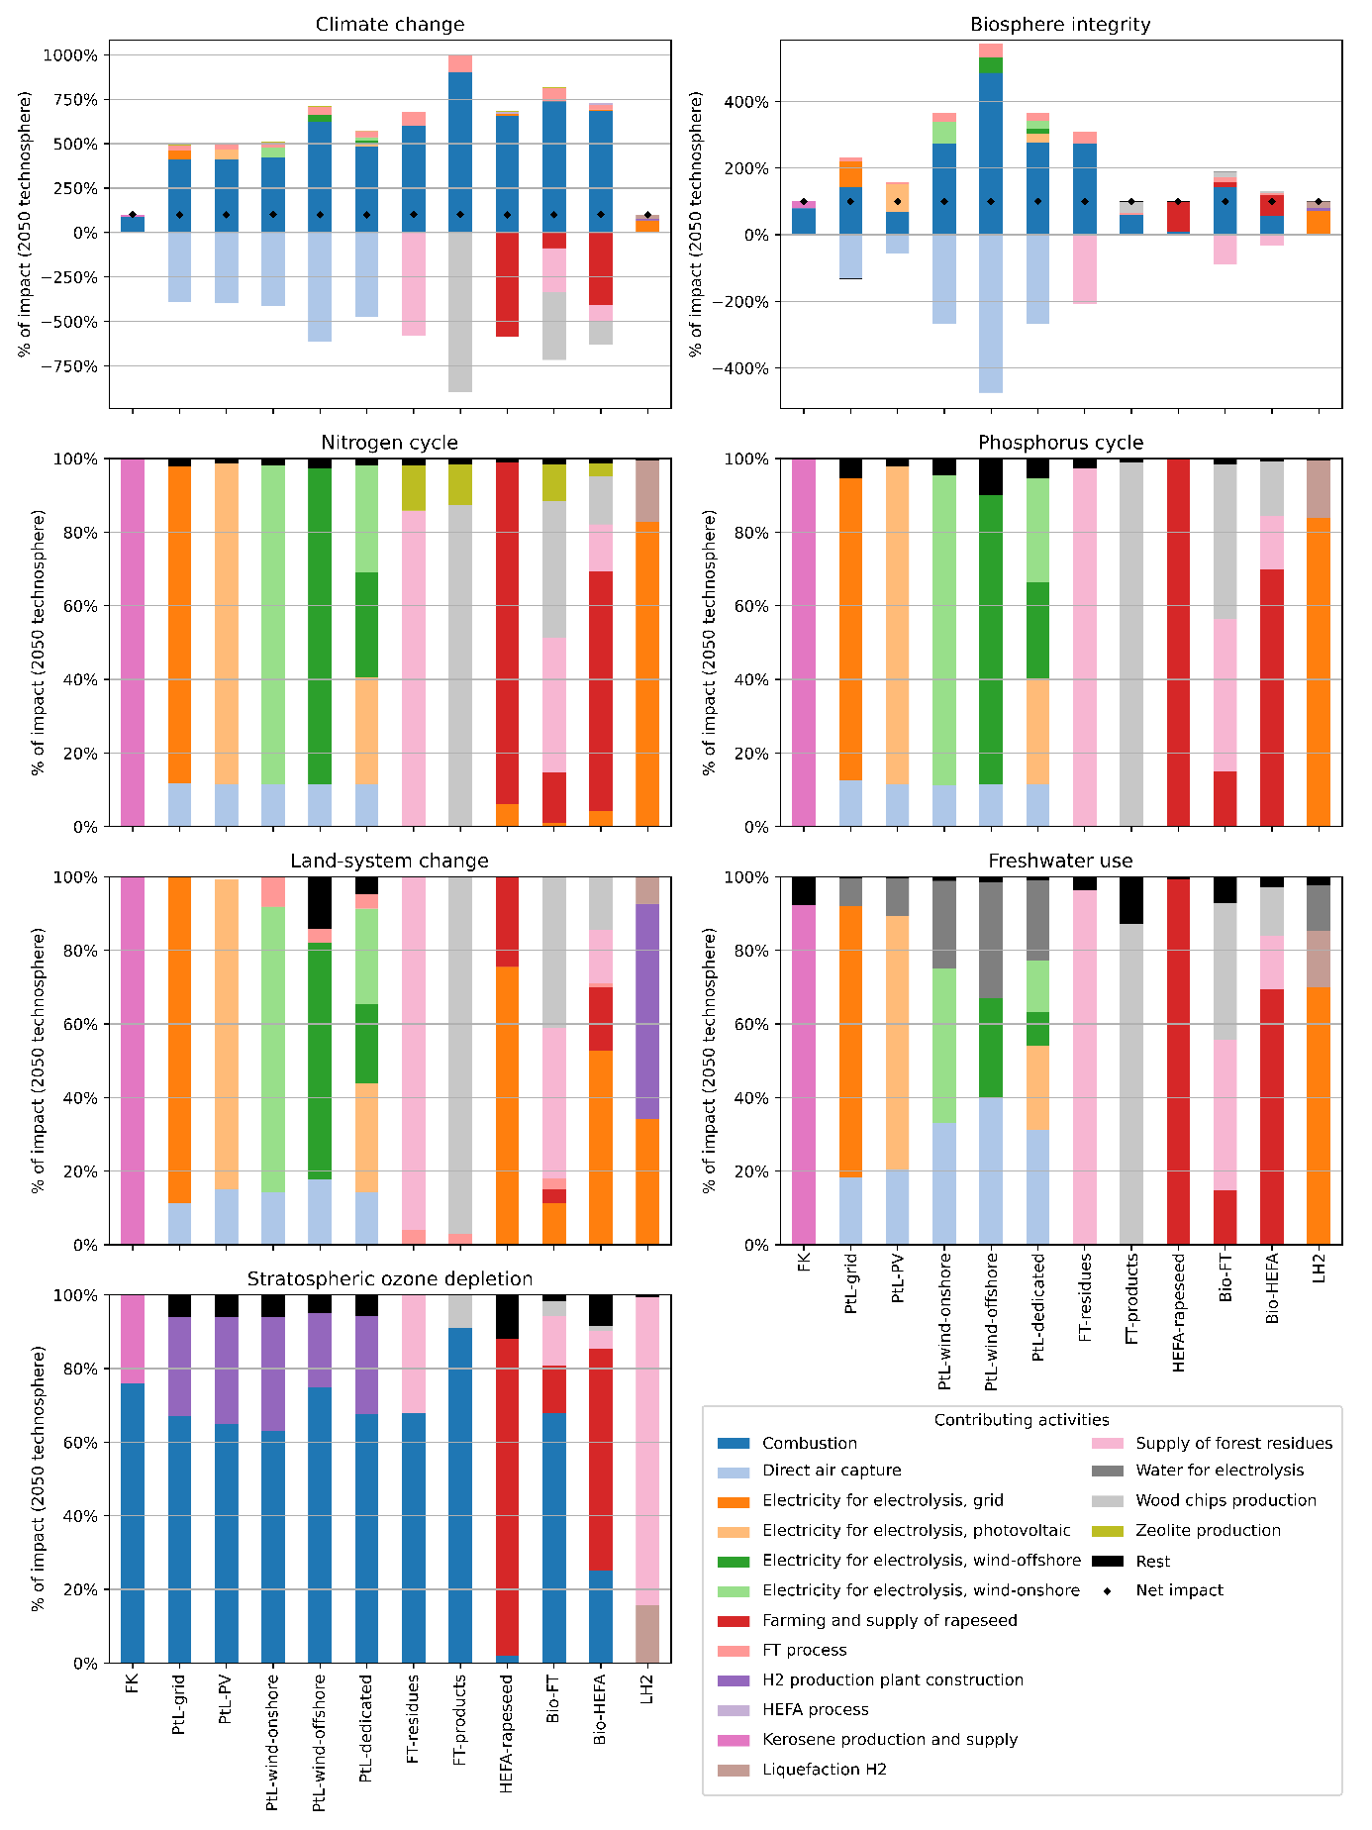

Each bar represents an AEC, and each color represents an activity. The results are expressed relative to the total impact. For example, in 2050, approximately 65% of the impact on stratospheric ozone depletion from PtL-PV is due to its combustion.

Distribution of biosphere integrity impact in 2050 between the climate change and land occupation drivers
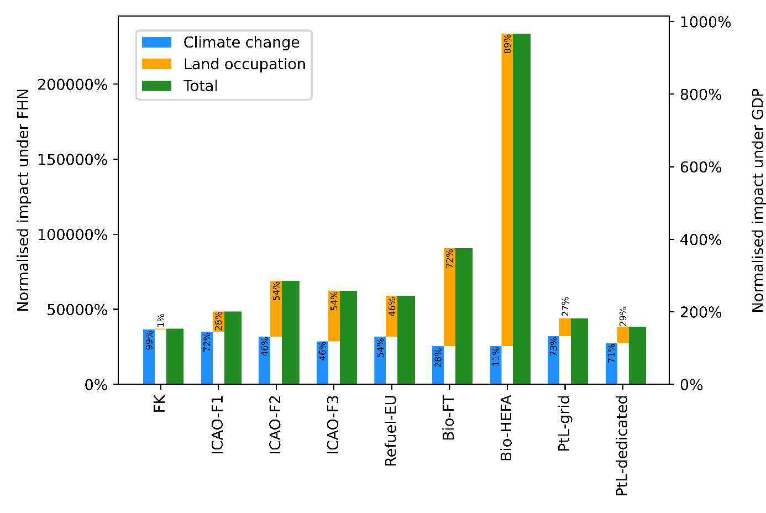

The impact on biosphere integrity is calculated using the Biodiversity Intactness Index (BII) and the methodology developed by Galan-Martin et al⁴. This methodology considers two primary drivers of biosphere loss: climate change and land occupation. Figure SI3 illustrates the distribution of the impact of aviation scenarios in 2050 on biosphere integrity between these two drivers. The percentages within the figure represent the contribution of each driver to the total impact. For example, 72% of the impact on biosphere integrity in the Bio-FT scenario is due to land occupation.

Sensitivity analysis of AESA of aviation scenarios to the choice of IAM-SSP-RCP
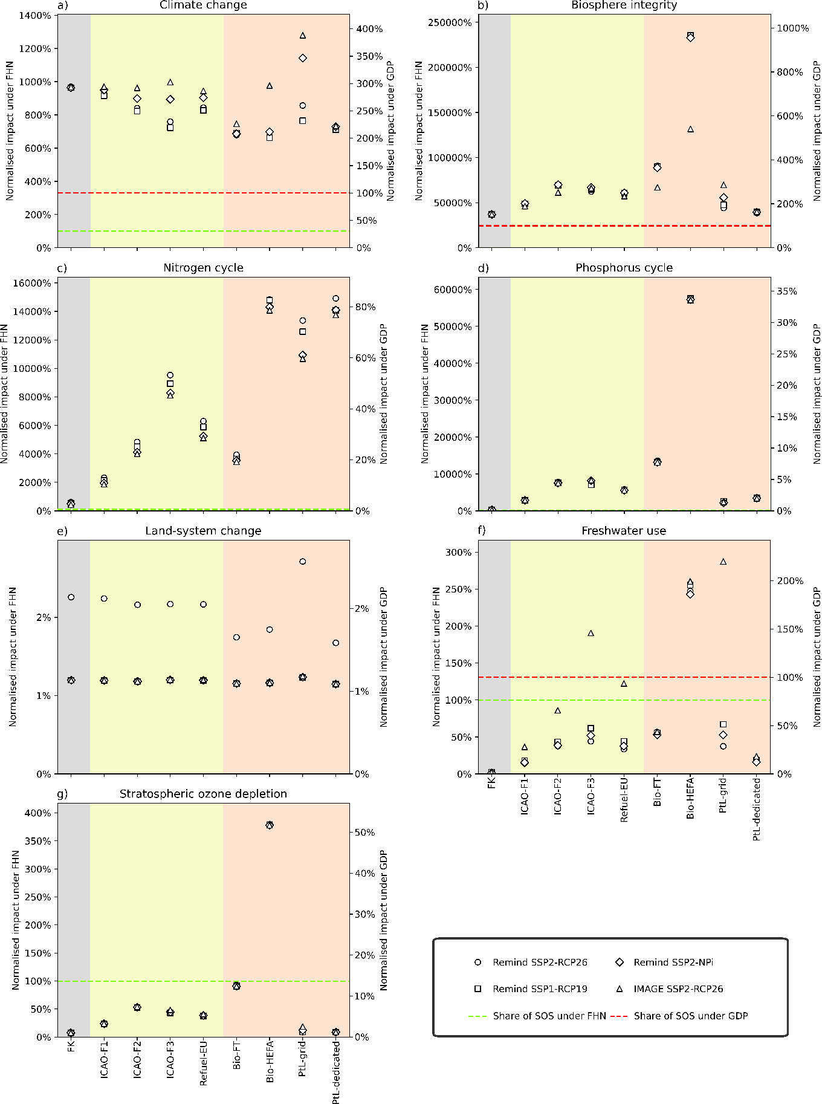

This is the same figure as Fig. 3 in the main body of the paper, but where the underlying SSP-RCP pathway used for the prospective LCA is varied. In the main body we consider one pathway (Remind SSP2-RCP2.6, represented by a circle) and we consider here three other underlying pathways: Remind SSP1-RCP1.9 (square), Remind SSP2-NPi (losange) and IMAGE SSP2-RCP2.6 (triangle).

Aggregated sensitivity analysis of AESA of aviation scenarios to the choice of IAM-SSP-RCP
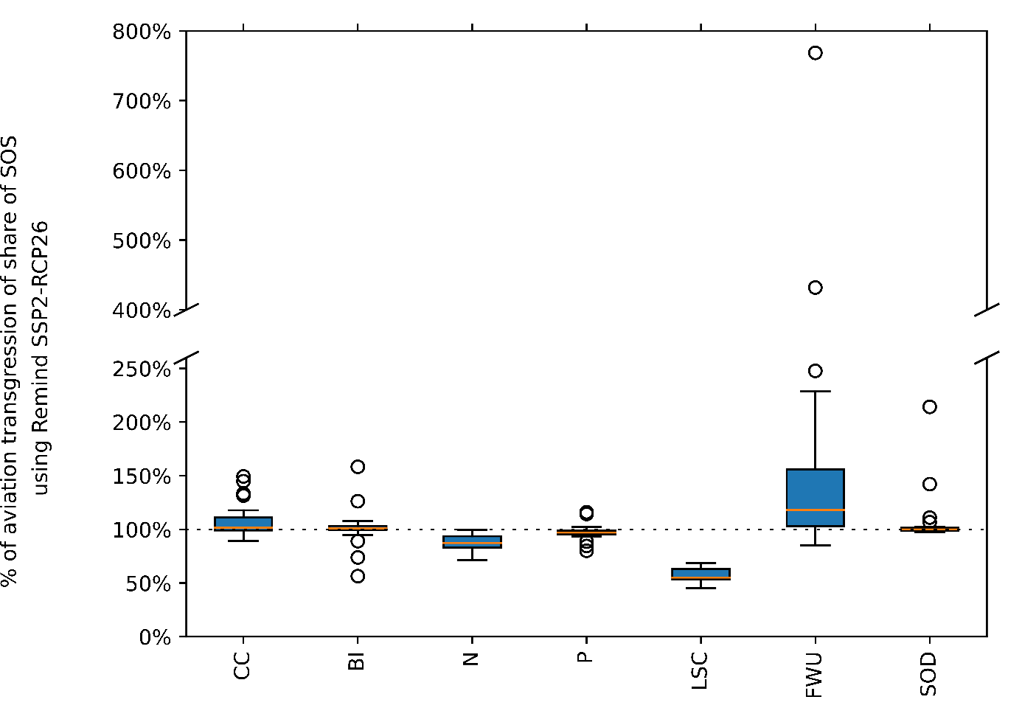

The goal of this figure is to assess the sensitivity of the results of Fig. 3 to both the aviation scenario and also to the underlying pathway used for prospective LCA. For this purpose, the values reported in Fig. SI10 are normalized by the value in the reference pathway used in the main body of the paper (namely, Remind SSP2-RCP2.6). Since there are 9 aviation scenarios and 3 alternative underlying pathways, this gives for each resource (electricity, biomass, land occupation, freshwater withdrawal, and direct air capture) 27 values which are reported in the form of a boxplot. We see that except for freshwater use, values are well concentrated, showing that the results of Fig. 2 are robust to the underlying pathway used for prospective LCA. For freshwater use there are more variations because of the electricity mix used, which varies significantly between the IAM-SSP-RCP scenarios but results then to be higher than the underlying pathway considered in the main body of the paper.

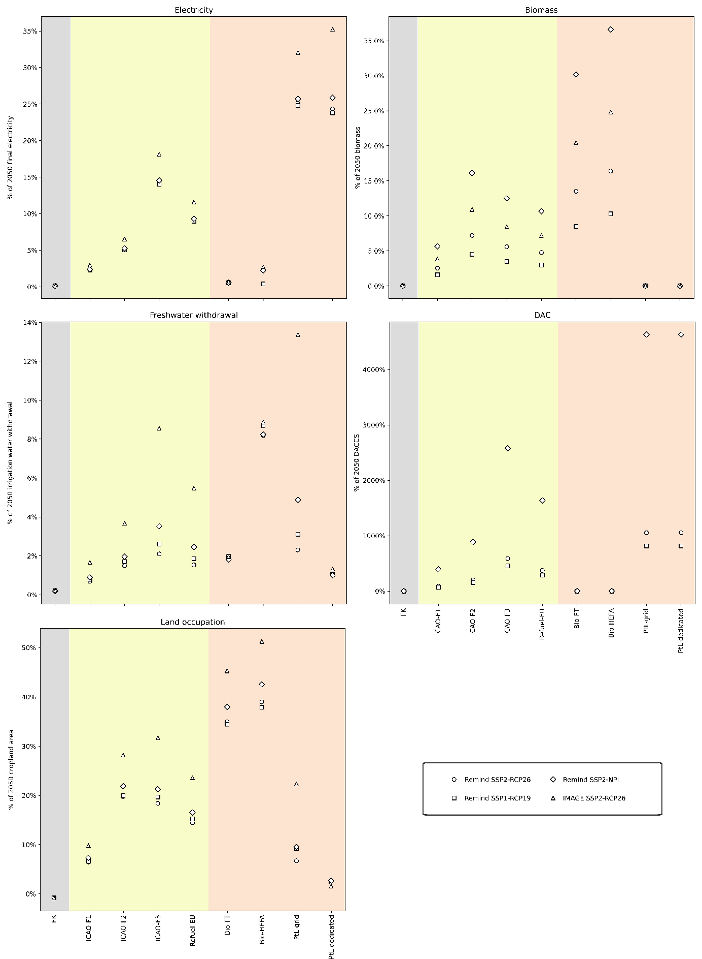
Sensitivity analysis of 2050 aviation relative resource needs to the choice of IAM-SSP-RCP

This is the same figure as Fig. 4 in the main body of the paper, but where the underlying SSP-RCP pathway used for the prospective LCA is varied. In the main body we consider one pathway (Remind SSP2-RCP2.6, represented by a circle) and we consider here three other underlying pathways: Remind SSP1-RCP1.9 (square), Remind SSP2-NPi (diamond) and IMAGE SSP2-RCP2.6 (triangle).

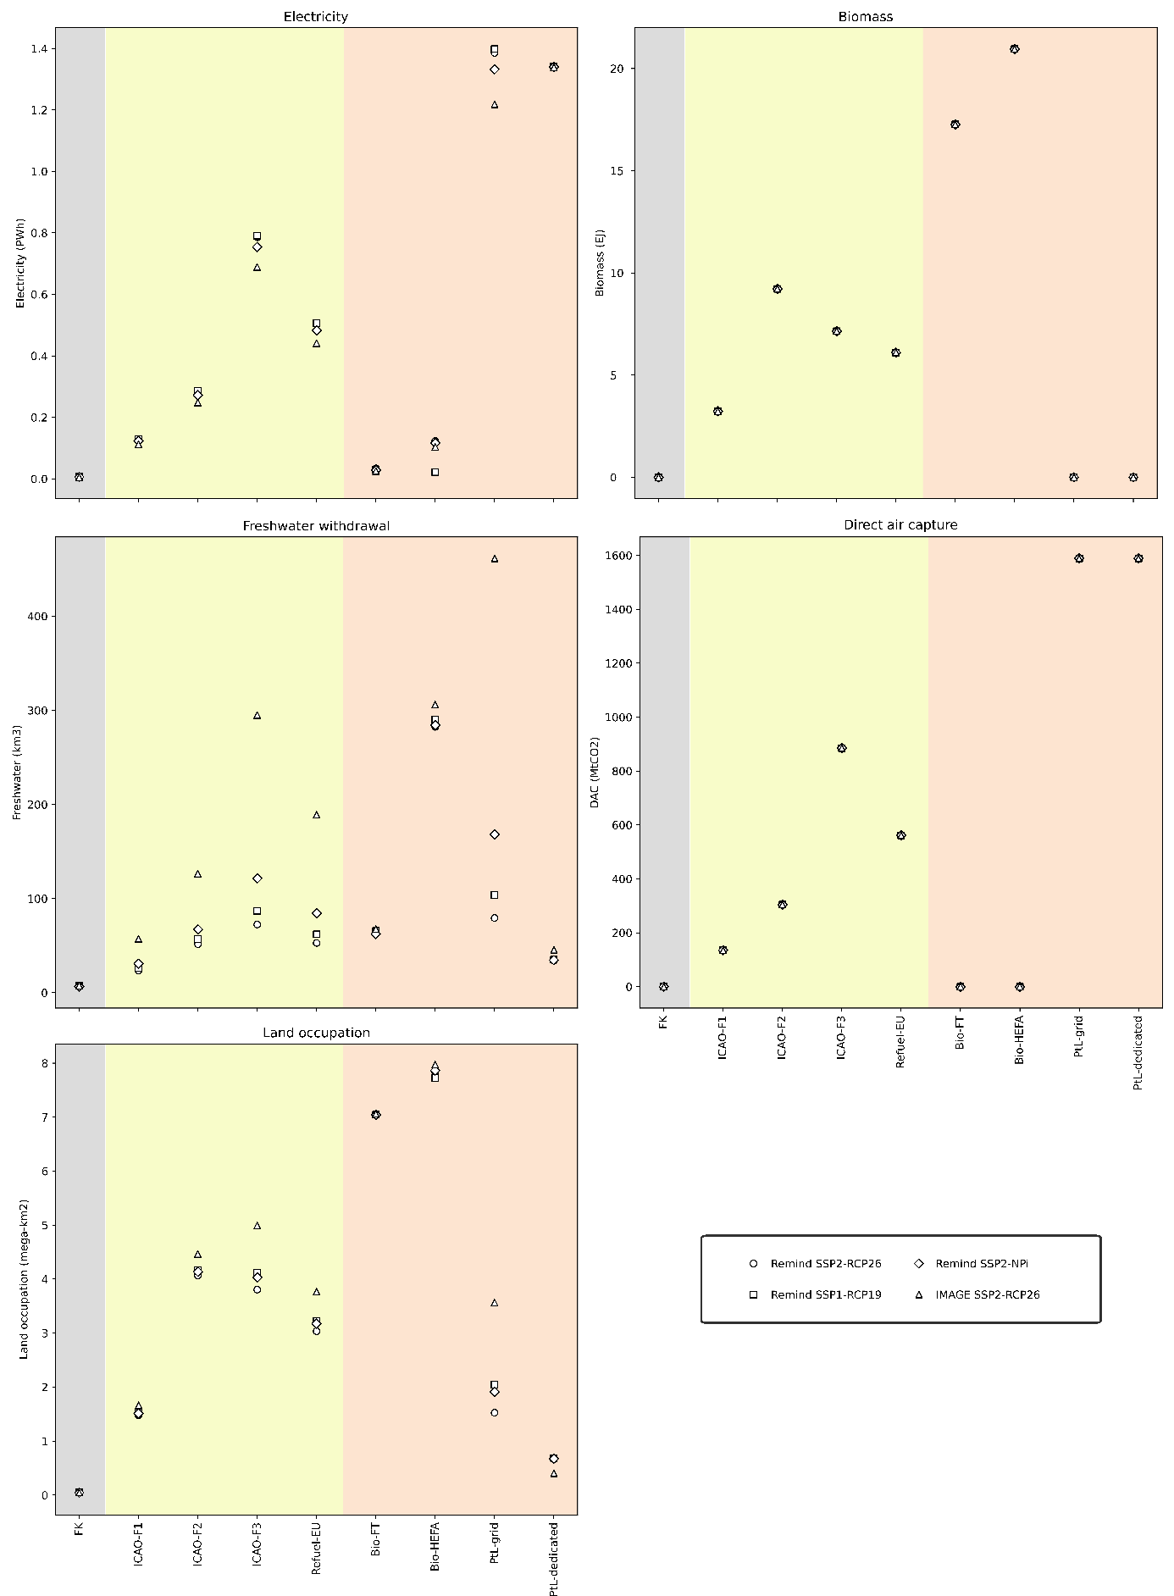
Sensitivity analysis of 2050 aviation absolute resource needs to the choice of IAM-SSP-RCP

Figures 4 and SI6 represent resource requirements relative to the resource availability in the underlying pathway used for prospective LCA: here, we only report the value of the absolute resource requirement. Thus, the difference between Fig. SI6 and Fig. SI7 is that the values reported in Fig. SI7 are divided by the resource availability for the considered resource in the underlying pathway used for prospective LCA.

Aggregated sensitivity analysis of 2050 aviation relative resource needs to the choice of IAM-SSP-RCP
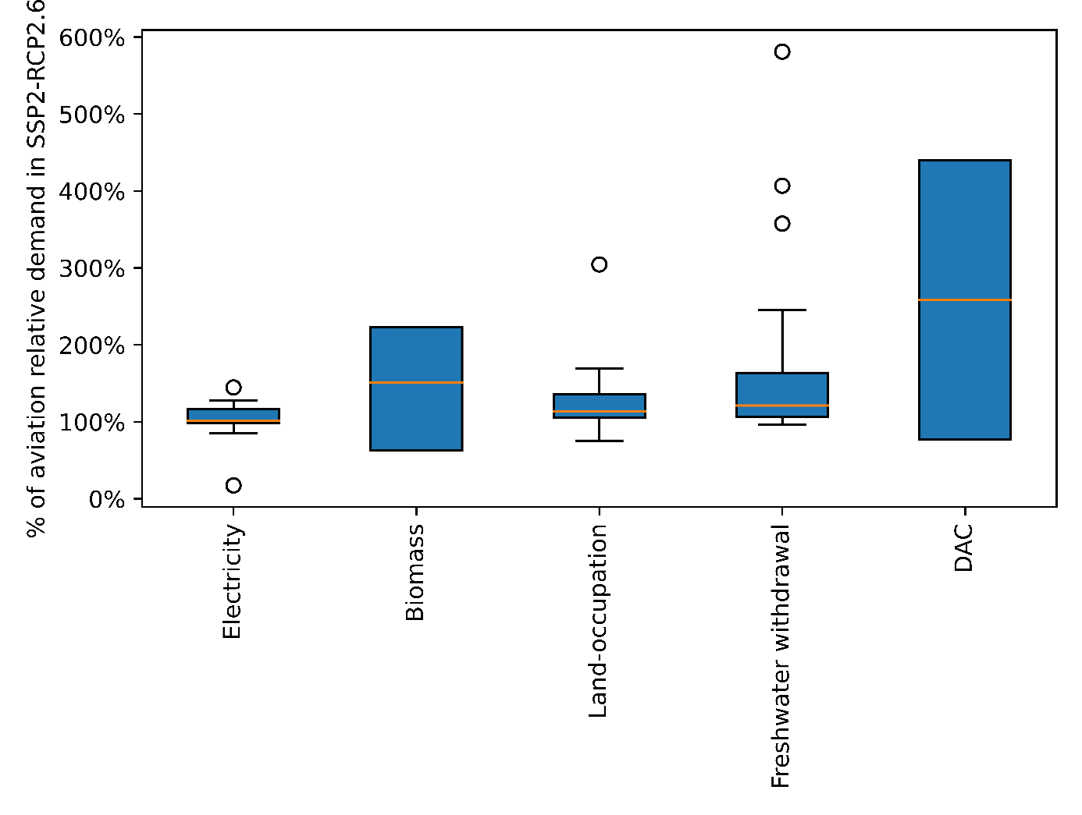

The goal of this figure is to assess the sensitivity of the results of Fig. 4 to both the aviation scenario and also to the underlying pathway used for prospective LCA. For this purpose, the values reported in Fig. SI5 are normalized by the value in the reference pathway used in the main body of the paper (namely, Remind SSP2-RCP2.6). Since there are 9 aviation scenarios and 3 alternative underlying pathways, this gives for each resource (electricity, biomass, land occupation, freshwater withdrawal and direct air capture) 27 values which are reported in the form of a boxplot. We see that most values are situated above 100%, meaning that in most cases, the relative resource requirement is higher in the alternative underlying pathways than in the reference underlying pathway used in the main body of the paper. This corresponds to the fact that in Fig. SI6, values for Remind SSP2-RCP2.6 (circle) are among the lowest ones when the underlying pathway is varied, i.e., circles tend to be below squares, diamonds, and triangles.

Resource requirements with CAGR=0% between 2023 and 2050
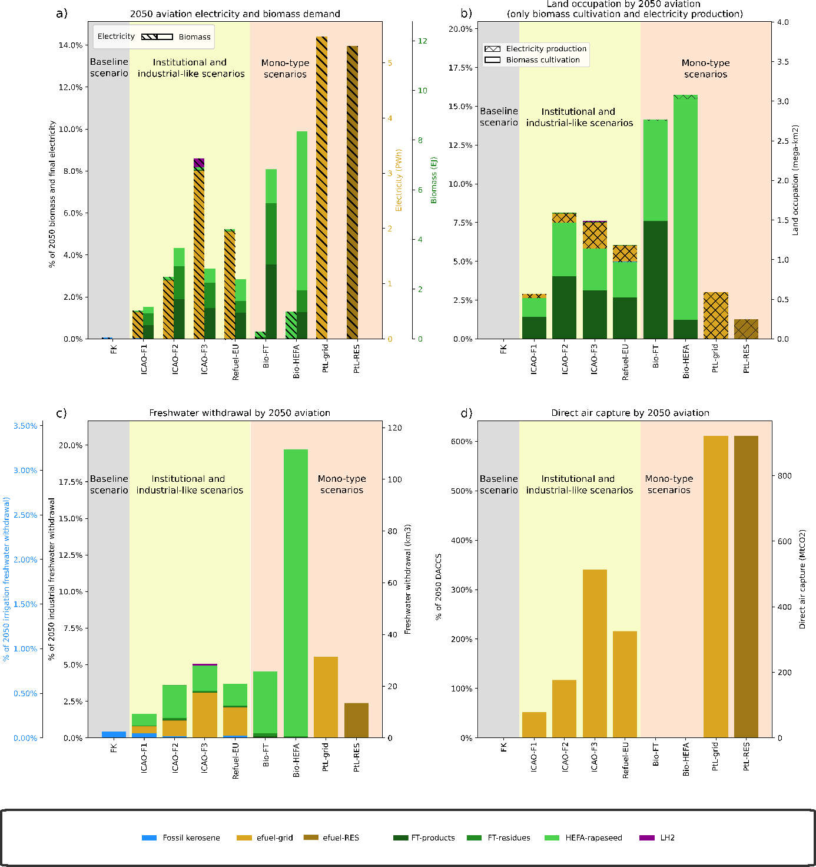

This figure presents the same results as in Fig. 4, but assuming a traffic growth rate of 0% y⁻¹ (i.e., traffic is stabilised at 2022 level between 2023 and 2050) instead of +3.6% y⁻¹ as in the main body of the paper.

Resource requirements with CAGR=-3% between 2023 and 2050
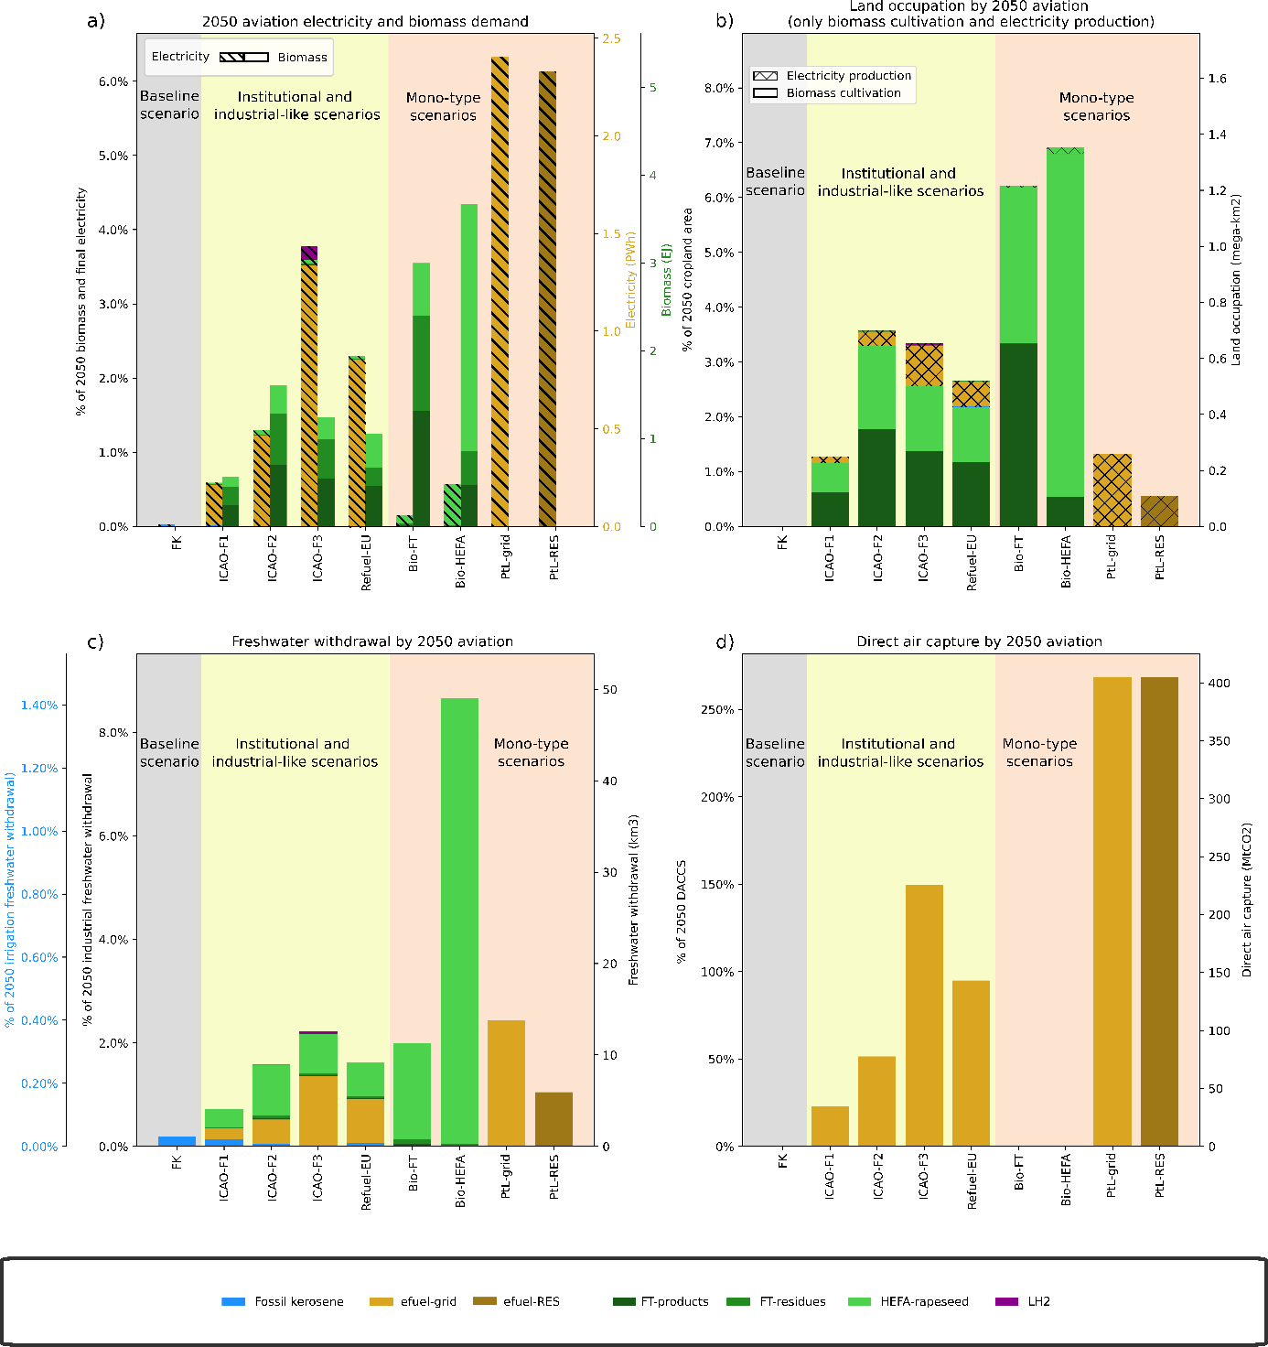

This figure presents the same results as in Fig. 4, but assuming a traffic growth rate of -3% y⁻¹ (i.e., traffic decreases by 3% per year between 2023 and 2050) instead of +3.6% y⁻¹ as in the main body of the paper.

Evolution of the energy mix for some institutional and industrial scenarios
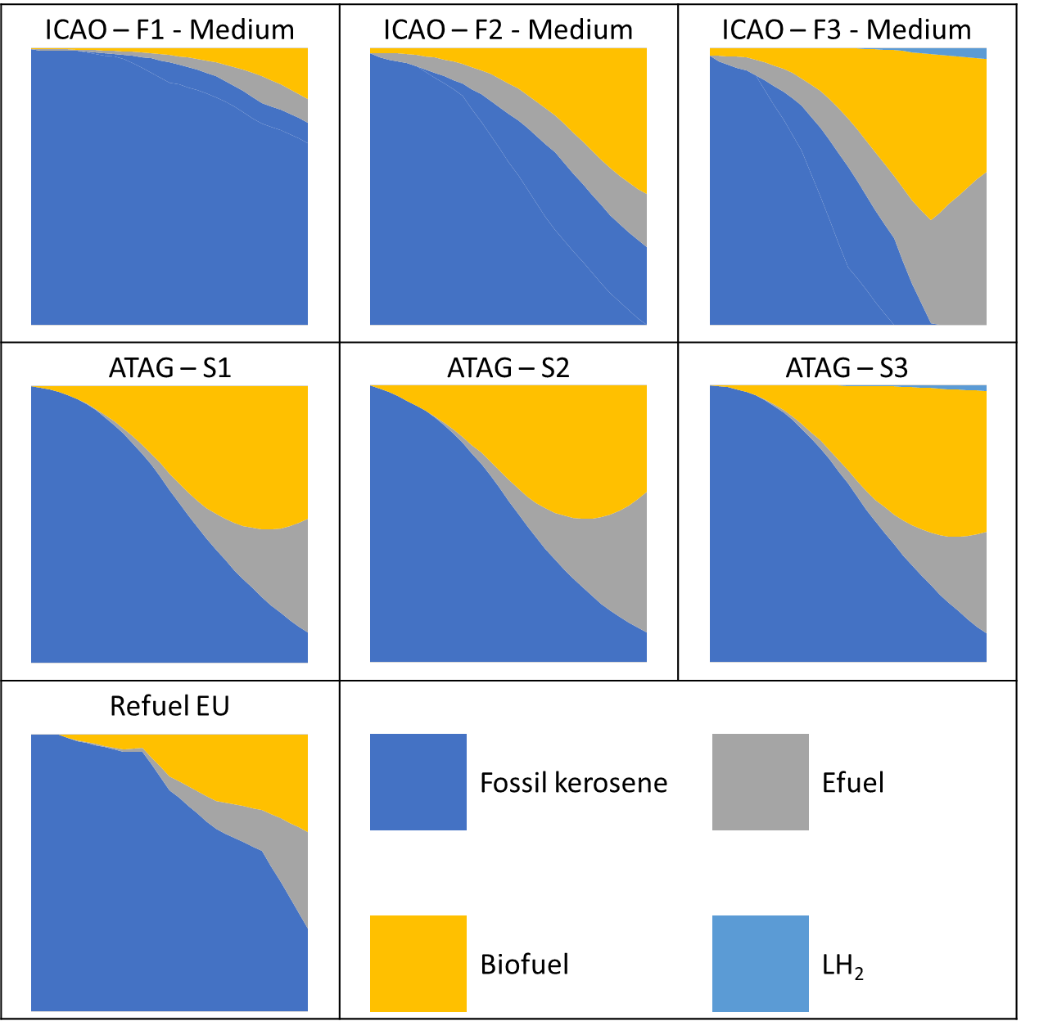

Each figure represents the relative composition (in percentage) of the fuel mix used by aviation from 2019 to 2050 for different scenarios proposed by different aviation stakeholders: ICAO, ATAG and the EU. These scenarios consider different perimeters explained below and form the basis on which the scenarios ICAO F1, ICAO F2, ICAO F3 and Refuel-EU of the paper were constructed.
The data for the ICAO scenarios are directly available on their website¹². These scenarios consider international commercial aviation.
The data for the ATAG scenarios were reconstructed from the 2nd “Waypoint 2050” report¹⁴ and the “Fueling net zero” report⁴⁷ for use in the AeroMaps tool⁹. These scenarios consider the entire commercial aviation.
The data for the Refuel EU scenario are constructed based on the incorporation mandates voted by the EU Council¹³, with linear interpolation between each data point. These scenarios consider the commercial aviation at the European level.

Table SI1 – Footprint data for each PB and for each reference country
 | FWU | LSC | P | N | SOD | BI
source | Mekonnen et Hoekstra (2011)³⁴ | Arto et al. (2022)³⁵ | Metson, Bennett et Elser (2012)³⁶ | Oita et al. (2016)³⁷ | Tian et al. (2019)³⁸ | Phillips et al. (2021)³⁹
unit | m³ yr⁻¹ | ha | kg P cap ⁻¹ yr ⁻¹ | kg N cap ⁻¹ yr ⁻¹ | Mt CO_{2-eq} | BII% yr⁻¹
year | 2011 | 2014 | 2007 | 2010 | 2012 | Average 2004-2014
Albania | 4,8E+09 | 1,7E+04 | 4,0E+00 | 1,8E+01 | 6,0E-01 | -3,7E-01
Algeria | 4,9E+10 | 1,5E+05 | 2,1E+00 | 1,6E+01 | 4,8E+00 | 1,4E-02
Armenia | 4,4E+09 | 3,4E+04 | 3,0E+00 | 1,1E+01 | 5,0E-01 | -1,4E-01
Costa Rica | 5,9E+09 | 1,2E+05 | 3,2E+00 | 1,7E+01 | 9,0E-01 | -2,5E-01
Dominican Republic | 1,2E+10 | 5,2E+04 | 2,5E+00 | 2,0E+01 | 2,6E+00 | -1,5E-01
Fiji | 1,4E+09 | 1,3E+04 | 2,3E+00 | 1,7E+01 | 2,0E-01 | -7,1E-02
Jordan | 8,3E+09 | 1,6E+04 | 2,3E+00 | 1,8E+01 | 1,1E+00 | X
Philippines | 1,1E+11 | 2,6E+05 | 1,9E+00 | 1,2E+01 | 9,3E+00 | -3,9E-01
Samoa | 3,7E+08 | 2,5E+03 | 3,3E+00 | X | 1,0E-01 | -1,0E-01
Sri Lanka | 2,4E+10 | 7,9E+05 | 1,1E+00 | 7,3E+00 | 1,0E+00 | -3,9E-01
Tunisia | 2,1E+10 | 2,1E+05 | 2,3E+00 | 1,8E+01 | 1,9E+00 | -2,7E-01
Botswana | 3,5E+09 | 5,2E+04 | 1,8E+00 | 6,1E+01 | 1,6E+00 | -1,9E-02
Cuba | 1,9E+10 | 5,3E+04 | 2,6E+00 | 2,1E+01 | 3,8E+00 | 1,4E-01
Dominica | 1,8E+08 | 1,9E+02 | 3,8E+00 | X | X | -2,0E-01
Egypt | 9,5E+10 | 2,1E+05 | 2,2E+00 | X | 1,6E+01 | X
Gabon | 1,8E+09 | 1,2E+05 | 2,2E+00 | 1,5E+01 | 2,0E-01 | -7,8E-03
Grenada | 2,2E+08 | X | 2,4E+00 | X | X | 2,6E-01
Indonesia | 2,3E+11 | 1,9E+06 | 1,2E+00 | 1,8E+01 | 5,9E+01 | -3,8E-01
Jamaica | 4,4E+09 | 1,3E+04 | 2,7E+00 | 2,1E+01 | 4,0E-01 | 6,3E-02
Peru | 2,8E+10 | 2,2E+05 | 1,6E+00 | 2,4E+01 | 1,3E+01 | -1,7E-01
Republic of Moldova | 5,4E+09 | 1,5E+04 | 2,4E+00 | 3,2E+00 | 3,0E-01 | 7,3E-02
Saint Lucia | 2,5E+08 | X | 3,8E+00 | X | X | X
Suriname | 6,3E+08 | 4,1E+03 | 2,2E+00 | 2,7E+01 | 1,0E-01 | -6,7E-03
Uruguay | 7,1E+09 | 2,8E+05 | 3,3E+00 | 9,4E+01 | 1,0E+01 | -2,5E-01

Table SI2 - 2019 trafic by country (domestic + flights departing from the country)
Country | ASK 2019 (AeroSCOPE)⁴⁸ | RPK 2019 (AeroSCOPE, load factor =0.824)
Albania | 2,04E+09 | 1,63E+09
Algeria | 1,44E+10 | 1,15E+10
Armenia | 3,43E+09 | 2,74E+09
Costa Rica | 1,05E+10 | 8,42E+09
Dominican Republic | 2,57E+10 | 2,06E+10
Fiji | 5,40E+09 | 4,32E+09
Jordan | 1,24E+10 | 9,94E+09
Philippines | 8,95E+10 | 7,16E+10
Samoa | 8,10E+08 | 6,48E+08
Sri Lanka | 1,88E+10 | 1,51E+10
Tunisia | 1,24E+10 | 9,92E+09
Botswana | 3,77E+08 | 3,02E+08
Cuba | 1,62E+10 | 1,29E+10
Dominica | 2,88E+07 | 2,31E+07
Egypt | 5,20E+10 | 4,16E+10
Gabon | 1,31E+09 | 1,05E+09
Grenada | 6,38E+08 | 5,10E+08
Indonesia | 1,51E+11 | 1,21E+11
Jamaica | 9,11E+09 | 7,29E+09
Peru | 3,88E+10 | 3,10E+10
Republic of Moldova | 2,45E+09 | 1,96E+09
Saint Lucia | 2,25E+09 | 1,80E+09
Suriname | 1,48E+09 | 1,19E+09
Uruguay | 3,85E+09 | 3,08E+09

Table SI3 - Allocation to the transport sector in the FHN reference countries
Reference countries | % allocated to transport
Albania | 4,7%
Algeria | 9,4%
Armenia | 5,3%
Costa Rica | 10,3%
Dominican Republic | 7,5%
Fiji | 5,4%
Jordan | 14,7%
Philippines | 14,2%
Samoa | 5,8%
Sri Lanka | 17,6%
Tunisia | 9,8%
Average | 9,5%

This table presents the allocation to the transport sector, adjusted with EAT-Lancet report⁴⁹ as done in Heide et al. (2023)⁶ for the reference countries.

References
1. Ryberg, M. W., Owsianiak, M., Richardson, K. & Hauschild, M. Z. Development of a life-cycle impact assessment methodology linked to the Planetary Boundaries framework. Ecological Indicators 88, 250–262 (2018).
2. United Nations Framework Convention on Climate Change. Paris Agreement. (2015).
3. Lee, D. S. et al. The contribution of global aviation to anthropogenic climate forcing for 2000 to 2018. Atmospheric Environment 244, 117834 (2021).
4. Galán-Martín, Á. et al. Sustainability footprints of a renewable carbon transition for the petrochemical sector within planetary boundaries. One Earth 4, 565–583 (2021).
5. Sacchi, R. et al. PRospective EnvironMental Impact asSEment (premise): A streamlined approach to producing databases for prospective life cycle assessment using integrated assessment models. Renewable and Sustainable Energy Reviews 160, 112311 (2022).
6. Heide, M., Hauschild, M. Z. & Ryberg, M. Reflecting the importance of human needs fulfilment in absolute sustainability assessments: Development of a sharing principle. Journal of Industrial Ecology (2023) doi:10.1111/jiec.13405.
7. IATA. Industry Statistics - Fact Sheet. https://www.iata.org/en/iata-repository/pressroom/fact-sheets/industry-statistics/ (2024).
8. Airbus. Global Market Forecast 2024. https://www.airbus.com/sites/g/files/jlcbta136/files/2024-07/GMF%202024-2043%20Presentation_4DTS.pdf (2024).
9. Planès, T., Delbecq, S., Pommier-Budinger, V. & Bénard, E. Simulation and evaluation of sustainable climate trajectories for aviation. Journal of Environmental Management 295, 113079 (2021).
10. Delbecq, S., Fontane, J., Gourdain, N., Planès, T. & Simatos, F. Sustainable aviation in the context of the Paris Agreement: A review of prospective scenarios and their technological mitigation levers. Progress in Aerospace Sciences 141, 100920 (2023).
11. Lee, J. J. Can we accelerate the improvement of energy efficiency in aircraft systems? Energy Conversion and Management 51, 189–196 (2010).
12. International Civil Aviation Organization (ICAO), Long-Term Aspirational Goal (LTAG). Report on the Feasibility of a Long-Term Aspirational Goal (LTAG) for International Civil Aviation CO2 Emission Reductions. https://www.icao.int/environmental-protection/LTAG/Pages/LTAGreport.aspx (2022).
13. Regulation (EU) 2023/2405 of the European Parliament and of the Council of 18 October 2023 on Ensuring a Level Playing Field for Sustainable Air Transport (ReFuelEU Aviation). (2023).
14. ATAG. Waypoint 2050 - Balancing Growth in Connectivity with a Comprehensive Global Air Transport Response to the Climate Emergency: A Vision of Net-Zero Aviation by Mid-Century. https://aviationbenefits.org/media/167417/w2050_v2021_27sept_full.pdf (2021).
15. IATA. Industry Statistics. https://www.iata.org/en/iata-repository/pressroom/fact-sheets/industry-statistics/ (2023).
16. Ryberg, M. W., Wang, P., Kara, S. & Hauschild, M. Z. Prospective Assessment of Steel Manufacturing Relative to Planetary Boundaries: Calling for Life Cycle Solution. Procedia CIRP 69, 451–456 (2018).
17. Fabre, A., Planès, T., Delbecq, S., Budinger, V. & Lafforgue, G. Life Cycle Assessment models for overall aircraft design. AIAA SCITECH 2022 Forum (2022) doi:10.2514/6.2022-1028.
18. van der Giesen, C., Kleijn, R. & Kramer, G. J. Energy and Climate Impacts of Producing Synthetic Hydrocarbon Fuels from CO ₂. Environ. Sci. Technol. 48, 7111–7121 (2014).
19. Cavalett, O. & Cherubini, F. Unraveling the role of biofuels in road transport under rapid electrification. Unraveling the role of biofuels in road transport under rapid electrification (2022) doi:10.1002/bbb.2395.
20. Thonemann, N. et al. Prospective Life Cycle Inventory Datasets for Conventional and Hybrid-Electric Aircraft Technologies. SSRN Scholarly Paper at https://doi.org/10.2139/ssrn.4537185 (2023).
21. Rockström, J. et al. Planetary Boundaries: Exploring the Safe Operating Space for Humanity. Ecology and Society 14, (2009).
22. Steffen, W. et al. Planetary boundaries: Guiding human development on a changing planet. Science 347, 1259855 (2015).
23. Richardson, K. et al. Earth beyond six of nine planetary boundaries. Science Advances 9, eadh2458 (2023).
24. Friman, M. & Hjerpe, M. Agreement, significance, and understandings of historical responsibility in climate change negotiations. Climate Policy 15, 302–320 (2015).
25. Trenberth, K. E. & Smith, L. The Mass of the Atmosphere: A Constraint on Global Analyses. Journal of Climate 18, 864–875 (2005).
26. Shine, K. P., Fuglestvedt, J. S., Hailemariam, K. & Stuber, N. Alternatives to the Global Warming Potential for Comparing Climate Impacts of Emissions of Greenhouse Gases. Climatic Change 68, 281–302 (2005).
27. Joos, F. et al. Carbon dioxide and climate impulse response functions for the computation of greenhouse gas metrics: a multi-model analysis. Atmospheric Chemistry and Physics 13, 2793–2825 (2013).
28. Ramaswamy, V. et al. Radiative Forcing of Climate Change. (2001).
29. IPCC. Climate Change 2021: The Physical Science Basis. 2409 (2021).
30. Hanafiah, M. M., Hendriks, A. J. & Huijbregts, M. A. J. Comparing the ecological footprint with the biodiversity footprint of products. Journal of Cleaner Production 37, 107–114 (2012).
31. IPCC. Climate Change 2013: The Physical Science Basis. Contribution of Working Group I to the Fifth Assessment Report of the Intergovernmental Panel on Climate Change. (2013) doi:10.1017/CBO9781107415324.
32. ATAG. Aviation Benefits Beyond Border - Powering Global Economic Growth, Employment, Trade Links, Tourism and Support for Sustainable Development through Air Transport, despite Global Crisis. https://aviationbenefits.org/media/167517/aw-oct-final-atag_abbb-2020-publication-digital.pdf (2020).
33. Fricko, O. et al. The marker quantification of the Shared Socioeconomic Pathway 2: A middle-of-the-road scenario for the 21st century. Global Environmental Change 42, 251–267 (2017).
34. Mekonnen, M. & Hoekstra, A. National water footprint accounts: The green, blue and grey water footprint of production and consumption. Volume 1: Main Report. Daugherty Water for Food Global Institute: Faculty Publications (2011).
35. Arto, I., Cazcarro, I., Garmendia, E., Ruiz, I. & Sanz, M. J. A new accounting framework for assessing forest footprint of nations. Ecological Economics 194, 107337 (2022).
36. Metson, G. S., Bennett, E. M. & Elser, J. J. The role of diet in phosphorus demand. Environ. Res. Lett. 7, 044043 (2012).
37. Oita, A. et al. Substantial nitrogen pollution embedded in international trade. Nature Geosci 9, 111–115 (2016).
38. Tian, W., Wu, X., Zhao, X., Ma, R. & Zhang, B. Quantifying global CH4 and N2O footprints. Journal of Environmental Management 251, 109566 (2019).
39. Phillips, H. et al. The Biodiversity Intactness Index - country, region and global-level summaries for the year 1970 to 2050 under various scenarios. (2021) doi:10.5519/HE1EQMG1.
40. Salgas, A., Sun, J., Delbecq, S., Planès, T. & Lafforgue, G. Compilation of an open-source traffic and CO2 emissions dataset for commercial aviation. Journal of Open Aviation Science 1, (2023).
41. Riahi, K. et al. The Shared Socioeconomic Pathways and their energy, land use, and greenhouse gas emissions implications: An overview. Global Environmental Change 42, 153–168 (2017).
42. van Zalk, J. & Behrens, P. The spatial extent of renewable and non-renewable power generation: A review and meta-analysis of power densities and their application in the U.S. Energy Policy 123, 83–91 (2018).
43. Food and Agriculture Organization of the United Nations & Our World in Data. Oil yields by crop type, World, 2021. (2023).
44. Payn, T. et al. Changes in planted forests and future global implications. Forest Ecology and Management 352, 57–67 (2015).
45. Graham, N. T. et al. Water Sector Assumptions for the Shared Socioeconomic Pathways in an Integrated Modeling Framework. Water Resources Research 54, 6423–6440 (2018).
46. Desport, L. et al. Deploying direct air capture at scale: How close to reality? Energy Economics 129, 107244 (2024).
47. Blanshard, A., McCurdy, M., Reid-Kay, A. & Chokhani, S. Fueling Net Zero - How the Aviation Industry Can Deploy Sufficient Sustainable Aviation Fuel to Meet Climate Ambitions. https://aviationbenefits.org/media/167495/fueling-net-zero_september-2021.pdf (2021).
48. Salgas, A., Sun, J., Delbecq, S., Planès, T. & Lafforgue, G. Compilation and Applications of an Open-Source Dataset on Global Air Traffic Flows and Carbon Emissions. Journal of Open Aviation Science 2, (2024).
49. Willett, W. et al. Food in the Anthropocene: the EAT–Lancet Commission on healthy diets from sustainable food systems. The Lancet 393, 447–492 (2019).

