Figure: S1 shows the structural formulas for DOM and PNT

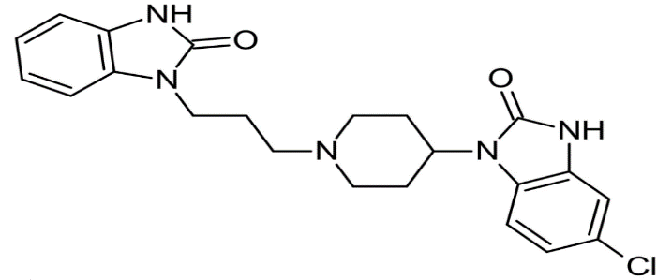
PNT DOM
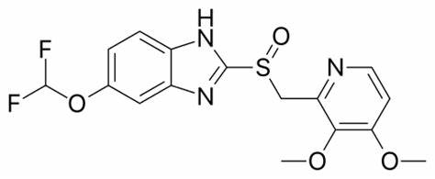

Table S1. Green assessments comparison and results of the proposed methods using AGREE

AGREE Metric | Description
1. Sample Treatment | Sample treatment in (At- line analysis)
2. Minimal Sample Size | Minimal sample size and minimal number of samples (1 mL)
3. In Situ Measurements | In situ measurements (At-line)
4. Integration of Processes | Integration of processes saves energy and reduces reagent use (one step used)
5. Automated Methods | Semi-automated and miniaturized methods
6. Derivatization | No derivatization needed
7. Waste Management | Volume and management of analytical waste (1 mL)
8. Multianalyte Methods | Multianalyte methods are preferred over single-analyte methods at a time.
9. Energy Use | Energy use should be minimized (<0.1 kWh per sample UV-Vis spectrophotometer)
10. Renewable Reagents | Reagents from renewable sources should be preferred (ethanol only solvent used)
11. Toxic Reagents | Toxic reagents should be eliminated or replaced (no toxic reagent used)
12. Operator Safety | Operator safety should be increased
A score of 0.82 indicates that the spectrophotometric methods were green

