Extended Data
Table E1 – Results of legacy LLM GPT-3.5 Instruct Turbo on a third of the unfiltered questions in terms of its accuracy at selecting the correct answer.
Exam condition | Accuracy
Closed Book | 47.3%
Oracle | 77.5%
Confused | 73.5%
Dense | 62.3%
Sparse | 60.8%
Hybrid | 66.7%

Figure E1 – Example of key messages from similar action pages (source documents) overlapping for a question. The source action document for the question is on the left (Leave headlands in fields unsprayed (conservation headlands)) but the action on the right was also used by human experts and LLMs to get the correct answer to the question.
Action: Leave headlands in fields unsprayed (conservation headlands). Key messages: Twenty-two studies from 14 replicated, controlled experiments (of which two randomized) including two reviews, from a total of 32 studies from 20 experiments (of which 17 replicated, controlled) including three reviews from Finland, Germany, the Netherlands, Sweden and the UK that investigated species richness and diversity of farmland wildlife found that conservation headlands contained higher species richness or diversity of invertebrates or plants than other habitat types. Twelve studies (including a review) from ten replicated experiments (of which eight controlled and three controlled and randomized) found that some or all invertebrates or plants investigated did not have higher species richness or diversity on conservation headlands compared to other habitat types. This included both replicated, controlled studies investigating bee diversity. Two replicated studies from the UK found that unfertilized conservation headlands had more plant species than fertilized conservation headlands.

Positive effects of conservation headlands on abundances or behaviours of some or all species investigated were found by 27 studies from 15 replicated experiments (of which 13 controlled) including five reviews out of a total of 36 studies from 20 experiments (17 replicated, controlled) including five reviews from Finland, Germany, the Netherlands, Sweden and the UK that investigated birds (some studies looked at number of visits), mammals (some studies looked at number of visits), invertebrates and plant abundance/cover. One review from the UK found a positive effect on grey partridge populations but did not separate the effects of several other interventions including conservation headlands. Nineteen studies from 13 replicated (12 controlled) experiments and a review from Finland, Germany, the Netherlands and the UK found that some or all species of birds, invertebrates or plants investigated were at similar, or lower, abundances on conservation headlands compared to other management. One review from the UK and a study in Germany found conservation headlands had a positive effect on plants and some, but not all invertebrates, or rare arable weeds but did not specify how.
All eight studies from the UK and Sweden that investigated species’ productivity, from three replicated (two controlled) experiments including two reviews found that grey partridge productivity or survival was higher in conservation headlands (or in sites with conservation headlands), compared to other management. One replicated study from the UK found that conservation headlands did not increase the proportion of young grey partridges in the population. A before-and-after study from the UK found that some invertebrates in conservation headlands survived pesticide applications to neighbouring fields. A review found crop margins reduce the effects of spray drift on butterflies.

A replicated study from Germany and a review found that conservation headlands appeared to prevent or reduce the establishment and spread of pernicious weeds.
Action: Reduce fertilizer, pesticide or herbicide use generally.
Key messages: Of 38 individual studies from Austria, the Czech Republic, Denmark, Finland, France, Germany, Ireland, the Netherlands, Sweden and the UK investigating the effects of reducing fertilizers, pesticides or herbicides, 34 studies (23 replicated, of which six also controlled and randomized, one review and one systematic review) found benefits to some invertebrates, plants, or farmland birds. Twenty-five studies (16 replicated, of which seven also randomized and controlled and one review) found negative, mixed, minimal or no effects on some invertebrates, farmland birds or plants.

Ten studies (six replicated, controlled studies of which two randomized) from three countries found positive effects of reducing or stopping pesticide applications on invertebrates, plants, or birds. Eight studies (two replicated controlled and randomized, one paired before-and-after trial) from four countries found inconsistent or no effects on some invertebrates or birds.

Ten studies (nine replicated, five also controlled and a European systematic review) from four countries found positive effects of reducing or stopping herbicide use on plants, invertebrates, and birds. Five replicated studies (two also controlled and randomized) from three countries found no or mixed effects on birds, invertebrates and plants.

Five studies (three replicated controlled of which two randomized) from four countries found positive effects of reducing or stopping fertilizer applications on invertebrates, Eurasian skylark, or plants. Four studies (three replicated, controlled and randomized) from two countries found reducing or stopping fertilizer inputs had no, or no consistent effects on some invertebrates and farmland birds. Two studies from the UK (one replicated) found plots where fertilizer inputs were not reduced tended to have higher earthworm biomass or abundance.

Fifteen studies (three replicated controlled of which one also randomized, five site comparisons and one review) from seven countries looked at the effects of reducing or stopping applications of two or more inputs: pesticides, herbicides, or fertilizers. Thirteen studies found positive effects of reducing two or more inputs on some or all invertebrates, plants, soil organisms, and birds studied. Seven studies found negative or no effects of reducing combinations of inputs on some invertebrates, plants or birds.
Question: Which of the following factors is most likely to enhance the effectiveness of conservation headlands for plant diversity?
Synopsis: Farmland Conservation

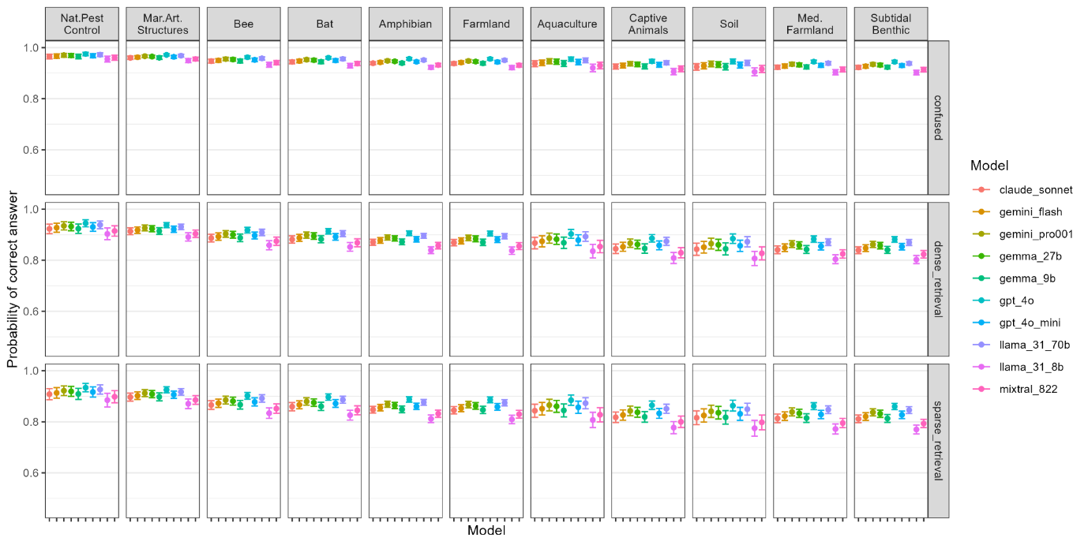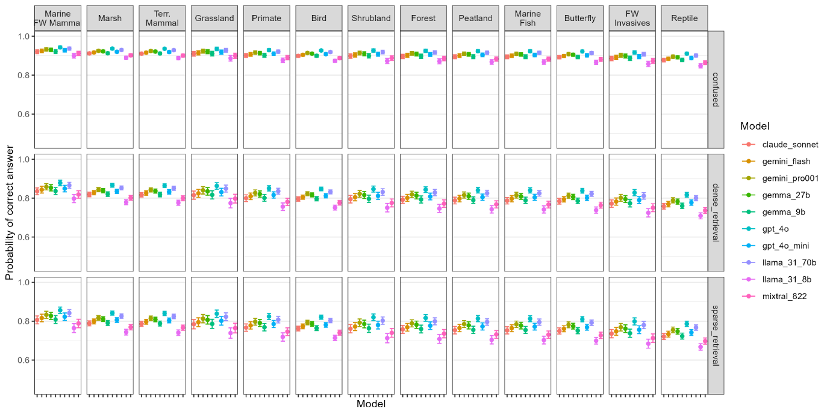Figure E2 - Logistic regression Generalised Linear Model (GLM) predictions of the accuracy of different LLMs across different synopses, under different exam types (mean and 95% Confidence Intervals). The results for oracle, hybrid retrieval, and closed book are found in Figure 1 in the main text.

Key messages
• Two studies evaluated the effects of prohibiting activities that cause disturbance in sensitive areas for marine mammals. One study was in the Kattegat Sea (Denmark) and one in the Indian Ocean (Australia).

COMMUNITY RESPONSE (0 STUDIES)

POPULATION RESPONSE (1 STUDY)
• Abundance (1 study): One before-and-after study in the Kattegat sea found that harbour porpoise activity increased at a stony reef after fishing was prohibited and the reef was restored with boulders.

BEHAVIOUR (1 STUDY)
• Behaviour change (1 study): One site comparison study in the Indian Ocean found that a beach where human access was fully prohibited had fewer Australian sea lions showing aggression or retreating compared to a beach where access was partly prohibited.

Supporting evidence from individual studies:
1. A before-and-after study in 2006–2012 of a stony reef in the Kattegat sea, Denmark (Mikkelsen et al. 2013) found that prohibiting fishing, along with restoring the reef, resulted in harbour porpoise Phocoena phocoena echolocation clicks being recorded more often and for longer periods than before protection and restoration. The average number of minutes with porpoise recordings and the average duration of porpoise encounters were higher at the reef in each of four years after fishing was prohibited and the reef restored (13–15 minutes/day; 4–5 minutes) than during two years before (6–10 minutes/day; 3 minutes). Porpoise activity at an intact reef 10 km away decreased over the same period (‘before’: 11–15 minutes/day; ‘after’: 3–7 minutes/day). In June–September 2008, a total of 100,000 t of norite boulders were dumped over 19 days to restore a 45,000 m² cavernous stony reef. Fishing was prohibited around the restored reef in 2009–2012. Porpoise activity was recorded with acoustic data loggers (two at the restored reef; two at an intact reef) for 33–75 days in June–August in each of two years before protection and restoration (2006 and 2007) and each of four years after (2009–2012).

Study and other actions tested

Referenced paper:
Mikkelsen L., Mouritsen K.N., Dahl K., Teilmann J. & Tougaard J. (2013) Re-established stony reef attracts harbour porpoises Phocoena phocoena. Marine Ecology Progress Series, 481, 239-248.

2. A site comparison study in 2013–2014 of two beaches on islands in the Indian Ocean, Western Australia (Osterrieder et al. 2017) found that a beach where human access was prohibited had fewer Australian sea lions Neophoca cinerea showing aggression or retreating compared to a beach where access was partly prohibited. The number of responses to vessels and people in which sea lions showed aggression (gaping or lunging) or retreated were lower at a beach where access was fully prohibited (aggression: 0 responses/h; retreated: 3 responses/h) than at a beach where access was partly prohibited (aggression: 14 responses/h; retreated: 21 responses/h). Less severe responses (e.g. sitting upright, lifting head, looking or entering the water) did not differ significantly between the two beaches (see original paper for data). Both beaches were sea lion haul-out sites designated as sanctuary zones. At one site, public access to the beach was fully prohibited, with viewing permitted from the water only via kayak or boat tours. At the other site, public access was permitted to part of the beach and prohibited in all other areas. Individual responses of sea lions to vessels and people were recorded by observers or remote live video cameras overlooking each of the two sites for a total of 134–142 h during 19–20 days in November–April 2013/2014.

Study and other actions tested

Referenced paper:
Osterrieder S.K., Salgado Kent C. & Robinson R.W. (2017) Responses of Australian sea lions, Neophoca cinerea, to anthropogenic activities in the Perth metropolitan area, Western Australia. Aquatic Conservation: Marine and Freshwater Ecosystems, 27, 414-435.

Background information and definitions:
There are many human activities that may cause disturbance and harm to marine and freshwater mammals and their habitats. This intervention involves prohibiting any such activity that may cause disturbance in particularly sensitive areas for marine and freshwater mammals. For example, in important feeding or resting grounds.

For studies that involve prohibiting activities as part of legal protection of an area, see Legally protect habitat for marine and freshwater mammals.

Synopsis: Marine and Freshwater Mammal Conservation
Action: Cease or prohibit activities that cause disturbance in sensitive areas for marine and freshwater mammals
Overall effectiveness category: Likely to be beneficial
Number of studies: 2
Figure E3 – Example of evidence summaries for a Conservation Evidence action page. This one can be found at: https://conservationevidence.com/actions/2917.

