Supplementary Materials：

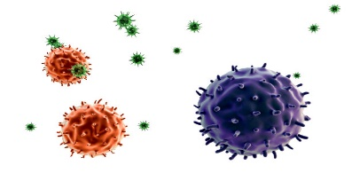

Virus
PLGA Nanoparticle
P6
0h
1h
12h
Cell
a:
0h
1h
12h
2h
Cell
b:
0h
1h
Cell
c:
4℃

Figure S1. A Schematic diagram of P6-PLGA antiviral experiments. a: Virus pretreatment: PEDV of 0.01MOI and P6-PLGA were equivalent volume pre-incubated at 37 ℃ for 1 h, after 1 h of action on the cells, the medium was discarded and washed with PBS 3 times, adding cell maintenance fluid and culturing to 12 h; b: Cell pretreatment: The cells were treated with P6-PLGA at 37 °C for 1 h, then PEDV of 0.01MOI was incubated for 1 h and lastly washed with PBS 3 times and cultured to 12 h; c: Co-treatment: PEDV of 0.01MOI was incubated with P6-PLGA at 4 °C for 1 h and then the samples were collected.

Figure S2A. The cytotoxicity of 110616 peptide on vero E6 cells. Vero E6 cell viability was measured by CCK-8 kit. All of values were normalized to the cell control, which represents 100% cell viability. Data on the above shown as the means ± standard deviation (SD) of three independent experiments, with the error bars representing the standard deviations.

Figure S2B. A mixture of virus at MOI 0.01 and increasing concentrations of the peptides (3.125–200 µM) were pre-cultured at 37 ℃ for 1 h, and then inoculated onto the vero E6 cells for 1 h, subsequently washed 3 times/well with PBS and replaced with maintenance medium containing 2% FBS DMEM incubated to 12 h. The positive control group (PEDV MOI = 0.01) were with no peptide 110616. Finally the total RNA was then extracted from the cells and viral N gene was quantified by qRT-PCR. Data are shown as the means ± standard deviation (SD) of three independent experiments, with the error bars representing the standard deviations. **** shows the P value p < 0.0001.

