Appendix A

a
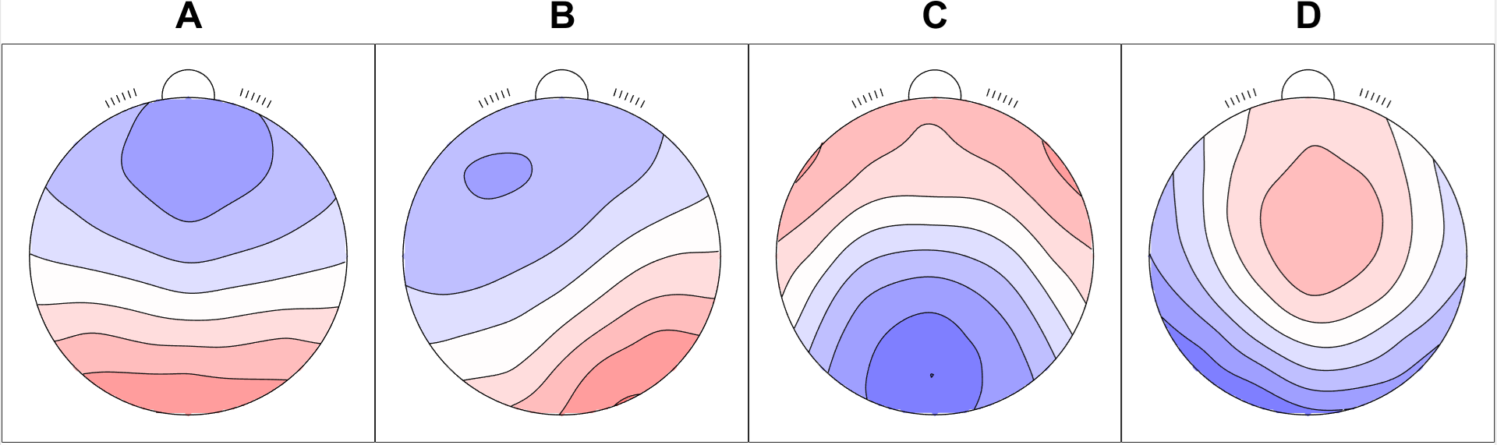
b
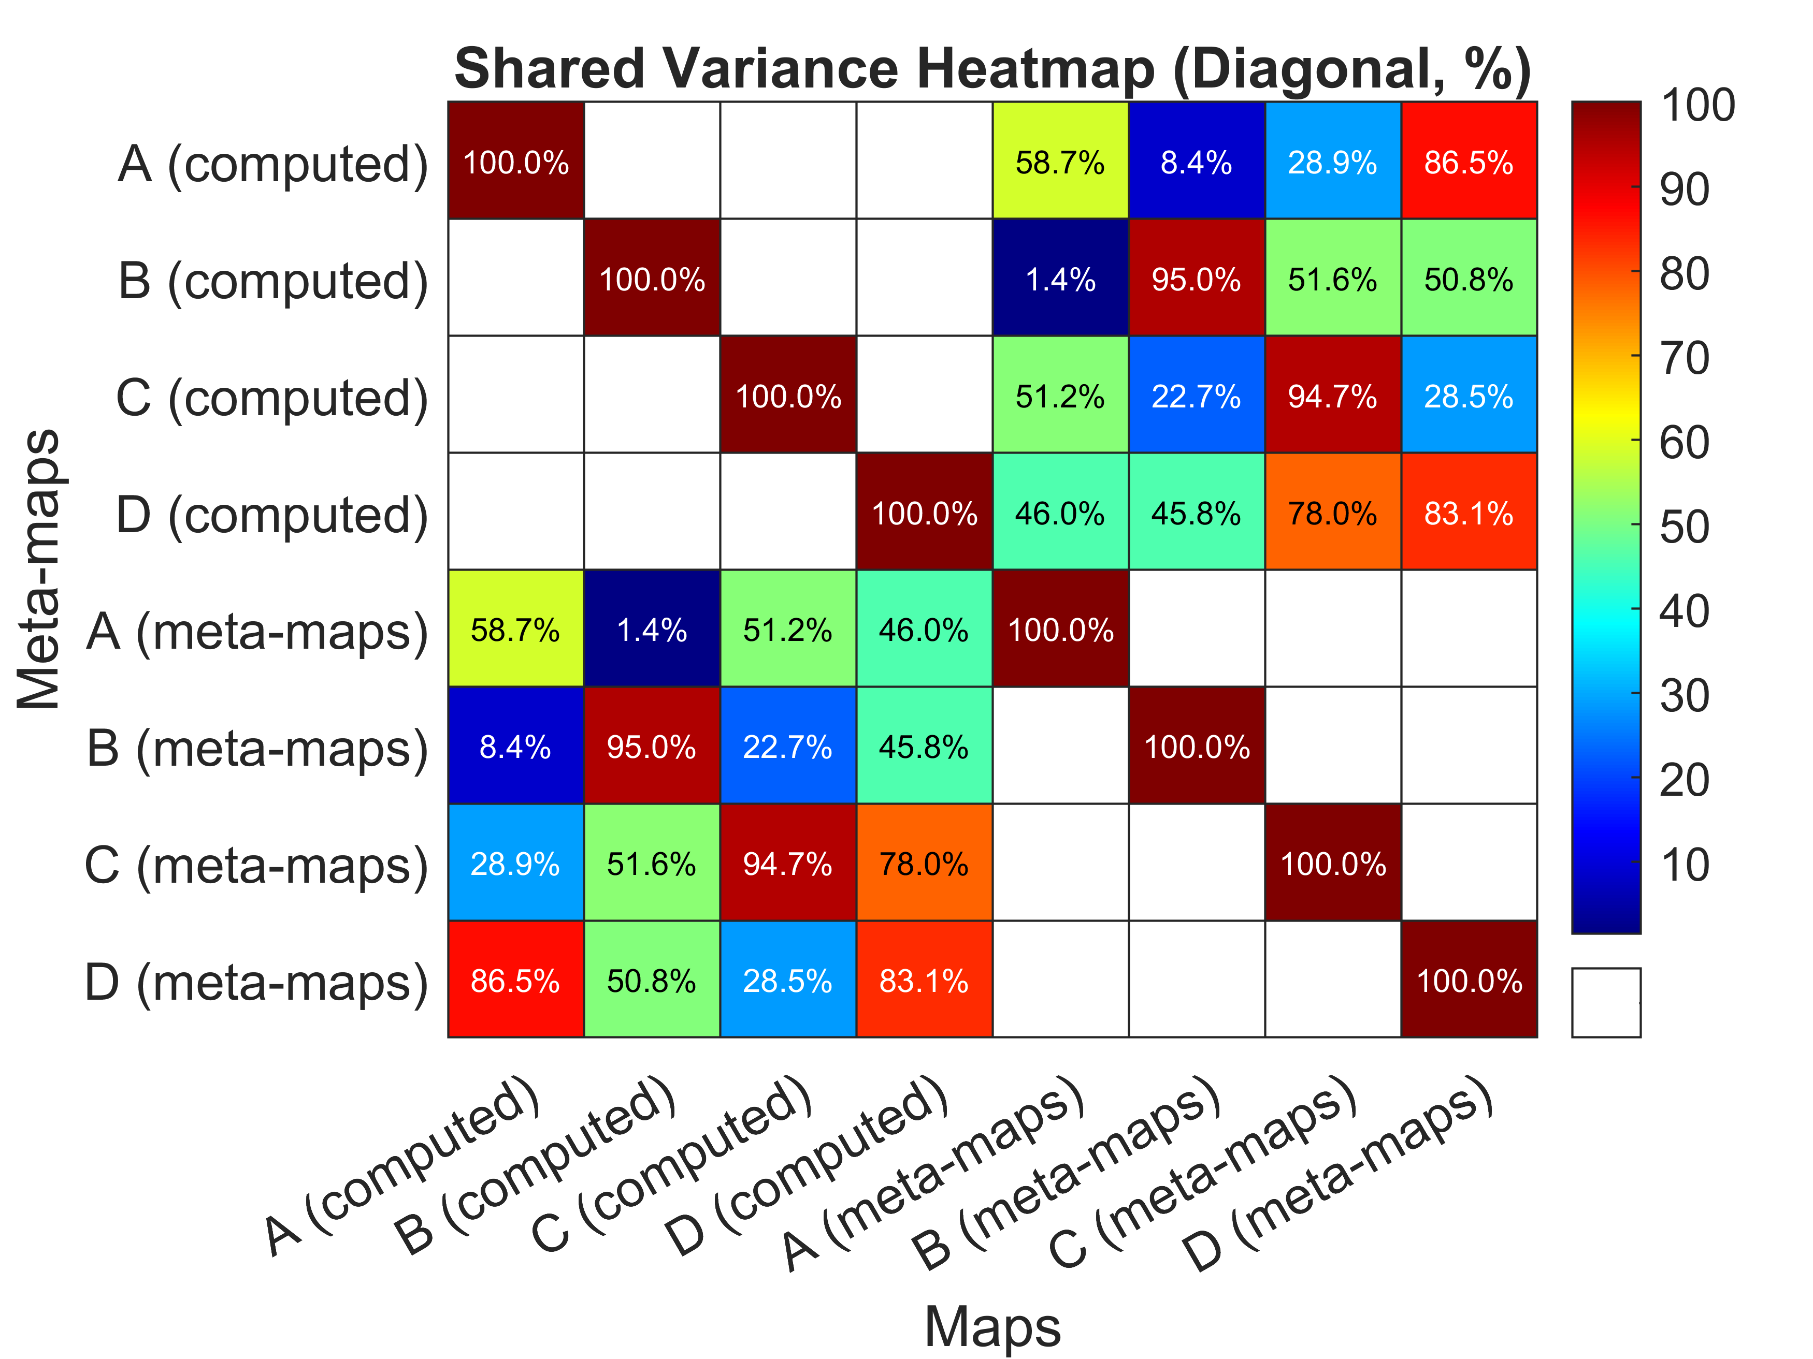
Fig. 4 a Computed mean microstate templates b spatial correlation matrix with microstate meta-maps (4 solution template) (Koenig et al. 2024; Nagabhushan Kalburgi et al. 2024)
a
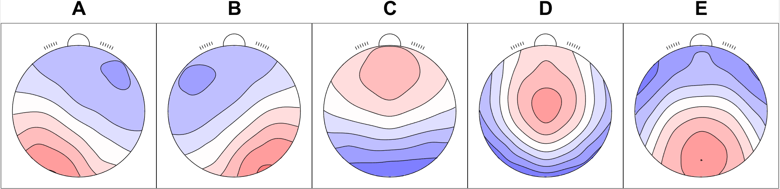
b
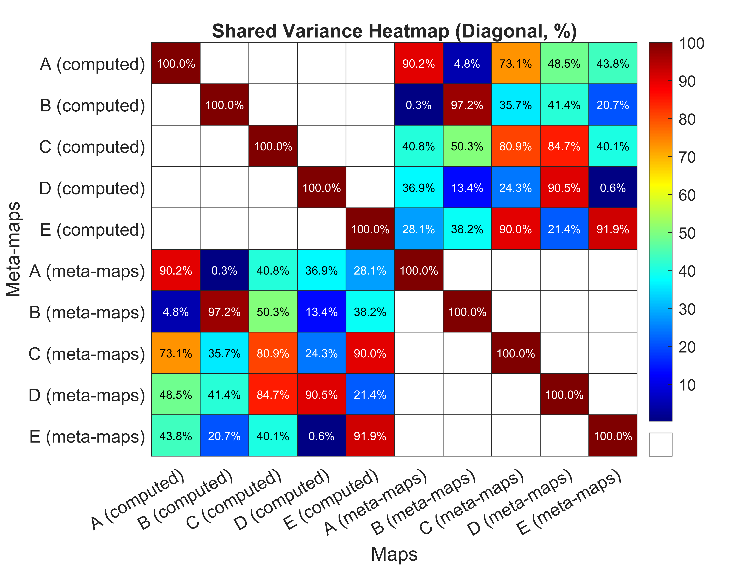
Fig. 5 a Computed mean microstate templates b spatial correlation matrix with microstate meta-maps (5 solution template) (Koenig et al. 2024; Nagabhushan Kalburgi et al. 2024)
a
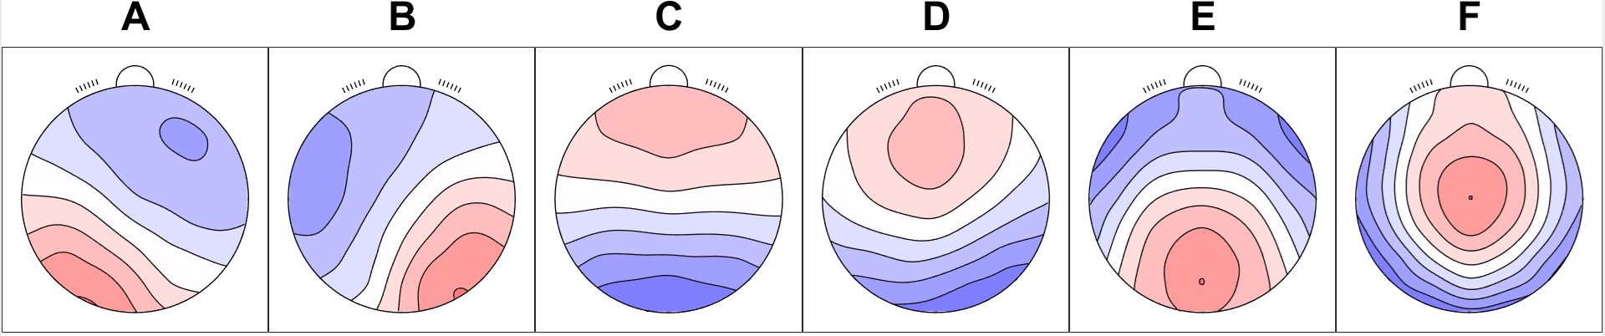
b
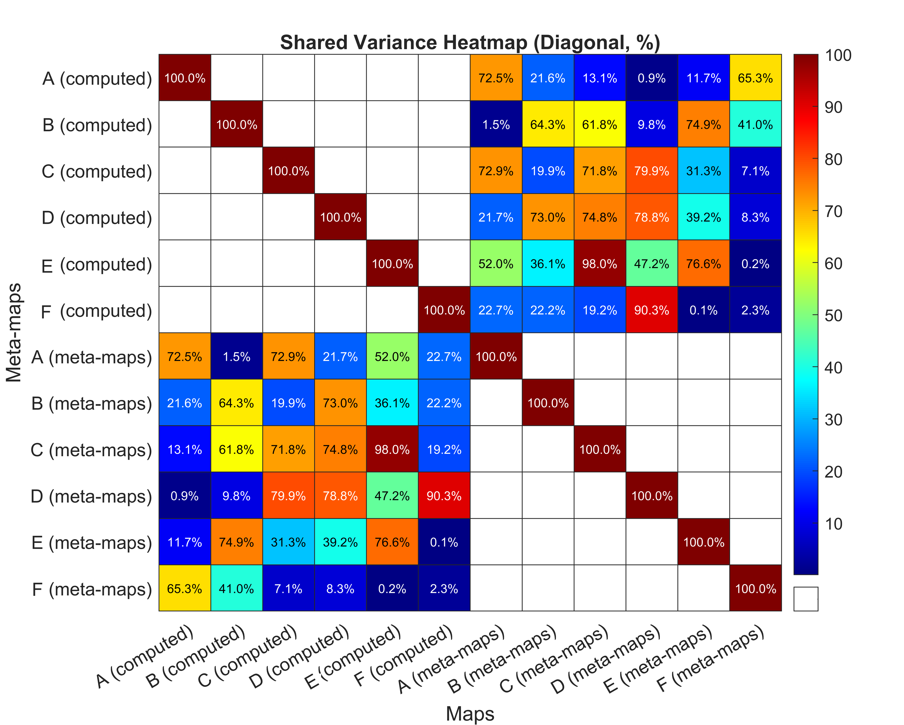
Fig. 6 a Computed mean microstate templates b spatial correlation matrix with microstate meta-maps (6 solutions template) (Koenig et al. 2024; Nagabhushan Kalburgi et al. 2024)

a
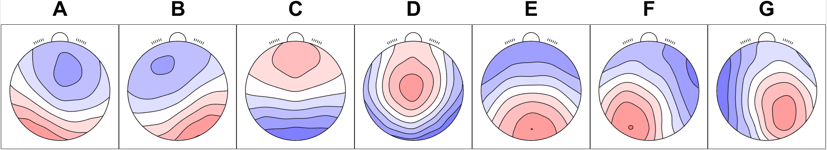
b
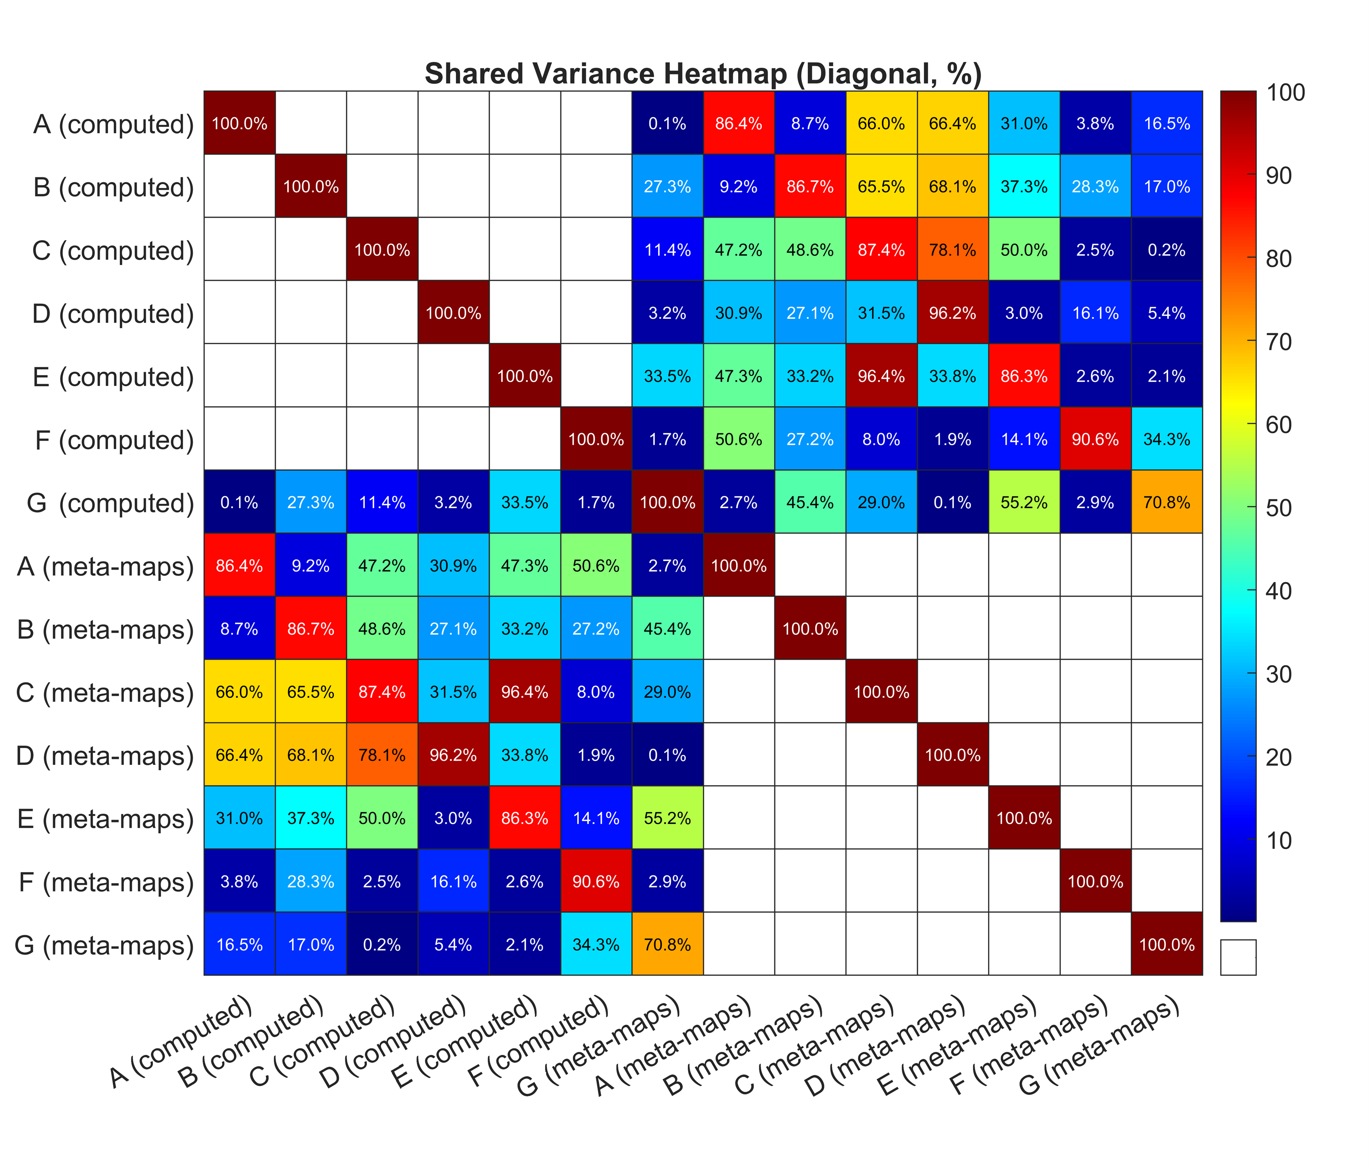
Fig. 7 a Computed mean microstate templates b spatial correlation matrix with microstate meta-maps (7 solutions template) (Koenig et al. 2024; Nagabhushan Kalburgi et al. 2024)

