Supplemental files
Table S1 Primer sequences, genes targeted, and length of PCR products.
Gene name | Gene ID | Primer sequences1 (5′→3′) | Amplicon Size (bp)
MCT1 | NM_001037319.1 | F: AGCCGCGTATAACGATACTTG  R:TCCAATTACCACTGCCCACC | 133
MCT4 | NM_001109980.3 | F:GAGCGGCAGCAGGGAG  R:TGACAGAGGCTGTTCCAAGG | 148
PAT1 | NM_001076852.2 | F:CTCTTGCCCGAGCTTGGTAG  R:TGTCCCTCTCTCCCGGC | 81
NHE1 | NM_174833.2 | F:GTCAGGCATCATGGCACTCA  R:TGATGGTCGTGTGGGACTTG | 89
NHE2 | XM_002691185.7 | F:ATCCGTCAGCGAACCTTGTC  R:AAGCTGCTGTCCTTCCGAAT | 128
NHE3 | NM_001192154.2 | F:GGGATCGAGTTCCTGGCAAA  R:GCAGGGTTGTCAATTCCTGAG | 71
DRA | NM_001083676.1 | F:AAAGTTGTGCCGCTGTTCTG  R:GCGATATGCTGGCAACCAAG | 85
HMGCL | NM_001075132.1 | F:GACCCTCCGGGCTGTCA  R:CGTCTCGAGGACCAACTTCC | 80
HMGCS-1 | NM_001206578.1 | F:GGTCCGCGGCTATAAAGCTA  R:TCTCCTCCTTCAGGCACCAA | 113
HMGCS-2 | NM_001045883.1 | F:TGACTTCCTGTTGGCCAGTG  R:AGCTTTAGTCCCCTGAAGGC | 75
BDH1 | NM_001034600.2 | F:CTGCGAAGCGCCAGGTTATC  R:CTCCTGGTGGGTTCCCAAAAC | 90
BDH2 | NM_001034488.2 | F:TTGCTGCTCTAAAATGTGACG  R:TATGCCTCTGACCACACAGC | 71
CLDN1 | NM_001001854.2 | F: TGCTGAATCTGAACAGCACT  R: CTCGTCGTCTTCCATGCACT | 128
OCLN | NM_001082433.2 | F: ATACCACTCCTCCTCCCTAGC  R: TGAGATCAGCCAATCTGCG | 129
ZO1 | XM_024982006.2 | F: GTCCATGACTCCTGACGGTT  R: GGTTTTAGGATCACCCGACGA | 70
GAPDH | NM_001034034.2 | F: AGGTCGGAGTGAACGGATTC  R: ATGGCGACGATGTCCACTTT | 85
The PCR amplification effciencies for all of the primers ranged between 96 and 100%.

Table S2 The effects of dietary supplementation L-leucine on messenger RNA (mRNA) expression of genes involved in rumen epithelial absorption, metabolism, and integrity in beef cattle (n=6).
Item ¹ | Treatment |  | SEM³ | P-value ⁴
Item ¹ | CON | Leu | SEM³ | P-value ⁴
MCT1 | 1ª | 2.16 | 0.22 | 0.002
MCT4 | 1 | 1.37 | 0.19 | 0.346
PAT1 | 1 | 0.91 | 0.13 | 0.737
NHE1 | 1ª | 1.66 | 0.21 | 0.120
NHE2 | 1ª | 2.16 | 0.24 | 0.008
NHE3 | 1ª | 2.14 | 0.23 | 0.004
DRA | 1ª | 4.70 | 0.90 | 0.032
BDH1 | 1^{ab} | 1.37 | 0.12 | 0.136
BDH2 | 1ª | 2.29 | 0.21 | 0.000
HMGCL | 1 | 2.08 | 0.22 | 0.005
HMGCS1 | 1ª | 2.81 | 0.33 | 0.001
HMGCS2 | 1ª | 6.15 | 0.91 | 0.001
COLD1 | 1 | 3.17 | 0.51 | 0.031
OCLN | 1ª | 3.67 | 0.68 | 0.042
ZO-1 | 1ª | 1.91 | 0.21 | 0.030

Table S3 The quality of metagenome (n=6).
Sample | Clean reads | Optimized reads | Contigs | N50, bp | N90, bp | ORF | Total length, bp | Average length, bp
A1 | 43,904,604 | 43,518,652 | 642,128 | 596 | 345 | 802,425 | 345,624,669 | 430.73
A2 | 49,324,798 | 48,910,866 | 739,653 | 587 | 343 | 917,143 | 391,151,253 | 426.49
A3 | 44,340,052 | 43,949,240 | 663,988 | 564 | 341 | 807,664 | 337,611,843 | 418.01
A4 | 45,437,350 | 45,049,604 | 731,522 | 603 | 346 | 906,077 | 397,721,397 | 438.95
A5 | 46,220,584 | 45,839,754 | 683,527 | 564 | 341 | 836,685 | 350,193,810 | 418.55
A6 | 46,631,310 | 46,239,588 | 712,795 | 586 | 343 | 898,315 | 377,962,800 | 420.75
B1 | 46,932,906 | 46,528,730 | 717,621 | 565 | 341 | 871,660 | 366,114,180 | 420.02
B2 | 46,800,670 | 46,400,642 | 735,970 | 604 | 346 | 916,347 | 399,280,728 | 435.73
B3 | 43,744,672 | 43,378,218 | 578,621 | 596 | 344 | 727,380 | 312,338,094 | 429.4
B4 | 45,888,368 | 45,478,028 | 736,802 | 543 | 339 | 896,307 | 370,840,794 | 413.74
B5 | 45,639,676 | 45,244,798 | 677,460 | 617 | 348 | 854,927 | 377,644,305 | 441.73
B6 | 45,177,238 | 44,774,336 | 654,254 | 576 | 343 | 802,545 | 340,915,179 | 424.79
ORF=open reading frame.

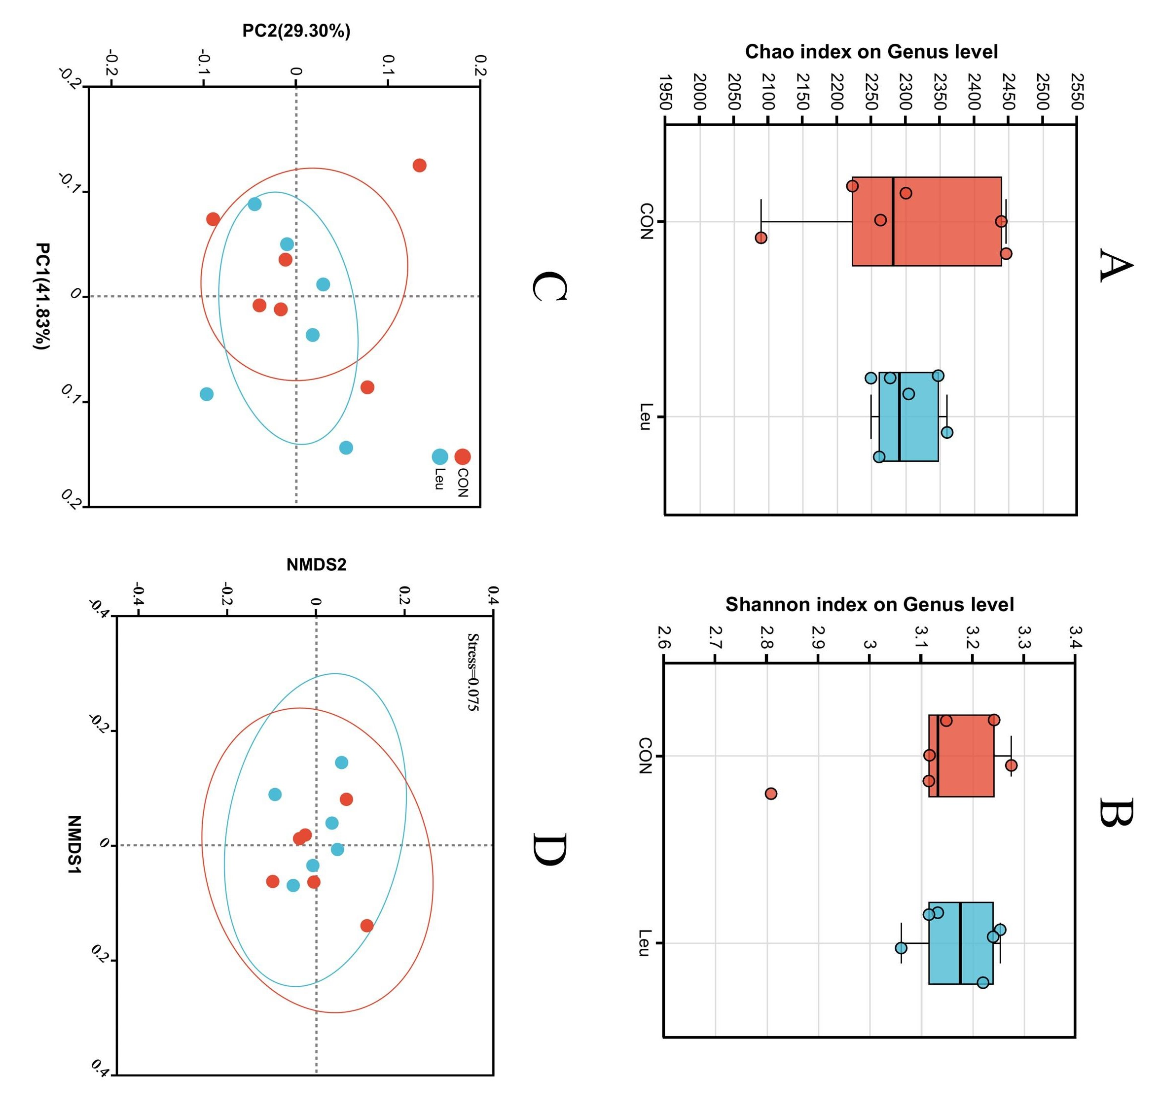
Fig. S1. The α-diversity indices including observed genus, (A) Chao and (B) Shannon indexes (n=6). (C) Principal coordinates analysis (PCoA). (D) non-metric multidimensional scaling (NMDS).
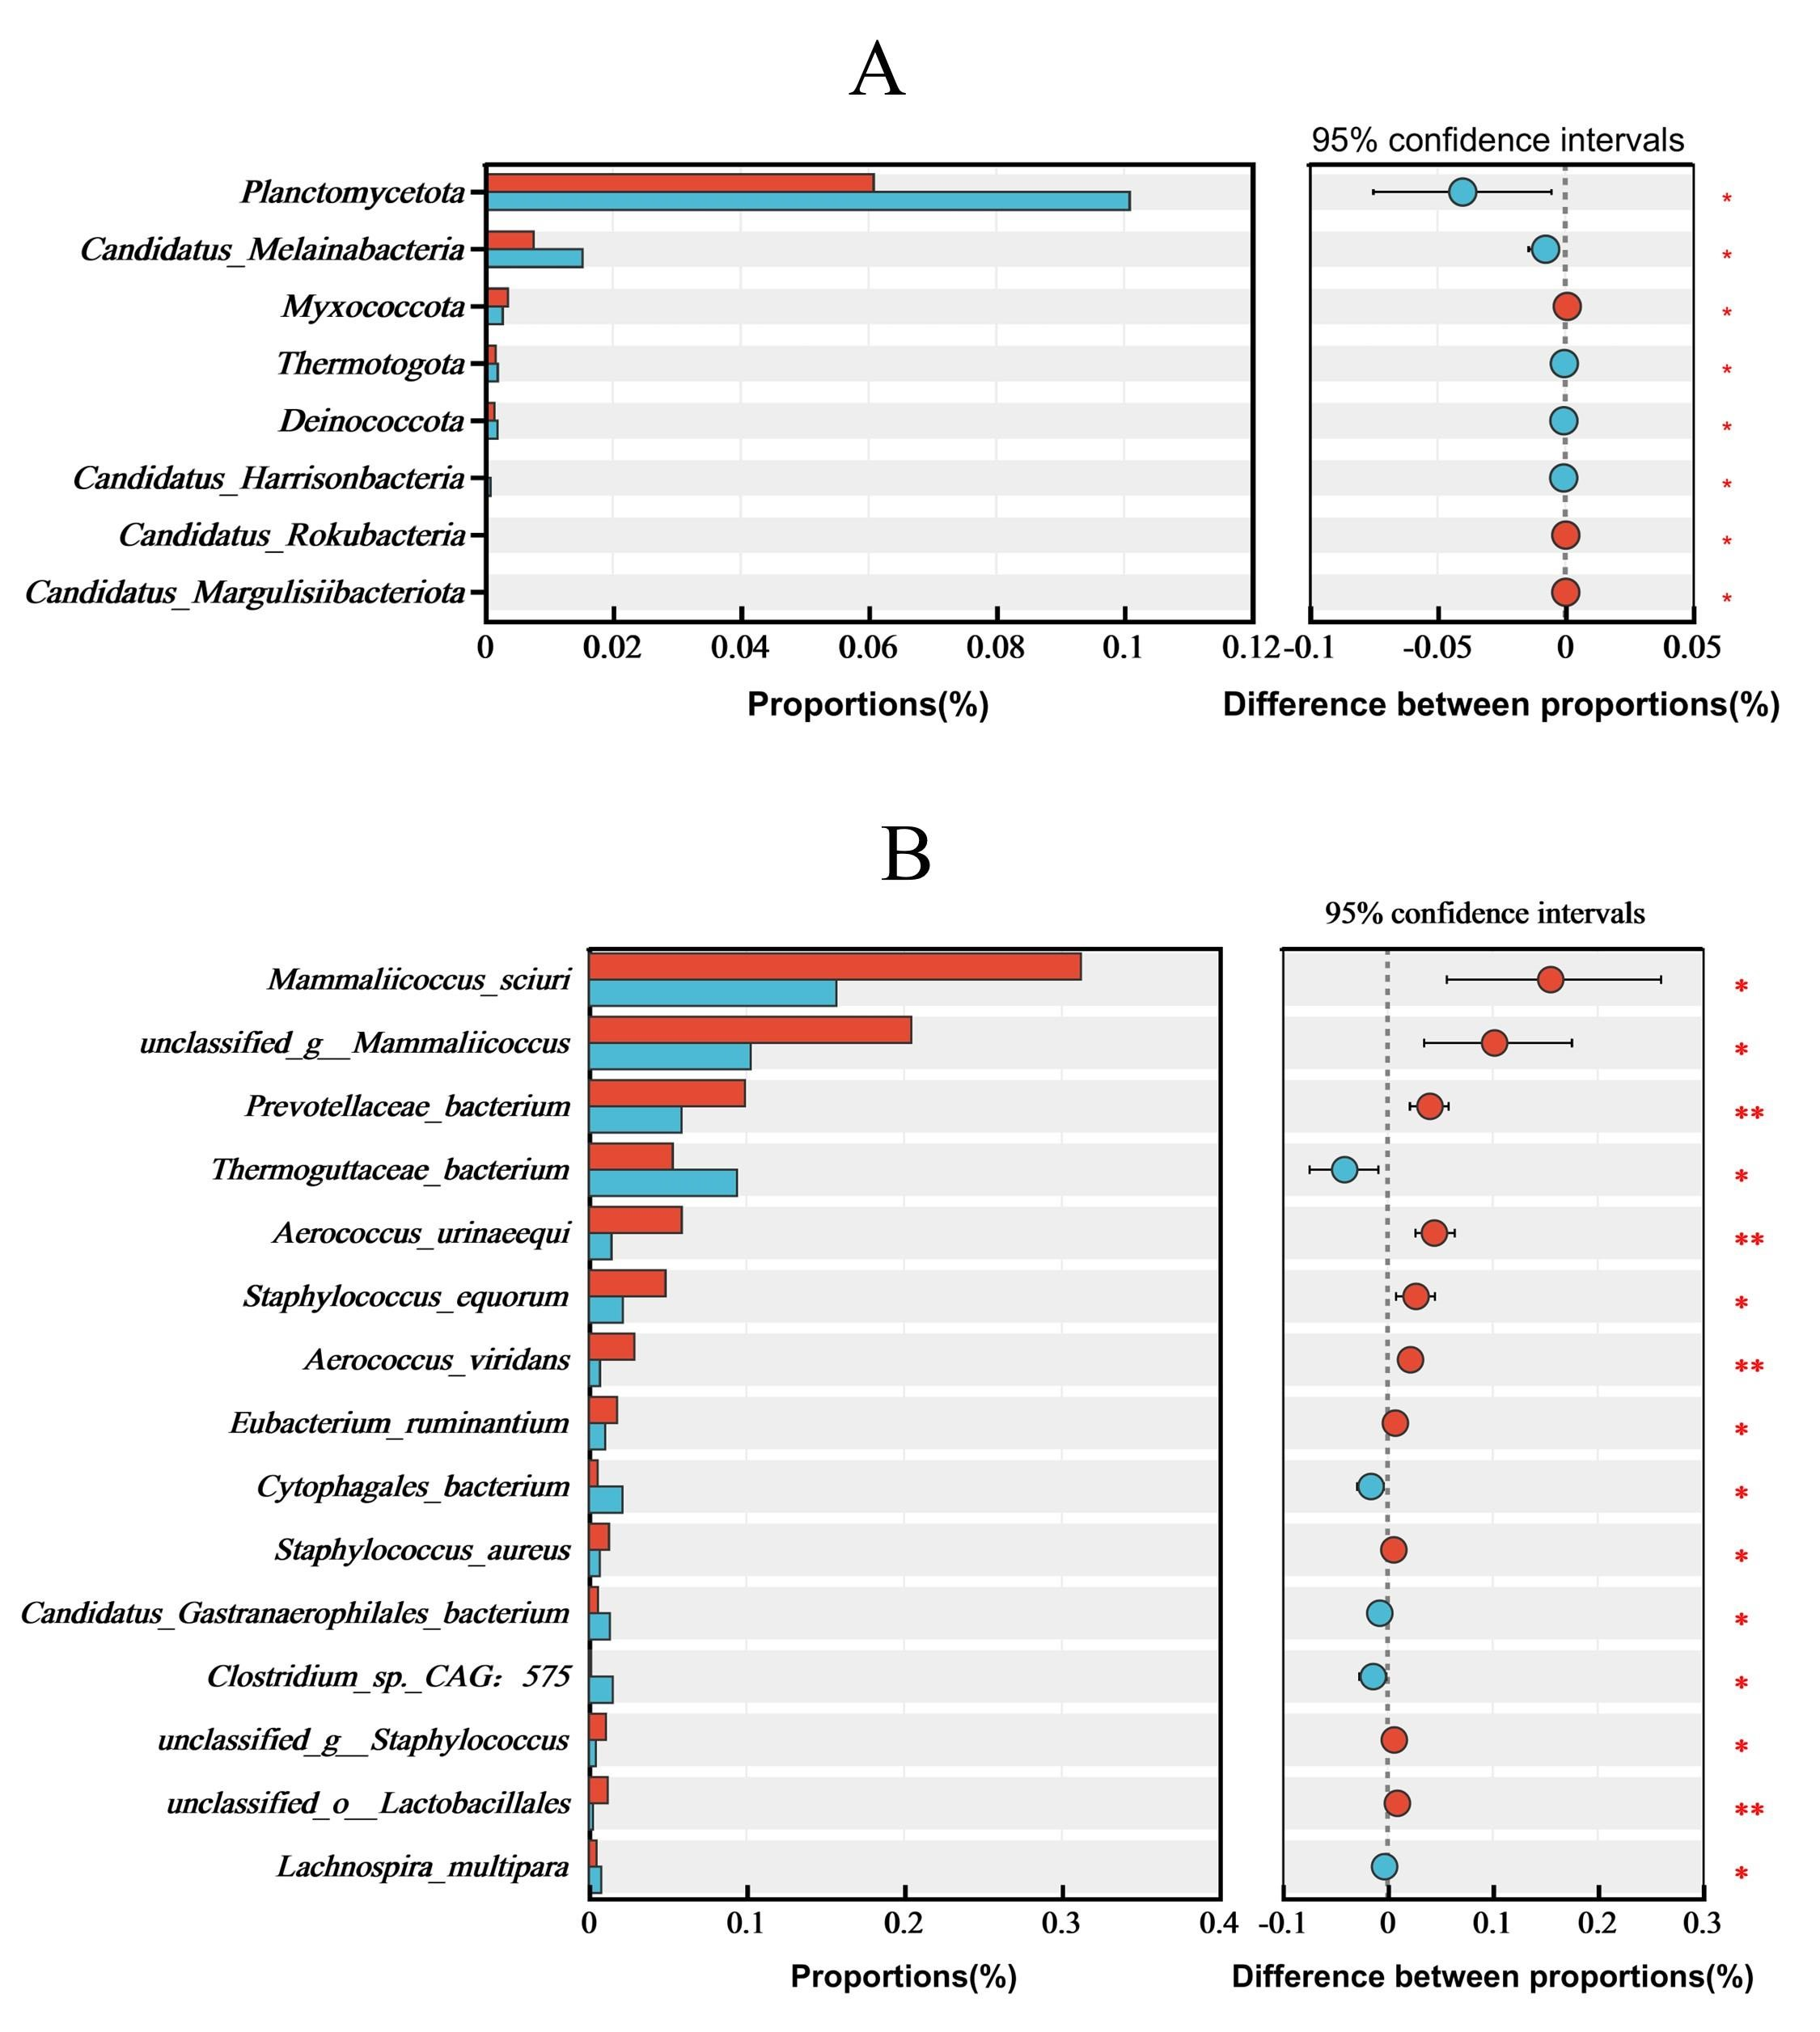
Fig. S2. Results of metagenomic sequencing of the rumen bacteria in the CON and Leu (n=6). (A) Differences in bacterial phylum levels. (B) Differences in bacterial species levels.

Fig. S3. Classification of rumen differential metabolites by KEGG compound database (CON/Leu, variable importance in the projection [VIP] > 1.0, P < 0.05) (n=5).

