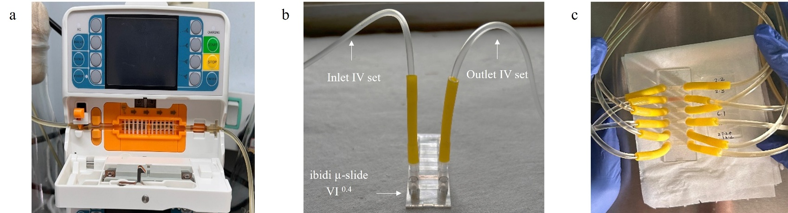

Supplementary figure 1: A closer look at the flow system: a) the passing of IV set through volumetric infusion pump that help in maintenance of flow rate, b) the connection of IV sets with the ibidi slide c) a closer look at of the slide after connecting all IV sets to the slide.

