Table S1: Details of the Anopheles mosquito DNA samples used in the study. ‘nd’ designates ‘non determined’ and represents where prior molecular species information on An. gambiae s.s and An. coluzzii was not available from the previous study from which the DNA samples were retrieved. For these species, identification was performed only when DNA showed positive for Microsporidia MB.

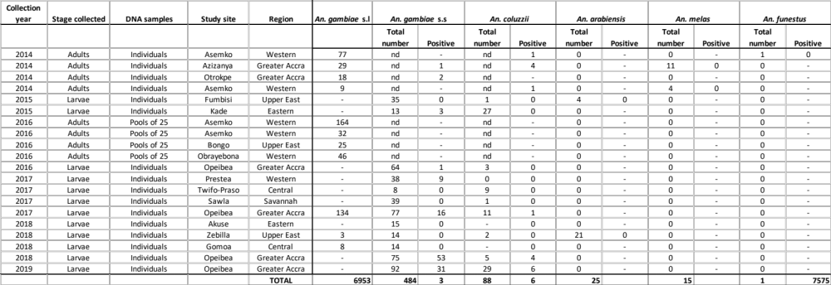

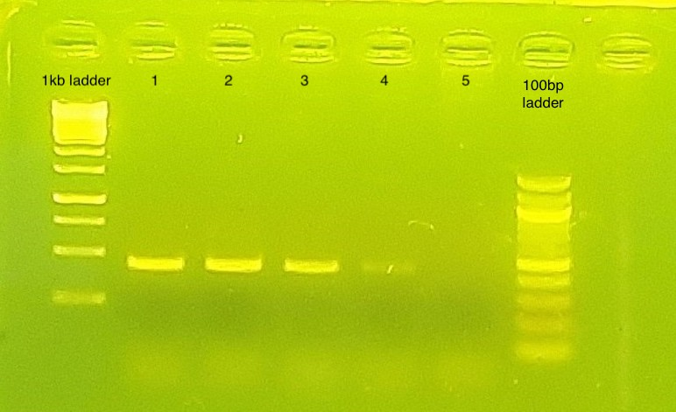
Fig S1: Gel photo for quality check and band size estimation of Microsporidia MB positive control. Well 1= mosquito DNA spiked with MB; 2= 1 in 10 diluted MB DNA; 3= 1 in 20 diluted MB DNA; 4= 1 in 100 diluted MB DNA; 5= no template control

