Supplemental Information

Fig S1. Survival rate of rice after high temperature treatment
Fig S2. WGCNA results obtained using RNA sequencing data. (A)Determination of the adjacency function parameter β in the WGCNA algorithm. (B) Dendrogram showing hierarchical clustering of genes based on dissimilarity of topological overlaps. (C) Correlations between modules and phenotypes.
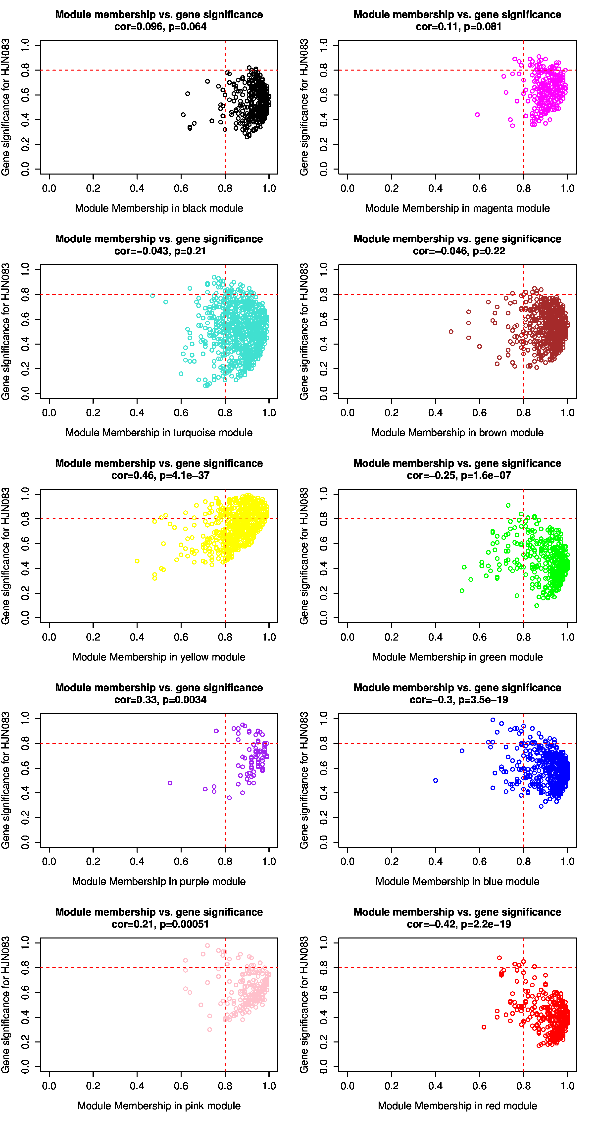
Fig S3. GS-MM scatter plot, co-expression network module analysis.

