Real-time selective sequencing using nanopores and deep learning

Artem Danilevsky, Avital Luba Polsky, and Noam Shomron

Faculty of Medicine and Edmond J Safra Center for Bioinformatics, Tel Aviv University, Tel Aviv 69978, Israel

Corresponding: nshomron@tauex.tau.ac.il

Abstract
Nanopore sequencing is an emerging technology that utilizes a unique method of reading DNA sequences and detecting various DNA modifications. Deep learning has increased in popularity as a useful technique to solve many complex computational tasks. Selective sequencing has been widely used in genomic research; although it introduces several caveats to the process of sequencing, its advantages supersede them. In this study we demonstrate an alternative method of software-based selective sequencing that is performed in real time by combining nanopore sequencing and deep learning. Our results show the feasibility of deep learning for classifying signals from only the first 200 nucleotides in a raw nanopore sequencing signal format. Using custom deep learning models and a script utilizing "Read-Until" framework to target mitochondrial molecules in real time, from a human cell line sample, we achieved a significant separation and enrichment ability of 2.3X. In a series of very short sequencing runs (10, 30, and 120 minutes), we identified genomic and mitochondrial reads with accuracy above 90%, although mitochondrial DNA comprises only 0.1% of the total material. We believe that our results will lay the foundation for rapid and selective sequencing using nanopore sequencing technology and will pave the way for future clinical applications using nanopore sequencing data.

Data availability
The sequencing data produced in this article are available at NCBI’s SRA with accession number PRJNA689046
Code availability
The code used for this work is provided for non-commercial use at: https://github.com/nshomron/Nanopore_Deep_Learning

Supplementary Materials

Supplementary Methods

Data overview
The dataset from the work of Jain et al. was acquired by sequencing the CEPH1463 human genome reference standard (NA12878/GM12878, Ceph/Utah pedigree), which was performed on the Oxford Nanopore MinION using 1D ligation kits on a R9.4 flow cell (FLO-MIN106). The samples were prepared without PCR in order to preserve the DNA modifications; this also benefits our goal for deep learning. The experiment produced nearly 14 million reads containing 90 million nucleotide bases, which produces approximately a 30x coverage of the human genome. From the 94% of reads that were mapped to the human genome, around 60,000 reads aligned to the mitochondria. In order to reduce the size of the dataset to a manageable size, we down-sampled the reads that aligned to the genome and randomly selected 200,000 reads to include in the training dataset, although we still used all 60,000 reads aligned to the mitochondria. The second dataset came from the sequencing of DNA extracted from blood samples of ONT Chief Technology Officer, Clive Brown. It was also produced without the use of PCR; therefore, additional information about the DNA-like modifications is present in the raw signal. The second dataset had around 18 million reads aligned to the genome and only 8K reads aligned to the mitochondria. From the second dataset we used all the mitochondrial reads and randomly selected 200K of the genomic reads to be used for the training and evaluation of the deep learning models.

Data organization and preprocessing
In each dataset we used a custom python script to analyze the alignment results and to separate the reads into appropriate groups. For each dataset the selected fast5 files were transferred to a separate folder corresponding to mitochondrial reads and genomic reads. Each of the fast5 files represent a sequenced read and contains the raw signal of the sequenced DNA molecule. In each folder we separated the files randomly into training, validation, and testing groups, each containing 80%/10%/10% of the total reads. Every measurement of a model’s accuracy was performed on the testing group of the reads of the mentioned dataset. A different custom python script was executed in order to extract the raw signal and to concentrate all the data into comma-separated value (CSV) files. The script found the hypothetical starting point of the raw signal from the actual DNA molecule, characterized by a high peak. Additionally, the custom script extracted only raw signals that had at least 5,000 values. By performing this selection, we eliminated reads that are too short and we created a suitable dataset for deep learning training. Even though the average raw signal length was around 140K, we only used the beginning of the raw signal in our datasets to allow the model to filter reads based on their beginning.

Data loading and manipulations
Our custom dataloader shuffles the reads in the dataset, then selects 64 reads from it, and finally applies four transformations to each signal; those transformations were critical to the success of the training process and were established in the course of the project.
The first transformation randomly selected a region of 2K datapoints from the signal, which originally was 5K in length; this transformation allowed us to artificially increase the dataset and to lower the chances of the model over-fitting on the data.
The second transformation changed the signal from raw values that represent the electric current level to differences between the values; this change allowed us to overcome the differences in the raw electric current levels that were generated differently between each sequencing device and the flow cell.
The third transformation cut the signal into a sliding window array, transforming the 1D-long linear signal into a 2D array of stacked sliding windows represented in the next example:

Regular signal: 1, 2, 3, 4, 5, 6, 7, 8
Transformed signal: (1, 2, 3, 4), (3, 4, 5, 6), (5, 6, 7, 8)
Window length = 4, stride = 2, window number = 3

We could change the length of the window and the stride between each window; this transformed the signal into a shape more suitable for our neural network architectures and also allowed us to reduce the total length of each sample by increasing the window size and stride, which in turn, reduced the number of windows. The default parameters were a window length of 1, a stride of 1, and a window number of 2000, which correspond to a regular signal with 2000 datapoints.
The fourth transform added Gaussian noise to the sample, which could mimic the background noise in Nanopore sequencing and could artificially increase the dataset further.
All of these transformations were carefully explored and fine-tuned during the initial phases of the project and were essential to the training process, since some models could not be effectively trained without them.

Model architecture
For our deep learning model architecture, we tested 5 main neural network types: regular CNN¹, very deep CNN², regular LSTM³, LSTM with recurrent batch normalization⁴, and a regular GRU⁵.
Each model was extensively tested with different parameters during training. All models were tested with 3 different sizes: large size, medium size, and small size models. Then for each model we changed the parameters related to the specific neural network and tested them with different sizes.
The regular CNN model consisted of a batch normalization layer, several layers of CNN with max-pooling, and ReLU layers in between, followed by a fully connected layer and a soft-max function. The 3 sizes of the network had 4/32/128 output features in the first CNN layer, whereas the consecutive CNN layers doubled the number of output features. The CNN networks were tested with 3 and 6 CNN layers; dropout was tested by adding a dropout layer before the fully connected layer, dilation was tested by adding a dilation factor of 2 to each CNN layer, and finally, a smaller kernel size was tested by reducing the kernel size.
The very deep CNN model had the default architecture described in the VDCNN paper², with an added fully connected layer and a soft-max function at the end. To test different model sizes, we selected VDCNN with a depth of 9/17/29, which was proposed and tested in the original paper. Dropout was tested by adding a dropout layer before the fully connected layer, a larger kernel size was tested by increasing the kernel size of each CNN layer in the model, the regular max pooling layer was compared to k-max pooling as the last layer before the fully connected layer, and finally, the presence of shortcut connections was tested by adding them to the network.
The regular LSTM model consisted of one LSTM layer followed by a fully connected layer. LSTM neural networks have a steep increase in running time when working with longer sequences; hence, we changed the parameters of the sliding window transformation of the signal to a window length of 32, a stride of 10, and a window number of 200, which decreased the sequence size from 2000 to 200. In order to test 3 sizes of the model, we selected 3 different numbers of features in the hidden state of the LSTM layer, 16/128/512. We also tested the addition of a batch normalization layer before the LSTM layer, we compared the regular LSTM with bi-directional LSTM, and we determined the difference between taking the last step from the output of the LSTM layer and taking the hidden state output from the LSTM layer.
The LSTM with recurrent batch normalization model was constructed similarly to the one in the original paper⁴, with a fully connected layer and a soft-max function at the end. We applied a sliding window transformation similar to the regular LSTM, with a window length of 32, a stride of 10, and a window number of 200. Different network sizes were achieved by setting 16/128/512 as the numbers of output features of the LSTM layer. We compared the performance of LSTM with one layer against an LSTM with two layers; dropout was also tested by adding a dropout layer after each layer of LSTM, and the difference between taking the last step from the output of the LSTM layer was compared to taking the hidden state output from the LSTM layer.
The regular GRU model had a batch normalization layer, then a GRU layer, followed by a fully connected layer and a soft-max function at the end. We applied a similar sliding window transformation like before, a window length of 32, a stride of 10, and a window number of 200. We tested different model sizes by setting the number of output features of the GRU layer to 16/128/512. We also tested the difference between a regular GRU and a bi-directional GRU. Adding dropout and changing the number of layers, reduced the stability of the model during training; thus, they were excluded.
After examining the results of the basic models, we decided to combine a convolutional neural network with a recurrent neural network, as can be seen in Supplementary Figure 1; from the results, we could observe that the VDCNN model is clearly superior to the regular CNN so we chose VDCNN as our default CNN-type network. In addition, the regular GRU model and the LSTM with recurrent batch normalization performed similarly; therefore, we decided to test the combination of VDCNN with either the regular GRU or LSTM and recurrent batch normalization.
The VDCNN + regular GRU model had the input go through a VDCNN network with a constant depth of 9 and without the final fully connected layer; then there is a batch normalization layer and finally, a GRU layer, followed by a fully connected layer and a soft-max function at the end. The input was transformed with the regular sliding window transformation because the output from the VDCNN was much shorter than a regular signal of 2000 datapoints. Different sizes of the model were tested by setting the number of output features of the GRU layer to 16/128/512. In addition, we compared working with the last step from the output of the GRU layer with working with the hidden state output of the GRU layer.
The VDCNN + LSTM with recurrent batch normalization model had a VDCNN network with a constant depth of 9; it was without the final fully connected layer, then there was an LSTM layer with recurrent batch normalization, followed by a fully connected layer and a soft-max function. The input was transformed with the regular sliding window transformation as well. Different sizes of the model were tested by setting the number of output features of the LSTM layer to 16/128/512. Here we also compared working with the last step from the output of the LSTM layer with working with the hidden state output.

Model architecture and training
After acquiring the training dataset and deciding which models should be tested, we wrote a custom python script for the training process of each model. For each model the accuracy was measured separately for genomic reads and for mitochondrial reads. The accuracy value for genomic reads is calculated by dividing the number of correctly classified genomic reads by the total number of genomic reads; the accuracy for mitochondrial reads is calculated similarly. Two dataloaders were used separately to load mitochondrial reads and genomic reads; in each iteration of training we loaded the same number of mitochondrial reads and genomic reads, shuffled the reads and their correct labels, and inserted the reads into the model. Additionally, a function was created to determine whether the loss value of the neural network stopped improving, indicating that the learning process had stopped, and if no improvement was detected, the function reduced the learning rate to half.
In order to monitor the progress of the training process, we calculated the epoch number based on the mitochondrial dataset; after each full iteration of the mitochondrial reads dataset, the epoch number was increased by one.
Supplementary Figure 2 illustrates the training process from the LSTM with recurrent batch normalization model. Sup. Fig. 2.A shows that the loss value decreased during training, there was a drop in the value at around 40,000 batches caused by lowering the learning rate. Sup. Fig. 2.B shows that the accuracy value increased during the training process; we can see a slight increase in accuracy at around 40,000 batches, also caused by reducing the learning rate. Finally, Sup. Fig. 2.C shows the accuracy values for the training dataset as well as the validation dataset side by side, which is a good indicator of over-fitting of the model; in this example both accuracy values increase similarly during the training, indicating a model without over-fitting problems. By keeping track of the change in the accuracy and loss values, we could identify models where the training process required a change in the training parameters.

MinION sequencing data analysis
An attempt was made to create a deep learning model to classify reads from the BRCA1 gene. The challenging part was the very low amount of data available, only 1,000 reads mapped to the region of the BRCA1 gene, compared with the 60,000 reads mapped to the mitochondria. Although the model showed an improvement in accuracy during training, the accuracy on the test data did not improve. Severe over-fitting was present in every training attempt probably because of the relatively low coverage of the BRCA1 gene. Therefore, we did not continue to the experimental testing for one gene selective sequencing. Supplementary Figure 2 shows accuracy values for the training dataset (blue) as well as the validation dataset (orange) side by side. We could clearly see the accuracy on the training dataset increasing during the training, whereas the accuracy for the validation dataset does not increase and stays near the 50% value. These results indicate a severe case of over-fitting, probably caused by the small size of the training dataset.

Additional selective sequencing experiment
In addition to the sequencing experiments presented, we ran another pair of sequencing runs for 30 minutes for experimental purposes; here we changed the number of batched reads from 10 to 100 in the read-until script. Those two experiments showed even a stronger support of our claim with even a larger proportion of mitochondrial nucleotides sequenced during those experiments. To estimate the enrichment factor, we compared the percentage of mitochondrial nucleotides in those two experiments to the values from the three sequencing runs without selective sequencing that were run for 30 minutes: the estimated enrichment factor was 3.8X. In those two experimental runs, an average of 0.4% from all nucleotides were mitochondrial and the average read length of the mitochondrial reads was 3900 nucleotides, whereas the genomic reads had an average read length of 950 nucleotides.

References

1. Krizhevsky, A., Sutskever, I. & Hinton, G. E. ImageNet Classification with Deep Convolutional Neural Networks. in Advances in Neural Information Processing Systems 25 (eds. Pereira, F., Burges, C. J. C., Bottou, L. & Weinberger, K. Q.) 1097–1105 (Curran Associates, Inc., 2012).
2. Conneau, A., Schwenk, H., Barrault, L. & Lecun, Y. Very Deep Convolutional Networks for Text Classification. ArXiv160601781 Cs (2016).
3. Hochreiter, S. & Schmidhuber, J. Long Short-Term Memory. Neural Comput 9, 1735–1780 (1997).
4. Cooijmans, T., Ballas, N., Laurent, C., Gülçehre, Ç. & Courville, A. Recurrent Batch Normalization. ArXiv160309025 Cs (2016).
5. Cho, K. et al. Learning Phrase Representations using RNN Encoder-Decoder for Statistical Machine Translation. ArXiv14061078 Cs Stat (2014).

Supplementary Figures

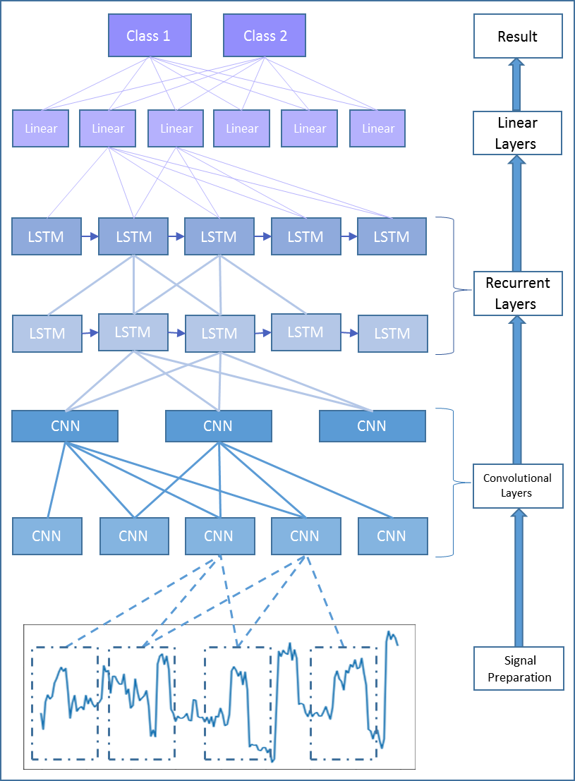
Supplementary Figure 1: Schematic overview of the information flow in the deep learning model that combines the CNN and RNN-type layers, from the signal to a final classification.

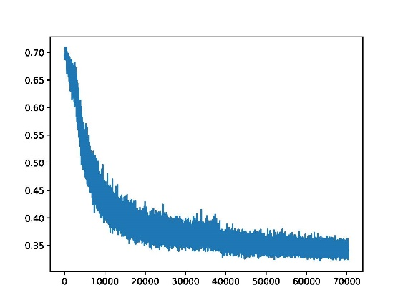
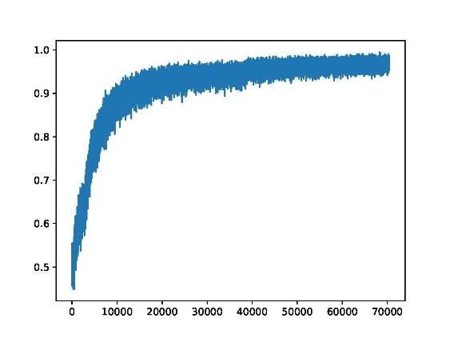
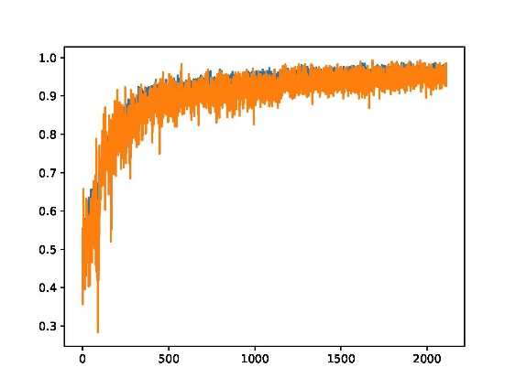
Supplementary Figure 2: Training process of the LSTM with recurrent batch normalization model. (A). Loss value curve during the training process. (B). Accuracy on the training dataset during the training process. (C). Accuracy on the training dataset (blue) and on the validation dataset (orange); the accuracy values are similar for both datasets; therefore, they overlap. The time-span of the X-axis is similar for all subplots and is equivalent to 300 epochs.

Loss value

Mini-batches

A

Accuracy

Mini-batches

B

Accuracy

Mini-batches

C

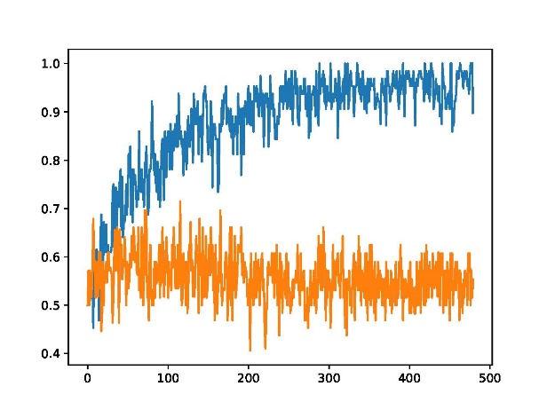
Mini-batches

Accuracy

Supplementary Figure 3: Training process for BRCA1 selective sequencing using the LSTM with recurrent batch normalization model. Accuracy on the training dataset (blue) compared to the accuracy on the validation dataset (orange). The time-span of the X is equivalent to 300 epochs.

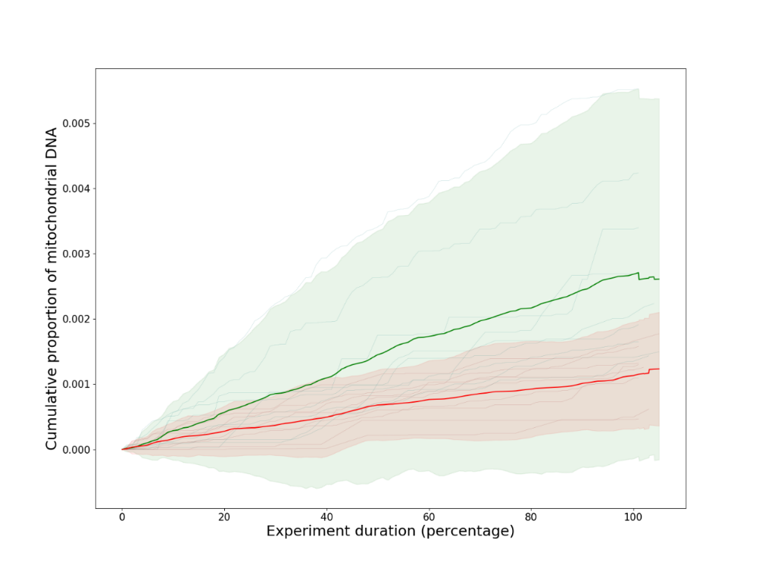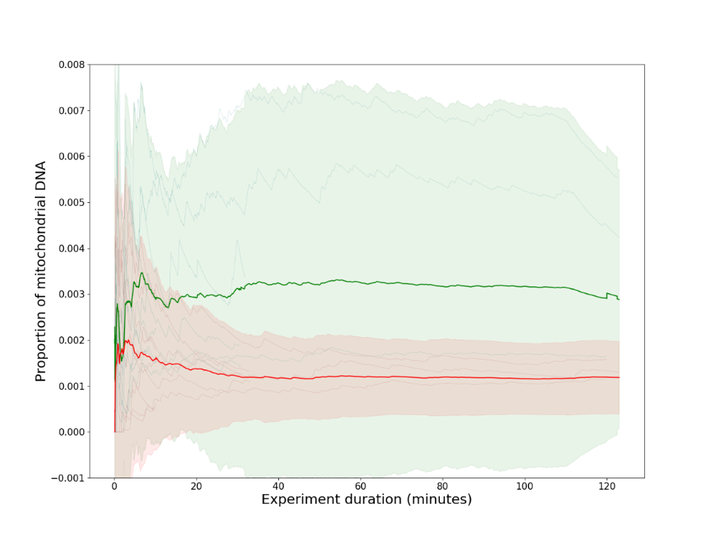
Supplementary Figure 4: Differences in the percentage of mitochondrial nucleotides between experiments with selective sequencing and those without it over time. The top is the cumulative proportion of mitochondrial reads over time (green denotes the average value between all experiments with selective sequencing, red is the average values of all experiments without selective sequencing). The bottom shows the proportion of mitochondrial DNA during the experiments (green is the average value between all experiments with selective sequencing and red is the average value of all experiments without selective sequencing).

