SN | Item question | Number of patient practised  (n = 447) | Odd ratio | ‘P’ value
1 | Salt reduction in diet (1 teaspoon /day or < 5 gm/day) | 325 (72.7%) | 0.9 | 0.04
2 | Intake of low-fat dairy products | 281 (62.8 %) | 0.5 | 0.03
3 | Reduced amount of fatty and oily food | 328 (73.37%) | 0.1 | 0.01
4 | Daily intake of vegetables | 429 (95.9%) | 1.83 | 0.02
5 | Daily exercise for 30 mins (brisk walking, jogging, cycling) | 214 (47.8%) | 0.1 | 0.04
6 | Daily intake of fruits | 277 (61.9%) | 0.43 | 0.03
7 | Cessation of smoking | 32 (7.1%) | 0.46 | 0.30
8 | Managing stress | 60 (13.4%) | 0.3 | 0.04
9 | Limit alcohol intake | 48 (10.7%) | 0.40 | 0.36
10 | Once daily lean meat/fish | 376 (84.1%) | 2.4 | 0.44
11 | Maintenance of weight reduction during treatment | 305 (68.2%) | 3.65 | 0.04

Table 1: Assessment of behavioural modification (lifestyle modification) practice of the patient and its association with blood pressure control. Bold letters show p value significant P < 0.05

ACE genotypes | Hypertensive  n = 100 | Normotensive  n = 100 | ‘P’ value | Hardy Weinberg  Equilibrium  ‘P’ value
II | 46 (46%) | 38 (35%) | 0.04 | Chi sq goodness  fit = 34.03  df = 2  p = 0.001
DD | 31 (31%) | 18 (18%) | 0.04 | Chi sq goodness  fit = 34.03  df = 2  p = 0.001
ID | 23 (23%) | 44 (47%) | 0.04 | Chi sq goodness  fit = 34.03  df = 2  p = 0.001

Table 2: Genetic frequencies of I/D polymorphism of ACE gene among hypertensives and normotensives. P value shows significant P < 0.05

ACE genotypes | Hypertensive  n = 100 | Normotensive  n = 100 | ‘P’ value
I | 115 (57.5%) | 120 (60%) | 0.002
D | 85 (42.5%) | 80 (40%) | 0.002
Table 3: Allele frequencies of I/D polymorphism of ACE gene among hypertensives and normotensives. P value shows significant P < 0.05.

Dominant model
Groups | ACE I/D genotypes |  | OR (odds ratio) | ‘P’ value
Groups | II | ID + DD | OR (odds ratio) | ‘P’ value
Hypertensive | 46 | 54 | 5.6 | 0.03
Normotensive | 35 | 62 | 2 | 0.03
Table 4: Dominant model to show the association of ACE I/D gene polymorphism with hypertensive study group. P value shows significant P < 0.05

Recessive model
Groups | ACE I/D genotypes |  | OR (odds ratio) | ‘P’ value
Groups | DD | ID + II | OR (odds ratio) | ‘P’ value
Hypertensive | 31 | 69 | 4 | 0.02
Normotensive | 18 | 82 | 0.6 | 0.02
Table 5: Recessive model to show the association of ACE I/D gene polymorphism with hypertensive study group. P value shows significant P < 0.05

ACE II genotypes
Drugs | Number of patient taking drug | Number of patient able to control BP (%) | Number of patient not able to control BP (%)
Amlodipine | 21 | 16 (76.1%) | 5 (23.8%)
Telmisartan | 16 | 7 (43. 7%) | 9 (56.2%)
Amlodipine + Telmisartan | 9 | 5 (55.5%) | 4 (44.4%)
Table 6: Association of drugs intake and ACE II genotypes hypertensive patients. Bold letter shows higher percentage of BP control.

ACE DD genotypes
Drugs | Number of patient taking drug | Number of patient able to control BP (%) | Number of patient not able to control BP (%)
Amlodipine | 16 | 7 (43.7%) | 9 (56.2%)
Telmisartan | 12 | 10 (83.3%) | 2 (16.6%)
Amlodipine + Telmisartan | 3 | 1 (33.3%) | 2 (66.6%)
Table 7: Association of drugs intake and ACE DD genotypes hypertensive patients. Bold letter shows higher percentage of BP control.

ACE ID genotypes
Drugs | Number of patient taking drug | Number of patient able to control BP (%) | Number of patient not able to control BP (%)
Amlodipine | 12 | 4 (33.3%) | 8 (66.6%)
Telmisartan | 5 | 2 (40%) | 3 (60%)
Amlodipine + Telmisartan | 6 | 3 (50%) | 3 (50%)
Table 8: Association of drugs intake and ACE ID genotypes hypertensive patients. Bold letter shows higher percentage of BP control

SN | Item question | Yes (values given in %) | No (values given in %)
1 | Add salt in food before eating | 75 | 25
2 | Eating process food such as pickle, processed fish or meat, papad etc | 92 | 8
3 | Limit in-take of salt in diet after high blood pressure was detected | 87 | 13
4 | Awareness regarding high intake high in-take salt may lead to high blood pressure | 91 | 9
5 | Family history of high blood pressure | 37 | 63
Table 9: History of salt in-take by the patient subject enrolled for the pharmacogenetic
study

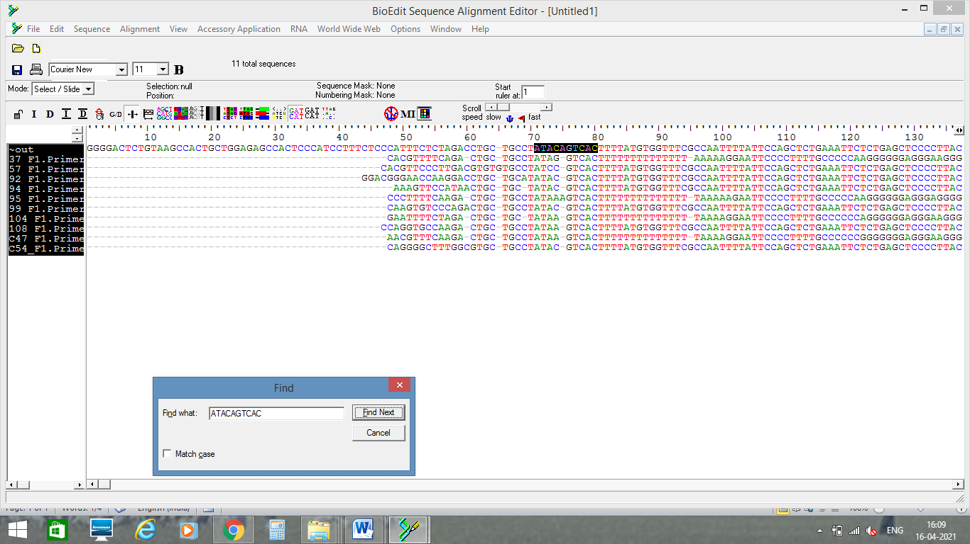
Table 10: DNA Sanger sequencing of the PCR products

