Supplementary Information for the manuscript “Effect of an invasive grass on carbon and nitrogen stocks in the Brazilian Cerrado”
This Supplementary Information includes three tables and one figure.
Diana B. Garcia, Rafael O. Xavier, Plinio B. Camargo, Simone A. Vieira, Vânia R. Pivello*
* Author for correspondence, vrpivel@ib.usp.br.

Table 1S. Mean (± standard deviation) C stock values on the root biomass along the soil profile in sites invaded and uninvaded by invasive African grasses in southeast Brazil.
Soil depth (cm) | Fine roots (Mg.ha⁻¹) |  |  | Coarse roots (Mg.ha⁻¹) |  |  | All roots (Mg.ha⁻¹)
 | Invaded | Uninvaded |  | Invaded | Uninvaded |  | Invaded | Uninvaded
0-10 | 2.31±1.04 | 1.35±0.29 |  | 1.00±1.44 | 0.19±0.16 |  | 3.31±2.22 | 1.54±0.29
10-20 | 1.12±0.38 | 1.06±0.23 |  | 1.80±1.45 | 0.99±0.86 |  | 2.93±1.61 | 2.05±0.93
20-30 | 1.07±0.45 | 0.85±0.25 |  | 0.99±0.35 | 0.99±1.07 |  | 2.07±0.71 | 1.83±1.26
40-50 | 0.95±0.40 | 0.82±0.24 |  | 0.82±0.81 | 1.61±2.84 |  | 1.77±0.82 | 2.43±2.87

Table 2S. Mean (± standard deviation) C, N and C/N ratio soil content along the soil profile in sites invaded and uninvaded by invasive African grasses in southeast Brazil.

Soil depth (cm) | Soil N content % |  |  | Soil C content % |  |  | C:N content ratio |  |  | 15N content |  |  | 13C content
 | Invaded | Uninvaded |  | Invaded | Uninvaded |  | Invaded | Uninvaded |  | Invaded | Uninvaded |  | Invaded | Uninvaded
0-5 | 0.245±0.02 | 0.190±0.026 |  | 5.31±0.46 | 4.29±0.45 |  | 21.68±1.20 | 22.76±1.68 |  | 1.78±0.64 | 2.39±0.46 |  | -17.86±1.20 | -18.04±0.90
5-10 | 0.167±0.023 | 0.166±0.031 |  | 4.33±0.30 | 3.99±0.53 |  | 26.18±2.10 | 24.3±1.86 |  | 3.66±0.44 | 3.64±0.64 |  | -17.93±0.98 | -17.74±0.63
10-20 | 0.115±0.066 | 0.107±0.025 |  | 3.75±0.87 | 3.34±0.38 |  | 35.83±6.87 | 31.91±3.66 |  | 5.19±1.27 | 5.38±0.58 |  | -17.97±0.42 | -17.77±0.93
20-30 | 0.056±0.02 | 0.064±0.014 |  | 2.99±0.27 | 2.75±0.25 |  | 56.34±11.87 | 43.78±6.72 |  | 6.56±0.70 | 6.63±0.47 |  | -17.77±0.49 | -17.31±0.67
30-40 | 0.046±0.031 | 0.042±0.016 |  | 2.76±0.34 | 2.42±0.24 |  | 86.06±53.98 | 63.99±18.76 |  | 7.23±1.09 | 7.60±0.66 |  | -17.63±0.79 | -17.05±0.59
40-50 | 0.042±0.046 | 0.033±0.019 |  | 2.83±0.85 | 2.36±0.27 |  | 156.67±117.66 | 88.76±38.22 |  | 6.78±2.01 | 8.14±1.09 |  | -17.61±0.83 | -17.00±0.43
70-80 | 0.014±0.008 | 0.010±0.004 |  | 2.40±0.15 | 1.91±0.16 |  | 212.33±86.76 | 201.26±69.56 |  | 8.12±0.60 | 9.26±0.38 |  | -17.92±0.49 | -17.10±0.35
90-100 | 0.015±0.009 | 0.010±0.004 |  | 2.26±0.27 | 1.84±0.06 |  | 183.01±72.47 | 213.54±70.87 |  | 8.11±0.84 | 8.84±0.67 |  | -18.13±0.29 | -17.43±0.37

Table 3S. Mean (± standard deviation) C and N soil stock values along the soil profile in sites invaded and uninvaded by invasive African grasses in southeast Brazil.
Soil depth (cm) | N stock in soil (Mg.ha⁻¹) |  |  | C stock in soil (Mg.ha⁻¹)
 | Invaded | Uninvaded |  | Invaded | Uninvaded
0-5 | 0.156±0.015 | 0.133±0.008 |  | 3.43±0.43 | 2.99±0.3
5-10 | 0.111±0.02 | 0.119±0.021 |  | 2.9±0.31 | 2.81±0.4
10-20 | 0.169±0.088 | 0.156±0.044 |  | 5.34±0.88 | 4.77±0.56
20-30 | 0.083±0.026 | 0.097±0.021 |  | 4.25±0.41 | 4.05±0.22
30-40 | 0.048±0.025 | 0.073±0.027 |  | 3.96±0.51 | 3.78±0.49
40-50 | 0.023±0.02 | 0.055±0.034 |  | 3.55±0.3 | 3.69±0.5
70-80 | 0.02±0.014 | 0.014±0.003 |  | 3.77±0.28 | 3.06±0.09
0-30 | 0.520±0.130 | 0.505±0.079 |  | 15.90±1.03 | 14.61±1.24
0-50 | 0.591±0.169 | 0.633±0.138 |  | 23.42±1.45 | 22.07±2.18

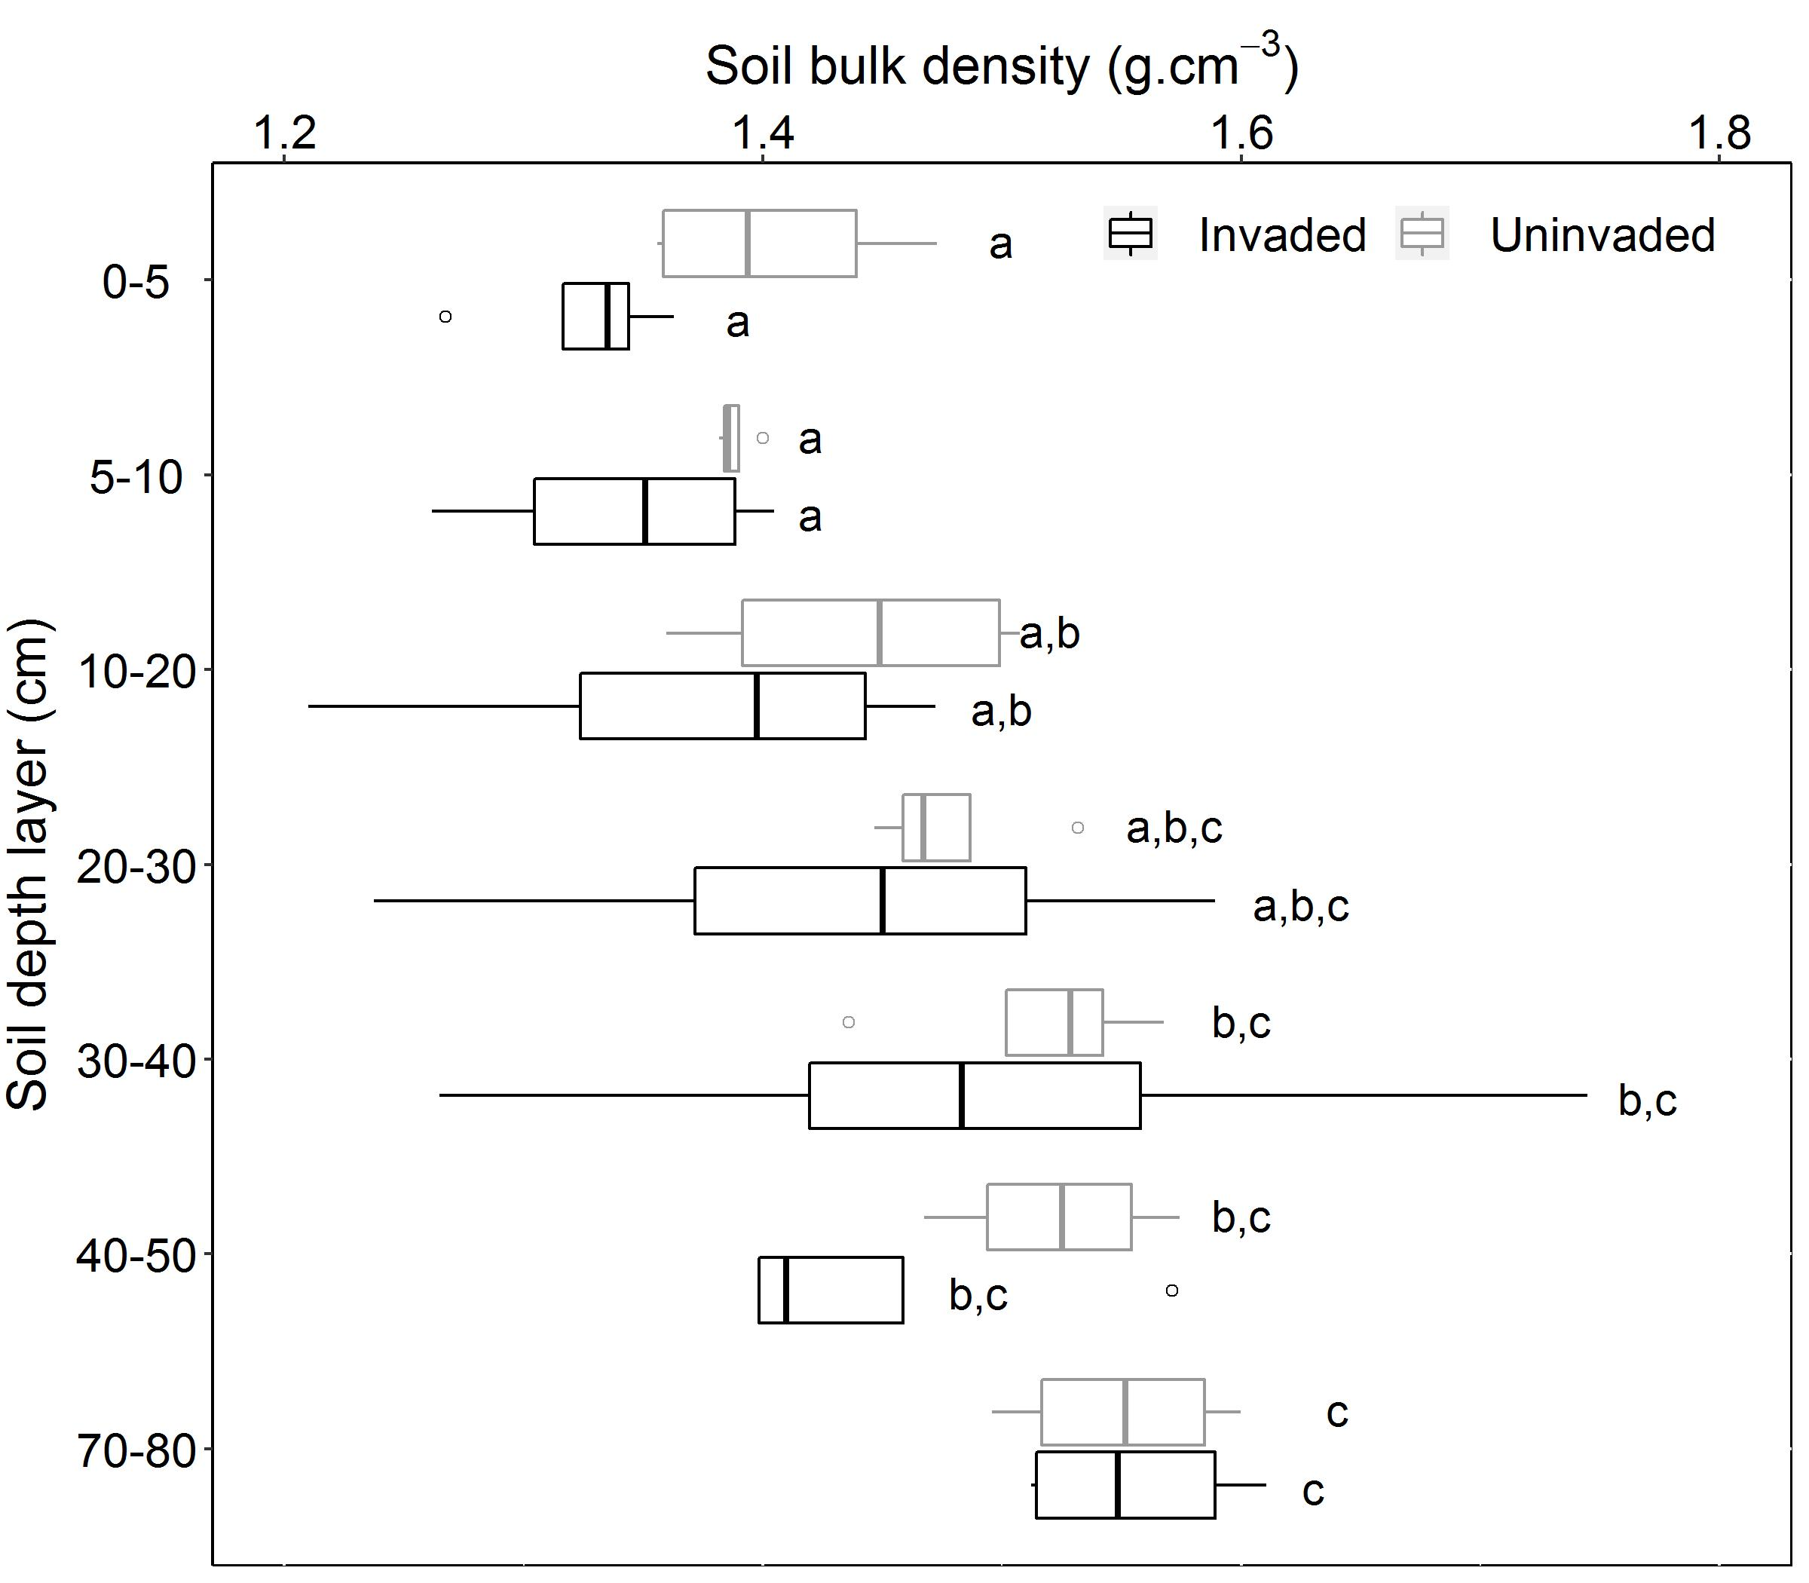

Figure 1S. Variation in soil bulk density along the soil profile in open Cerrado uninvaded and invaded by the African grass Urochloa decumbens. Equal letters indicate absence of significant differences between soil layers in each area based on post-hoc pairwise comparisons (p<0.05).

