NLGN1_P1 | Forward Primer | CATCGTTTGGCTGCACACTA
NLGN1_P1 | Reverse Primer | CTTTCTCTCTAAGCCCCGTT
NLGN1_P2 | Forward Primer | TTCATGCTGCCTACATGCCA
NLGN1_P2 | Reverse Primer | ATTGGCGTTCACATGTCCCT

Table S1: qPCR primer sets of NLGN1 CNV region.

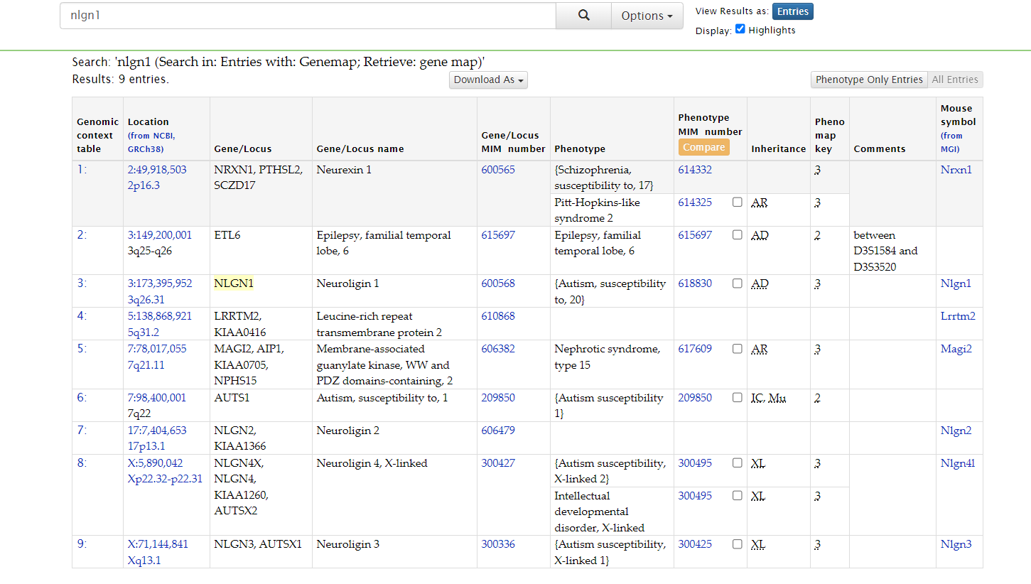

Table S2: The disease annotations of NLGN1 as per the data of OMIM database.

Tissue | PLIER
Choroid | 22.8459
Ciliary body | 19.841
Cornea | 9.73006
Iris | 14.5982
Lens | 21.3038
Optic nerve | 16.4207
Optic nerve head | 21.6341
Retina | 44.3257
Sclera | 19.9611
Trabecular meshwork | 23.5382

Table S3 : NLGN1 expression values in eye tissues ( Source:Ocular Tissue Database).

ID | Tissue | Rank | Decile | log2(TPM + 1)
NLGN1 | Cornea - Stem Cell Endothelium | 3463 | 10 | 10.71638
NLGN1 | RPE - Stem Cell Line | 4011 | 9 | 10.41766
NLGN1 | Cornea - Cell Line Endothelium | 4705 | 9 | 10.37102
NLGN1 | Retina - Adult Tissue AMD MGS 4 | 4026 | 9 | 10.35183
NLGN1 | Retina - Adult Tissue MGS 1 | 4030 | 9 | 10.34373
NLGN1 | Retina - Adult Tissue AMD MGS 2 | 4056 | 9 | 10.33826
NLGN1 | Retina - Adult Tissue AMD MGS 3 | 4094 | 9 | 10.31889
NLGN1 | Retina - 3D Organoid Stem Cell | 4140 | 9 | 10.30817
NLGN1 | Retina - RGC Stem Cell | 4426 | 9 | 10.26331
NLGN1 | RPE - Cell Line | 5685 | 9 | 9.771954
NLGN1 | Retina - Adult Tissue | 6120 | 9 | 9.678226
NLGN1 | Lens - Stem Cell Line | 7526 | 8 | 9.430172
NLGN1 | Brain - Hypothalamus | 7664 | 8 | 9.288239
NLGN1 | Retina - Fetal Tissue | 7356 | 8 | 9.237891
NLGN1 | RPE - Fetal Tissue | 7825 | 8 | 9.177008
NLGN1 | Cornea - Fetal Endothelium | 8008 | 8 | 9.172092
NLGN1 | Brain - Hippocampus | 8200 | 8 | 9.156086
NLGN1 | Brain - Putamen (basal ganglia) | 8114 | 8 | 9.133908
NLGN1 | Brain - Amygdala | 8260 | 8 | 9.105323
NLGN1 | Brain - Frontal Cortex (BA9) | 8320 | 8 | 9.059033
NLGN1 | Brain - Nucleus accumbens (basal ganglia) | 8636 | 8 | 8.961668
NLGN1 | Retina - Fetal Eye | 8433 | 8 | 8.929483
NLGN1 | Brain - Anterior cingulate cortex (BA24) | 8897 | 8 | 8.877174
NLGN1 | Brain - Caudate (basal ganglia) | 9056 | 8 | 8.833887
NLGN1 | Brain - Cerebellar Hemisphere | 9105 | 8 | 8.746781
NLGN1 | Brain - Substantia nigra | 9476 | 8 | 8.715279
NLGN1 | Brain - Cortex | 9305 | 8 | 8.693914
NLGN1 | Brain - Cerebellum | 9236 | 8 | 8.680822
NLGN1 | Brain - Spinal cord (cervical c-1) | 10352 | 8 | 8.350626
NLGN1 | RPE - Adult Tissue | 10463 | 7 | 8.122351
NLGN1 | Cornea - Adult Tissue | 12832 | 7 | 7.326162
NLGN1 | Cornea - Endothelium | 16772 | 6 | 5.602968

Table S4: TPM values and the decile of expression of NLGN1 in ocular and brain tissues, from eyeIntegration.

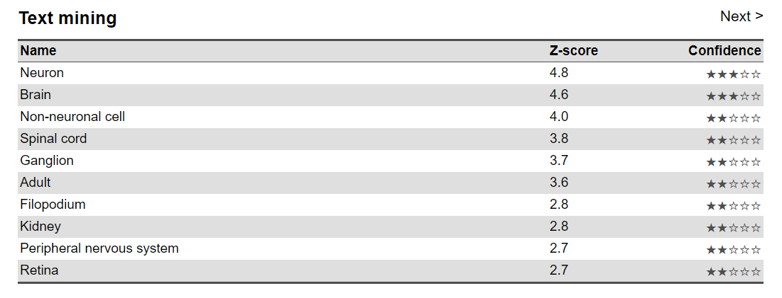
Table S5: NLGN1 gene expression data on TISSUES.
Accession | Term
GO:0007155 | cell adhesion
GO:0007157 | heterophilic cell-cell adhesion via plasma membrane cell adhesion molecules
GO:0007158 | neuron cell-cell adhesion
GO:0007268 | chemical synaptic transmission
GO:0007399 | nervous system development
GO:0007416 | synapse assembly
GO:0016080 | synaptic vesicle targeting
GO:0016339 | calcium-dependent cell-cell adhesion via plasma membrane cell adhesion molecules
GO:0023041 | neuronal signal transduction
GO:0031175 | neuron projection development
GO:0032230 | positive regulation of synaptic transmission, GABAergic
GO:0035418 | protein localization to synapse
GO:0045184 | establishment of protein localization
GO:0045664 | regulation of neuron differentiation
GO:0048488 | synaptic vesicle endocytosis
GO:0048489 | synaptic vesicle transport
GO:0048789 | cytoskeletal matrix organization at active zone
GO:0050804 | modulation of chemical synaptic transmission
GO:0050808 | synapse organization
GO:0051491 | positive regulation of filopodium assembly
GO:0051965 | positive regulation of synapse assembly
GO:0051968 | positive regulation of synaptic transmission, glutamatergic
GO:0060291 | long-term synaptic potentiation
GO:0060999 | positive regulation of dendritic spine development
GO:0061002 | negative regulation of dendritic spine morphogenesis
GO:0071277 | cellular response to calcium ion
GO:0072553 | terminal button organization
GO:0097091 | synaptic vesicle clustering
GO:0097104 | postsynaptic membrane assembly
GO:0097105 | presynaptic membrane assembly
GO:0097113 | AMPA glutamate receptor clustering
GO:0097114 | NMDA glutamate receptor clustering
GO:0097115 | neurexin clustering involved in presynaptic membrane assembly
GO:0097119 | postsynaptic density protein 95 clustering
GO:0097120 | receptor localization to synapse
GO:0098698 | postsynaptic specialization assembly
GO:0098942 | retrograde trans-synaptic signaling by trans-synaptic protein complex
GO:0099054 | presynapse assembly
GO:0099174 | regulation of presynapse organization
GO:0099560 | synaptic membrane adhesion
GO:0140058 | neuron projection arborization
GO:1900029 | positive regulation of ruffle assembly
GO:1900244 | positive regulation of synaptic vesicle endocytosis
GO:1902474 | positive regulation of protein localization to synapse
GO:1902533 | positive regulation of intracellular signal transduction
GO:1904861 | excitatory synapse assembly
GO:1905520 | positive regulation of presynaptic active zone assembly
GO:2000302 | positive regulation of synaptic vesicle exocytosis
GO:2000310 | regulation of NMDA receptor activity
GO:2000311 | regulation of AMPA receptor activity
GO:2000463 | positive regulation of excitatory postsynaptic potential
GO:2000809 | positive regulation of synaptic vesicle clustering

Table S6: CNVs identified in genomic region of chr3:173239453-173289281, from Database of Genomic Variants (dbVar)

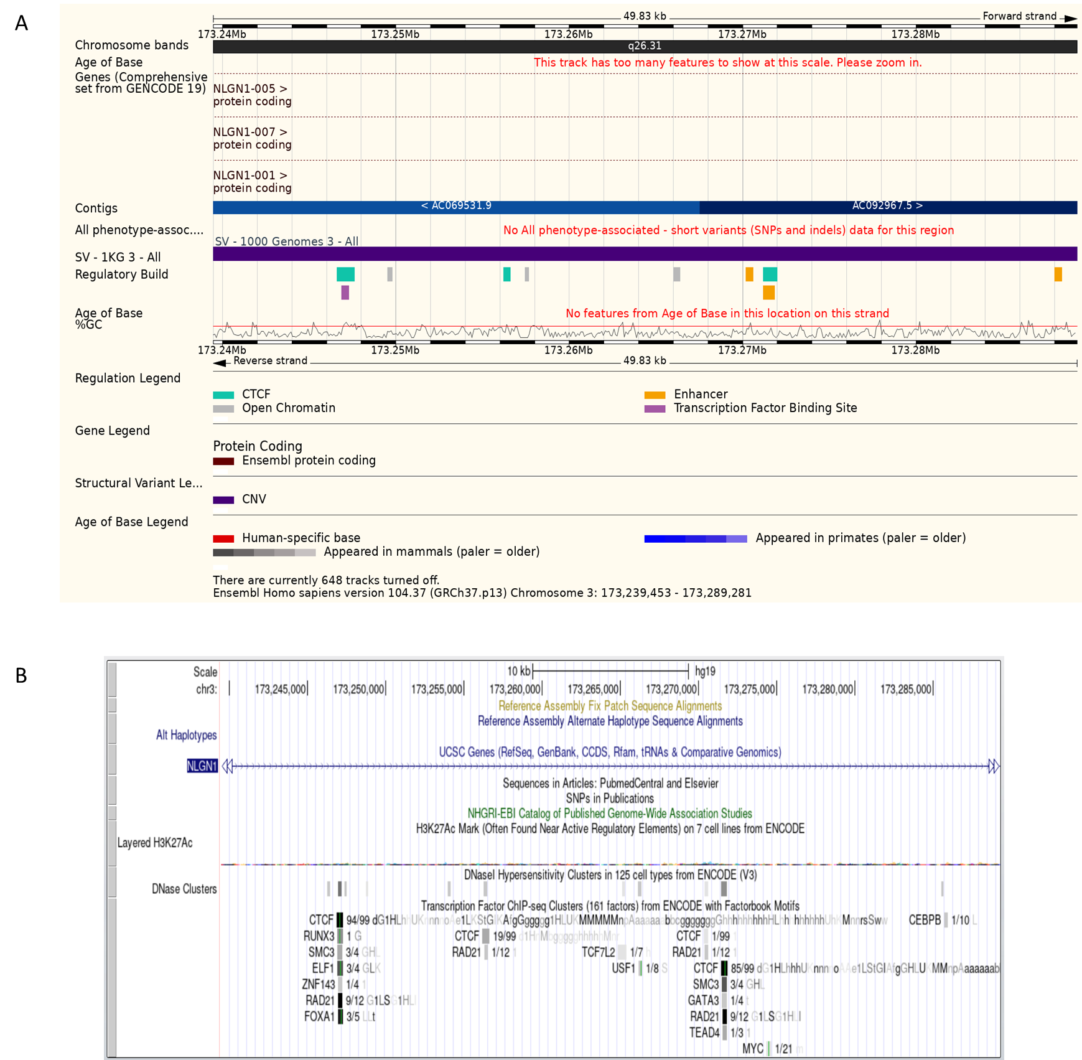

Figure S1A: CNVs identified in genomic region of0 chr3:173239453-173289281, from Ensembl genome browser B. CNVs identified in genomic region of chr3:173239453-173289281, from UCSC genome browser

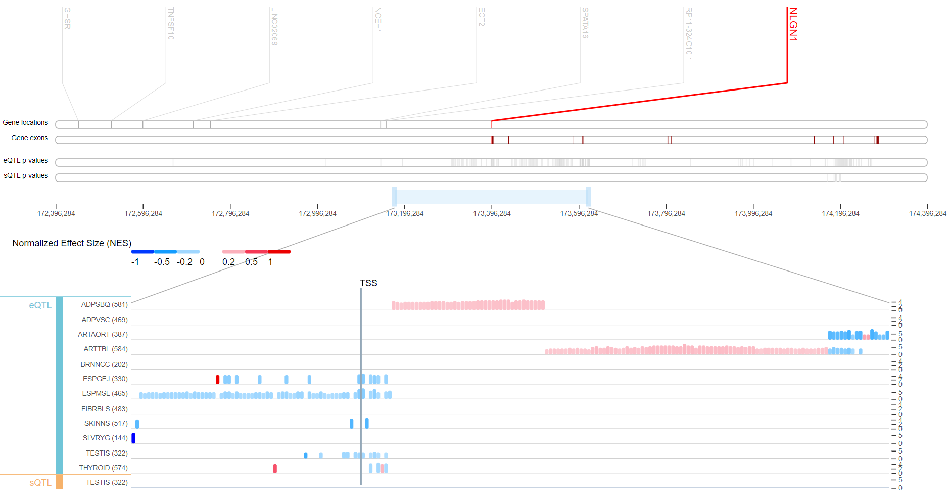

Figure S2: GTEx Locus Browser for the gene NLGN1 to check the gene regulatory features.

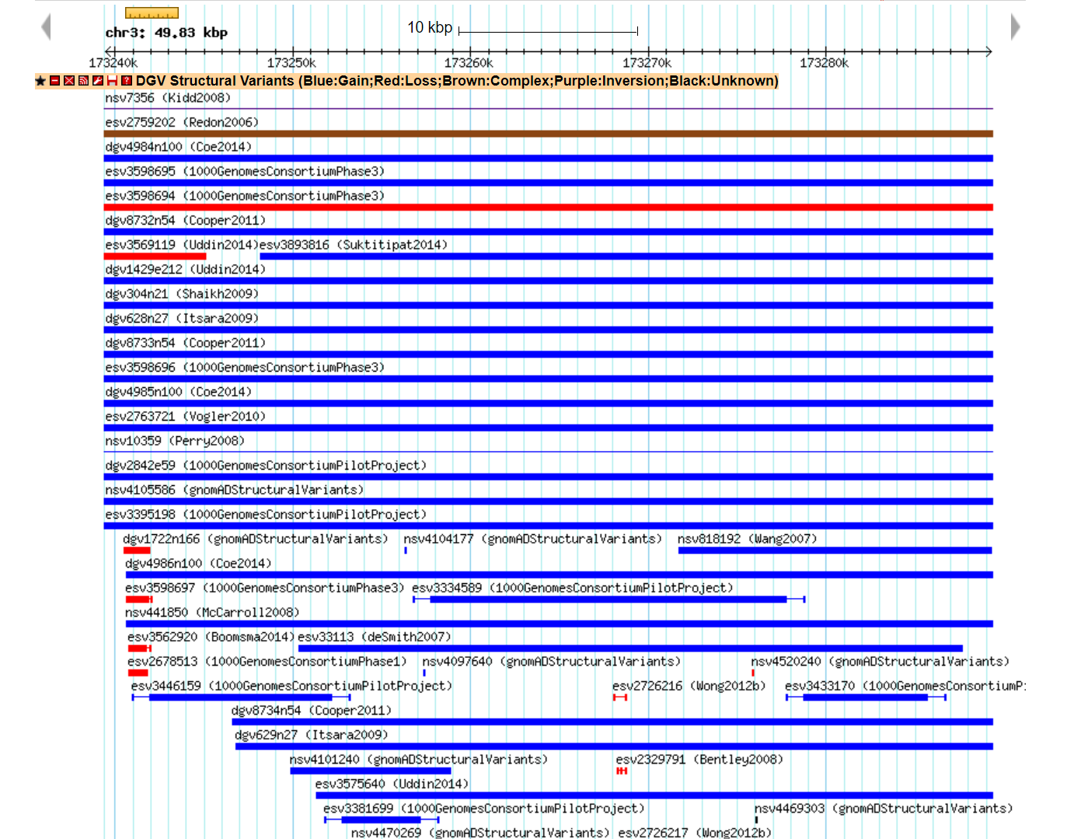
Figure S3: CNVs identified in genomic region of chr3:173239453-173289281, from Database of Genomic Variants (dbVar)
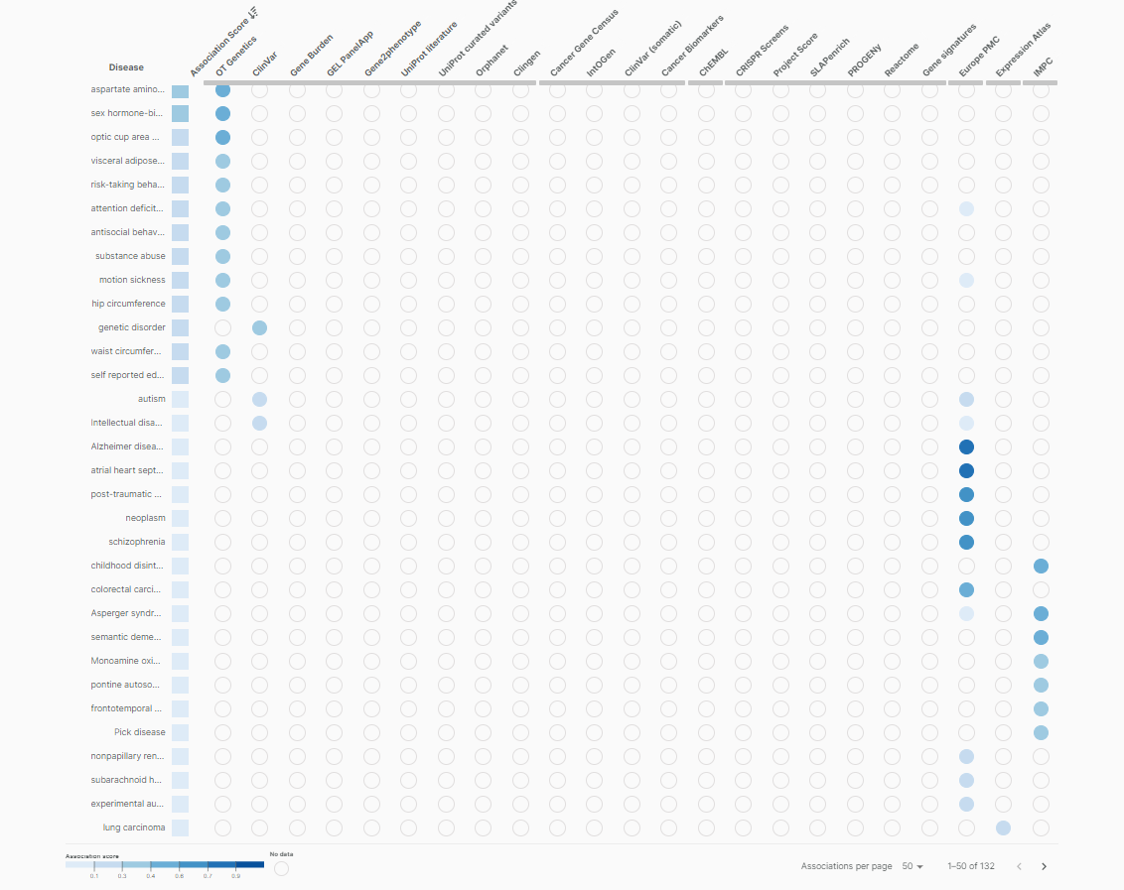
Figure S4: Open Target Platform shows disease associations with NLGN1.

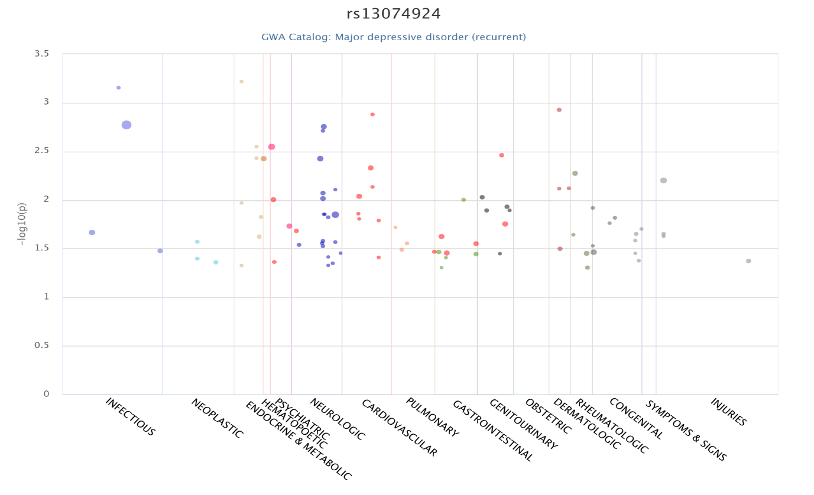
Figure S5: The disease annotations of NLGN1 as per the data of PheWAS catalog.

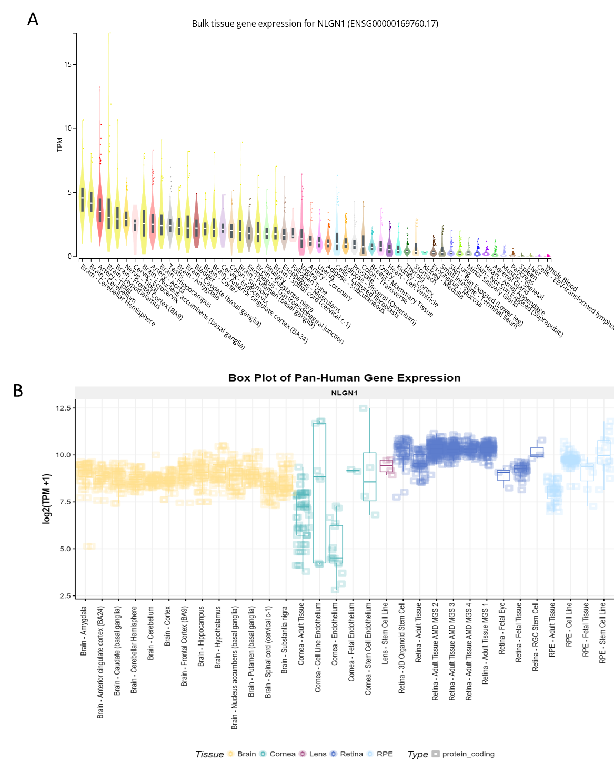

Figure S6 A: NLGN1 expression status in whole body tissues (Source: GTeX portal) B. NLGN1 expression status in ocular tissues in comparison to brain tissues, from eyeIntegration.

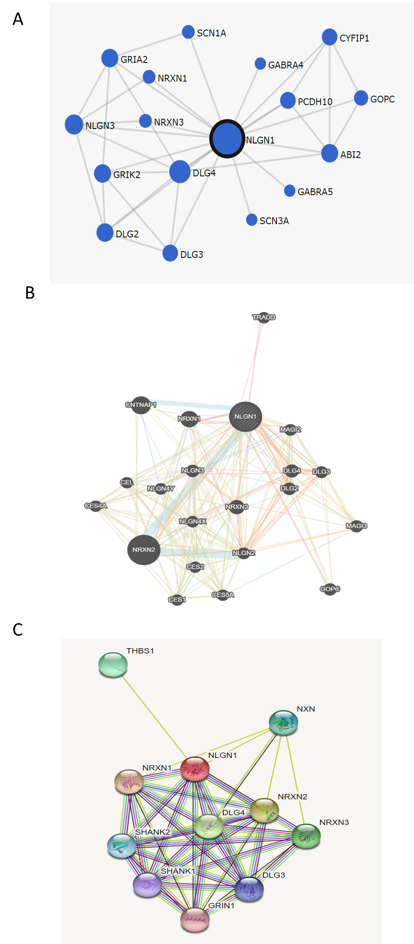

Figure S7: Gene interactions network of NLGN1 in different databases, A. FunCoup B. GeneMANIA C. STRING.

