Supplementary Information

Table S1: Predicted daily BMR and the proportion of the population for individuals or groups of both sexes
Predicted daily BMR | Infants & children |  | Ages 10–18 y. and over 30 kg |  |  | Adults |  |  | Data source
Predicted daily BMR | Wt (kg) | MJ | Wt (kg) | Boys | Girls | Wt (kg) | Men | Women | J.V.G.A. Durnin (1981)
 |  |  |  | MJ | MJ | Wt (kg) | MJ | MJ | J.V.G.A. Durnin (1981)
Predicted daily BMR | 14.65±7.65 | 2.93±1.24 | 51±11.53 | 6.25±0.71 | 5.77±0.53 | 65±11.53 | 6.68±0.92 | 6.03±0.85 | J.V.G.A. Durnin (1981)
Population (%) |  | 17.52 |  | 8.39 | 7.84 |  | 32.98 | 33.27 | The World Bank (data in 2015)

Table S2: Original parameters of BMR for all kinds of species
Taxon | Body weight  (g) | BMR  (ml O₂ g⁻¹ h⁻¹) | References
horse | 260000 | 0.25 | M. A. Elgar and P. H. Harvey (1987)
pig | 75000 | 0.11 | M. A. Elgar and P. H. Harvey (1987)
cattle/buffalo | 272000 | 0.17 | M. A. Elgar and P. H. Harvey (1987)
goat | 36000 | 0.19 | M. A. Elgar and P. H. Harvey (1987)
sheep | 30000 | 0.34 | M. A. Elgar and P. H. Harvey (1987)
poultry | 862.3* | 2.50* | B. M. Freeman (1963)
* Body weight is the average of different breeding ages and gender. The BMR is the average of different ages.

Table S3: Comparison of cattle production from GLW and national census.
cattle | GLW | census | source
Beijing (10000 head) | 547.0 | 31.8 | National Agriculture Census in China
Shanghai (10000 head) | 6.4 | 6.8 | National Agriculture. Census in China
Delhi (10000 head) | 9.9 | 8.2 | 19 Livestock Census-2012 All India Report
São Paulo (head) | 413.0 | 500.0 | Produção da Pecuária Municipal - 2014 source, Istituto Brasileiro de Geografia e Estatistica,
* To be consistent with GLW, the census statistic data comes from national census 2010.

Table S4: Comparison of livestock production in Beijing
Production (10000 head) | GLW | census
pig | 219.0 | 494.0
chicken/duck | 1074.0 | 11774.0
sheep/goat | 158.4 | 60.6
cattle | 547.0 | 31.8
horse | 0.3 | 0.2
* The census statistic data coms from National Bureau of Statistics of China 2010.

Table S5. Compare the carbon release from respiration within urban and suburban.
City or metropolitan region | City area |  | Total respiration |  | Human |  | Livestock
City or metropolitan region | Urban (%) | Suburban (%) | Urban (%) | Suburban (%) | Urban (%) | Suburban (%) | Urban (%) | Suburban (%)
Bangkok | 75.0 | 25.0 | 93.4 | 6.6 | 93.5 | 6.5 | 56.9 | 43.1
Beijing | 20.1 | 79.9 | 66.7 | 33.3 | 81.3 | 18.7 | 15.0 | 85.0
Cape Town | 30.3 | 69.7 | 82.0 | 18.0 | 83.0 | 17.0 | 30.7 | 69.3
Delhi | 84.2 | 15.8 | 91.0 | 9.0 | 91.3 | 8.7 | 86.0 | 14.0
Greater London | 93.8 | 6.2 | 99.3 | 0.7 | 99.4 | 0.6 | 89.6 | 10.4
Greater Paris | 27.4 | 72.6 | 88.7 | 11.3 | 89.7 | 10.3 | 49.4 | 50.6
Greater Toronto | 24.8 | 75.2 | 79.9 | 20.1 | 82.4 | 17.6 | 12.1 | 87.9
Los Angeles | 35.7 | 64.3 | 96.2 | 3.8 | 96.7 | 3.3 | 33.4 | 66.6
Manhattan | 72.5 | 27.5 | 91.4 | 8.6 | 91.4 | 8.6 | 69.6 | 30.4
New York | 91.5 | 8.5 | 98.3 | 1.7 | 98.3 | 1.7 | 87.5 | 12.5
Sao Paulo | 69.8 | 30.2 | 99.0 | 1.0 | 99.1 | 0.9 | 71.5 | 28.5
Shanghai | 51.3 | 48.7 | 86.1 | 13.9 | 88.0 | 12.0 | 45.5 | 54.5
Tokyo | 71.8 | 28.2 | 97.5 | 2.5 | 97.5 | 2.5 | 77.5 | 22.5
Washington DC | 92.1 | 7.9 | 99.6 | 0.4 | 99.6 | 0.4 | 94.0 | 6.0

Table S6. CO₂ emission from individual from literatures.
Value  kg C yr⁻¹ | Notes of source parameter | reference
52.96 ± 0.43 | For all ages and genders. | West, 2009
99.5 | Typically 1 kg CO₂ day⁻¹ | Bréon et al., 2014
79.0 |  | Zhao et al., 2014
92.7 | Average of 254 g C day⁻¹. | Gurney et al., 2017
76.3 | 8.87 mg CO₂ s⁻¹ per person. | Christen et al., 2010
138.0 | 31.5 mol CO₂ day⁻¹. Assuming an average person weighs 70 kg, metabolic rate is about 2 times of resting, and only metabolize carbohydrate. | Koerner and Klopatek, 2002
160.1 | 1.61 kg of CO₂ day⁻¹ | Huang et al., 2018

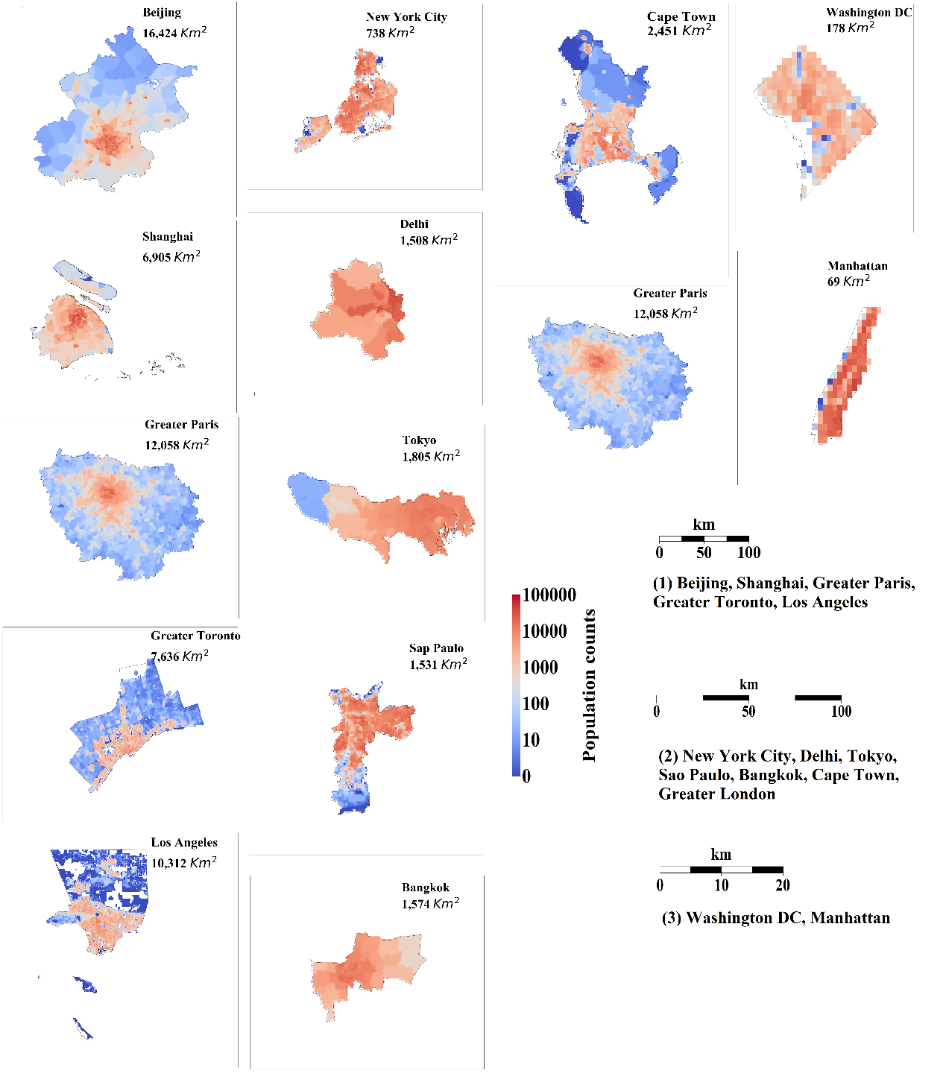
Figure S1. Population counts in 14 cities and metropolitan regions in 2010 at a resolution of 1km based on the GPW high-resolution datasets. Three scale bars were included in this distribution. Scale bar (1) corresponds to Beijing, Shanghai, Greater Paris, Greater Toronto and Los Angeles; scale bar (2) to New York City, Delhi, Tokyo, Sao Paulo, Bangkok, Cape Town and Greater London; scale bar (3) to Washington D.C. and Manhattan.

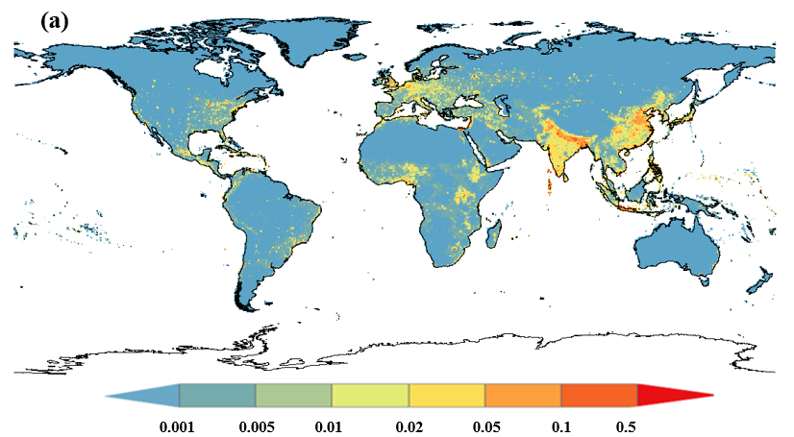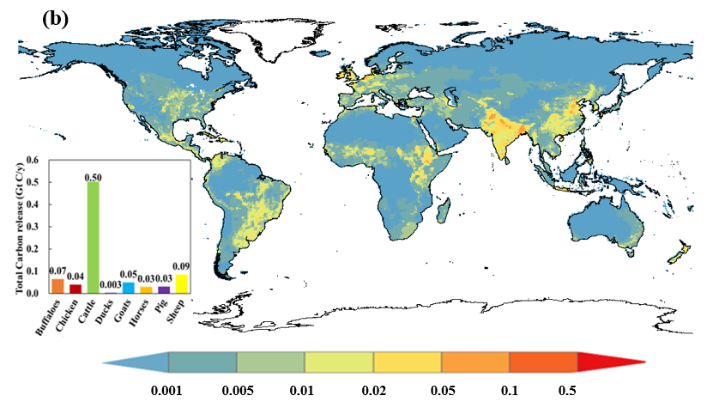
Figure S2. The spatial distribution of carbon release from (a) human and (b) livestock respiration (kg C m⁻² yr⁻¹). The bar graph in (b) shows the global total carbon output (Gt C yr⁻¹) from each species of livestock in 2010.

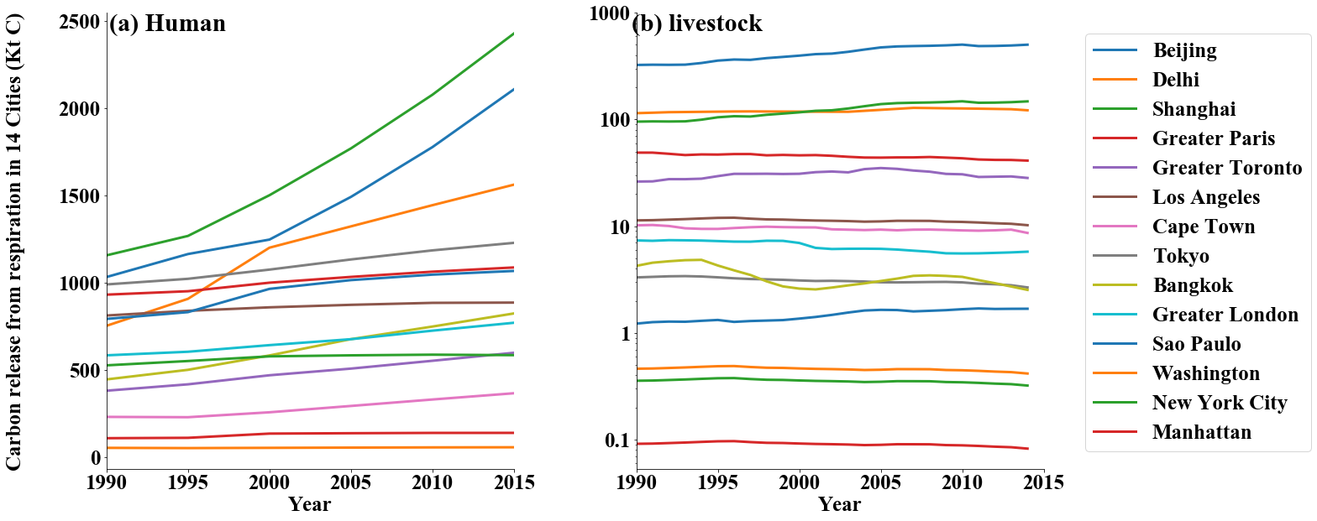
Figure S3. Variation of carbon emission from (a) human and (b) livestock respiration in 14 cities (Kt C yr⁻¹). The value of carbon emission from animal is presented in Figure (a) with a logarithmic scale along the y-axis.

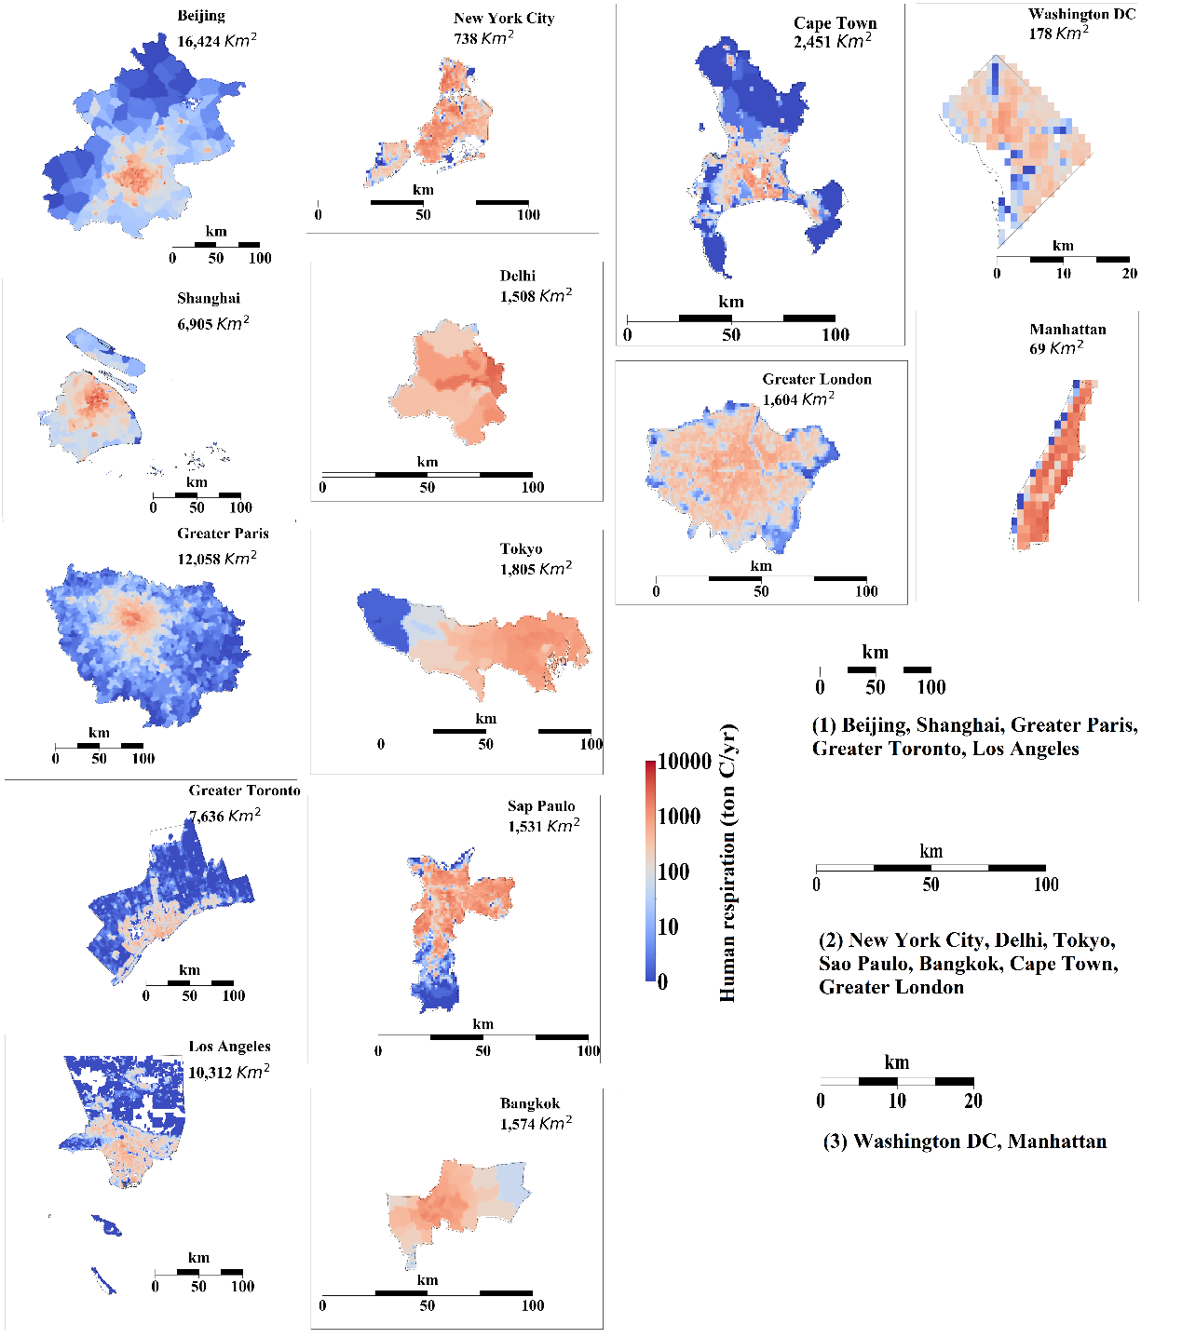
Figure S4. Carbon release from human respiration in 14 cities and metropolitan regions in 2010. Three scale bars were included in this distribution. Scale bar (1) corresponds to Beijing, Shanghai, Greater Paris, Greater Toronto and Los Angeles; scale bar (2) to New York City, Delhi, Tokyo, Sao Paulo, Bangkok, Cape Town and Greater London; scale bar (3) to Washington D.C. and Manhattan.

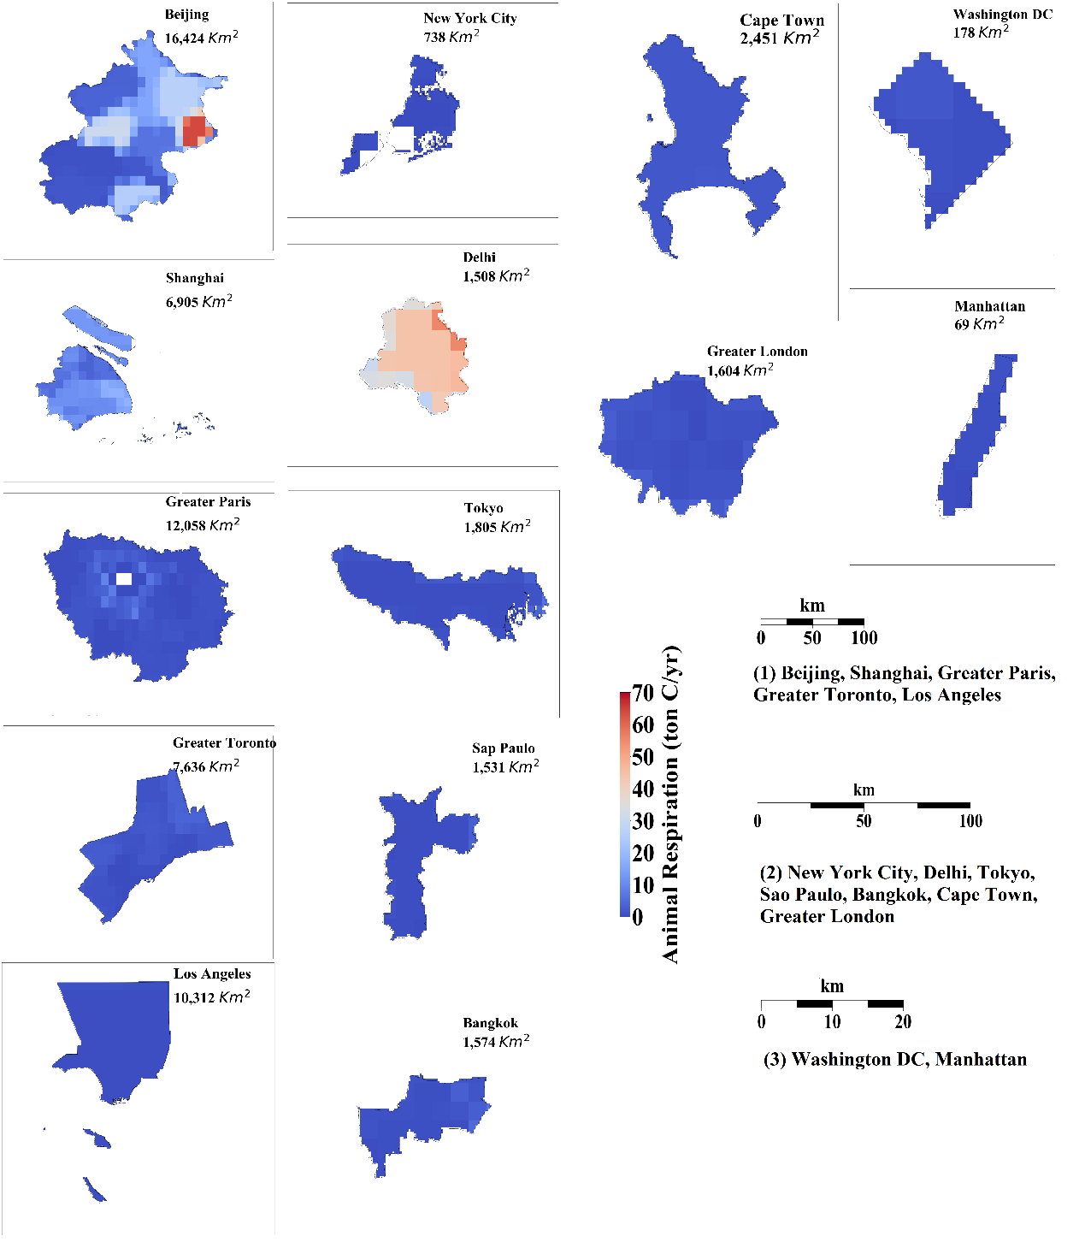
Figure S5. Carbon release from animal respiration in 14 cities and metropolitan regions in 2010. Three scale bars were included in this distribution. Scale bar (1) corresponds to Beijing, Shanghai, Greater Paris, Greater Toronto and Los Angeles; scale bar (2) to New York City, Delhi, Tokyo, Sao Paulo, Bangkok, Cape Town and Greater London; scale bar (3) to Washington D.C. and Manhattan.

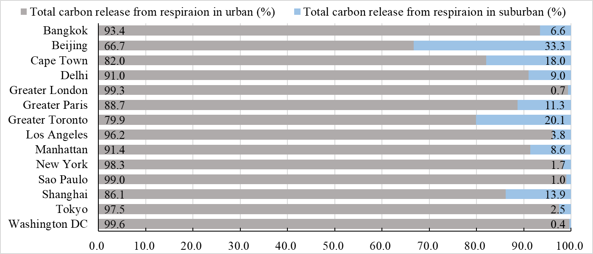
Figure S6. The proportions of total HLR in urban and suburban areas (in %). The values beside the left side of the bar are the proportions of CO₂ from urban areas, and the values beside the right side of the bar are the proportions of CO₂ from suburban areas.

Figure S7. The ratio of total CO₂ release from human and livestock respiration to fossil fuel emissions (in %). (a) The urban areas with ratio larger than 10%. (b) The urban areas with ratio less than 10%.

