Supporting information
Nanodiamond embedded tungsten disulfide nanosheets for electrochemical detection of a bacterial metabolite pyocyanin
S. Keerthana, K.P.Divya, A. Rajapriya, C. Viswanathan and N. Ponpandian*
Department of Nanoscience and Technology, Bharathiar University, Coimbatore 641046, India.

S1. CV analysis for the calculation of ESA
The analytical performance of the electrodes is initially studied to know the conductivity and electrochemical surface area of the material. The CV was examined for bare GCE, WS₂ NSs/GCE, ND/GCE and WS₂ NSs-ND/GCE in the presence of 5 mM of [Fe(CN₆)]^{3-/4-} containing 0.1 M of KCl solution at the constant scan rate of 50 mVs⁻¹ and its shown in Fig. S1A. All modified electrodes show a well-shaped redox peak and WS₂ NSs-ND/GCE offers the highest current density of all the modified electrodes due to its higher electron transfer kinetics arising from the greater active sites present in the material. Moreover, the performance of the scan rate analysis has great significance in the diffusion controlled or the absorption-controlled process and the WS₂ NSs-ND/GCE was studied at various scan rates ranging from 20 to 200 mVs⁻¹ (Fig. S1B), displaying enhanced peak current in both the anodic and cathodic areas. The linearity curve of WS₂ NSs- ND/GCE of the square root of scan rate vs. the current density obtained is shown in Fig. S1C The catalytic performance of the electrode material is influenced by the effective active surface area, which drives the electron transfer process of the materials. The active surface area was calculated by Randel’s- Sevcik equation,
$$I_{p}={(2.69×10}^{5}) n^{3/2} {AD}^{1/2 }{Cv}^{1/2}$$
$I_{p}$ it belongs to the peak current, A- signifies the electroactive area, C is the concentration of [Fe(CN₆)]³⁻/⁴⁻, and D denotes the diffusion co-efficient ($7.20 ×{10}^{-6 }{cm}^{2} s^{-1})$, n- is the number of electrons involved in the redox process and v represents the scan rate. The effective surface area (ESA) of bare GCE, WS₂/GCE, ND/GCE and WS₂-ND/GCE was calculated and depicted in Fig. 3B.
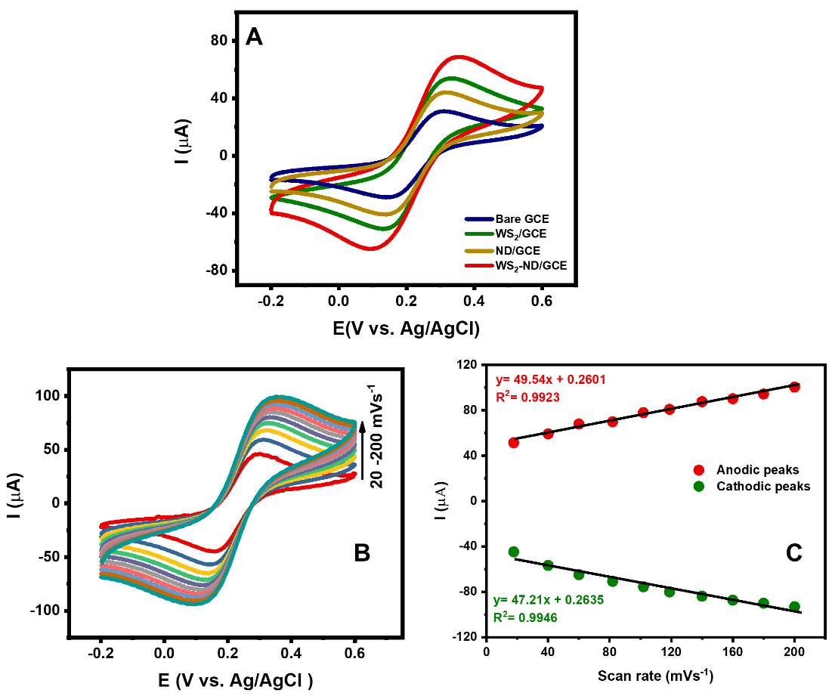
Fig S1. A) CV analysis of modified electrodes in 0.1 M KCl in 0.1 M Fe[CN]₆)^{3-/4-} B) CV analysis of WS₂-ND/GCE at various scan rate (20-200 mV s⁻¹) C) calibration plot between scan rate vs. current.

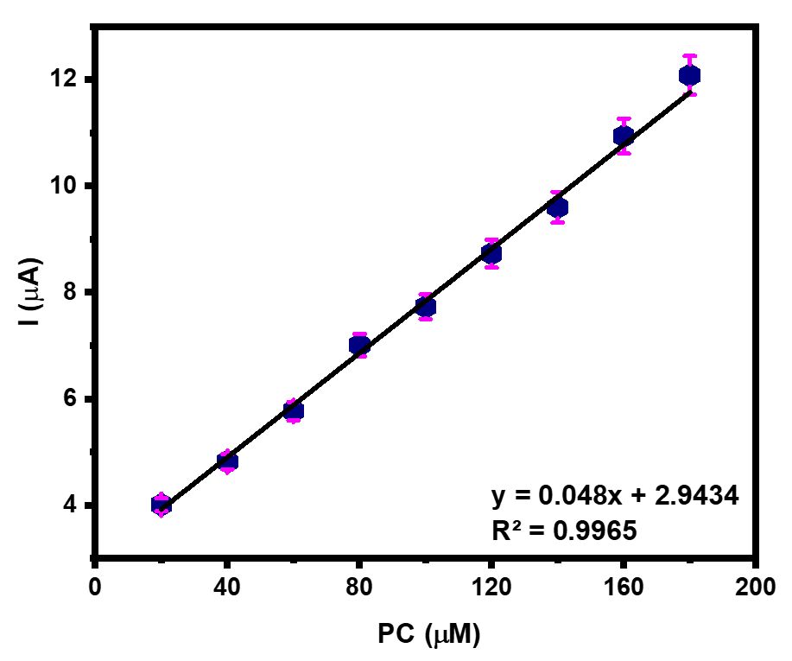
Fig. S2. calibration plot between concentration of PYO vs. current density

