Table 1
Data Training | Total | Data Testing | Total
Stage 2 | 36 | Stage 2 | 8
Stage 3 | 12 | Stage 3 | 6
Stage 4 | 28 | Stage 4 | 6

Table 2
Wound Stage | H | S | L | A | B
Stage 2 | 0.15 | 0.45 | 0.60 | 0.30 | 0.20
Stage 3 | 0.25 | 0.50 | 0.50 | 0.35 | 0.25
Stage 4 | 0.35 | 0.55 | 0.40 | 0.40 | 0.30

Table 3
Wound Stage | Overall Accuracy | F1-Score | Precision | Recall
Stage 2 | 85% | 0.94 | 1.00 | 0.89
Stage 3 | 85% | 0.77 | 0.71 | 0.83
Stage 4 | 85% | 0.80 | 0.80 | 0.80

Table 4
Wound Stage | Accuracy | F1-Score | Precision | Recall
SVM | 85% | 0.93 | 1.00 | 0.89
Decision Tree | 50% | 0.51 | 0.51 | 0.50
Logistic Regression | 70% | 0.77 | 0.71 | 0.83

Table 5
No. | Aspects | Our System | (Shaik et al., 2015) | (Reiter et al., 2006)
1 | Accuracy | The accuracy of wound depth measurement reaches 85% | The accuracy of wound depth measurement reaches 80% | The accuracy of wound depth measurement reaches 70%
2 | Flexibility | The measurement results are not affected by the distance from which the images are taken | The measurement results are not affected by the distance from which the images are taken | The measurement results are not affected by the distance from which the images are taken
3 | Application | On the wound object | On the skin object | On the face object
4 | Method | Color Manipulation | Color Manipulation | 3D Reconstruction

Table 6
Image | Actual Stage | Prediction Stage | Result
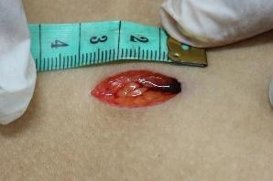 | Stage 4 | Stage 4 | Correctly Classified
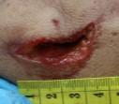 | Stage 3 | Stage 4 | Misclassified

