Supplementary Materials

Table of Contents
Supplementary Materials 1
1. Coordinate refinement of segmental duplication pairs 2
2. Data Preparation 5
3. Identifying homologous counterparts based on Dijkstra's algorithm 7
4. Precise tracking of the homologous counterparts of functional coding regions 9
5. Preparation of genome contigs for realignment 10
6. Graph-based phasing 10
7. Misalignment Identification with Binary Integer Linear Constraint Programming 14
8. Preparations for benchmarking 17
9. Mapping quality distribution shift 19
10. False duplication identification 19
References 21

1. Coordinate refinement of segmental duplication pairs
The map constructed by Whole-Genome Assembly Comparison (WGAC)[1] cataloged all segmental duplications (SDs) identified in a reference genome as numerous SD pairs. Although SD pairs share substantial sequence similarity (>90%) and are considerably long (>1kb), they seem to include sub-segments with high local mismatch rates that are sufficiently different to avoid mapping ambiguity. To identify such regions within the SD pairs, minimap2 [2] was used to align SDs against their paired counterparts, generating alignments CIGAR strings that differentiate mismatches (“X”) from matches (“=”) in the resulting Sequence Alignment Map (SAM). The CIGAR strings are then used to calculate local mismatch rates (LMRs) for every base in a 41-bp window centered by each base. The LMRs are calculated as the total size of mismatches and gaps (total editing distances) within the 41-bp windows divided by the window size. Segments within the alignments with LMRs < 30% are selected as candidate regions for SDrecall, leaving the rest segments eliminated for downstream analysis (Figure 2B). The remaining paired SD segments are illustrated by a circle chart in the upper panel of Supplementary Fig1. The refinement process leads to an increased average sequence similarity between SD pairs and a decreased average size of SD pairs, as shown in Supplementary Fig 2. Subsequently, the remaining SD pairs are used to build a multiplex network to catalog all the SDs across the reference genome comprehensively. SD pairs defined by WGAC [3, 4] are available from the links below:
GRCh37: https://hgdownload.soe.ucsc.edu/goldenPath/hg19/database/genomicSuperDups.txt.gz
GRCh38: https://hgdownload.soe.ucsc.edu/goldenPath/hg38/database/genomicSuperDups.txt.gz

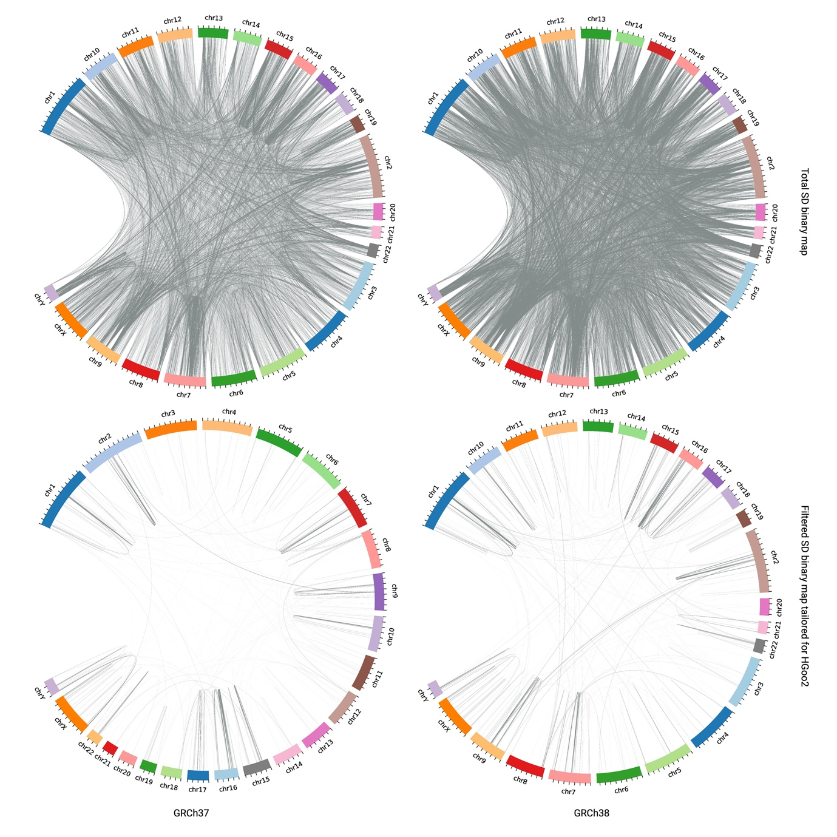
Supplementary Fig.1. Genomic representation of segmental duplications (SDs) in GRCh37 (left) and GRCh38 (right). SD pairs illustrated in the upper panel are obtained after coordinate refinement. SD pairs displayed in the lower panel are a subset of SD pairs corresponding to the upper panel after selecting the SD pairs that are covered by at least one read regardless of the mapping qualities and the SD pairs that are larger than the average fragment size of the HG002 alignment file.

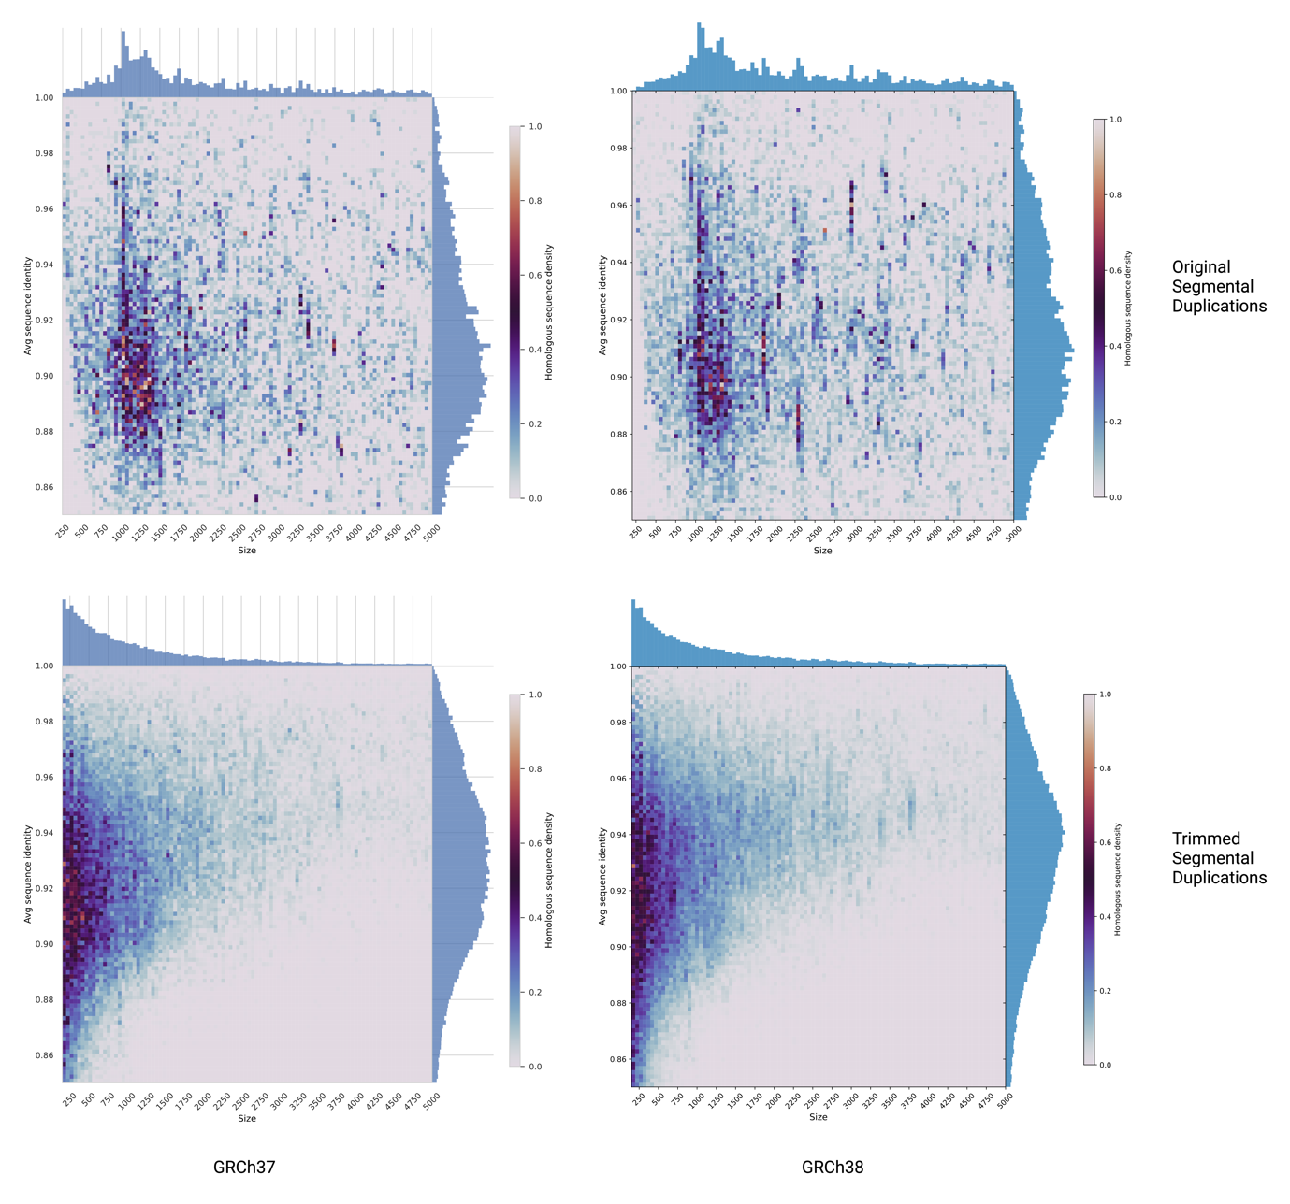
Supplementary Fig 2. The distribution of segmental duplication pair size and sequence similarity before (upper panel) and after (lower panel) the refinement on sequence similarities of the binary SD map from whole genome assembly comparison.

2. Data Preparation
To test the efficacy of SDrecall, we applied SDrecall to 6 samples from the Genome-In-A-Bottle project (GIAB). GIAB has provided for each sample both the next-generation sequencing (NGS) data and the curated short variant callset derived from multiple sequencing technologies, including third-generation sequencing (TGS), linked short reads sequencing, and NGS. The six samples consist of two trio families: HG002, HG003, and HG004 represent the Ashkenazi Jewish trio, while HG005, HG006, and HG007 belong to the Chinese trio. For all six samples, we downloaded the whole genome sequencing (WGS) paired-end short-read Binary Sequence Alignment Map (BAM) files generated by novoalign (https://www.novocraft.com/products/novoalign). Sequencing parameters vary across samples and reference assemblies and are listed in Supplementary Table 1. While the average read depth and read length are provided by the GIAB official documents, the average fragment size and standard deviation of fragment sizes are calculated by Samtools [5] stats. The downloading links of the 6 novoalign generated BAM files are listed below:
HG002:
GRCh37: ftp://ftp-trace.ncbi.nlm.nih.gov/ReferenceSamples/giab/data/AshkenazimTrio/HG002_NA24385_son/NIST_HiSeq_HG002_Homogeneity-10953946/NHGRI_Illumina300X_AJtrio_novoalign_bams/HG002.hs37d5.300x.bam
GRCh38: ftp://ftp-trace.ncbi.nlm.nih.gov/ReferenceSamples/giab/data/AshkenazimTrio/HG002_NA24385_son/NIST_HiSeq_HG002_Homogeneity-10953946/NHGRI_Illumina300X_AJtrio_novoalign_bams/HG002.GRCh38.300x.bam
HG003:
GRCh37: ftp://ftp-trace.ncbi.nlm.nih.gov/ReferenceSamples/giab/data/AshkenazimTrio/HG003_NA24149_father/NIST_HiSeq_HG003_Homogeneity-12389378/NHGRI_Illumina300X_AJtrio_novoalign_bams/HG003.hs37d5.300x.bam
GRCh38: ftp://ftp-trace.ncbi.nlm.nih.gov/ReferenceSamples/giab/data/AshkenazimTrio/HG003_NA24149_father/NIST_HiSeq_HG003_Homogeneity-12389378/NHGRI_Illumina300X_AJtrio_novoalign_bams/HG003.GRCh38.300x.bam
HG004:
GRCh37: ftp://ftp-trace.ncbi.nlm.nih.gov/ReferenceSamples/giab/data/AshkenazimTrio/HG004_NA24143_mother/NIST_HiSeq_HG004_Homogeneity-14572558/NHGRI_Illumina300X_AJtrio_novoalign_bams/HG004.hs37d5.300x.bam
GRCh38: ftp://ftp-trace.ncbi.nlm.nih.gov/ReferenceSamples/giab/data/AshkenazimTrio/HG004_NA24143_mother/NIST_HiSeq_HG004_Homogeneity-14572558/NHGRI_Illumina300X_AJtrio_novoalign_bams/HG004.GRCh38.300x.bam
HG005:
GRCh37: ftp://ftp-trace.ncbi.nlm.nih.gov/ReferenceSamples/giab/data/ChineseTrio/HG005_NA24631_son/HG005_NA24631_son_HiSeq_300x/NHGRI_Illumina300X_Chinesetrio_novoalign_bams/HG005.hs37d5.300x.bam
GRCh38: ftp://ftp-trace.ncbi.nlm.nih.gov/ReferenceSamples/giab/data/ChineseTrio/HG005_NA24631_son/HG005_NA24631_son_HiSeq_300x/NHGRI_Illumina300X_Chinesetrio_novoalign_bams/HG005.GRCh38_full_plus_hs38d1_analysis_set_minus_alts.300x.bam
HG006:
GRCh37: ftp://ftp-trace.ncbi.nlm.nih.gov/ReferenceSamples/giab/data/ChineseTrio/HG006_NA24694-huCA017E_father/NA24694_Father_HiSeq100x/NHGRI_Illumina100X_Chinesetrio_novoalign_bams/HG006.hs37d5.100x.bam
GRCh38: ftp://ftp-trace.ncbi.nlm.nih.gov/ReferenceSamples/giab/data/ChineseTrio/HG006_NA24694-huCA017E_father/NA24694_Father_HiSeq100x/NHGRI_Illumina100X_Chinesetrio_novoalign_bams/HG006.GRCh38_full_plus_hs38d1_analysis_set_minus_alts.100x.bam
HG007:
GRCh37: ftp://ftp-trace.ncbi.nlm.nih.gov/ReferenceSamples/giab/data/ChineseTrio/HG007_NA24695-hu38168_mother/NA24695_Mother_HiSeq100x/NHGRI_Illumina100X_Chinesetrio_novoalign_bams/HG007.hs37d5.100x.bam
GRCh38: ftp://ftp-trace.ncbi.nlm.nih.gov/ReferenceSamples/giab/data/ChineseTrio/HG007_NA24695-hu38168_mother/NA24695_Mother_HiSeq100x/NHGRI_Illumina100X_Chinesetrio_novoalign_bams/HG007.GRCh38_full_plus_hs38d1_analysis_set_minus_alts.100x.bam

Sequencing Parameter | Assembly | HG002 | HG003 | HG004 | HG005 | HG006 | HG007
Avg Read length (bp) | GRCh37 | 150 | 150 | 150 | 250 | 150 | 150
Avg Read length (bp) | GRCh38 | 150 | 150 | 150 | 250 | 150 | 150
Avg Fragment length (bp) | GRCh37 | 570.4 | 568.0 | 565.5 | 589.0 | 566.1 | 562.6
Avg Fragment length (bp) | GRCh38 | 592.6 | 588.7 | 578.4 | 705.7 | 577.4 | 589.2
Std Fragment length (bp) | GRCh37 | 150.7 | 143.8 | 142.2 | 158.4 | 144.5 | 138.5
Std Fragment length (bp) | GRCh38 | 322.5 | 312.3 | 229.5 | 895.8 | 211.8 | 355.4
Avg Depth | GRCh37 | 300x | 300x | 300x | 300x | 100x | 100x
Avg Depth | GRCh38 | 300x | 300x | 300x | 300x | 100x | 100x
Supplementary Table 1. The sequencing profiles of 6 samples from the Genome-In-A-Bottle project.
Given the huge data size and uncommon read depth of the downloaded original alignment file, for a focused analysis of SD region variants, we extracted all read pairs mapped to SD regions described by the WGAC. Then, to mimic a common sequencing library, the extracted reads were randomly downsampled to ~30X by Samtools. The downsampled reads were then extracted as FASTQ files using Samtools fastq and realigned to the reference genome using BWA-MEM[6], which tagged multi-aligned reads as XA or XS. The resulting alignment files are then used for subsequent alignment manipulation and variant detection.

3. Identifying homologous counterparts based on Dijkstra's algorithm
To avoid redundant and unnecessary computation burdens, SDrecall tailors a selection of SDs for each input alignment file based on its coverage and average fragment size. First, SDrecall filters out SD pairs with no reads covered (regardless of the mapping quality) in the input alignment file. Second, SDrecall filters out SD pairs with both intervals smaller than the average fragment size. Last, SDrecall filters out SD pairs with no overlapping multi-aligned reads (Supplementary Fig 1, Supplementary Fig 2) in the input alignments generated by BWA-MEM[6].
The refined SD pairs are further used to construct a multiplex network of SDs addressing their convoluted nature via a Python package named graph-tool. This tool is written in C++ with a clear and concise Python interface and offers highly efficient computational performance. Every SD is instantiated as a node with genomic coordinates and the located strand as attributes. In the multiplex network, there are two types of edges: one is used to record the sequence-sharing relationship between two SDs (hereafter termed SS edges), and the other is used to record the physical overlap between two SDs (hereafter termed PO edges). Therefore, we draw an SS edge between each pair of SDs and a PO edge between SDs that physically overlap. For a PO edge, we use the overlap coefficient of the two overlapping SD intervals as the weight score to indicate the overlap extent(Supplementary Equation 1). Meanwhile, for an SS edge, we use the global mismatch rate (including gaps) between two SDs as the weight to indicate how similar they are.
$$OVL\left(S_{A},S_{B}\right)= \frac{|S_{A}∩S_{B}|}{\min_{}{(\left|S_{A}\right|, |S_{B}|)}}$$
Supplementary Equation 1. The overlapping coefficient formula used to calculate the weights of PO edges. $S_{A}$ and $S_{B}$ are, respectively, representing the intervals of segmental duplication A and segmental duplication B
An SD network was constructed in GraphML format for HG002-HG007 on both GRCh37 and GRCh38 assemblies. It is recommended to inspect the networks via Cytoscape[7] with the Spring Embedded Layout[8]. Each network contains multiple components, within which SDs are further grouped into modules connected by PO edges, which are further termed POMs (PO edge-connected modules). Interestingly, SS edges are enriched in the pairs of inter-POM nodes, implying the convoluted relationships of SD pairs among POMs. Given the structure of networks, we came up with a method to extract all the homologous counterparts for each SD encompassing functional coding elements based on Dijkstra's algorithm[9]. Functional coding regions are by default the targeting regions where we try to rescue variants from while users can specify their own targeting regions by providing regions of interest in BED format.
Specifically, given a query SD, we search for the shortest path between it and all the other SDs in the same component (a set of nodes directly or indirectly connected by either edge type). The shortest path is the path with the smallest total summation of edge weights. Given the edge weights for SS edges are mismatch rates, which are usually smaller than the weights of PO edges (overlap coefficients), the shortest path identified is more likely to be the path involving more SS edges than PO edges. The shortest paths identified are then filtered based on the sequence of edge types along the path. Referring to the first node along the path as the query SD and the last node along the path as the target SD, if the last edge along the path is a PO edge, then it implies that only part of the target SD shares a similar sequence with the query SD. Under this circumstance, the second last node (SD) is more representative of the homologous counterpart of the query SD, leaving the last SD region redundant. Therefore, target SDs with such shortest paths are filtered out to prevent double counting (Supplementary Fig 3). The remaining target SDs are the final selection of homologous counterparts given a query SD.

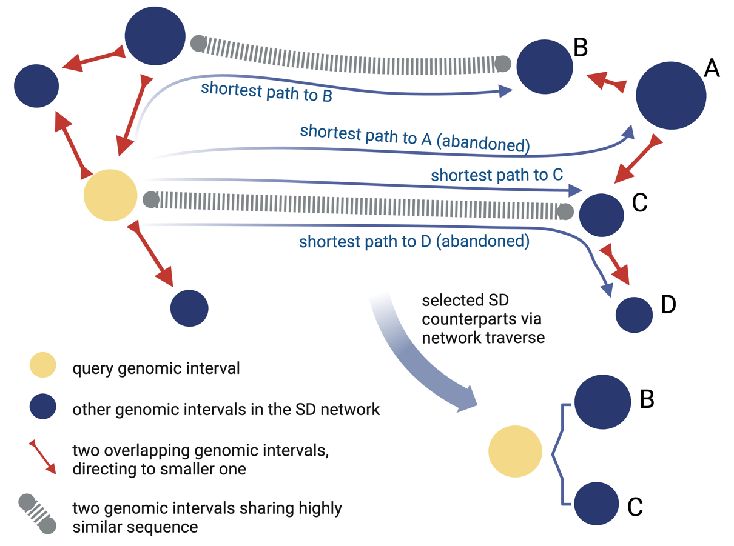
Supplementary Fig 3. The shortest-path-based algorithm to find homologous counterparts given a query SD.

4. Precise tracking of the homologous counterparts of functional coding regions
Based on the previous method, we can efficiently navigate the network and identify the homologous counterparts given a query SD. However, by default, we only care about the missed variants on SD-overlapping exons. Considering the realignment downstream, it is too computationally expensive to realign all the reads from the entire region of all the homologous counterparts to the query SD. A more efficient approach is to identify the segments of functional coding regions on the query SD and track the relative positions of the corresponding segments on the counterparts (Supplementary Fig 4).
To realize this, we defined a Python class to represent the nodes in the network and record the relative positions of functional segments on each SD. More importantly, the searched homologous counterparts are returned as the self-defined class instances with class attributes to record the relative positions of the corresponding functional segments in the query SD. Since one SD can be a homologous counterpart to different query SDs, this method allows flexibility in keeping track of the locations of the corresponding segments sharing homologous sequences with the functional segments on different query SDs. Hereafter, one query SD and its homologous counterparts are called one SD group.
In this work, every query SD should meet two criteria to be considered as a target of the realignment process: First, a realignment targeting SD should overlap with a functional coding region (padded by 20bp to both directions) offered by RefSeq. Second, a realignment targeting SD should be poorly aligned, which is further defined by three criteria. Given a single base, first, it should be covered by at least one read regardless of the mapping quality (MAPQ). Second, more than 50% of the overlapping reads should contain an “XA” tag implying the multi-aligned status. Third, it should not be covered by more than ten reads with MAPQ larger than or equal to 41, otherwise it can offer sufficient evidence to perform variant calling for a conventional caller. Meeting all the criteria above makes an SD a target for downstream read realignment, hereafter referred to as a functional coding SD (target SD).
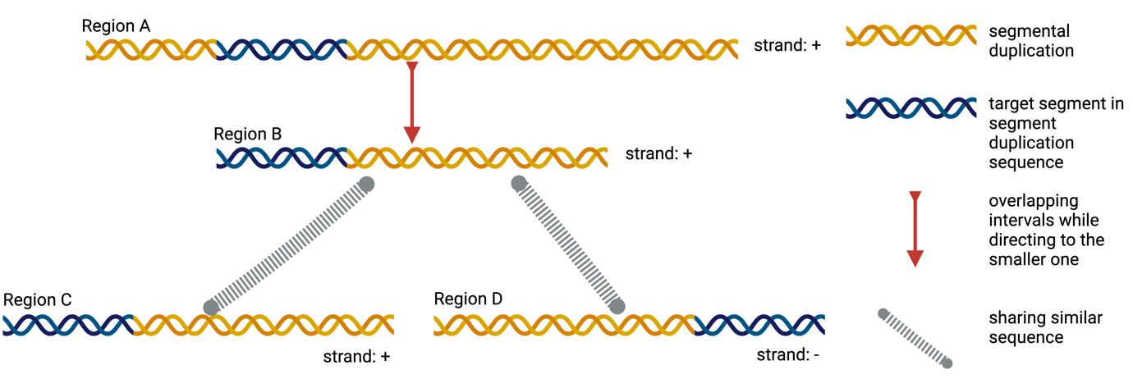
Supplementary Fig 4. Keeping track of the relative positions of the functional coding segment (target segment) when identifying homologous counterparts for a query segmental duplication.

5. Preparation of genome contigs for realignment
SDrecall, by default, focuses on improving variant detection in clinically significant regions like coding regions. Therefore, before realignment, SDrecall identifies which SDs overlap with functional coding regions, which can be later used as targets for read realignment (hereafter termed as target SDs). In addition, users can choose their own targeting regions by providing a BED file containing their regions of interest. SDrecall will then focus on the SDs overlapping with their targeting regions instead of the functional coding regions.
The network traverse algorithm described previously helps extract groups of SDs sharing homologous sequences. Within each group of SDs, there might be multiple SDs overlapping with user-defined target regions, hence multiple target SDs. Each target SD will be used as the target for a realignment process and multiple reciprocal realignment processes might be performed within a group of SDs based on the number of SDs overlapping target regions.
For each target SD, the reference genomic sequence is extracted and padded on both sides with 1000 Ns as a new customized genome contig for realignment. Then we pool the reads, including those overlapping the target SD itself and those multi-aligned reads overlapping the homologous counterparts (“XA” is used to tag multi-alignment for BWA-MEM) into a pair of FASTQ files. With the pair of FASTQ files, SDrecall force realigns the reads to the customed contigs, which are named after the start coordinate of the target SD in the reference genome. After the alignment against the target SD contig, we map the coordinate relative to the target SD contig back to the coordinate relative to the reference genome via an in-house developed script written in mawk[10].
In addition, for each target SD, we also extract the reference sequences from the homologous counterparts and align them against the reference sequence of the target SD, generating a BAM file (hereafter referred to as the intrinsic BAM file) used for downstream false positive identification.

6. Graph-based phasing
After the realignment, all the reads from multiple places are mapped to the target SD and inevitably introduce a lot of false positives if directly used to call variants. To identify the reads that do not originate from the target SD region, we first group and assemble reads into longer consensus sequences representing distinct haplotypes via a graph-based algorithm.
Specifically, treating each read pair (RP) as a vertex in a graph, we connect edges among the vertices based on their overlap conditions. The overlap condition can be generally divided into three categories. First, if two RPs overlap with at least one high-quality mismatch in their intersections, we leave the two RPs unconnected since there is clear evidence to reject the possibility that two RPs originate from the same haplotype. Second, if two RPs overlap with shared high-quality variants within the intersection, we connect the two RPs with a highly weighted edge, implying a high confidence that these two RPs originate from the same haplotype. Third, if two RPs do not overlap or overlap with no shared high-quality variants within the intersection, we still connect two RPs with an edge where the edge weight can be 0 or low, depending on the overlap size.
With an RP graph, to effectively identify a group of RPs originating from the same haplotype, we need to find a set of nodes where no pair of them are unconnected, therefore leading to the identification of disjoint maximal cliques on the graph. This identification process can be quite computationally expensive, especially with an exhaustive algorithm. To balance the computation performance and efficacy, we developed an approximate but greedy algorithm similar to the Greedy Clique Expansion algorithm[11] (termed GCE algorithm hereafter).
Specifically, within each component, we first identify the vertex with the highest edge weight summation. Then, extend to one of its neighbors with the highest edge weight. Continue this extension and ensure every newly added vertex has edges connected with all the previous members of the clique until we cannot find a new vertex meeting this requirement. To ensure non-overlapping, remove the vertices that have already been assigned to identified cliques and repeat the process described above until all the vertices in the graph are exhausted. There, we have a collection of disjoint maximal cliques of the graph.
A typical difference between our implementation of the GCE algorithm and the basic implementation of the GCE algorithm is we set cutoffs on edge weights when extending cliques and perform two or more rounds of GCE algorithms with gradual loosening cutoffs. In our work, given that we identify and eliminate misalignment based on assembled haplotypes downstream, we need the reads phasing to be highly accurate to limit the risk of filtering out correctly aligned reads. Therefore, on the clique extension step, we not only require the added neighbor to be connected to all previous members of the clique but also require the added neighbor to have an edge weight larger than a certain cutoff value with the previous vertex along the extending route.
At the first round of the GCE algorithm, we set the cutoff value to a score that ensures the new neighbor shares at least two single nucleotide variants (SNVs) or one indel with the previous read pairs within their intersections. Therefore, the grouped cliques may not be greedy but are highly accurate after the first round of the GCE algorithm. There are still gonna be a lot of fragmented small cliques left. Therefore, we remove the larger cliques (containing more than 3 vertices) from the graph to perform the second round of the GCE algorithm with a lower edge weight cutoff for clique extension. The second cutoff is set to a score ensuring the extended neighbor shares at least one SNV with the previous clique member. After the second round of the GCE algorithm, many fragmented cliques are merged into bigger ones to allow a higher sensitivity for phasing without harming the downstream variant calling.
The disjoint maximal cliques do not represent the final haplotypes that all reads get classified into. Within each clique, we remove the 0 weighted edges from the graph and classify the read-pairs still located in the same component as ones originating from the same haplotype. Subsequently, we assemble the reads assigned to the same haplotype to a consensus sequence. During the assembly, if sequences/bases from two reads conflict on a given site, we prioritize the sequence with higher base qualities. Finally, we’ll have multiple haplotypes with varying sizes and coverages for every target SD composed of the realigned reads.
Last but not least, to increase the computational performance, we did several optimizations in phasing implementation. First, to increase the performance of the GCE algorithm, we implement the algorithm on the adjacency matrix instead of directly on the graph itself (Supplementary Fig 5). Unlike a conventional adjacency matrix, we use value -1 to fill the cells where the column-indexed vertex and the row-indexed vertex do not have an edge in between. Additionally, we use value 0 to fill the cells where two read-pairs do not sufficiently overlap. Second, the adjacency matrix is sparse and can be implemented via the Scipy[12] sparse matrix object. Third, the Python functions executing the GCE algorithms on the sparse matrix are further decorated by numba[13] to allow parallel calculation and potential GPU acceleration. Fourth, to allow efficient batch query of overlapping reads given a genomic region, we utilize the Python nested containment list[14, 15] instead of the IO-bound pysam (https://github.com/pysam-developers/pysam) fetch or pileup function.
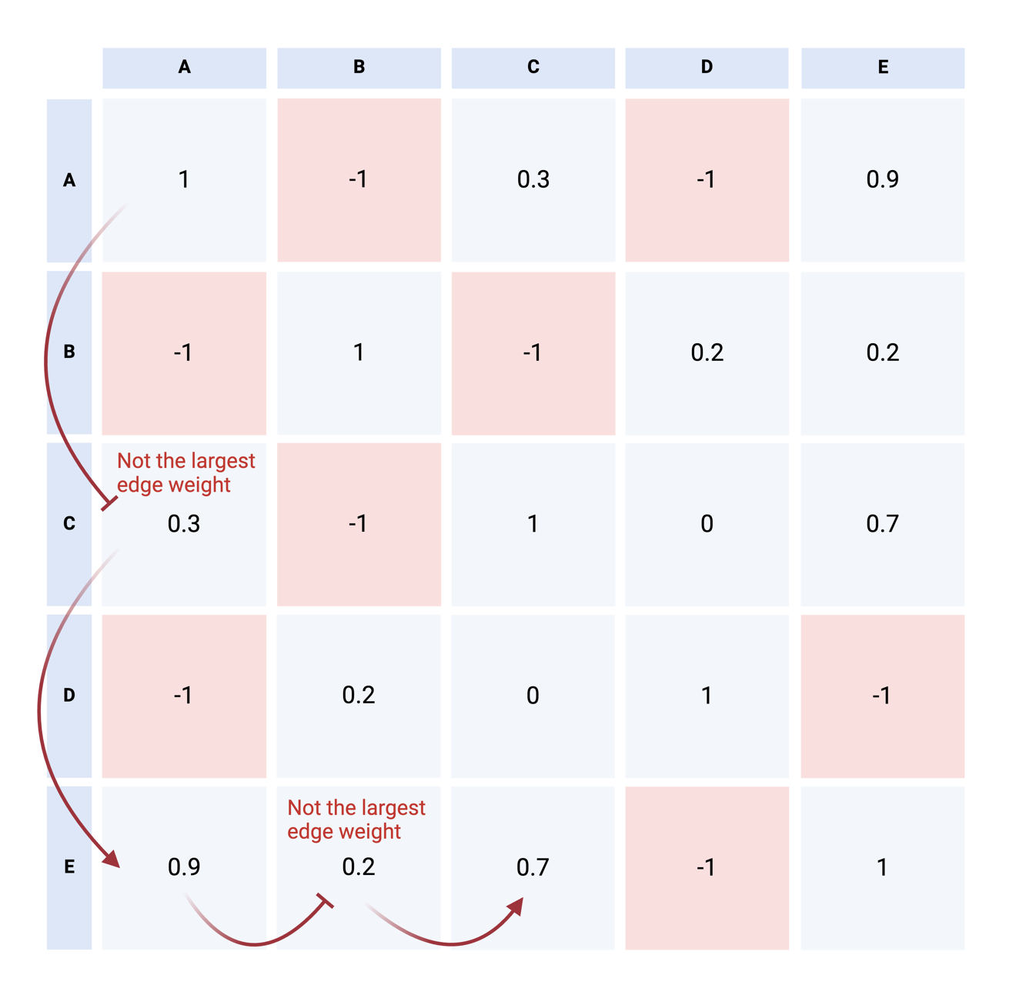
Supplementary Fig 5. An illustrative implementation of the Greedy Clique Expansion algorithm in our self-defined adjacency matrix. The A-C-E set of nodes is the searched maximal clique in this symbolic case. Negative one represents that two read pairs have clear evidence to reject the possibility that they originate from the same haplotype. Diagonal value are all 1 and other positive values represent the confidence score in-house calculated to measure how likely the two read pairs originate from the same haplotype.

7. Misalignment Identification with Binary Integer Linear Constraint Programming
Based on the previous phasing results, we need to further identify which reads are misaligned based on the consensus sequences of their assigned haplotypes. First, given the diploidy nature of the human genome and our highly accurate phasing of reads, at any window within a well-covered region, there should be only 1-2 overlapping haplotypes that truly originate from here. Since SDrecall prioritizes variant detection sensitivity over false positive rate, we intend to reserve at least two haplotypes for each window. Generally speaking, we can identify the misaligned haplotypes from two perspectives. First, misaligned haplotypes are likely to possess more variants than correctly aligned haplotypes within the same region by carrying variants originated elsewhere and the intrinsic sequence difference between paired SDs on the reference genome (hereafter referred to as intrinsic variants). Second, misaligned haplotypes may be significantly more similar to the reference sequence where they originate from than to the currently aligned reference sequence.
To determine the misaligned haplotypes based on the variant numbers and similarities with reference sequences from the homologous regions, we developed a method based on the Binary Integer Linear Constraint Programming (BILC). Specifically, for each haplotype $i$, we set a binary integer variable $X_{i}$ of 1 or 0, respectively, representing whether the haplotype is correctly aligned or misaligned. We then linearly combine all the binary variables with a coefficient $ε_{i}$ assigned to each $X_{i}$. The value of coefficient $ε_{i}$ is proportional to the likelihood that this haplotype $i$ is misaligned. In general, the BILC tries to minimize the output of the linear combination, which can be interpreted as the total likelihood of misalignment for the identified correctly aligned haplotypes. Thus, without constraints, all $X_{i}$ will be 0. However, considering every base should be covered by at least two haplotypes, we can have one constraint to the values of $X_{i}$ for all overlapping haplotypes in any given well-covered window(Figure 5A). Specifically, we use a sliding window to sweep through the well-covered regions with a window size of 120 and a step size of 30. Throughout all the windows, we applied multiple constraints to each $X_{i}$ value. With the added constraints, BILC can eliminate as many misaligned haplotypes as possible while ensuring every base is covered by at least two haplotypes.
The coefficient $ε_{i}$ for each haplotype serves as a metric for the likelihood of misalignment and is derived from two key considerations. First, it assesses how much more similar the haplotype is to the currently aligned reference sequence compared to other overlapping haplotypes (Supplementary Fig 6A). Second, it compares the similarity of the haplotype with the homologous counterpart sequences to the similarity of the haplotype with the currently aligned reference sequence (Supplementary Fig 6B) to evaluate whether the haplotype is significantly more similar to the current mapping position. The first aspect is measured by the average ranks of a haplotype across all the inspecting windows. As previously mentioned, we employed a sliding window to step through the region covered by realignments. Within each window, we rank the haplotypes enclosing the window by the carried number of variants in ascending order. For each haplotype, we calculate the averaged rank across the ranks in all windows and use it as one term for the coefficient calculation. The second aspect is measured by the difference in variant count between the variants represented by the haplotype and those represented by the haplotype when aligning it against the homologous counterpart sequence (Supplementary Fig 5). The corresponding formulas are listed in Equation 1 and Supplementary Equation 2.
$$\min_{X_{i}∈\left\{0,1\right\}}{\sum_{i=1}^{N}{ε_{i}X_{i}}}$$
Equation 1. The Binary linear integer formula where $X_{i}∈\left\{0\right., \left.1\right\}$ indicates whether haplotype $i$ is correctly mapped (1) or mismapped (0), as N is the total number of haplotypes, ${}_{i}$ is the coefficient of each binary integer proportional to the likelihood of misalignment.
$$ε_{i}=\frac{1}{K}\sum_{k=1}^{K}{s_{k}\sqrt{1-f_{ik}}r_{ik}}+\max_{j∈J}\left(d_{ij}+z_{ij}\right)$$
$$d_{ij}=c_{i}-c_{ij}$$
$$z_{ij}={c_{i}}/{c_{ij}}$$
Supplementary Equation 2. The calculation of coefficient $ε_{i}$ is composed of two items. Given a total number of $K$ windows, the first item is the weighted average rank of haplotype $i$ across $K$ windows, where $r_{ik}$ is the rank of haplotype $i$ in window $k$. The weights are the product of $s_{k}$ which represents the spanning region size of window $k$ and squared root of 1 - $f_{ik}$, where $f_{ik}$ is the read count fraction of haplotype $i$ in window $k$. Given haplotype $i$ overlaps with totally $J$ reference sequences from the homologous counterparts, the second item is the maximal value of $d_{ij}+z_{ij}$ across $J$ reference sequences, where $d_{ij}$ is the delta between $c_{i}$ and $c_{ij}$ and $z_{ij}$ is the ratio between $c_{i}$ and $c_{ij}$. Here $c_{i}$ is the number of variants currently carried by haplotype $i$ and $c_{ij}$ is the number of variants carried by haplotype $i$ if aligning it against the reference sequence of the homologous counterpart $j$.
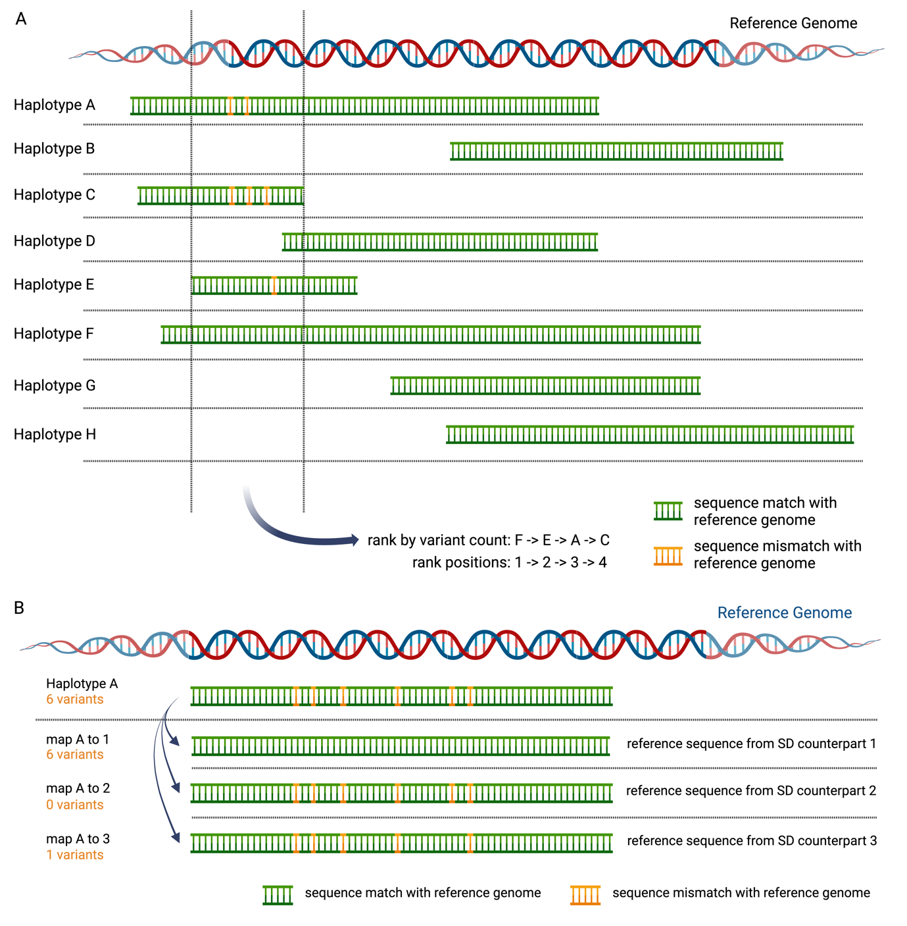
Supplementary Fig 6. The two major considerations composing the coefficient for each haplotype binary variable. A. Given a window, rank the haplotypes by their carried variant number in ascending order to measure how much more similar the query haplotype is to the aligned reference sequence than the other overlapping haplotypes. B. Given a query haplotype, measure how similar it is to the aligned reference sequence than to other homologous counterpart sequences by counting the variants when aligning the haplotype against different reference sequences.

8. Preparations for benchmarking
Given that SDrecall serves as a supplementary tool to detect variants in segmental duplications on top of traditional variant callers, to have a final collection of variants for benchmarking, we merge the variants called by SDrecall and GATK. Before merging SDrecall variants with GATK variants, we first prepared the callset of SDrecall by merging the variants called from unfiltered realigned BAMs and the variants called from filtered realigned BAMs. We developed a Python script based on pysam to merge variants from different sources while prioritizing one source when meeting conflicts. In our SDrecall variants merging, variants from filtered realigned BAMs are reserved when conflicting with variants from unfiltered BAMs. Furthermore, variants exclusively generated from the unfiltered BAMs are marked by a FILTER tag named “MISALIGNED”. The merged SDrecall callset is later merged into the GATK callset to have the final callset for benchmarking, and variants from GATK are prioritized when conflicting with variants from SDrecall on genotype calling.
The final benchmark region is the intersection of three groups of regions. The first group is regions suffering from mapping ambiguity. Specifically, the definition of suffering mapping ambiguity is composed of three criteria. Given a single base site, first, it should be covered by at least one read regardless of the MAPQ. Second, more than 50% of the overlapping reads should contain an “XA” tag implying the multi-aligned status. Third, it should not be covered by more than 10 reads with MAPQ larger than or equal to 41, otherwise, it can offer sufficient evidence to perform variant calling for a conventional caller. The second group is functional coding regions annotated by RefSeq. The third group is the benchmark region offered by GIAB, where they have high confidence in variants. We prepared two benchmark regions from GIAB for the third group. One is the version 4.2.1 benchmark region, and the other is the Challenging Medical Relevant Genes (CMRG) benchmark region (only available to HG002), leading to two final benchmark regions. In addition, we removed a few true positives from the benchmark callset since we found that the downsampled BAM files, used as the input BAM files for SDrecall, lack variant alleles (ALT depth = 0 ) at those sites, which might be a result from random downsampling. The detailed downloading links of the two benchmark regions for the third group are provided below:
GIAB v4.2.1 benchmark region:
HG002:
GRCh37: https://ftp-trace.ncbi.nlm.nih.gov/giab/ftp/release/AshkenazimTrio/HG002_NA24385_son/NISTv4.2.1/GRCh37/HG002_GRCh37_1_22_v4.2.1_benchmark_noinconsistent.bed
GRCh38: https://ftp-trace.ncbi.nlm.nih.gov/giab/ftp/release/AshkenazimTrio/HG002_NA24385_son/NISTv4.2.1/GRCh38/HG002_GRCh38_1_22_v4.2.1_benchmark_noinconsistent.bed
HG003:
GRCh37: https://ftp-trace.ncbi.nlm.nih.gov/giab/ftp/release/AshkenazimTrio/HG003_NA24149_father/NISTv4.2.1/GRCh37/HG003_GRCh37_1_22_v4.2.1_benchmark_noinconsistent.bed
GRCh38: https://ftp-trace.ncbi.nlm.nih.gov/giab/ftp/release/AshkenazimTrio/HG003_NA24149_father/NISTv4.2.1/GRCh38/HG003_GRCh38_1_22_v4.2.1_benchmark_noinconsistent.bed
HG004:
GRCh37: https://ftp-trace.ncbi.nlm.nih.gov/giab/ftp/release/AshkenazimTrio/HG004_NA24143_mother/NISTv4.2.1/GRCh37/HG004_GRCh37_1_22_v4.2.1_benchmark_noinconsistent.bed
GRCh38: https://ftp-trace.ncbi.nlm.nih.gov/giab/ftp/release/AshkenazimTrio/HG004_NA24143_mother/NISTv4.2.1/GRCh38/HG004_GRCh38_1_22_v4.2.1_benchmark_noinconsistent.bed
HG005:
GRCh37: https://ftp-trace.ncbi.nlm.nih.gov/giab/ftp/release/ChineseTrio/HG005_NA24631_son/NISTv4.2.1/GRCh37/HG005_GRCh37_1_22_v4.2.1_benchmark.bed
GRCh38: https://ftp-trace.ncbi.nlm.nih.gov/giab/ftp/release/ChineseTrio/HG005_NA24631_son/NISTv4.2.1/GRCh37/HG005_GRCh37_1_22_v4.2.1_benchmark.bed
HG006:
GRCh37: https://ftp-trace.ncbi.nlm.nih.gov/giab/ftp/release/ChineseTrio/HG006_NA24694_father/NISTv4.2.1/GRCh37/HG006_GRCh37_1_22_v4.2.1_benchmark.bed
GRCh38: https://ftp-trace.ncbi.nlm.nih.gov/giab/ftp/release/ChineseTrio/HG006_NA24694_father/NISTv4.2.1/GRCh38/HG006_GRCh38_1_22_v4.2.1_benchmark.bed
HG007:
GRCh37: https://ftp-trace.ncbi.nlm.nih.gov/giab/ftp/release/ChineseTrio/HG007_NA24695_mother/NISTv4.2.1/GRCh37/HG007_GRCh37_1_22_v4.2.1_benchmark.bed
GRCh38: https://ftp-trace.ncbi.nlm.nih.gov/giab/ftp/release/ChineseTrio/HG007_NA24695_mother/NISTv4.2.1/GRCh38/HG007_GRCh38_1_22_v4.2.1_benchmark.bed

GIAB CMRG benchmark region (only for HG002):
GRCh37: https://ftp-trace.ncbi.nlm.nih.gov/giab/ftp/release/AshkenazimTrio/HG002_NA24385_son/CMRG_v1.00/GRCh37/SmallVariant/HG002_GRCh37_CMRG_smallvar_v1.00.bed
GRCh38: https://ftp-trace.ncbi.nlm.nih.gov/giab/ftp/release/AshkenazimTrio/HG002_NA24385_son/CMRG_v1.00/GRCh38/SmallVariant/HG002_GRCh38_CMRG_smallvar_v1.00.bed

Assembly | Symbol | SDrecall_exclusive | GATK_captured | Associated Phenotypes
GRCh37 | CYP21A2 | 8 | 12 | Congenital adrenal hyperplasia
GRCh37 | HYDIN | 1 | 0 | Primary ciliary dyskinesia 5
GRCh37 | MSTO1 | 1 | 2 | Mitochondrial myopathy-cerebellar ataxia-pigmentary retinopathy syndrome
GRCh37 | NCF1 | 1 | 4 | Chronic granulomatous disease
GRCh37 | NEB | 5 | 15 | Nemaline myopathy
GRCh37 | PMS2 | 5 | 5 | Lynch syndrome
GRCh37 | TNXB | 2 | 19 | Ehlers-Danlos syndrome
GRCh37 | TTN | 1 | 1 | Tibial muscular dystrophy
GRCh38 | CBS | 1 | 3 | Homocystinuria
GRCh38 | KCNE1 | 3 | 0 | Jervell and Lange-Nielsen syndrome 2;Long QT syndrome
GRCh38 | MSTO1 | 1 | 2 | Mitochondrial myopathy-cerebellar ataxia-pigmentary retinopathy syndrome
GRCh38 | NEB | 6 | 14 | Nemaline myopathy
GRCh38 | OCLN | 4 | 0 | Pseudo-TORCH syndrome 1
GRCh38 | PMS2 | 2 | 5 | Lynch syndrome
GRCh38 | PRODH | 1 | 1 | Proline dehydrogenase deficiency
GRCh38 | STRC | 1 | 7 | Rare genetic deafness
Supplementary Table 2. The list of known disease-causing genes according to ClinVar where SDrecall recovered variants GATK failed to capture.

9. Mapping quality distribution shift
To fully evaluate the potential list of genes benefiting from SDrecall, we inspect the MAPQ distribution before and after the realignment in regions with resolution up to a single exon. Within the GIAB v4.2.1 benchmark region, the MAPQ scores of all the reads overlapping with each exon are collected before and after the realignment. The MAPQ scores across different samples are merged for global evaluation. The results on reference assembly GRCh37 and reference assembly GRCh38 are respectively recorded in Supplementary Fig 8 and Supplementary Fig 9.

10. False duplication identification
In our study, during misalignment identification and filtration, we found that misaligned reads are likely to have more variants. This is because these reads can contain extra mismatches due to differences in the sequences between homologous counterparts, and the variants truly originate from other homologous counterparts. However, some regions also have one correctly mapped haplotype with an unusually high number of heterozygous variants. This kind of region was first identified in one sample, HG002, by crosschecking the haplotype-resolved alignments composed of PacBio HiFi2 reads and realigned reference sequences in previously mentioned intrinsic BAM files.
Interestingly, when we examined the intrinsic alignments file generated earlier in the same regions, we discovered that nearly all the heterozygous variants can be explained by differences in reference sequences between homologous counterparts (Supplementary Fig 7). This means that the haplotype carrying a high number of variants has an almost identical sequence with the reference sequence from a homologous counterpart region. Considering that HiFi2 reads are 15-20kb long, which is longer than most SDs, this finding suggests an issue with the assembly of the human reference genome rather than a true biological phenomenon.
When assembling reference genomes, sometimes the sequences from the other copy within a region are mistakenly treated as reference sequences from a different region and assembled into the same copy, creating an artificial duplication. These false duplications (FDs) are not part of our goal to recover variants, so we need to systematically identify and remove them from our final results in both GRCh37 and GRCh38 reference genomes. To do this, we compare the intrinsic alignments file with the haplotype-resolved PacBio alignments file for sample HG002 and find the regions that are at least 1kb long, have a high number of variants, and share nearly identical sequences with other similar regions. The detailed coordinates of FDs for both assemblies are recorded in supplementary materials in BED format.

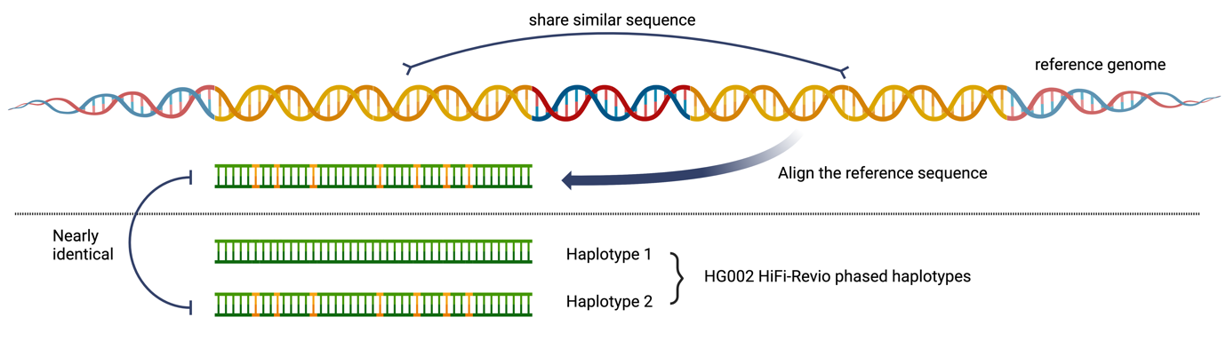
Supplementary Fig 7. The identification of false duplications. For some segmental duplications, one of their homologous counterparts shares a nearly identical sequence with the genomic sequence on the other copy, implying an artificial duplication in the homologous counterpart region led by the potential false assembling of the short reads.

References
1. Rouchka, E.C., W. Gish, and D.J. States, Comparison of whole genome assemblies of the human genome. Nucleic acids research, 2002. 30(22): p. 5004-5014.
2. Li, H., Minimap2: pairwise alignment for nucleotide sequences. Bioinformatics, 2018. 34(18): p. 3094-3100.
3. Bailey, J.A., et al., Recent segmental duplications in the human genome. Science, 2002. 297(5583): p. 1003-1007.
4. Bailey, J.A., et al., Segmental duplications: organization and impact within the current human genome project assembly. Genome research, 2001. 11(6): p. 1005-1017.
5. Danecek, P., et al., Twelve years of SAMtools and BCFtools. Gigascience, 2021. 10(2): p. giab008.
6. Li, H. and R. Durbin, Fast and accurate short read alignment with Burrows–Wheeler transform. Bioinformatics, 2009. 25(14): p. 1754-1760.
7. Smoot, M.E., et al., Cytoscape 2.8: new features for data integration and network visualization. Bioinformatics, 2011. 27(3): p. 431-432.
8. Kobourov, S.G., Spring embedders and force directed graph drawing algorithms. arXiv preprint arXiv:1201.3011, 2012.
9. Johnson, D.B., A note on Dijkstra's shortest path algorithm. Journal of the ACM (JACM), 1973. 20(3): p. 385-388.
10. Aho, A.V., B.W. Kernighan, and P.J. Weinberger, Awk—a pattern scanning and processing language. Software: Practice and Experience, 1979. 9(4): p. 267-279.
11. Lee, C., et al., Detecting highly overlapping community structure by greedy clique expansion. arXiv preprint arXiv:1002.1827, 2010.
12. Virtanen, P., et al., SciPy 1.0: fundamental algorithms for scientific computing in Python. Nature methods, 2020. 17(3): p. 261-272.
13. Lam, S.K., A. Pitrou, and S. Seibert. Numba: A llvm-based python jit compiler. in Proceedings of the Second Workshop on the LLVM Compiler Infrastructure in HPC. 2015.
14. Alekseyenko, A.V. and C.J. Lee, Nested Containment List (NCList): a new algorithm for accelerating interval query of genome alignment and interval databases. Bioinformatics, 2007. 23(11): p. 1386-1393.
15. Stovner, E.B. and P. Sætrom, PyRanges: efficient comparison of genomic intervals in Python. Bioinformatics, 2020. 36(3): p. 918-919.

