Supplementary Information
Flexible Monolithic 2-terminal Kesterite Cu₂ZnSnSe₄ /Perovskite Tandem Solar Cells
Muhammad Rehan ^{a+}, Hung Van Tran ^{a,b+}, Inyoung Jeong ^{a+}, Ara Cho ^{a,b}, Sejin Ahn ^{a,b}, Sungjun Hong ^{a,b}, Junho Kim ^{c}, Kihwan Kim ^{a,b}, Jae Ho Yun ^{d}*, Jihye Gwak ^{a,b}*, Donghyeop Shin ^{a,}*
ª Photovoltaics Research Department, Korea Institute of Energy Research (KIER), 152-Gajeong-ro, Yuseong-gu, -Daejeon, 34129 Korea
^{b} Department of Renewable Energy Engineering, University of Science & Technology (UST) 217-Gajeong-ro, Yuseong-gu, Dajeon, 34113, Korea
^{c} Department of Physics, Incheon National University (INU), Songdo-gu 119Academy-ro, Yonsu-gu, 22012, Incheon, Korea
^{d} Department of Energy Engineering, Korea Institute of Energy Technology, Naju, 58217, Republic of Korea
⁺These authors are equally contributed.
Corresponding Author
*Email: donghyeop.shin@kier.re.kr (Donghyeop Shin) / bleucoeur@kier.re.kr (Jihye Gwak) jhyun@kentech.ac.kr (Jae Ho Yun)

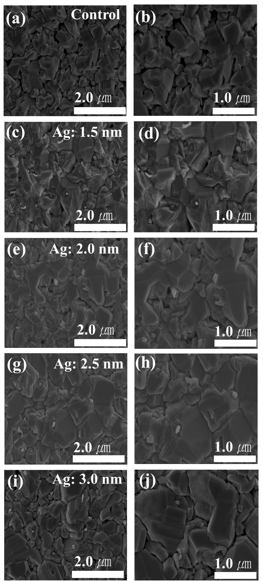
Supplementary Figure 1. SEM images of CZTSe surfaces: without Ag, control (a,b) and with Ag with various thicknesses: (c, d) 1.5 nm, (e, f) 2.0 nm, (g, h) 2.5 nm, (i, j) 3.0 nm.

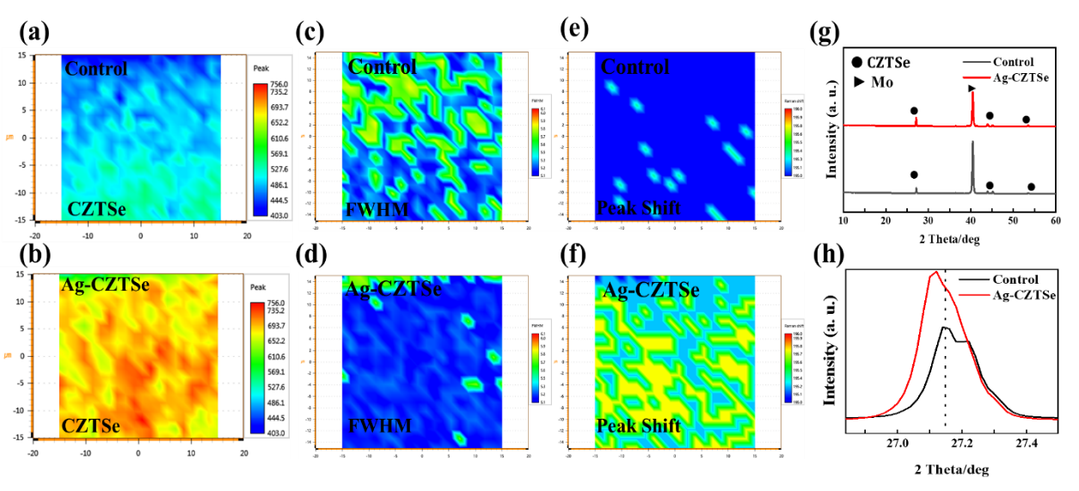
Supplementary Figure 2. (a,b) Raman maps imaging (c,d) FWHM and (e,f) peak shift of the CZTSe peak of control and Ag-CZTSe film. (g) XRD pattern and (h) magnified view of the main peak originated from (112) plan of control and Ag-CZTSe film.

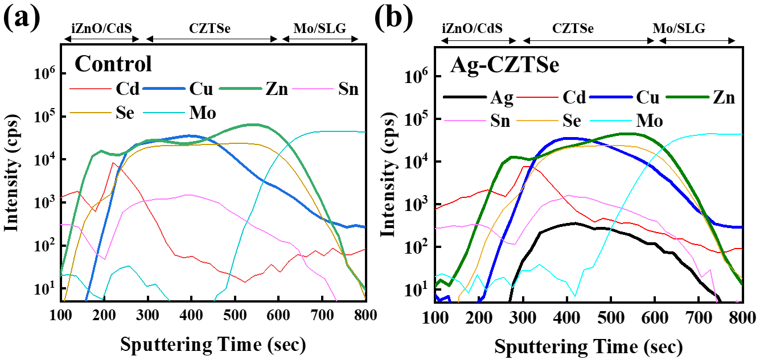
Supplementary Figure 3. SIMS depth profile of the (a) control (without Ag) and (b) Ag-doped Cu₂ZnSnSe₄ PV device.
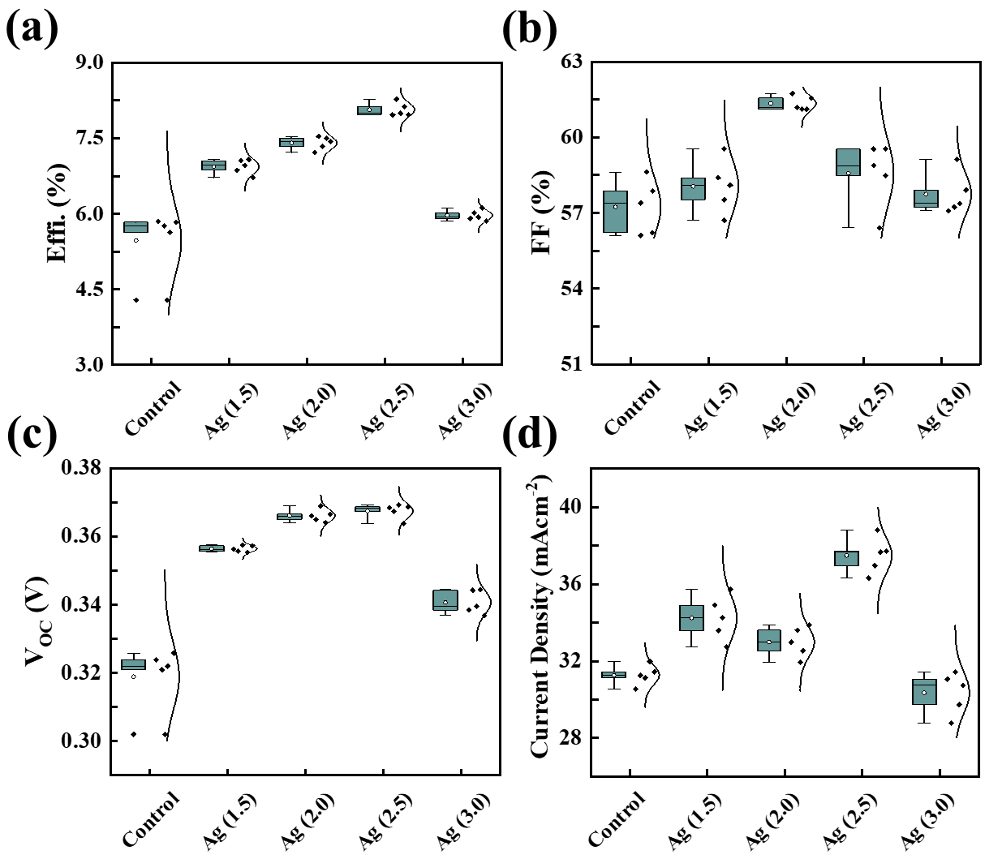
Supplementary Figure 4. Summary of the photovoltaic parameters (a) efficiency, (b) fill factor, (c) open-circuit voltage, and (d) short-circuit current-density measured from the illuminated current density-voltage (JV) curve of the CZTSe solar cell with various thicknesses of Ag layer from 0 to 3 nm. The CZTSe film prepared without Ag doping is referred as the control.

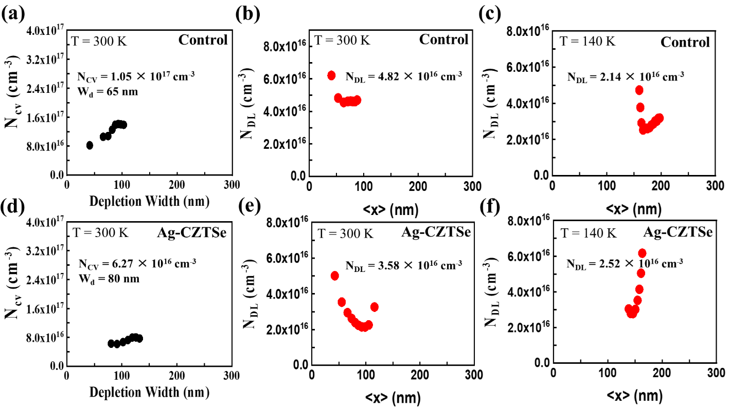
Supplementary Figure 5. Plots of (a,d) N_{CV} at 300 K, (b,e) N_{DL} at 300 K and (c,f) N_{DL} at 140 K as a function of depletion width for control and Ag-CZTSe PV devices. These plots are derived from capacitance-voltage (CV) and drive-level capacitance profiling (DLCP). (N_{CV}: carrier density extracted from CV profile, N_{DL}: carrier density extracted from DLCP profile).

Supplementary Table 1. Summary of the free carrier (N_{A}), bulk defect (N_{BULK}), and interface defect (N_{IF}) density extracted from the capacitance-voltage (CV) and drive-level capacitance profiling (DLCP) analysis.
 | N_{IF}  (cm⁻³) | N_{BULK}  (cm⁻³) | N_{A}  (cm⁻³) | W_{d}  (nm)
Control | 5.7 × 10¹⁶ | 2.68 × 10¹⁶ | 2.14 × 10¹⁶ | 65
Ag-CZTSe | 2.6 × 10¹⁶ | 1.06 × 10¹⁶ | 2.52 × 10¹⁶ | 80

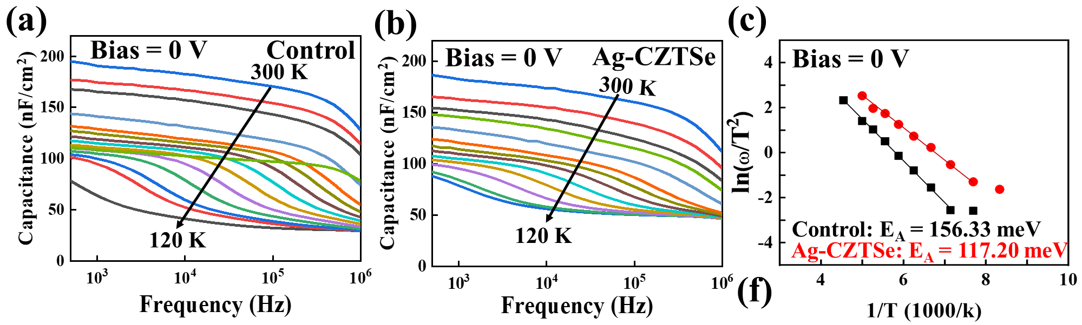
Supplementary Figure 6. Capacitance-frequency (C-f) spectra of (a) Control, (b) Ag-CZTSe PV device and (c) drove Arrhenius plot extracted from C-f spectra Control and Ag-CZTSe PV devices. Admittance spectra were measured in the temperature range between 120 K and 300 K.

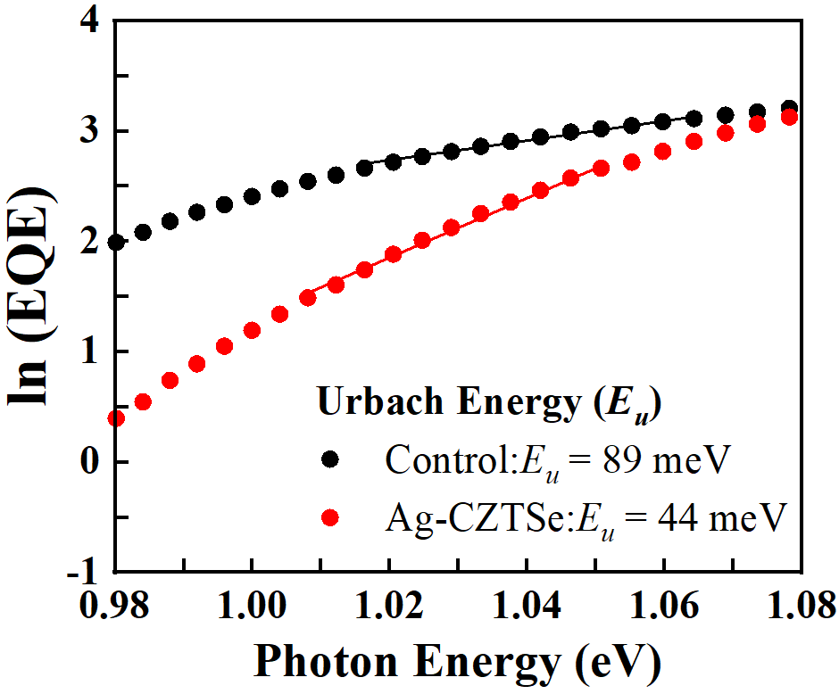
Supplementary Figure 7. Urbach energy (E_{u}) extracted from EQE profile of control and Ag-Cu₂ZnSnSe₄ (CZTSe) PV devices.¹
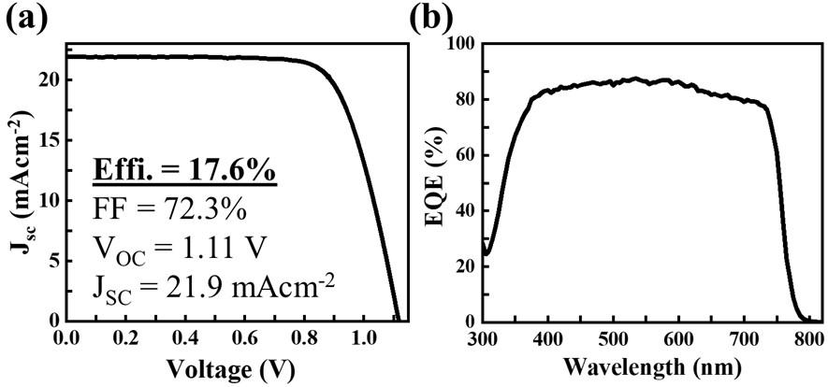
Supplementary Figure 8. (a) Current density-voltage (JV) curve and (b) external quantum efficiency (EQE) spectrum for the standalone semitransparent perovskite solar cell.

References
- Li, X., et al. Achieving 11.95% efficient Cu2ZnSnSe4 solar cells fabricated by sputtering a Cu–Zn–Sn–Se quaternary compound target with a selenization process. J. Mater. Chem. A. 7 (16), pp.9948-9957 (2019).

