Support information for
“Quantifying the impacts of wildfires on soil thermal, hydrological and carbon dynamics in northern Eurasia from 2003 to 2016”
Yiming Xu¹, Qianlai Zhuang¹, Bailu Zhao¹, Michael Billmire², Christopher Cook², Jeremy Graham², Nancy HF French², Ronald Prinn³
¹ Department of Earth, Atmospheric and Planetary Sciences, Purdue University, West Lafayette, IN 47907 USA
² Michigan Tech Research Institute, Michigan Technological University, Ann Arbor, MI 48105 USA
³ Department of Earth, Atmospheric, and Planetary Sciences, MIT, Cambridge MA

Model description
In the model, gross primary production (GPP) is calculated as:
$GPP= C_{max}×f(PAR)×f(PHEN)×f(FOLIAGE)×f(T)×f(Ca, Gv)×f(NA)$ (1)
where C_{max} is the maximum rate of C assimilation, f(PAR) is a scalar that depends on monthly photosynthetically active radiation (PAR), f(PHEN) is a function of leaf area index and EET, f(T) is a scalar that depends on monthly air temperature, f(Ca, G_{V}) is a scalar that depends on atmospheric CO₂ concentration (Ca) and relative canopy conductance (Gv), and f(NA) is a function of monthly N available for incorporation into plant production of new tissue. The formulation for f(FOLIAGE) is a scalar function that ranges from 0.0 to 1.0.
Vegetation needs time to recover after fire. One direct impact of vegetation combustion is GPP decrease. When there is no fire, FOLIAGE is a function of vegetation C, which is considered as a pool in the model. However, in the first five years after fire, FOLIAGE is assumed to be 0.05. In the sixth year after fire, FOLIAGE is again a function of vegetation C.
$$FOLIAGE= \frac{1}{1+m_{1}×e^{m_{2}×\sqrt{f\left(C_{V}\right)}}} (2)$$
Where m₁ and m₂ are parameters, C_{V} is vegetation C.
In the model, heterotrophic respiration (R_{H}) represents decomposition of all soil organic matter in an ecosystem and is calculated as:
$$R_{H}= K_{d}×C_{s}×f\left(M_{v}\right)×e^{0.069H_{T}} (3)$$
where K_{d} is a parameter that defines the rate of decomposition at ⁰C, C_{S} is carbon in soil organic matter, M_{V} is volumetric soil moisture, and H_{T} is temperature of the humic organic soil layer.
In the model, fires also destroy moss. Moss layer is the uppermost layer in soil thermal module and its thickness impacts soil temperature. In the year of fire, TEM assumes the moss layer is completely combusted. After fire, moss thickness is described by an empirical function depends on the number of years after fire:
$$moss= a_{1} ×\left(1-e^{b_{1} ×t} \right) (4)$$
Where moss is the moss thickness, a₁ and b₁ are parameters, and t is the year after fire.
The soil surface energy budget is estimated as:
$$Q=SH+LH+SR+LR (5)$$
where Q is the energy budget, SH is the sensible heat flux, LH is the latent heat flux, SR is the short-wave radiation and LR is the long-wave radiation. These variables are calculated based on the meteorological input data and leaf area index. More details can be found in Xu & Zhuang (2023).
In TEM, evapotranspiration is calculated as:
$$trans=\frac{slope×drad+c_{p}×pa×\frac{vpd}{ra}}{(slope+gamma×\left(1+\frac{rc}{ra}\right))×le}×dayl (6)$$
where trans is evapotranspiration (mm/month), slope is the slope of vapor pressure curve, drad is the canopy daily average radiation, a function of the leaf area index. C_{p} is the specific heat of air (J kg⁻¹K⁻¹), pa is the density of air (kg m⁻³), vpd is the vapor pressure deficient from canopy to air (mbar), ra is canopy aerodynamic resistance, rc is canopy resistance to water vapor, le is latent heat of vaporization of water (J kg⁻¹), dayl is the length of a day (s) and gamma is a parameter.
More details can be found in Zhuang et al (2002) and Zhao et al (2021).

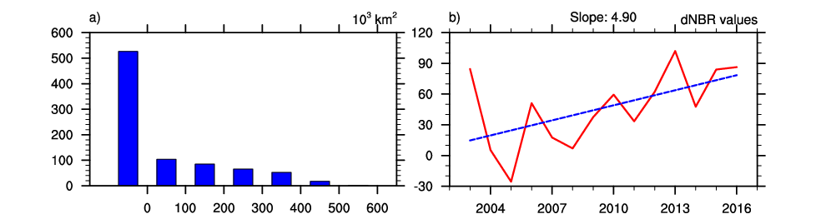
Figure S1: Summary of fire regimes: (a) Histograms of dNBR. The heights of bars are total fire area in which average dNBR is within the thresholds indicated by the x axis. (b) Annual area-weighted mean dNBR value (red line) and its linear trend (blue line).

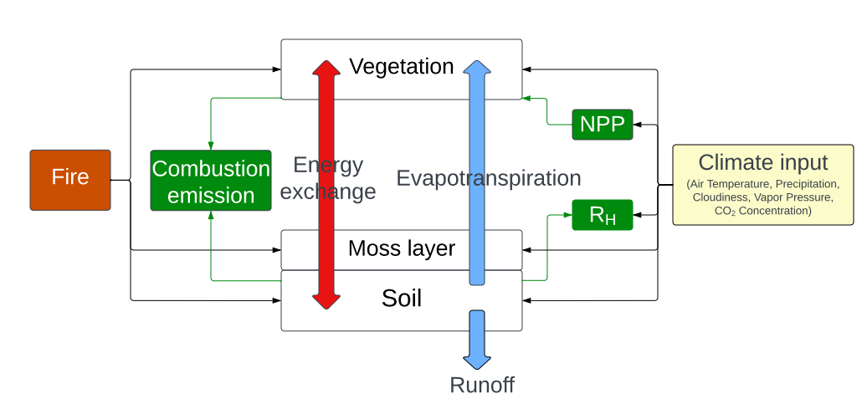Figure S2: Fire effects on forest ecosystem dynamics of energy, water, and carbon.

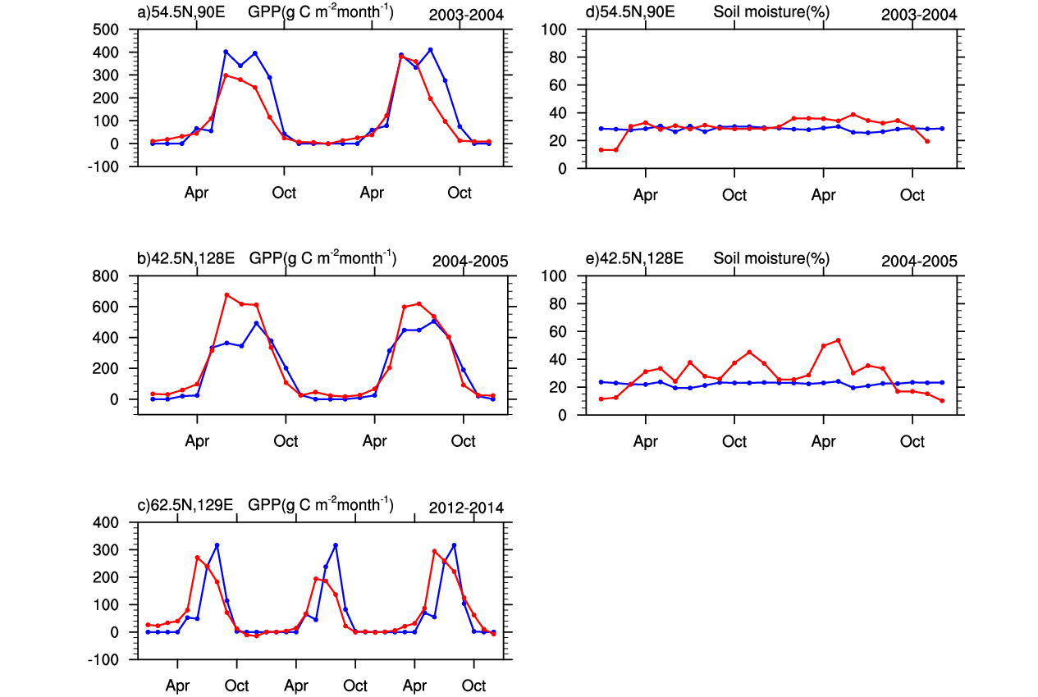
Figure S3 Comparison between simulated (blue lines) and observed (red lines) GPP (a, b, c) and soil moisture (d, e) at three different sites.

Table S1: Combustion emissions of sensitivity test simulations and their relative change compared with the original simulation. The simulation name indicates the modified parameter in Eqns. 3 and 4.

Simulations | Description | Value | Combustion emission (Tg C yr⁻¹) | Percentage change (%)
P₁ | Slope of the linear regression of CBI on dNBR | 0.0023 | 126.6 | 3.9
P₂ | Intercept of the linear regression of CBI on dNBR | 0.5561 | 125.8 | 3.2
P₃ | Slope of the linear regression of the ratio of removed carbon on CBI | 51.42 (for soil) / 14.15 (for vegetation) | 131.0 | 7.4
P₄ | Intercept of the linear regression of the ratio of removed carbon on CBI | -63.49 (for soil) / 48.63 (for vegetation) | 124.7 | 2.3

