Supplementary materials

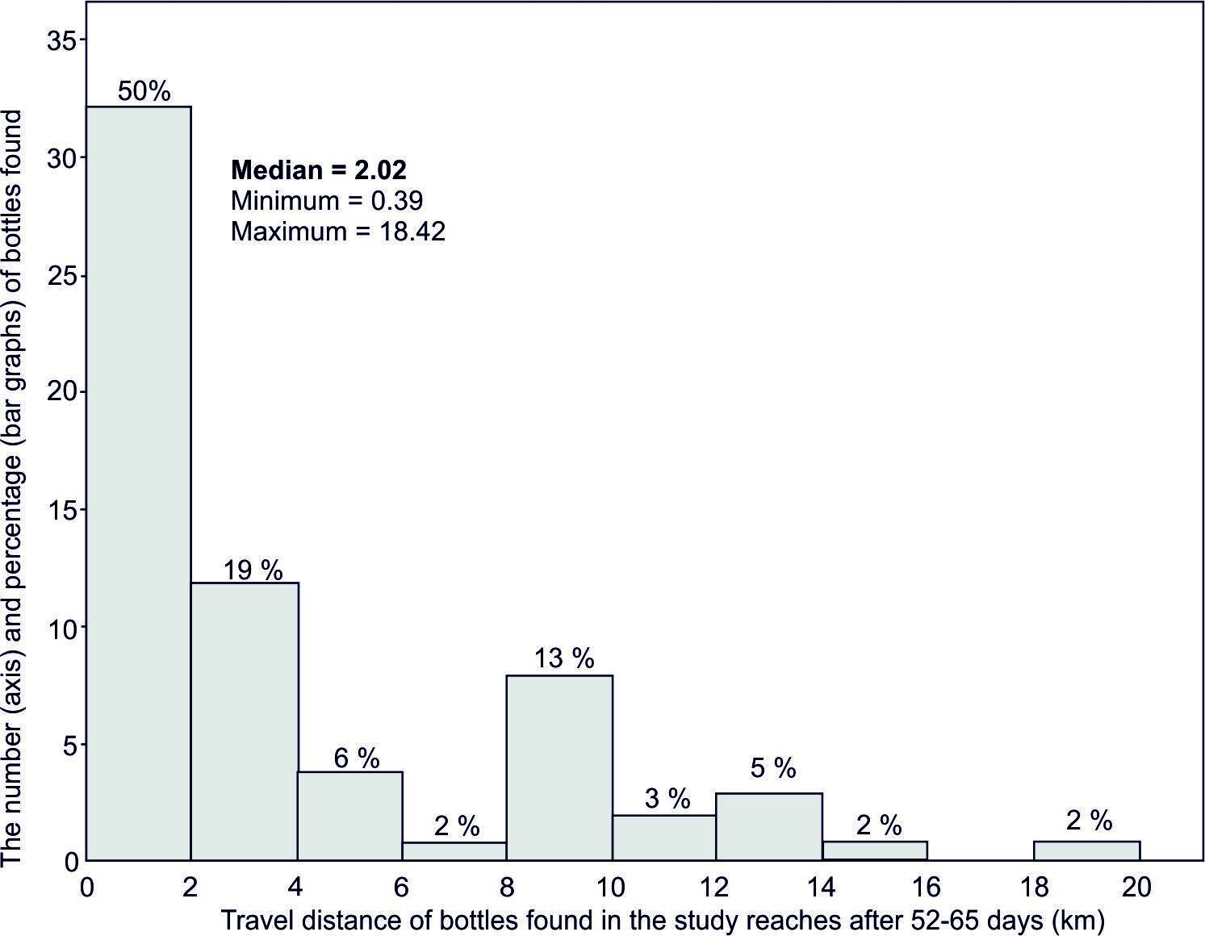
Figure S1. Statistical characteristics of travel distance of found PET bottles (n=64) found along the study reaches during 52-65 days of experiment.

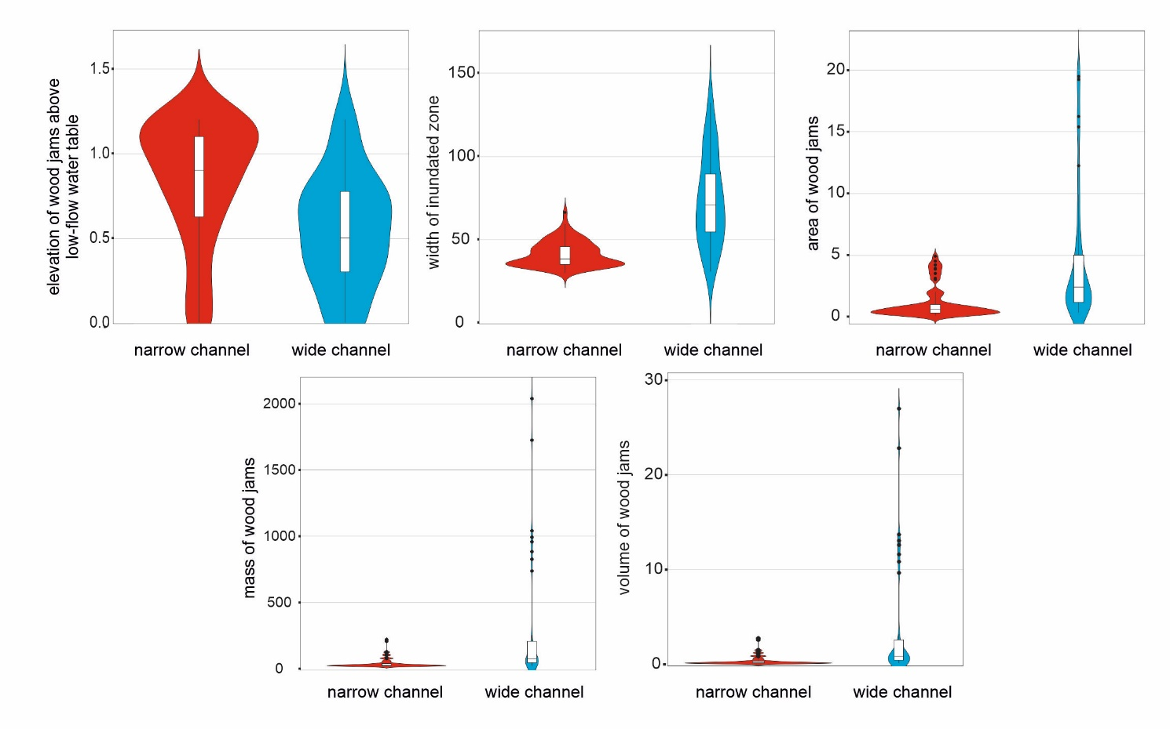
Figure S2. Violin-plot distribution of wood jam characteristics in reaches 2 and 3 with kernel density estimation representing the spread of values. The median value and interquartile ranges for each group are shown in boxplots.

