Supplementary materials

Flow velocity and nutrients affect CO₂ emissions from agricultural drainage channels in the North China Plain
Peifang Leng^{1,2,3}, Fadong Li^{1,3}, Kun Du^{1,3}, Zhao Li^{1,3}, Congke Gu^{1,3}, and Matthias Koschorreck²

¹ Key Laboratory of Ecosystem Network Observation and Modeling, Institute of Geographic and Natural Resources Research, Chinese Academy of Sciences, Beijing, China,
² Department of Lake Research, Helmholtz Centre for Environmental Research-UFZ, Magdeburg, Germany,
³ College of Resources and Environment, University of Chinese Academy of Sciences, Beijing, China
Corresponding author: Fadong Li (lifadong@igsnrr.ac.cn)

This supporting information contains additional presentation of the controlled experiments methods and results, including three figures.
Methods of chamber flux measurements

The fluxes of carbon dioxide were measured by a floating chamber connected to a cavity ring-down spectrometer (CRDS) (Picarro G2508, USA) with high precision in real-time (Martin & Moseman-Valtierra, 2015). A cylindrical static chamber of fiber reinforced plastic (20 cm diameter × 13 cm height) was placed at the water surface, penetrating 1-2 cm into the water. The chamber was kept floating by polyethylene (PE) foam. For each measurement, the chamber was placed at the water surface for up to 3 min for CO₂ measurement. The CO₂ flux (mmol m⁻² d⁻¹) was calculated from the observed change rate of $S$ (ppm s⁻¹) in the chamber using equation (1) (see Campeau and Giorgio (2014) for more details):
 | $F=(S×V/A)×t_{1}×t_{2}$ | (1)
where $V$ is the chamber gas volume (m³), $A$ is the chamber area (m²),
 | $t_{1}=8.64×{10}^{4} s d^{-1}$ | (2)
denotes the conversion factor from seconds to days, and $t_{2}$ is a conversion factor from mole fraction (ppm) to concentration (mmol m⁻³) at in-situ air temperature (T in K) and atmospheric pressure (p in Pa):
 | $t_{2}=P/{\left(8.314×T×1000\right)}$ | (3)
The cumulative CO₂ evasion at a certain time was calculated as the integral of CO₂ flux over time. The CO₂ flux can be delineated according to the fitting result from the relationship between time and CO₂ flux:
 | $$f_{t}=f_{0}∙exp⁡(-kt)$$ | (4)
where $f_{0}$ and $f_{t}$ is the CO₂ flux (mmol m⁻² h⁻¹) at the initial time and a certain reaction time (t; h), respectively. k (h⁻¹) is the reaction constant. When the CO₂ flux is integrated by t, the total CO₂ evasion amount ($n_{t}$) in each container at a certain time t can be defined as:
 | $$n_{t}=S×\int_{0}^{t}{f_{t}}dt=S∙\frac{f_{0}}{k}∙[1-\exp\left(-kt\right)]$$ | (4)
where$S$ is the surface area of the water (m²) in each container.

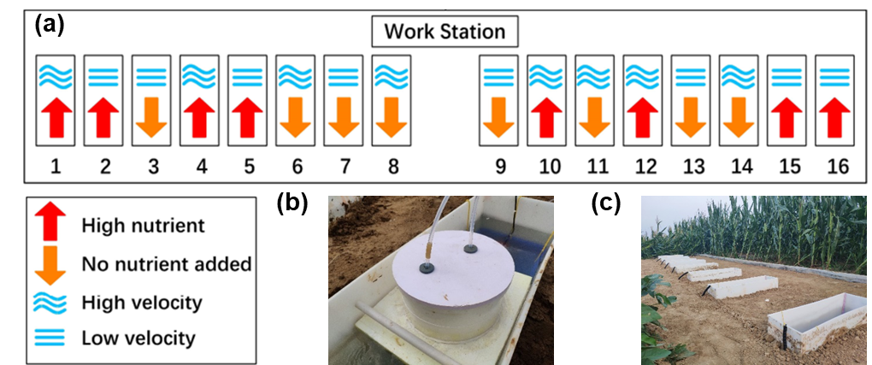

Figure S1. The illustration of the 16 experimental mesocosms arrangement (a), a photo showing the floating chamber used for direct flux measurement (b), and a photo showing the mesocosm system for the controlling experiments (c).
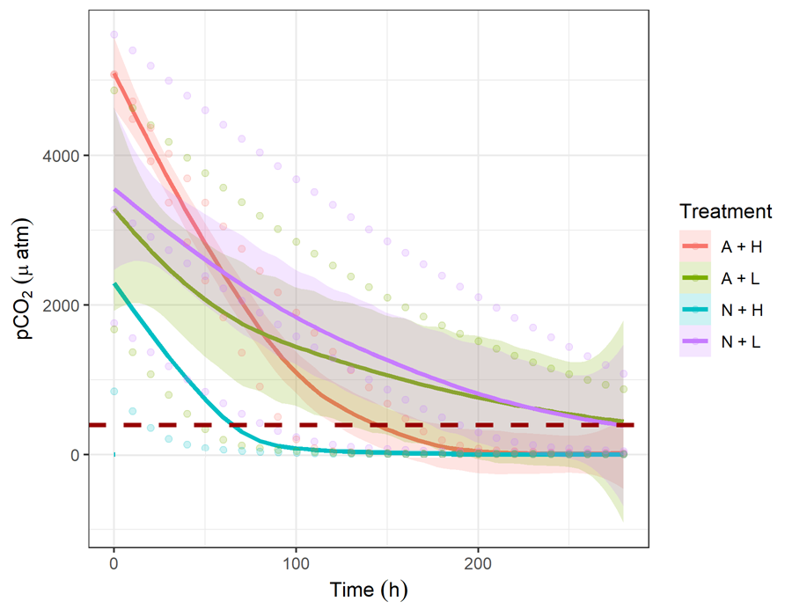

Figure S2. pCO₂ changing over time. pCO₂ could be calculated using alkalinity and DIC by the CO2SYS program. Alkalinity was measured at the beginning and in the end with a linear decrease over time. DIC is from Figure 3 (a-d). The intersection of the horizontal red dashed line (pCO_{2air} = 395 μatm) and the pCO₂ changing line indicates the time when pCO₂ under different treatments was equal to pCO₂ in the air.
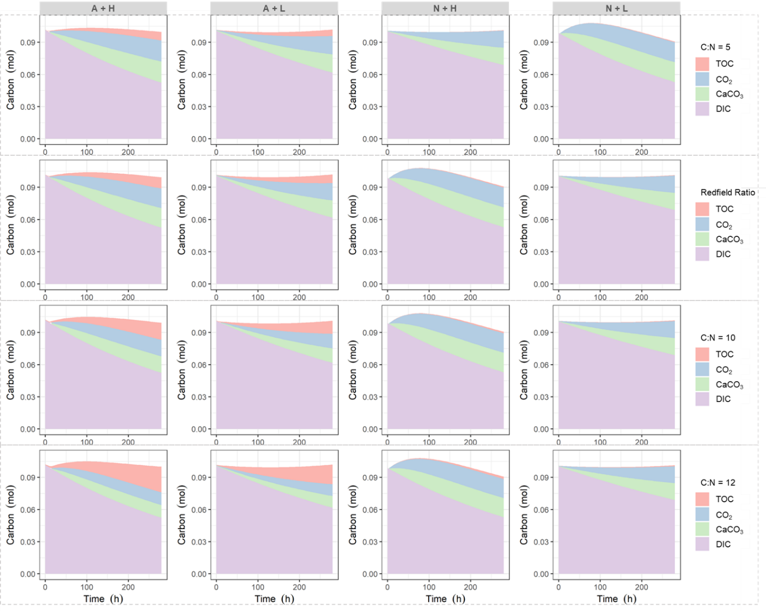

Figure S3. Stacked area of DIC, TOC, CO₂, and CaCO₃ over time under different C:N ratio (C:N = 5, Redfield Ratio, 10, and 12) among four treatments.

References
Campeau, A., & Giorgio, P. A. (2014). Patterns in CH₄ and CO₂ concentrations across boreal rivers: Major drivers and implications for fluvial greenhouse emissions under climate change scenarios. Global change biology, 20(4), 1075-1088. doi:10.1111/gcb.12479
Martin, R. M., & Moseman-Valtierra, S. (2015). Greenhouse Gas Fluxes Vary Between Phragmites Australis and Native Vegetation Zones in Coastal Wetlands Along a Salinity Gradient. Wetlands, 35(6), 1021-1031. doi:10.1007/s13157-015-0690-y

