Supplementary Material: Cerebrospinal Fluid (CSF) Proteomic Signature in Preclinical and Clinical AD: Role of Adhesion Molecules.
Reem Neal, MD¹; Zhiyi Yang, PhD¹, Malik Obideen, MD¹, Melissa Peterson, PhD², Amil Shah, MD³, Ihab Hajjar, MD^{1,3}

¹ Department of Neurology, University of Texas Southwestern Medical Center, Dallas, Texas, USA 75390.
² Family Medicine and Osteopathic Manipulative Medicine, Texas College of Osteopathic Medicine, The University of North Texas Health Science Center
³Department of Medicine, University of Texas Southwestern Medical Center, Dallas, Texas, USA, 75390.

Figures:
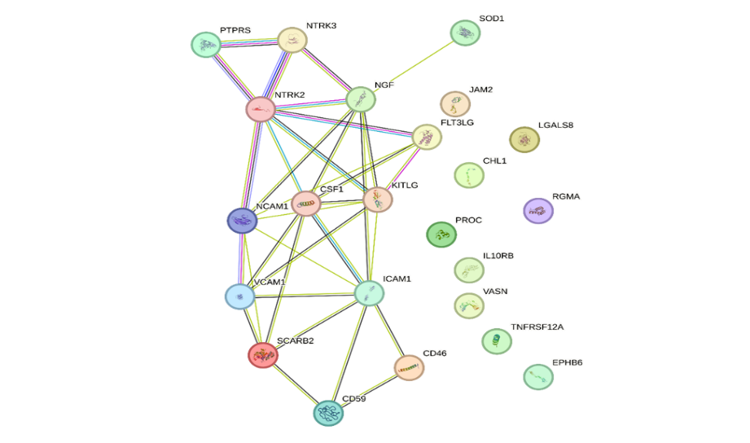
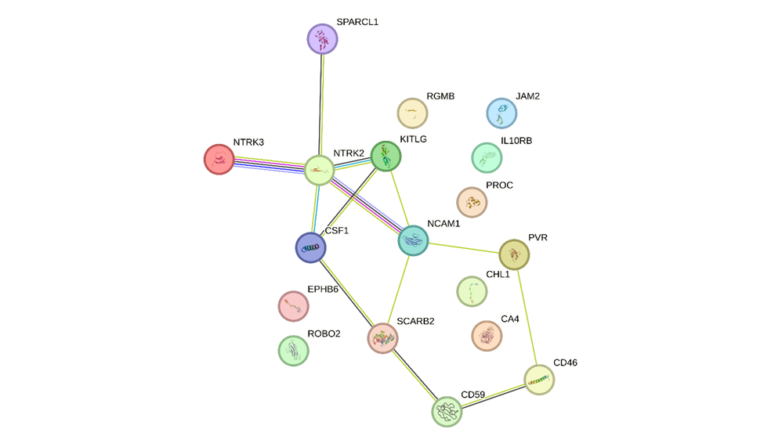
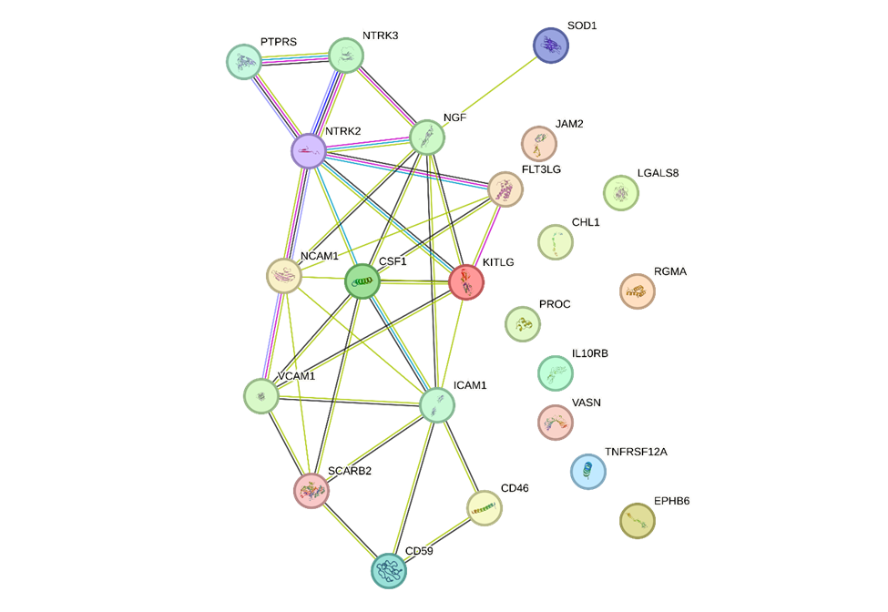
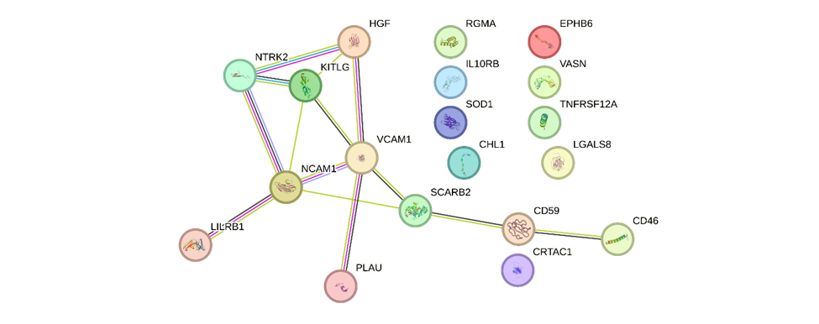
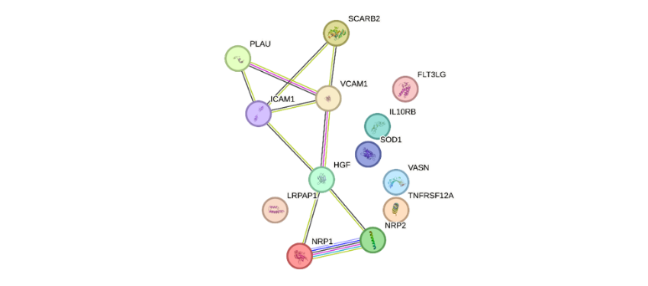
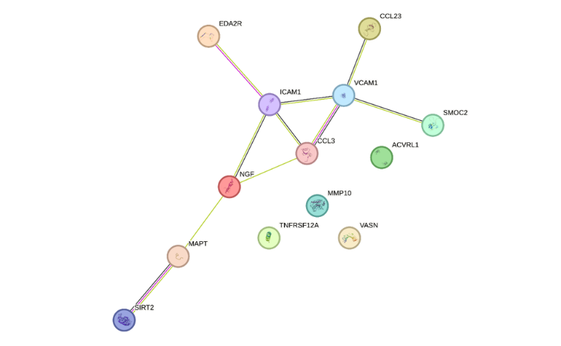
Figure S. 1: Hub proteins PPI networks:
Tau
AB42
pTau
TAR
TAR & Cognitive Status
Progressors
Figure S. 2: Box Plots of Critical Proteins progressors and MCI diagnosis:
MCI Diagnosis
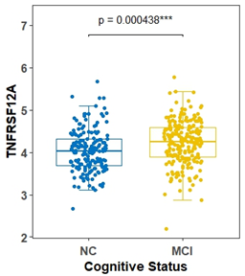

Disease Progression
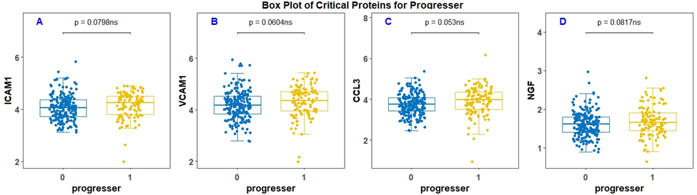

Figure S.3: Box Plots of Critical Proteins (Plasma) for Cognitive Status and Tau/Aβ-42
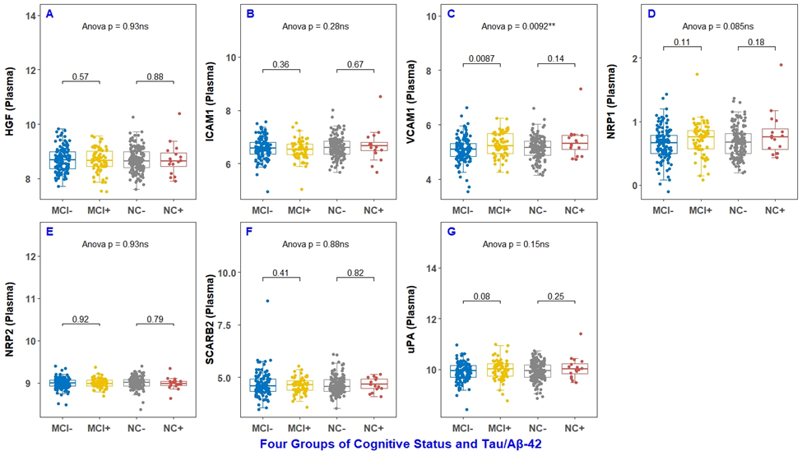

Tables:
Table S.1: Pearson Correlation of AD blood-based biomarkers BSHARP cohort
Pearson Correlation Coefficients
Prob > |r| under H0: Rho=0
Number of Observations
Characteristic | ICAM1 | VCAM1 | NCAM1
Aβ42 | 0.19 | 0.15 | 0.04
Aβ42 | 0.01 | 0.03 | 0.57
Aβ42 | 189 | 189 | 189
Tau | 0.18 | 0.18 | 0.02
Tau | 0.01 | 0.02 | 0.75
Tau | 188 | 188 | 188
pTau | 0.08 | 0.09 | 0.11
pTau | 0.24 | 0.19 | 0.12
pTau | 210 | 210 | 210

Table S.2: Pearson Correlation of AD blood-based biomarkers HBS-HD cohort
Pearson Correlation Coefficients
Prob > |r| under H0: Rho=0
Number of Observations
Characteristic | ICAM1 | VCAM1 | NCAM1
Aβ42 | 0.01 | 0.16 | 0.09
Aβ42 | 0.84 | <0.0001 | 0.04
Aβ42 | 997 | 997 | 481
Tau | 0.09 | 0.18 | -0.03
Tau | 0.004 | <0.0001 | 0.48
Tau | 998 | 998 | 481
pTau | -0.04 | 0.16 | 0.06
pTau | 0.24 | <0.0001 | 0.22
pTau | 972 | 972 | 477

Abbreviations: MCI: Mild Cognitive Impairment, , NC: Normal cognition, ICAM: Intercellular Adhesion Molecule 1, VCAM: Vascular Adhesion Molecule 1, CCL3: C-C Motif Chemokine Ligand 3, NGF: Nerve Growth Factor.
Abbreviations: Aβ42: Amyloid-β42, Tau: Tau protein, pTau: Phosphorylated Tau protein, HGF: Hepatocyte growth factor, ICAM: Intercellular Adhesion Molecule 1, VCAM: Vascular Adhesion Molecule 1, NRP-1: Neuropilin 1, NRP-2: Neuropilin 2, SCARB2: Scavenger Receptor Class B Member 2, PLAU: Plasminogen Activator, Urokinase.
Abbreviations: Aβ42: Amyloid-β42, Tau: Tau protein, pTau: Phosphorylated Tau protein, , ICAM: Intercellular Adhesion Molecule 1, VCAM: Vascular Adhesion Molecule 1, NCAM: Neural Adhesion Molecule 1
Abbreviations: Aβ42: Amyloid-β42, Tau: Tau protein, pTau: Phosphorylated Tau protein, , ICAM: Intercellular Adhesion Molecule 1, VCAM: Vascular Adhesion Molecule 1, NCAM: Neural Adhesion Molecule 1

