Supplementary Information

Supplementary Texts S1. Innovations
I-Viewer offers the following innovation as a cloud-based framework to facilitate collaboration between pathologists and AI algorithms (Table 1).

Advanced copilot system with Agentic-RAG. I-Viewer initially integrated three high-performance agents to handle various pathological tasks across different magnifications. Specifically, I-Viewer: 1) utilized HD-Yolo for nuclei classification, detection, and segmentation; 2) provided HD-LLaVA and GPT-4V/4o for ROI-level image captioning; 3) integrated TME feature extraction pipelines to analyze nuclei morphologies, distributions, and interactions with the surrounding environment. All these agents, along with any additional user-provided agents, were supervised by the I-Viewer Agentic-RAG router. The RAG system selected the most relevant agents to address user prompts and used LLaMA3 and GPT-4 to summarize results, resolve conflicts, and provide informative responses. By using the RAG system to facilitate communication between users and AI agents, I-Viewer increased response efficiency and reduced errors and hallucinations.

Flexible visualization for pathologists and researchers. I-Viewer proposed a high-performance frontend plugin to organize and render annotations across different zoom levels. Users could seamlessly explore pathological images and interact with extensive annotations contributed by various users, AI agents, and projects. This capability enabled detailed examination and comparison of model performances through a dual viewer interface.

Supporting simultaneous collaboration. I-Viewer supported cross-platform collaborations, enabling multiple users, including pathologists, trainees, and AI copilots, to collaborate, annotate, and communicate on shared slides and projects. Additionally, the system distinguished between human comments and AI-generated content, ensuring the authenticity and reliability of the information.

Streamlined model calibration. I-Viewer supported model registration and offers flexible database APIs for machine learning engineers to retrieve annotations for model development. This framework facilitated convenient data collection, denoising, and formatting, as well as model fine-tuning and downstream analysis, effectively reducing the lifecycle of model development and calibration.

Enhanced data security, user authentication, and authorization: Pathology slides are often associated with private information. To fulfill the need for data security and AI analysis, I-Viewer was designed to apply Cross-Origin Resource Sharing (CORS) and de-identification techniques. These methods minimized unnecessary data transfers and ensured the confidentiality of sensitive information. In addition, I-Viewer assigned user roles defined with preset permissions. Administrators could add, edit, and delete users, groups, and APIs, and assign different image batches for various groups to view, while members had restricted permissions to view images and annotations only. This approach improved security and efficiently managed access.

Supplementary Texts S2. Extending I-Viewer
The function of I-Viewer can be extended in 4 steps:
Step 1: Create a GeneratorAgent. The GeneratorAgent facilitates communication between the security proxy server and the analysis service. When a user triggers an analysis event, the GeneratorAgent decodes incoming requests and uses the proxy server to fetch information such as bounding boxes, images, and user inputs from the slide gallery and databases. If this agent registry requires real-time responses to frontend requests, users can directly call the analysis_online interface in the AnalysisAgent to fetch the analysis results. For high-latency agents or those resulting in large-volume transactions, it is recommended to send the serialized data used for analysis into message queue system and utilize the analysis_offline interface in AnalysisAgent.

Step 2: Build an AnalysisAgent. The AnalysisAgent encapsulates the pipeline to analyze given inputs (e.g., image, text) and provides agent level results to I-Viewer. If the analysis pipeline requires real-time responses, the analysis_online interface functions as a normal predictor entry point and directly returns the outputs. If the pipeline requires offline analysis, the analysis_offline interface fetches the serialized inputs from the message queue and exports the outcomes to the databases. Users can later observe the results when the frontend pulls annotations from the database. To avoid duplicated computing, the queue system stores incoming queries in the database and skips inputs that have already been analyzed.

Step 3: Deploy the agents through ModelRegistry. After defining the GeneratorAgent and the AnalysisAgent, users can initiate and register the agent through our ModelRegistry. The registered analysis is assigned a specific name with version control. The agent will be then dockerized as asynchronous microservices, and the server and route information is registered into the API control system.

Step 4: Assign the upstream and downstream tasks of the agent (optional). To fully utilize the I-Viewer Agentic-RAG system, users can assign upstream and downstream tasks and provide language prompts for specific agents. After registering the agent interconnection information within the RAG system, users can trigger agents using language prompts. The RAG system will identify the trigger criteria based on the language prompt and automatically execute linked agents in topological order. Thus, users can access new customer services via both frontend API calls and language prompts through the AI copilot.

Supplementary Figure 1. Prompts used for Foundation Model Evaluation. System prompts used in the I-Viewer AI Copilot system.
System prompt: You possess comprehensive training in surgical pathology and possess an adept understanding of the visual elements present in Hematoxylin and Eosin (H&E) images. Utilizing histological terminology, analyze the histology features, patterns, and nuclei morphologies depicted in the images. Provide a comprehensive summary addressing the following aspects based on the content of the images:

Prompt 1: Interpret the tumor interface and describe the growth patterns, secondary structures/architectural.

Prompt 2: Identify and characterize cellular/nuclear/cytoplasmic morphological features.

Summary prompt: Generate histology descriptions and provide insights based on the above information.

Supplementary Figure 2. Extending the I-Viewer System with Customized Pipelines Using Abstract Classes and Interfaces.
We provided a code skeleton that includes the basic steps for users to incorporate specific analysis extensions into the I-Viewer System. The I-Viewer system has a predefined abstract class and model registry interface, which allows users to add their own offline and online analysis functions.
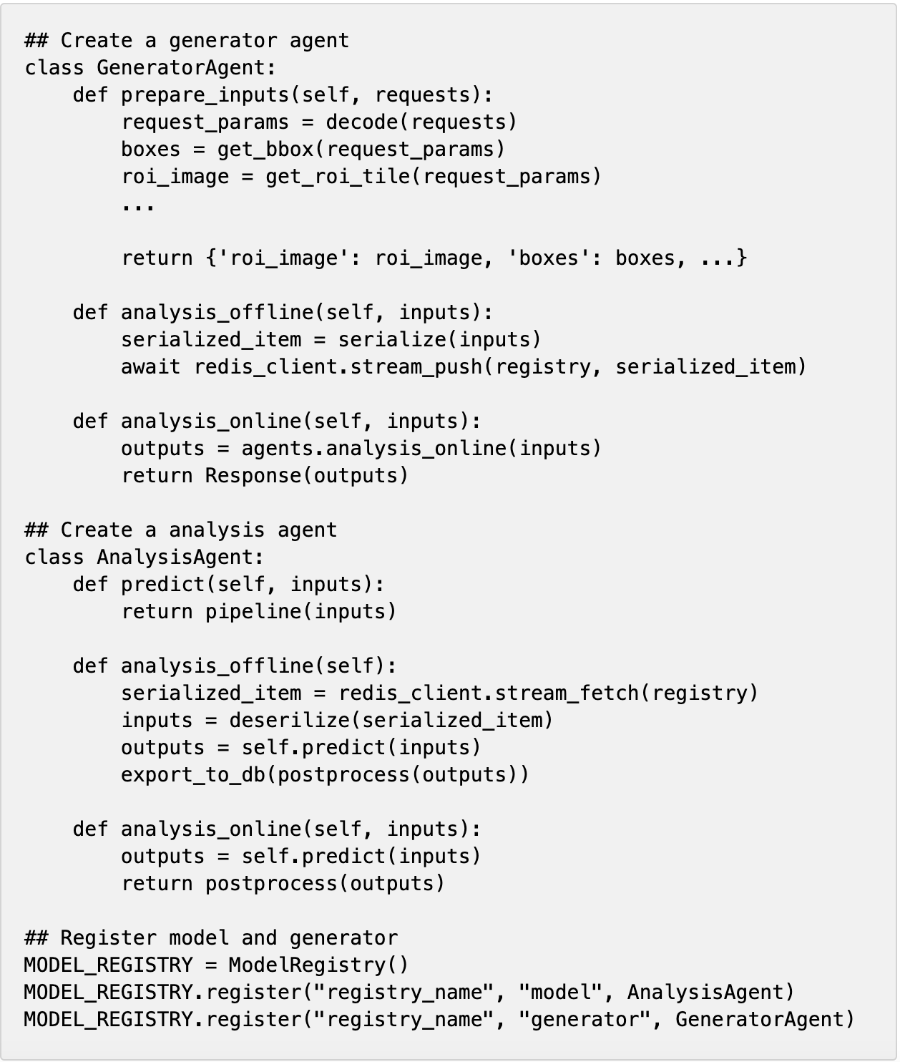

Supplementary Figure 3. The Overall Workflow of I-Viewer.
The gray block represents the user and project management system; the light blue block denotes the frontend functionalities; and the orange block shows the backend services. Blue arrows depict the workflow and interactions between different components of the user interface; green arrows display the workflow of AI agents and the copilot for histological analysis; and red dotted arrows illustrate the AI model refinement process incorporating human feedback.
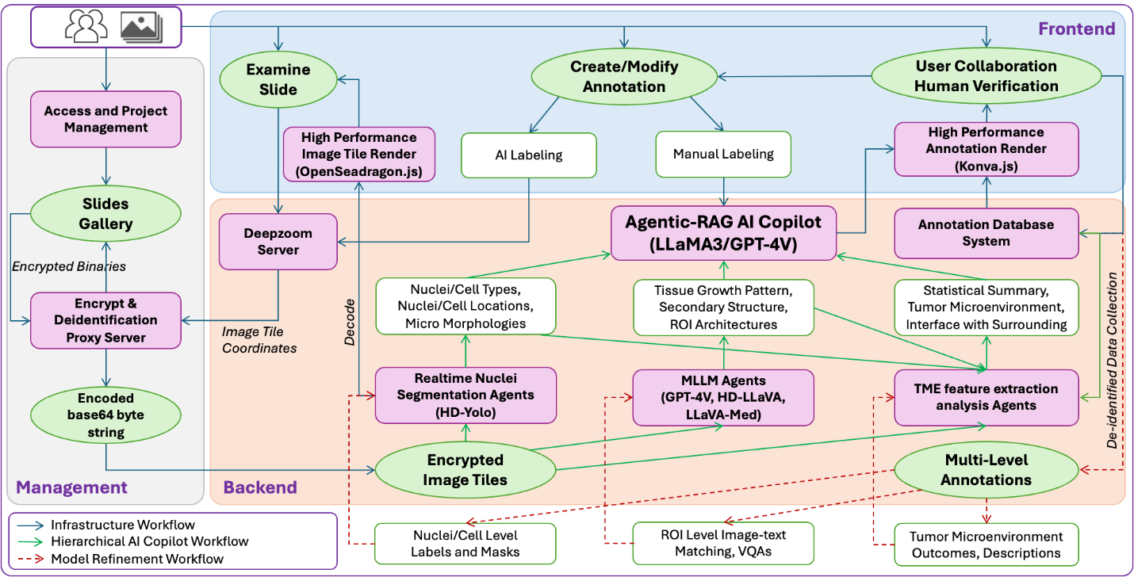

Supplementary Video 1. Real-time Nuclei Segmentation Demonstration using I-Viewer.
We created a screencast demonstrating how users can utilize the HD-Yolo agent in I-Viewer. The video is publicly available on YouTube: https://youtu.be/bgI6hzfOBzU?si=XXMJpWq1_3-8a7cd

Supplementary Video 2. Interacting with Agentic-RAG AI Copilot System in I-Viewer.
We have produced a screencast that showcases how users can engage with the Agentic-RAG AI Copilot system in I-Viewer. The video is publicly available on YouTube: https://youtu.be/5D8wHQDhEj8?si=_q13wOFUflRBnkeM

