Supplementary file 3
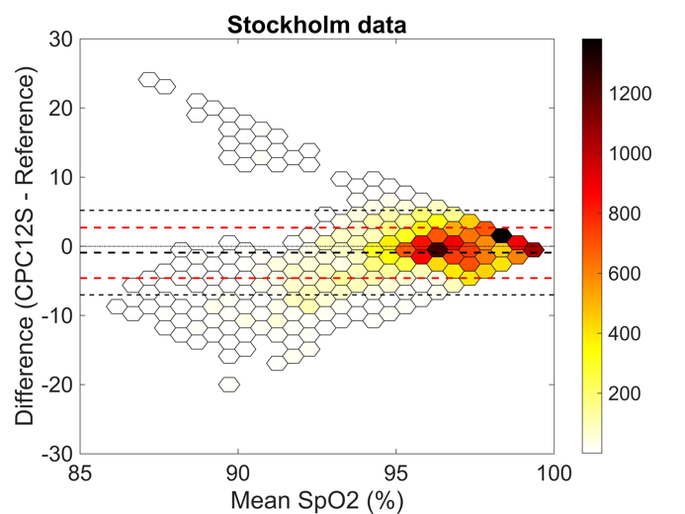
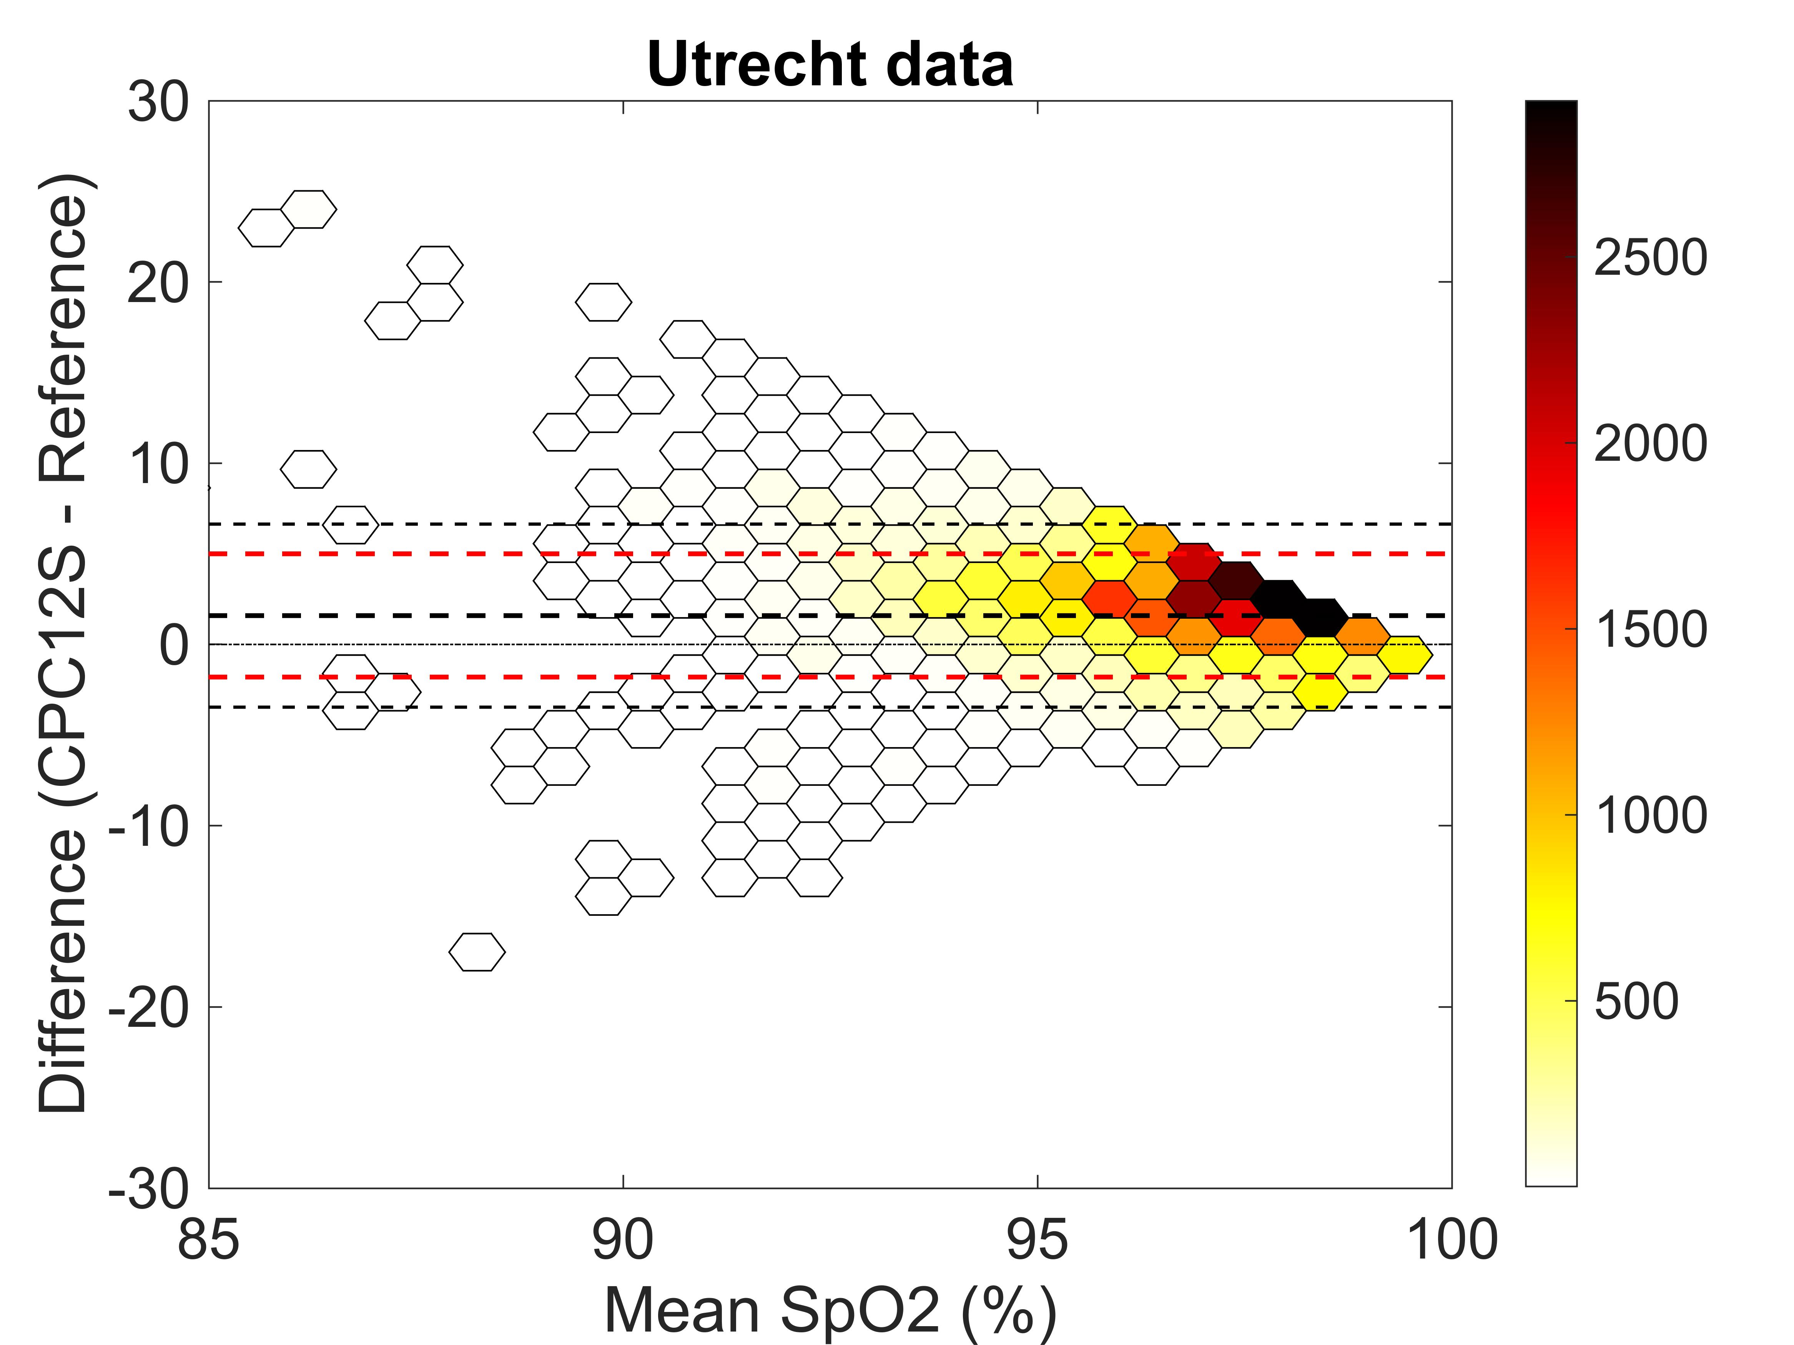

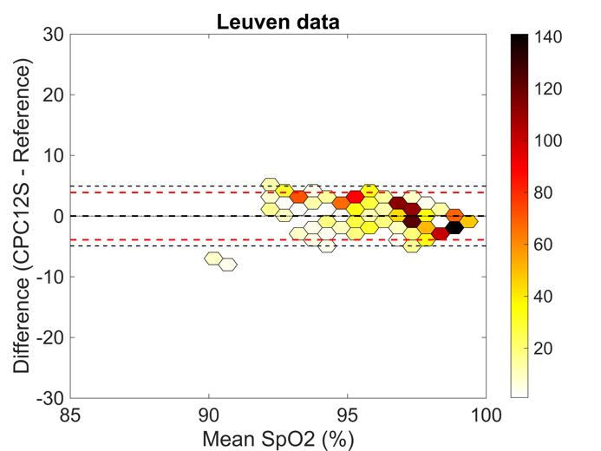
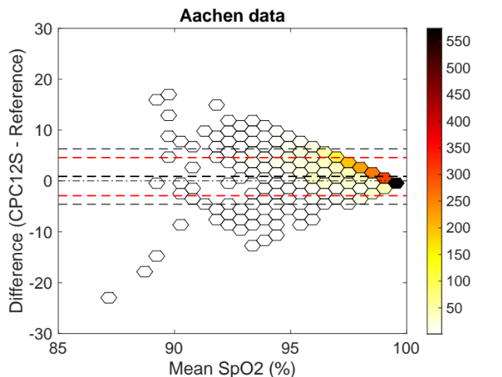
Fig. 8a-d Bland-Altman plots of oxygen saturation for Utrecht, Stockholm, Aachen and Leuven respectively. Bias from the Bland-Altman method in black, and limits of agreement from mixed effects models in red.

