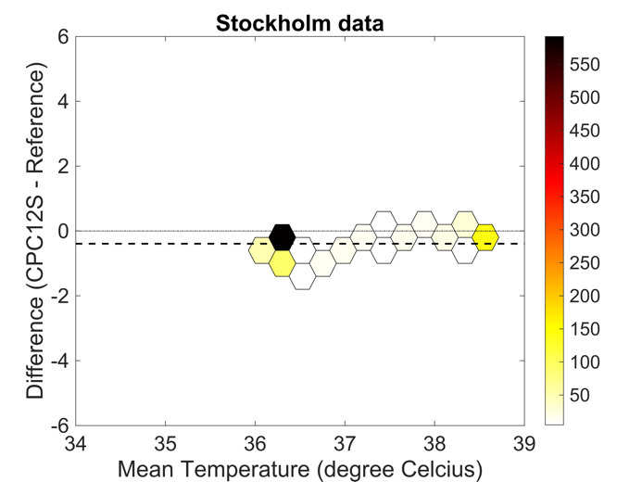
Supplementary file 5
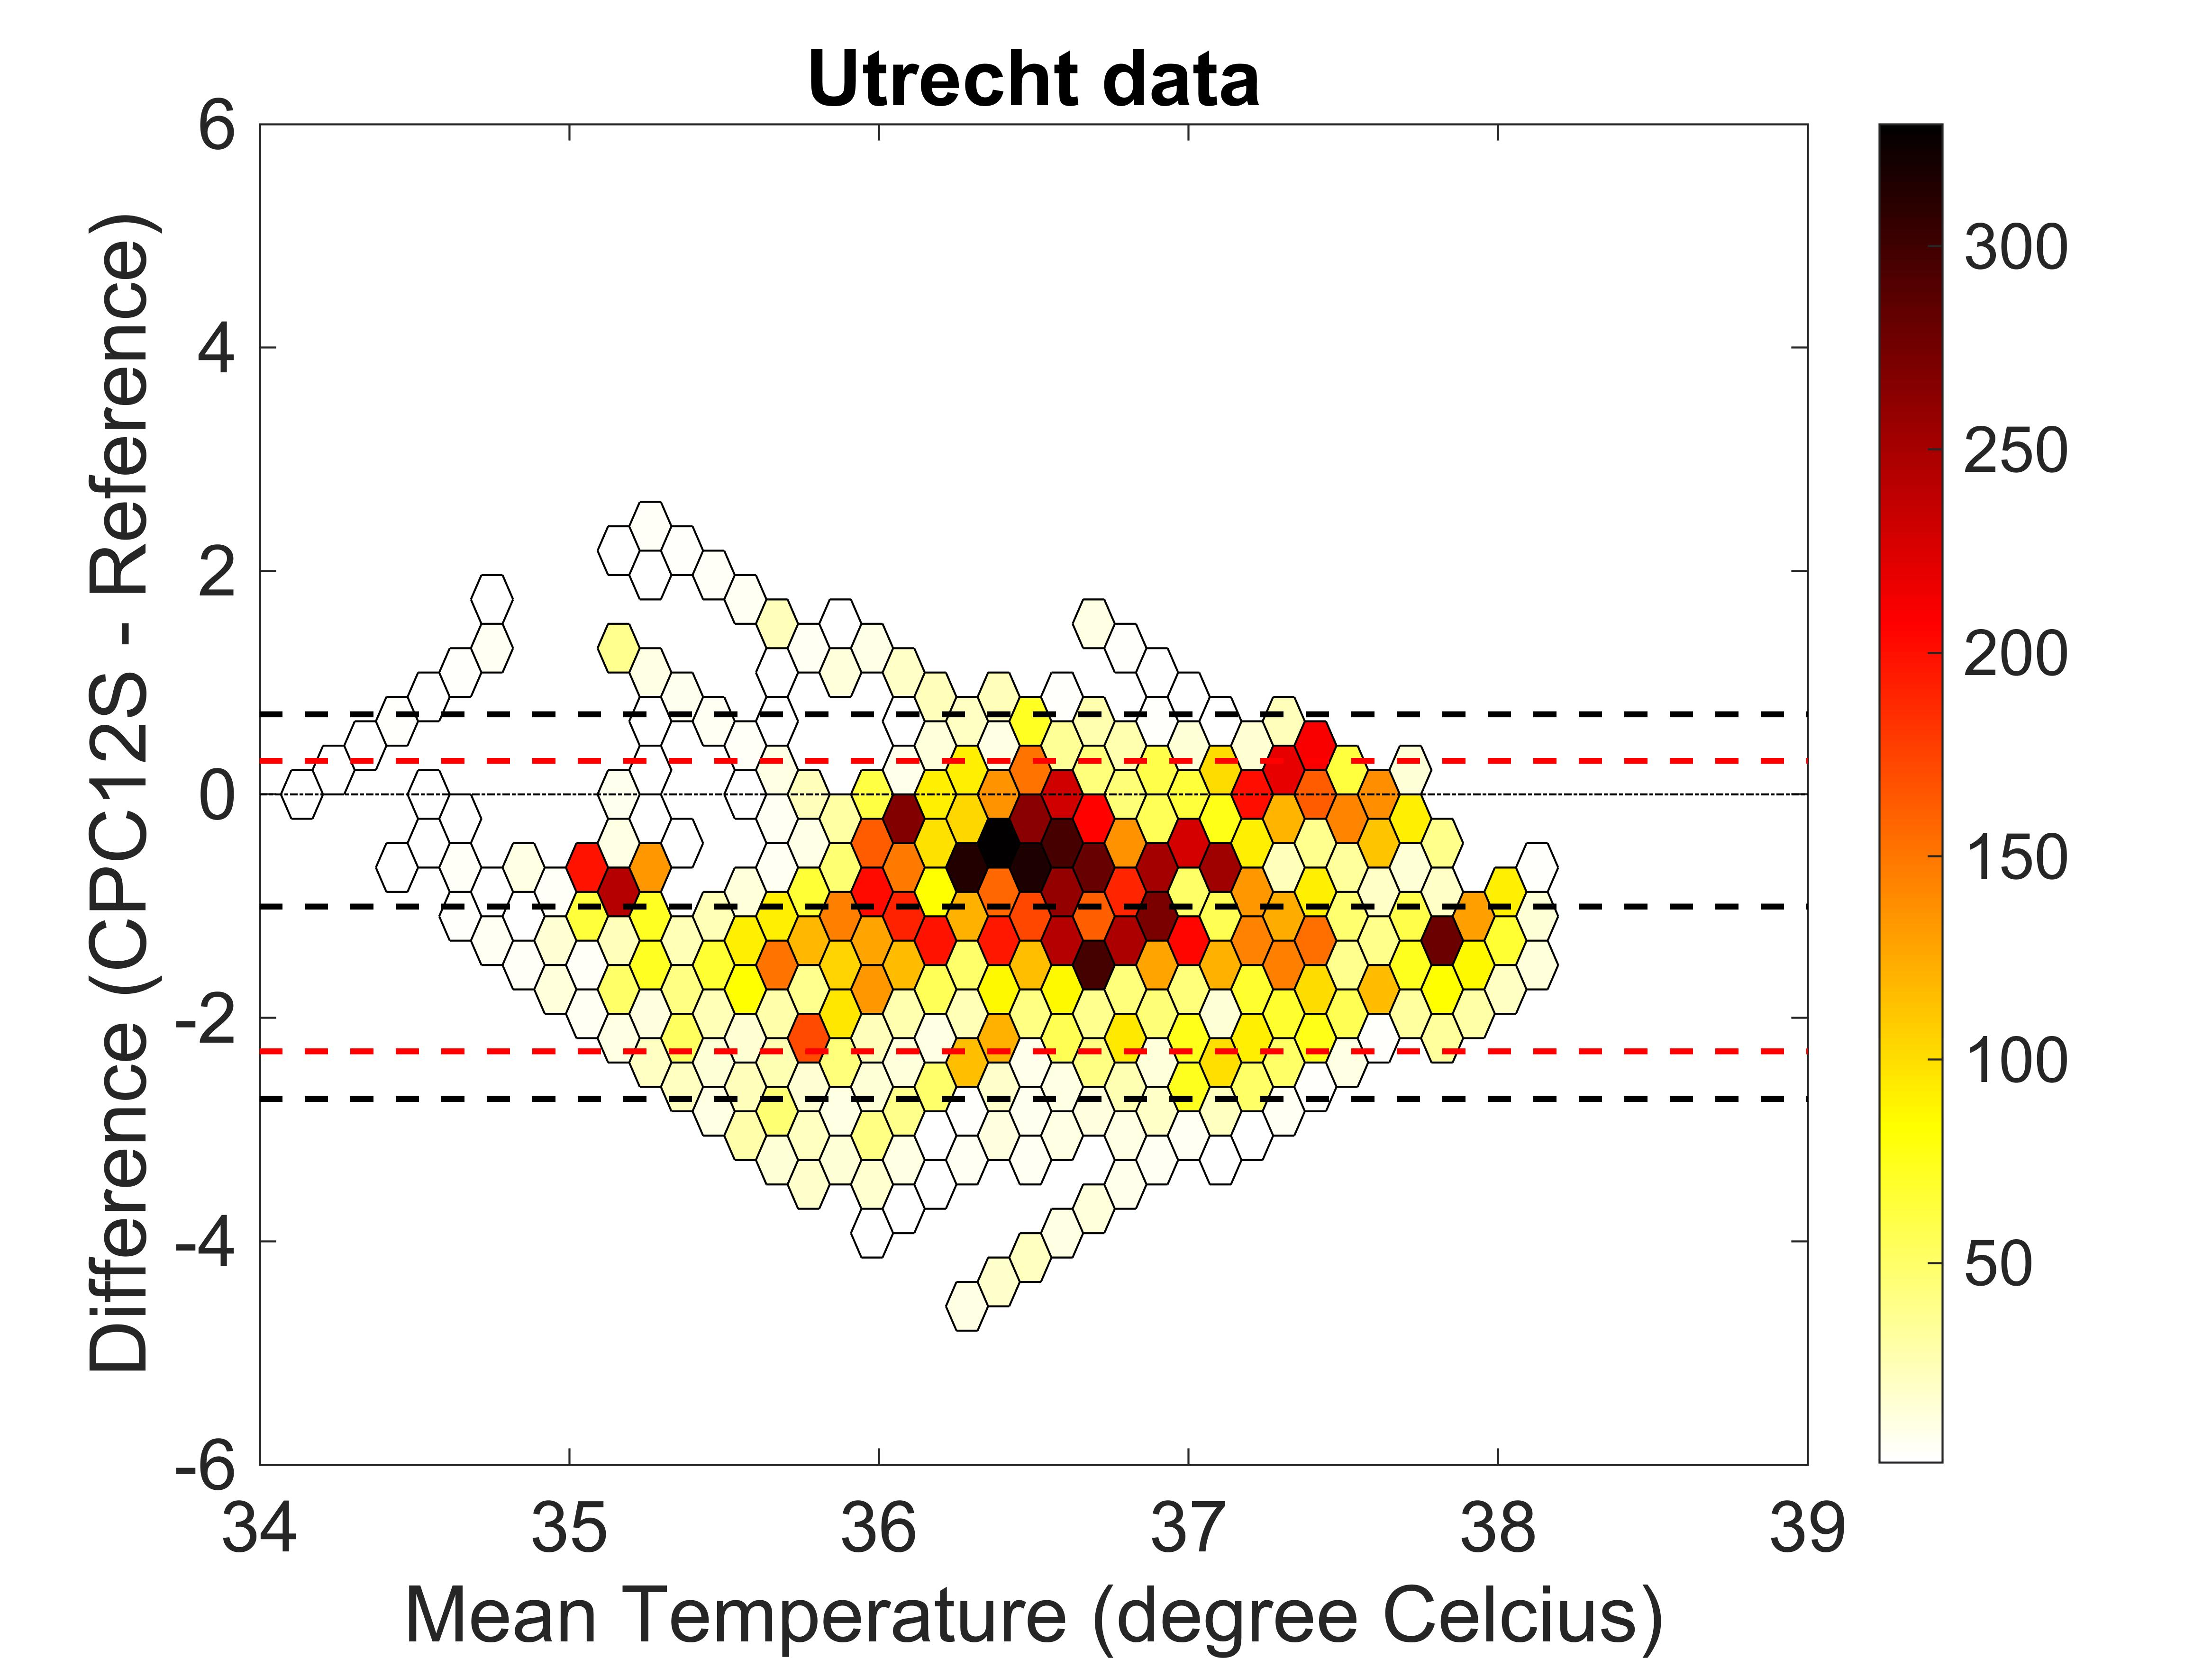
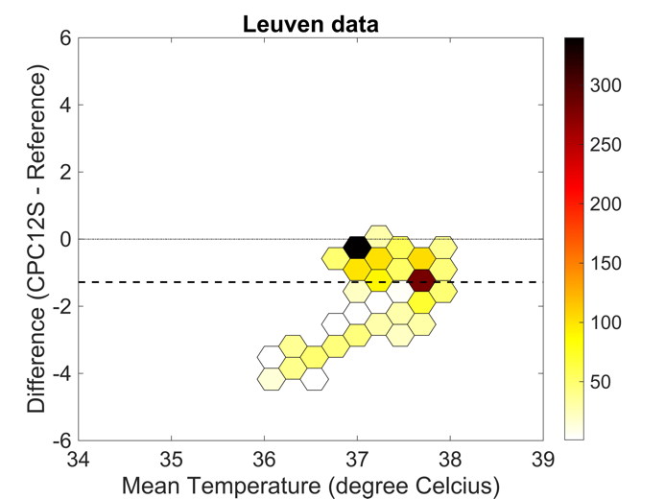
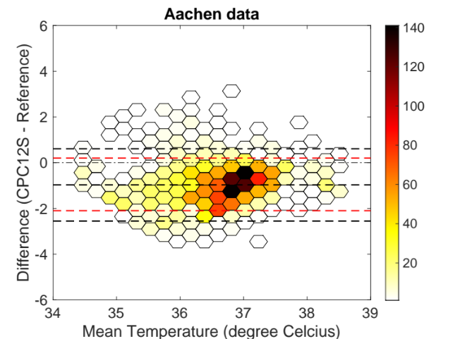

Fig. 10a-d Bland- Altman plots of temperature measurements for Utrecht, Stockholm, Aachen and Leuven respectively. Bias from the Bland-Altman method in black (if present), and limits of agreement from mixed effects models in red (if present).

