Supplementary file 1
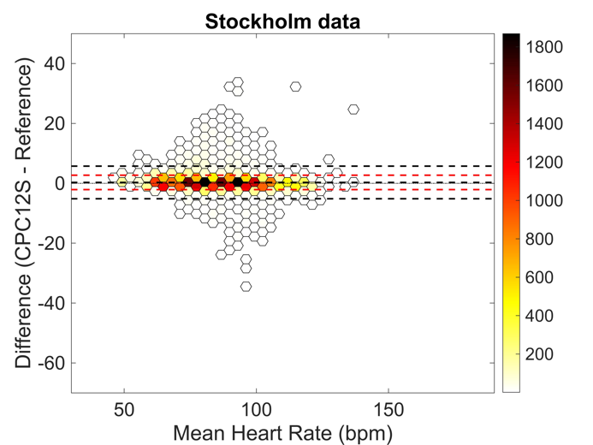
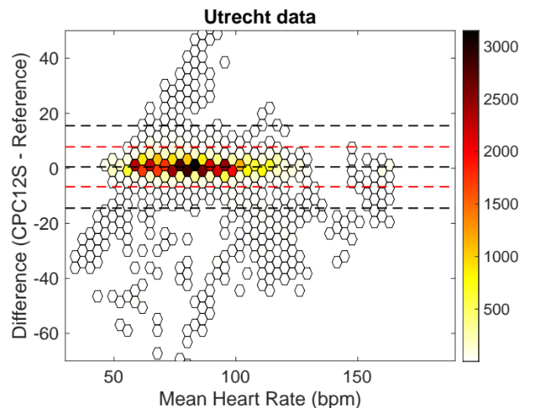
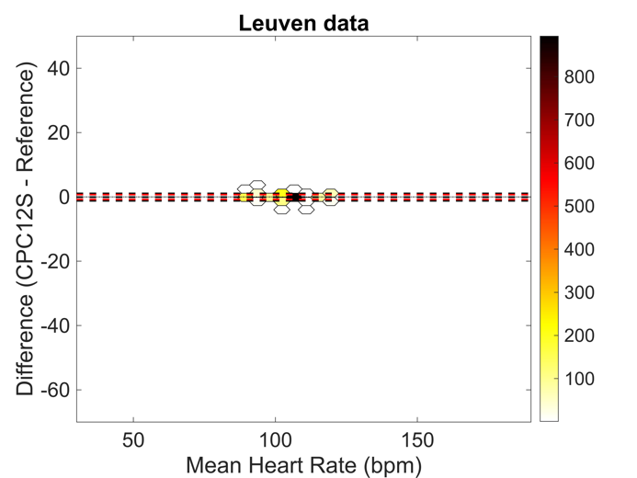
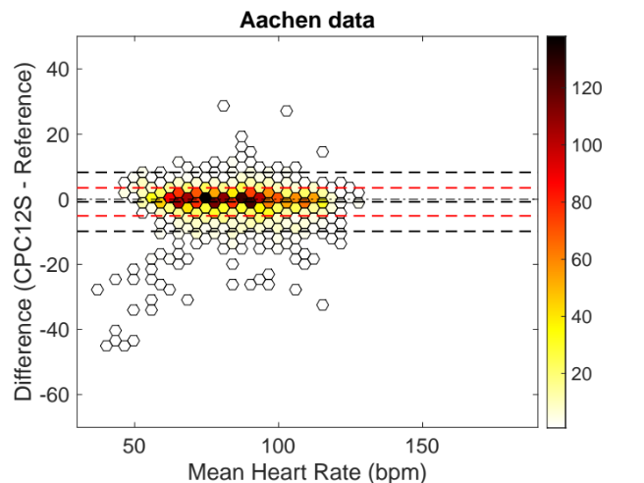

Fig. 6a-d Bland-Altman plots of heart rate for Utrecht, Stockholm, Aachen and Leuven respectively. Bias from the Bland-Altman method in black, and limits of agreement from mixed effects models in red.

