Supplementary file 4
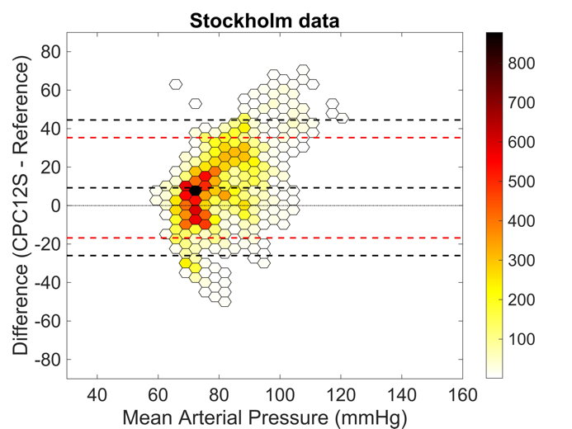
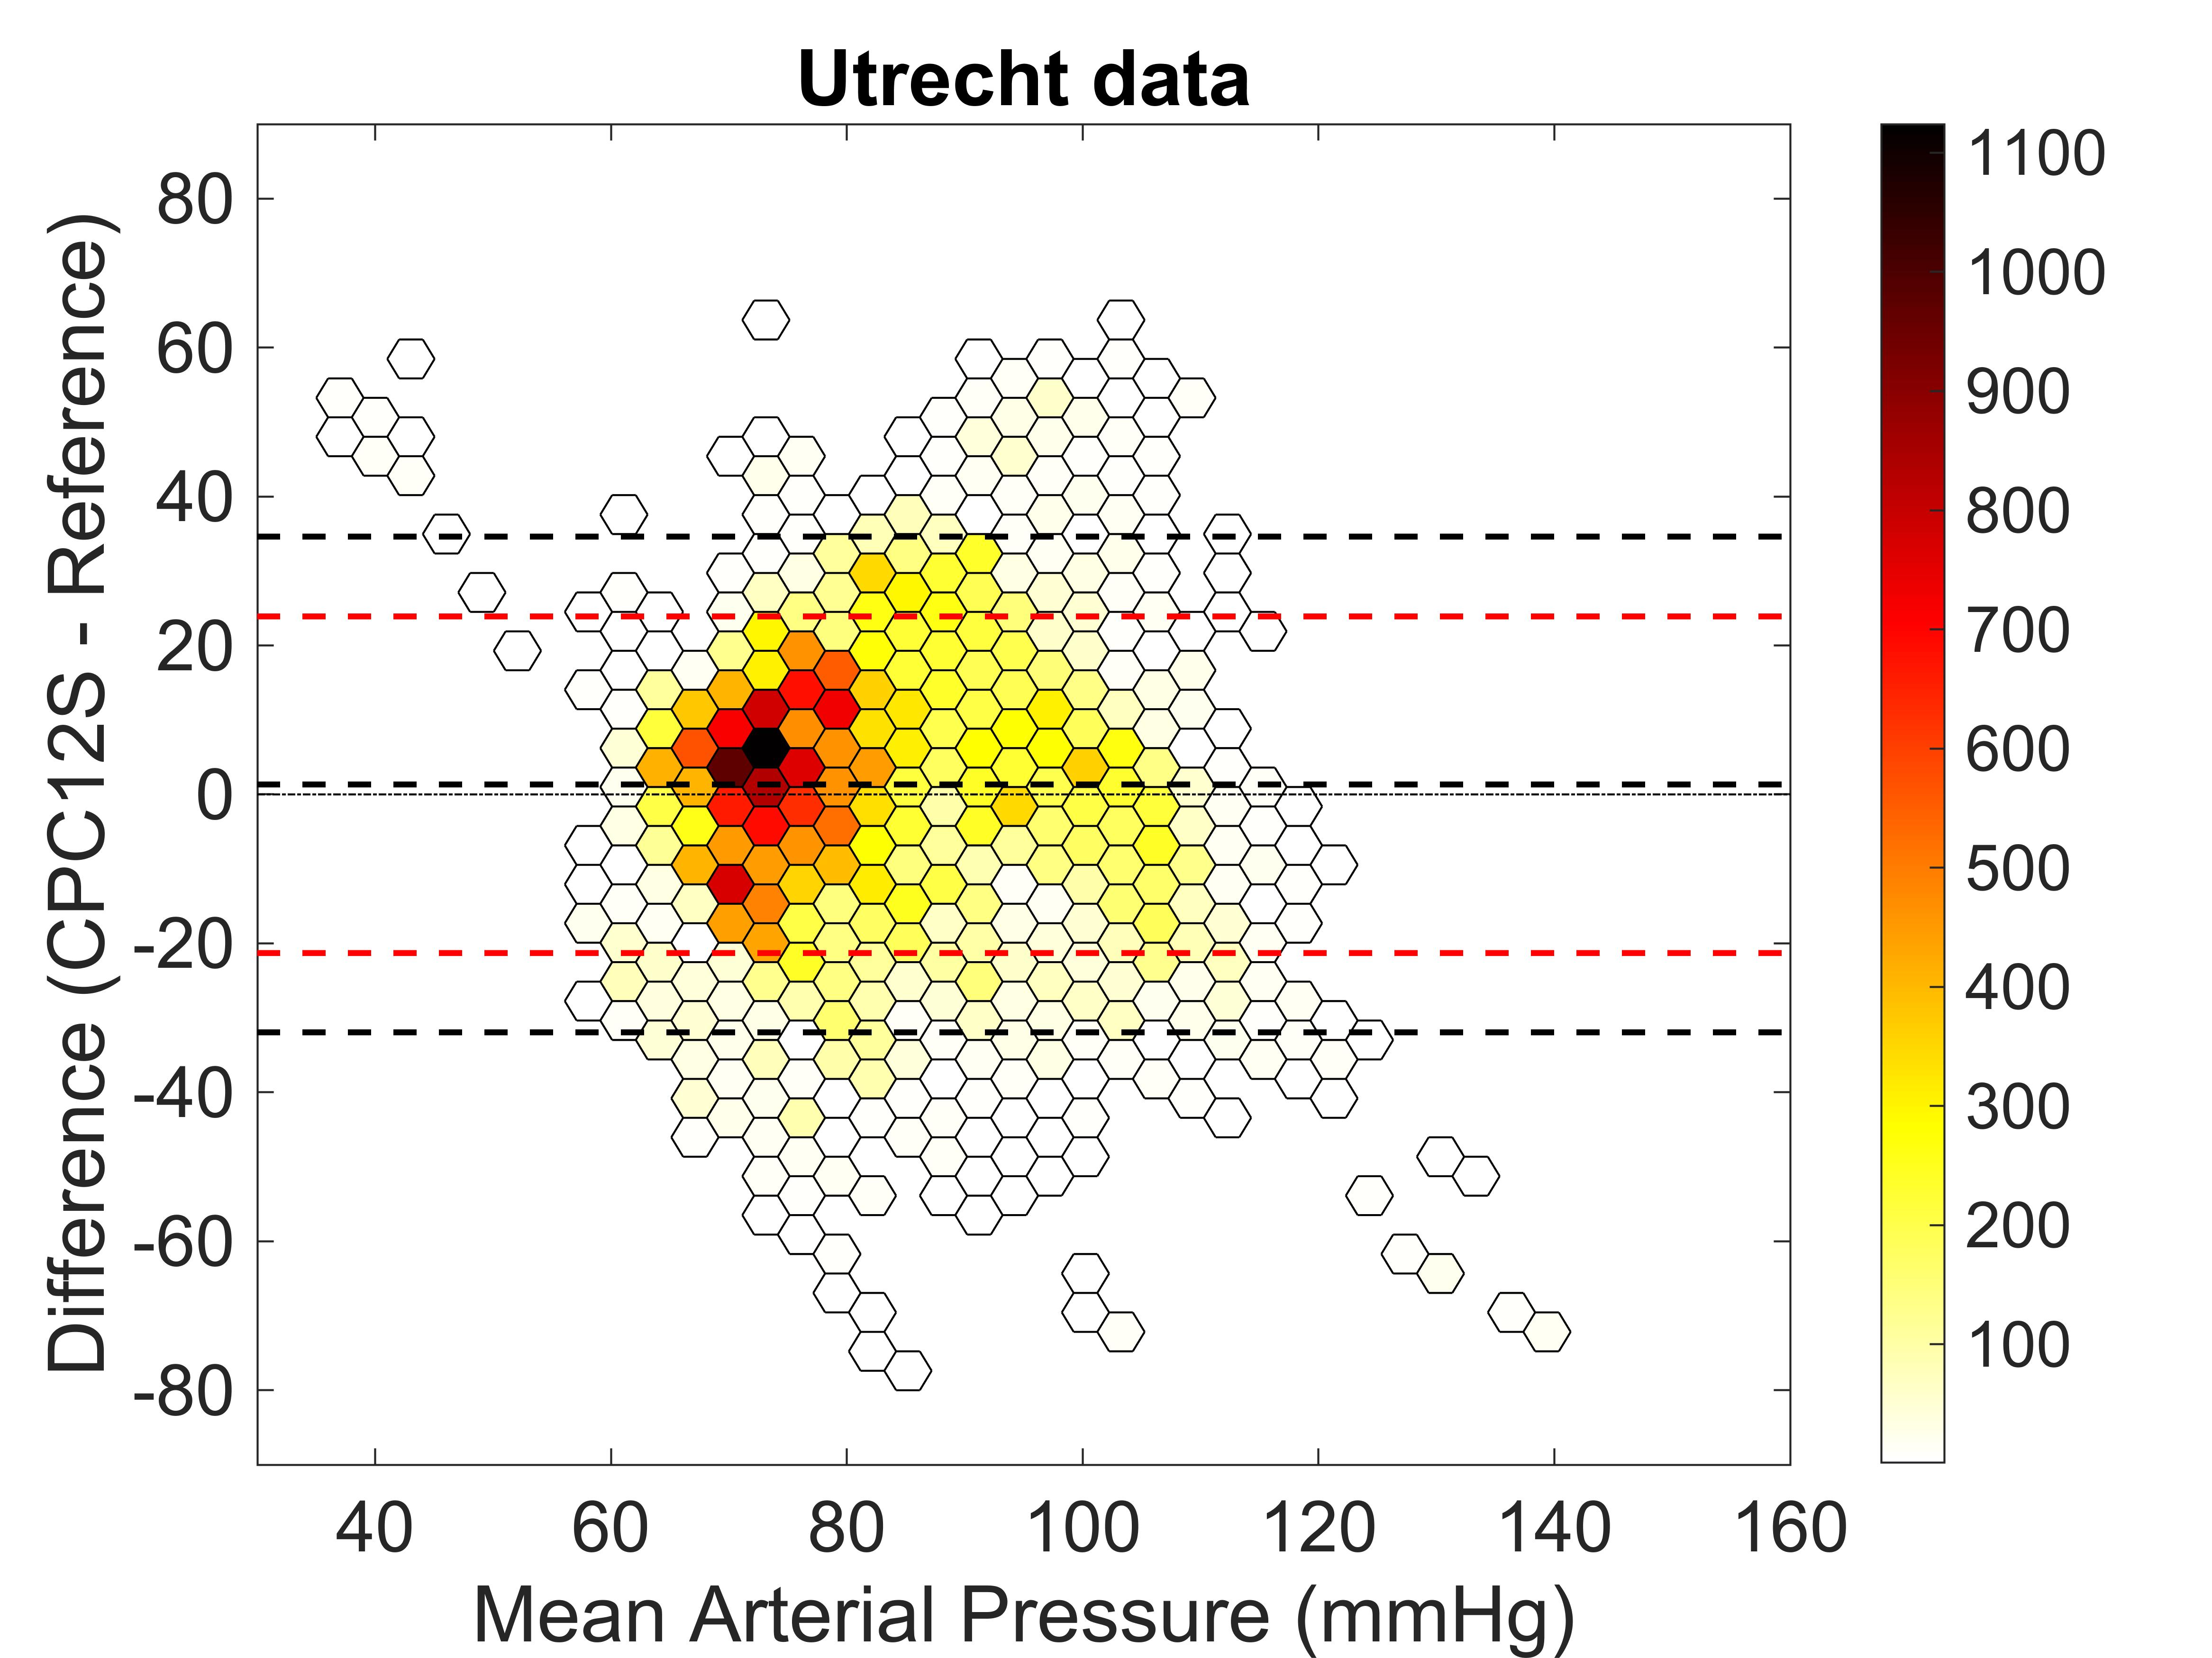

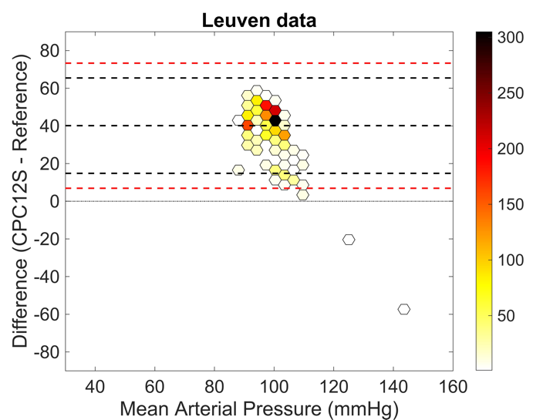
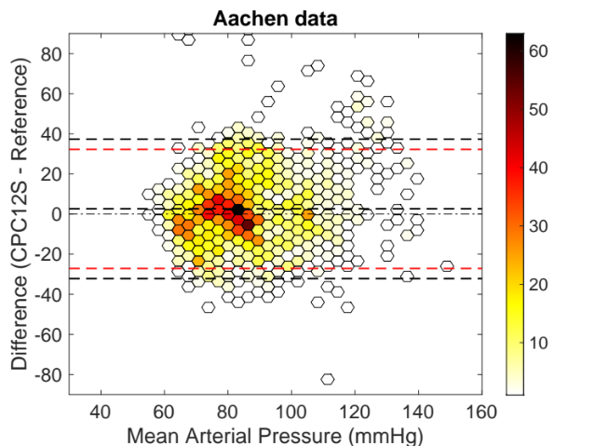

Fig. 9a-d Bland-Altman plots of mean arterial blood pressure measurements for Utrecht, Stockholm, Aachen and Leuven respectively. Bias from the Bland-Altman method in black (if present), and limits of agreement from mixed effects models in red (if present).

