Supplementary information
Supplementary material (.pdf)
Supplementary Fig. 1 Transcriptomic profiling of TDP-43^{A382T} and TDP-43^{G348C} MNs
Supplementary Fig. 2 miRNAs profiling and integrated miRNA/mRNA analysis highlight protocadherin-coding genes
Supplementary Table 1. Overview of iPSC lines used
Supplementary Table 2. List of primers and TaqMan probes
Supplementary Table 3. Shared differentially expressed genes
Supplementary Table 4. Shared dysregulated miRNAs and genomic location
Supplementary Table 5. Predicted TDP-43 binding sites by the RBPmap database
Supplementary Table 6. Top-scoring predicted compounds by the CMap database
Supplementary references

Supplementary Data 1 (.xls)
Differentially expressed genes from RNA-seq experiments

Supplementary Data 2 (.xls)
Differentially expressed miRNAs from small RNA-seq experiments

Supplementary Data 3 (.xls)
Predicted targets of dysregulated miRNAs by the miRGate database

Supplementary Data 4 (.xls)
CMap τ scores outputs

Supplementary Figures
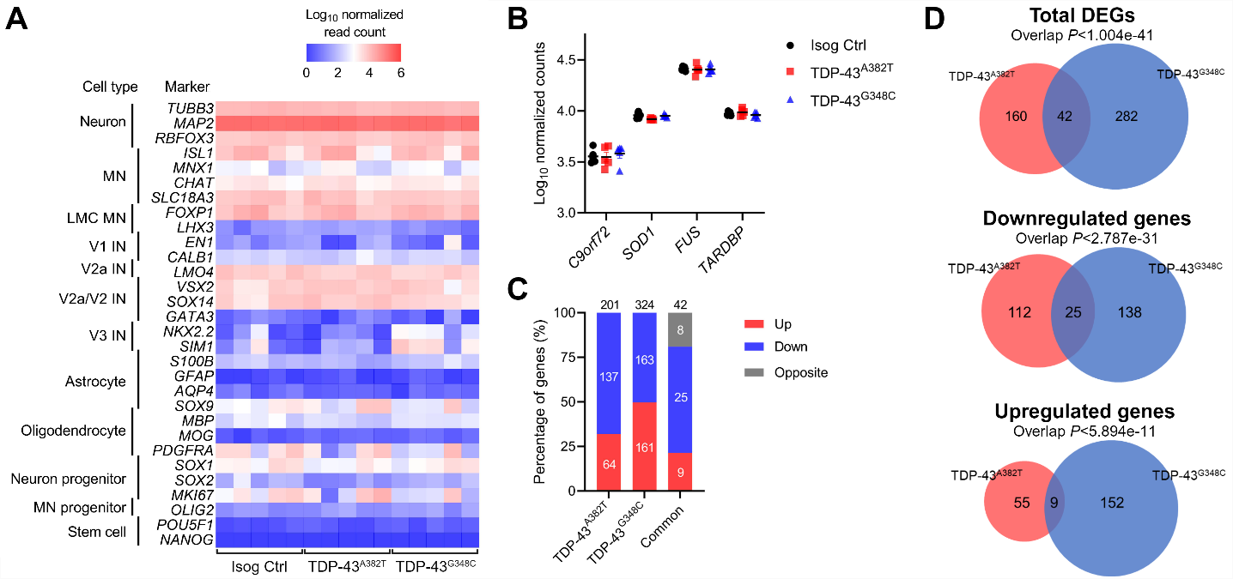

Supplementary Fig. 1 Transcriptomic profiling of TDP-43^{A382T} and TDP-43^{G348C} MNs. a Heatmap of normalized counts of cell type markers determined by RNA-seq. b Normalized counts of ALS-associated genes. c, d Stacked bar graph (c) and Venn diagram (d) comparing differentially expressed genes (DEGs) in TDP-43 MNs relative to isogenic control. n=5.

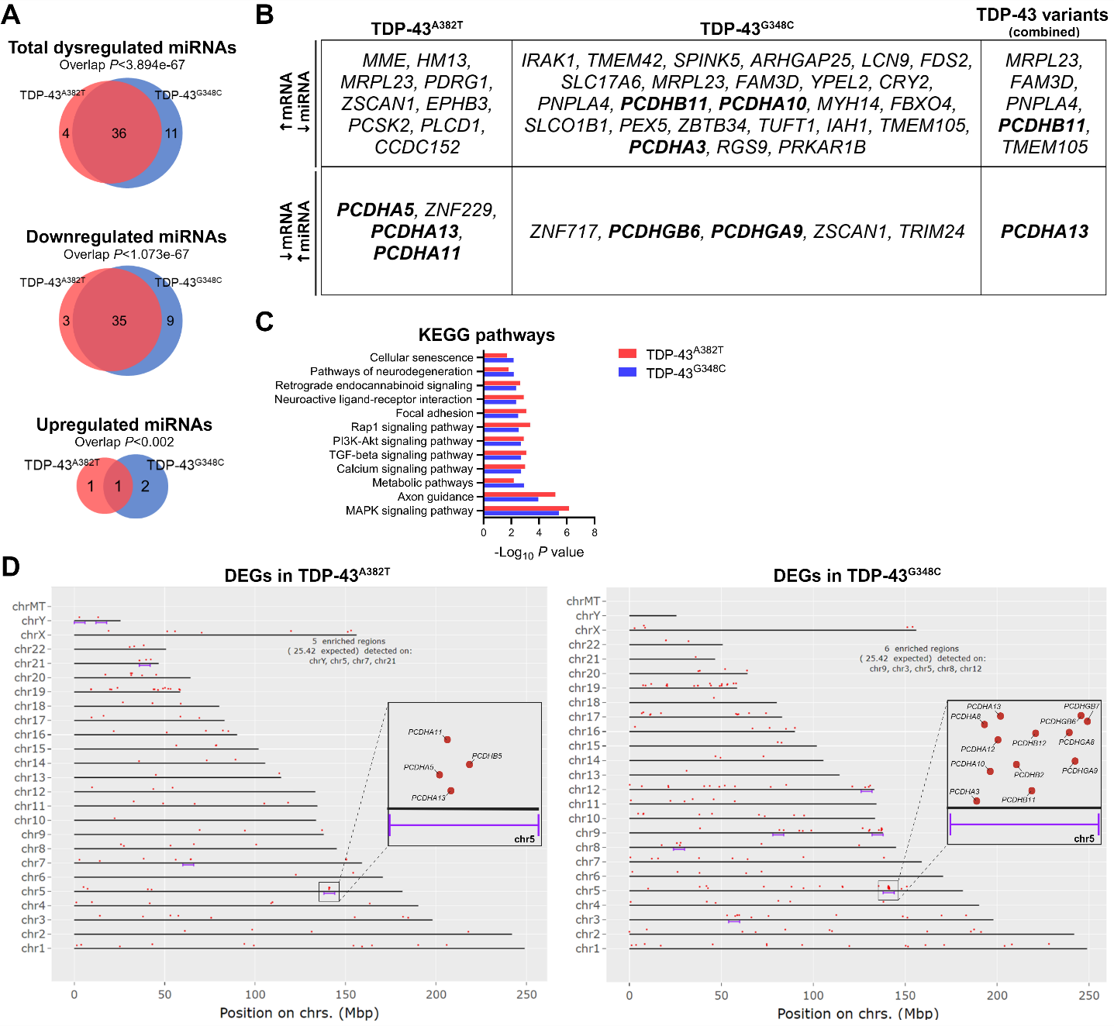

Supplementary Fig. 2 miRNAs profiling and integrated miRNA/mRNA analysis highlight protocadherin-coding genes. a Venn diagram comparing differentially expressed miRNAs in TDP-43 MNs relative to isogenic control. n=5. b Differentially expressed genes (DEGs) predicted to be targeted by dysregulated miRNAs. c KEGG pathway analysis of predicted target genes of dysregulated miRNAs. d Genomic regions of statistical DEGs enrichment (FDR<0.05) determined by the ShinyGO web app. DEGs are enriched at the clustered protocadherin gene locus (chr5q31).
Supplementary Tables
Supplementary Table 1. Overview of iPSC lines used

Cell line ID | ALS mutation | Sex | Age |  | Ethnicity | Primary cell line | Reprogramming method | Reference
AIW002-02 | None | Male | 37 | Caucasian |  | PBMC | Sendai virus | Chen et al., 2021¹
TARDBP A382T/AIW002-02 | p.A382T | Male | 37 |  | Caucasian | Knock-in | n/a | Lépine et al., 2024²
TARDBP G348C/AIW002-02 | p.G348C | Male | 37 |  | Caucasian | Knock-in | n/a | Lépine et al., 2024²
* PBMC, peripheral blood mononuclear cell; n/a, not applicable.

Supplementary Table 2. List of primers and TaqMan probes
Gene/miRNA | Reference
18S (RN18S1) | Hs.PT.39a.22214856.g
HPRT1 | Hs.PT.58v.45621572
PPIA | Hs.PT.58v.38887593.g
POLR2A | Hs.PT.39a.19639531
ZNF502 | Hs.PT.58.24576237
MEG3 | Hs.PT.58.25426100
PTGDS | Hs.PT.58.2258847
ZNF283 | Hs.PT.58.27732356
RAD51C | Hs.PT.58.40910176
PCDHA13 | Hs.PT.58.27085852.g
GPR50 | Hs.PT.58.39777811
NNAT | Hs.PT.58.24260117.g
CHCHD2 | Hs.PT.58.38445645
PDE12 | Hs.PT.58.19439493
CBR1 | Hs.PT.56a.22365466
GSE1 | Hs.PT.58.40478286
EBF2 | Hs.PT.58.818465
PRKCD | Hs.PT.58.21209513
CHRNA2 | Hs.PT.58.20688322
hsa-miR-191-5p | 477952_mir
hsa-miR-432-5p | 478101_mir
hsa-miR-654-5p | 478368_mir
hsa-miR-381-3p | 477816_mir
hsa-miR-485-5p | 478126_mir
hsa-miR-411-5p | 478086_mir
hsa-miR-127-5p | 477889_mir
hsa-miR-370-3p | 478326_mir
Supplementary Table 3. Shared differential expressed genes
Gene symbol** |  | Gene name |  | Functions/Comments*** | LogFC
 |  |  |  | Functions/Comments*** | p.A382T | p.G348C
Upregulated
CYCSP49 |  | CYCS pseudogene 49 |  | Pseudogene | 2.925 | 2.149
PPP1R12BP1 |  | Protein phosphatase 1 regulatory subunit 12B pseudogene 1 |  | Pseudogene | 2.743 | 2.291
MRPL23 |  | Mitochondrial ribosomal protein L23 |  | Mitochondrial translation and metabolism of proteins | 1.417 | 1.324
GSE1 |  | Gse1 coiled-coil protein |  | May be subunit of a BRAF35-HDAC (BHC) histone deacetylase complex; overexpressed in breast cancer | 0.401 | 0.428
ANKRD36P1 |  | Ankyrin repeat domain 36 pseudogene 1 |  | Pseudogene | 2.990 | 2.644
EBF2 |  | EBF transcription factor 2 |  | Transcription factor | 1.897 | 1.186
NUTM2F |  | NUT family member 2F |  | Protein-coding gene of unknown function | 0.852 | 1.084
PRKCD |  | Protein kinase C delta |  | Related to autophagy and apoptosis; associated with various human diseases; predicted ALS gene³ | 1.237 | 0.922
CHRNA2 |  | Cholinergic receptor nicotinic alpha 2 subunit |  | Nicotinic acetylcholine receptor subunit widely expressed in the brain; associated with epilepsy | 1.899 | 1.637
Downregulated
ZNF626 |  | Zinc finger protein 626 |  | Predicted to enable DNA-binding transcription factor activity | -0.949 | -0.925
ZNF502 |  | Zinc finger protein 502 |  | Predicted to enable DNA-binding transcription factor activity | -7.415 | -7.231
LINC00839 |  | Long intergenic non-protein coding RNA 839 |  | lncRNA | -8.769 | -8.667
ENSG00000285876 |  | Novel transcript |  | lncRNA | -11.862 | -6.14
ENSG00000269993 |  | Novel transcript |  | lncRNA | -3.728 | -3.179
MEG3 |  | Maternally expressed 3 |  | lncRNA associated with rare syndromes; known TDP-43 target^{4–6} | -8.439 | -9.004
PTGDS |  | Prostaglandin D2 synthase |  | Functions as a neuromodulator and trophic factor in the CNS; known TDP-43 target⁴ | -3.579 | -3.477
ZNF717 |  | Zinc finger protein 717 |  | Kruppel-associated box (KRAB) zinc-finger protein; transcriptional regulator | -7.149 | -9.269
LINC02506 |  | Long intergenic non-protein coding RNA 2506 |  | lncRNA | -6.348 | -4.170
ZNF283 |  | Zinc finger protein 283 |  | Predicted to enable DNA-binding transcription factor activity | -3.759 | -3.404
SVIL-AS1 |  | SVIL antisense RNA 1 |  | lncRNA | -7.275 | -7.288
RAD51C |  | RAD51 paralog C |  | Homologous recombination and DNA repair | -0.455 | -0.301
PCDHA13 |  | Protocadherin alpha 13 |  | Neural cadherin-like cell adhesion protein; enriched in the brain | -6.492 | -6.244
ZNF736 |  | Zinc finger protein 736 |  | Predicted to enable DNA-binding transcription factor activity | -5.283 | -6.767
ENSG00000229370 |  | Novel transcript |  | lncRNA | -8.090 | -6.443
ENSG00000287069 |  | Novel transcript, antisense to KCNH8 |  | lncRNA | -4.777 | -4.134
NNAT |  | Neuronatin |  | May play a role in the formation and maintenance of the CNS, and regulation of ion channels during brain development | -10.147 | -11.453
GPR50 |  | G protein-coupled receptor 50 |  | G-coupled receptor activity; associated with bipolar affective disorder and major depressive disorder | -3.561 | -3.455
CHCHD2 |  | Coiled-coil-helix-coiled-coil-helix domain containing 2 |  | Involved in mitochondrion organization; negative regulator of mitochondria-mediated apoptosis; associated with PD; predicted ALS gene³ | -10.399 | -11.938
LINC02527 |  | Long intergenic non-protein coding RNA 2527 |  | lncRNA | -0.873 | -1.342
MIR4458HG |  | MIR4458 host gene |  | lncRNA | -10.030 | -9.931
CCNYL2 |  | Cyclin Y like 2 |  | Predicted to enable cyclin-dependent protein serine/threonine kinase regulator activity | -4.539 | -4.344
PDE12 |  | Phosphodiesterase 12 |  | Localized to the mitochondrial matrix; involved in RNA metabolic process, cytokine signaling and mitochondrial mRNA stability | -0.392 | -0.393
CBR1 |  | Carbonyl reductase 1 |  | NADPH-dependent oxidoreductase activity; linked to fatty acid metabolism | -0.834 | -0.615
ABCA4 |  | ATP binding cassette subfamily A member 4 |  | Retina-specific ATP-binding cassette (ABC) transporter; associated with retinal diseases | -2.794 | -2.913
Discordant
ASNSP1 |  | Asparagine synthetase pseudogene |  | Pseudogene | 2.776 | -5.693
MYH14 |  | Myosin heavy chain 14 |  | Non-muscle myosin involved in cytokinesis, cell motility, and cell polarity; associated with hearing impairment and peripheral neuropathy; predicted ALS gene³ | -5.120 | 4.971
NBEAP1 |  | Neurobeachin pseudogene 1 |  | Pseudogene | 1.213 | -5.991
BMS1P10 |  | BMS1 pseudogene 10 |  | Pseudogene | 1.785 | -2.262
ENSG00000272234 |  | Novel transcript, antisense to SEPP1 |  | lncRNA | 2.231 | -3.091
CCDC152 |  | Coiled-coil domain containing 152 |  | Protein-coding gene of unknown function | 2.421 | -4.929
PUS7L |  | pseudouridine synthase 7 like |  | Predicted to enable pseudouridine synthase activity; associated with epilepsy | 0.333 | -0.610
ZSCAN1 |  | Zinc finger and SCAN domain containing 1 |  | DNA-binding transcription factor activity | 1.697 | -9.783
* ALS, amyotrophic lateral sclerosis; CNS, central nervous system; FC, fold change; lncRNA, long non-coding RNA; PD, Parkinson's disease
** Bolded genes selected for validation by qPCR
*** According to the GeneCards database available at https://www.genecards.org/

Supplementary Table 4. Shared dysregulated miRNAs and their genomic location
miRNA | Genomic coordinate |  | LogFC p.A382T | LogFC p.G348C
hsa-miR-6832-3p | chr6: 31633787-31633858 [+] | 6p21.33 | 5.39753821 | 5.09015244
hsa-miR-377-5p | chr14: 101062050-101062118 [+] | 14q32.31 | -3.4987295 | -3.5640906
hsa-miR-432-5p | chr14: 100884483-100884576 [+] | 14q32.2 | -8.5096634 | -7.6425164
hsa-miR-370-3p | chr14: 100911139-100911213 [+] | 14q32.31 | -6.1090404 | -5.9600407
hsa-miR-485-3p | chr14: 101055419-101055491 [+] | 14q32.31 | -2.7175301 | -3.2348732
hsa-miR-487a-3p | chr14: 101052446-101052525 [+] | 14q32.31 | -2.9450634 | -3.1297286
hsa-miR-134-5p | chr14: 101054687-101054759 [+] | 14q32.31 | -2.7123204 | -2.9936839
hsa-miR-495-3p | chr14: 101033755-101033836 [+] | 14q32.31 | -2.8734665 | -2.7943359
hsa-miR-329-3p | chr14: 101026785-101026864 [+] chr14: 101027100-101027183 [+] | 14q32.31 | -2.7681077 | -3.276883
hsa-miR-758-3p | chr14: 101026020-101026107 [+] | 14q32.31 | -3.1996719 | -3.1022029
hsa-miR-487b-3p | chr14: 101046455-101046538 [+] | 14q32.31 | -3.191169 | -3.2420759
hsa-miR-654-5p | chr14: 101040219-101040299 [+] | 14q32.31 | -2.8213098 | -2.9534777
hsa-miR-412-5p | chr14: 101065447-101065537 [+] | 14q32.31 | -2.9474603 | -3.6345566
hsa-miR-656-3p | chr14: 101066724-101066801 [+] | 14q32.31 | -2.9487844 | -4.1468312
hsa-miR-323a-3p | chr14: 101025732-101025817 [+] | 14q32.31 | -2.6949508 | -2.9099091
hsa-miR-376a-3p | chr14: 101040782-101040849 [+] chr14: 101040069-101040148 [+] | 14q32.31 | -3.4993597 | -3.7251577
hsa-miR-409-3p | chr14: 101065300-101065378 [+] | 14q32.31 | -3.2102507 | -3.0777423
hsa-miR-381-3p | chr14: 101045920-101045994 [+] | 14q32.31 | -3.132852 | -3.4426206
hsa-miR-889-3p | chr14: 101047901-101047979 [+] | 14q32.31 | -3.040022 | -3.4464336
hsa-miR-485-5p | chr14: 101055419-101055491 [+] | 14q32.31 | -2.8677297 | -3.1330652
hsa-miR-136-3p | chr14: 100884702-100884783 [+] | 14q32.2 | -7.2324032 | -6.4719432
hsa-miR-411-5p | chr14: 101023325-101023420 [+] | 14q32.31 | -2.8392333 | -3.491725
hsa-miR-433-3p | chr14: 100881886-100881978 [+] | 14q32.2 | -6.6722867 | -6.9097905
hsa-miR-379-3p | chr14: 101022066-101022132 [+] | 14q32.31 | -3.6183613 | -2.809508
hsa-miR-382-5p | chr14: 101054306-101054381 [+] | 14q32.31 | -2.9233342 | -3.2294855
hsa-miR-411-3p | chr14: 101023325-101023420 [+] | 14q32.31 | -3.1726077 | -3.1718531
hsa-miR-493-5p | chr14: 100869060-100869148 [+] | 14q32.2 | -8.8452075 | -6.2919642
hsa-miR-369-5p | chr14: 101065598-101065667 [+] | 14q32.31 | -3.348575 | -3.6018686
hsa-miR-379-5p | chr14: 101022066-101022132 [+] | 14q32.31 | -2.9522166 | -3.1315874
hsa-miR-493-3p | chr14: 101033755-101033836 [+] | 14q32.31 | -7.4756617 | -5.4134923
hsa-miR-1185-2-3p | chr14: 101044198-101044283 [+] | 14q32.31 | -3.5779433 | -3.6520981
hsa-miR-127-3p | chr14: 100882979-100883075 [+] | 14q32.2 | -6.2099569 | -6.7713807
hsa-miR-654-3p | chr14: 101040219-101040299 [+] | 14q32.31 | -2.9824453 | -3.1408796
hsa-miR-655-3p | chr14: 101049550-101049646 [+] | 14q32.31 | -3.1648455 | -3.6508573
hsa-miR-543 | chr14: 101031987-101032064 [+] | 14q32.31 | -2.9567885 | -2.6150719
hsa-miR-410-3p | chr14: 101065912-101065991 [+] | 14q32.31 | -3.0472873 | -3.2986066
* FC, fold change

Supplementary Table 5. Predicted TDP-43 binding sites by the RBPmap database⁷
Gene | Genomic coordinate | Motif | Predicted binding sites | Z-score | P-value
MIR377 | chr14:101062114 | guaug | guugaaucacacaaaggcaacuuuuguuug | 2.214 | 1.34E-02
MIR370 | chr14:100911182 | guaug | acgucucugcaguuacacagcucacgagugccugcugggguggaaccuggucugu | 2.051 | 2.01E-02
MIR370 | chr14:100911194 | guaug | uuacacagcucacgagugccugcugggguggaaccuggucugucu | 2.316 | 1.03E-02
MIR370 | chr14:100911206 | guaug | cgagugccugcugggguggaaccuggucugucu | 2.714 | 3.32E-03
MIR485 | chr14:101055424 | gagug | acuuggagagaggcuggccgugaugaauucgauuc | 2.073 | 1.91E-02
MIR485 | chr14:101055426 | gagug | acuuggagagaggcuggccgugaugaauucgauucau | 2.073 | 1.91E-02
MIR134 | chr14:101054689 | guaug | cagggugugugacugguugaccagaggggcau | 2.469 | 6.77E-03
MIR134 | chr14:101054691 | guaug | cagggugugugacugguugaccagaggggcaugc | 3.194 | 7.02E-04
MIR134 | chr14:101054693 | guaug | cagggugugugacugguugaccagaggggcaugcac | 3.194 | 7.02E-04
MIR134 | chr14:101054697 | guaug | cagggugugugacugguugaccagaggggcaugcacugug | 2.551 | 5.37E-03
MIR134 | chr14:101054710 | gagug | agggugugugacugguugaccagaggggcaugcacuguguucacccuguggg | 2.303 | 1.06E-02
MIR134 | chr14:101054715 | guaug | ggugugugacugguugaccagaggggcaugcacuguguucacccugugggccacc | 2.918 | 1.76E-03
MIR654 | chr14:101040221 | guaug | ggguaaguggaaagauggugggccgcagaaca | 1.684 | 4.61E-02
MIR412 | chr14:101065458 | guaug | cugggguacggggauggauggucgaccaguuggaaaguaau | 1.776 | 3.79E-02
MIR412 | chr14:101065462 | guaug | cugggguacggggauggauggucgaccaguuggaaaguaauuguu | 1.776 | 3.79E-02
MIR412 | chr14:101065525 | guaug | acuucaccugguccacuagccguccguauccgcugcag | 1.673 | 4.72E-02
MIR656 | chr14:101066758 | guaug | guugccugugagguguucacuuucuauaugaugaauauuauacagucaaccucuu | 1.684 | 4.61E-02
MIR376A2 | chr14:101040094 | guaug | gguauuuaaaagguagauuuuccuucuaugguuacguguuugaugguuaaucaua | 1.929 | 2.69E-02
MIR889 | chr14:101047910 | guaug | gugcuuaaagaauggcuguccguaguauggucucuauau | 2.306 | 1.06E-02
MIR889 | chr14:101047925 | guaug | gugcuuaaagaauggcuguccguaguauggucucuauauuuaugaugauuaaua | 3.041 | 1.18E-03
MIR411 | chr14:101023349 | guaug | ugguacuuggagagauaguagaccguauagcguacgcuuuaucugugacguaug | 2.276 | 1.14E-02
MIR411 | chr14:101023356 | guaug | uuggagagauaguagaccguauagcguacgcuuuaucugugacguauguaacacg | 2.276 | 1.14E-02
MIR411 | chr14:101023374 | guaug | guauagcguacgcuuuaucugugacguauguaacacgguccacuaacccucagua | 2.786 | 2.67E-03
MIR379 | chr14:101022087 | guaug | agagaugguagacuauggaacguaggcguuaugauuucugaccuauguaac | 1.816 | 3.47E-02
MIR379 | chr14:101022094 | guaug | gaugguagacuauggaacguaggcguuaugauuucugaccuauguaacauggucc | 1.816 | 3.47E-02
MIR493 | chr14:100869128 | guaug | uuugcacauucggugaaggucuacugugugccaggcccugugccag | 1.755 | 3.96E-02

Supplementary Table 6. Top-scoring predicted compounds by the CMap database⁸
Name* | Description | τ score**
Name* | Description | p.A382T | p.G348C | Combined
sulpiride | Dopamine receptor antagonist | 0.00 | 1.35 | -94.56
tacedinaline (CI-994) | HDAC inhibitor | -1.02 | -0.92 | -92.30
XMD-892 | MAP kinase inhibitor | 0.00 | 11.26 | -91.09
QS-11 | ARFGAP inhibitor | -0.49 | -14.82 | -90.83
bimatoprost | Prostanoid receptor agonist | 0.00 | 0.00 | -90.58
XMD-885 | Leucine rich repeat kinase inhibitor | -40.03 | -5.53 | -90.49
GR-46611 | Serotonin receptor agonist | -1.30 | -2.04 | -90.17
CS-110266 | Dopamine receptor agonist | -1.21 | 14.28 | -89.57
benzohydroxamic-acid | Antifungal | 1.80 | -2.33 | -88.57
MLN4924 (Pevonedistat) | Nedd activating enzyme inhibitor | 0.39 | -49.65 | -87.49
piperlongumine | Glutathione transferase inhibitor | -71.64 | 1.06 | -87.05
alpha-linolenic-acid | Omega 3 fatty acid stimulant | 0.00 | 1.62 | -85.92
4-hydroxy-2-nonenal | Cytotoxic lipid peroxidation product | 0.00 | 0.00 | -85.32
prunetin | Breast cancer resistance protein inhibitor | -95.71 | 29.48 | -71.45
mitomycin-c | DNA alkylating agent | -93.55 | 74.75 | -69.90
zaldaride | Calmodulin antagonist | 0.00 | -88.60 | 0.60
* Bolded compounds selected for further experimental investigation
**Green highlights indicate scores below the score threshold of -85.

Supplementary References
1. Chen, C. X. Q. et al. A multistep workflow to evaluate newly generated iPSCs and their ability to generate different cell types. Methods Protoc. 4, 50 (2021).
2. Lépine, S. et al. Homozygous ALS-linked mutations in TARDBP/TDP-43 lead to hypoactivity and synaptic abnormalities in human iPSC-derived motor neurons. iScience 27, 109166 (2024).
3. Bean, D. M., Al-Chalabi, A., Dobson, R. J. B. & Iacoangeli, A. A knowledge-based machine learning approach to gene prioritisation in amyotrophic lateral sclerosis. Genes (Basel). 11, 1–17 (2020).
4. Krach, F. et al. Transcriptome–pathology correlation identifies interplay between TDP-43 and the expression of its kinase CK1E in sporadic ALS. Acta Neuropathol. 136, 405–423 (2018).
5. Polymenidou, M. et al. Long pre-mRNA depletion and RNA missplicing contribute to neuronal vulnerability from loss of TDP-43. Nat. Neurosci. 14, 459–468 (2011).
6. Tollervey, J. R. et al. Characterizing the RNA targets and position-dependent splicing regulation by TDP-43. Nat. Neurosci. 14, 452–458 (2011).
7. Paz, I., Kosti, I., Ares, M., Cline, M. & Mandel-Gutfreund, Y. RBPmap: a web server for mapping binding sites of RNA-binding proteins. Nucleic Acids Res. 42, W361-7 (2014).
8. Lamb, J. et al. The Connectivity Map: using gene-expression signatures to connect small molecules, genes, and disease. Science (80-. ). 313, 1929–1935 (2006).

