Supplementary Figure 1. Picture of the original mint leaves showing MMV-associated symptoms from the Me1 isolate.
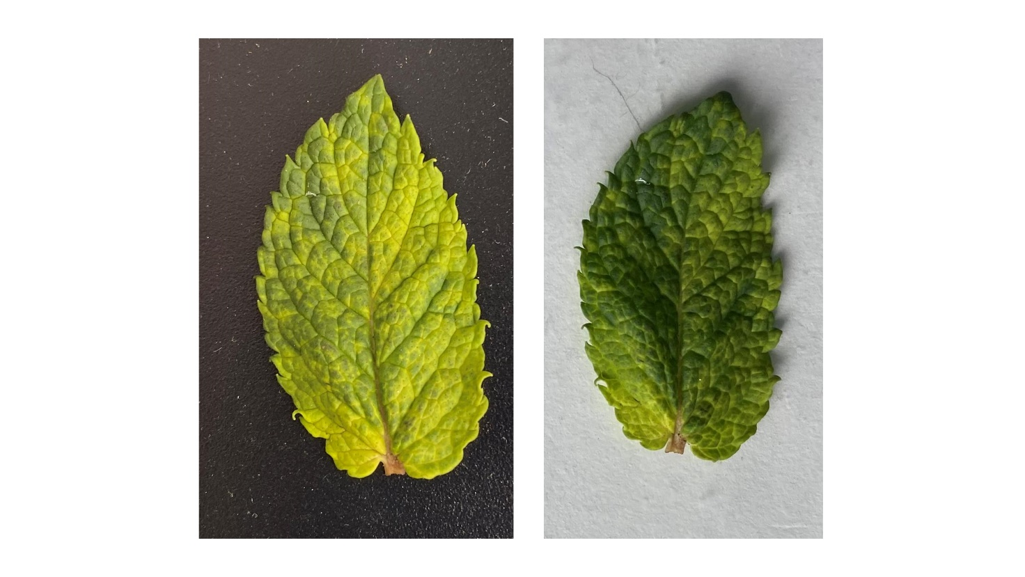

Supplementary Table 1. List of viruses included in the phylogenetic analysis of the family Betaflexiviridae.
NCBI ID | Virus
M58152 | Apple chlorotic leaf spot virus
MH084695 | Peach chlorotic leaf spot virus isolate RP19-1
AY713379 | Apricot pseudo-chlorotic leaf spot virus isolate Sus2
MK770441 | Cherry latent virus 1 isolate Mskhvil Nakota
AF170028 | Cherry mottle leaf virus
DQ117579 | Peach mosaic virus strain 2022-01 CA-1 putative polyprotein
MK012336 | Peach virus M isolate trichomex 2 RNA-dependent RNA polymerase
D88448 2 | Grapevine berry inner necrosis virus genomic RNA
FR877530 | Grapevine Pinot gris virus complete genome
KF533710 | Carrot betaflexivirus 2 isolate CBV-2 S15 ORF1
KF533711 | Carrot betaflexivirus 1 isolate CBV-1 S20 ORF1
OK032418 | Hogweed virus 4 isolate HV4
MG208123 | Lettuce chordovirus 1 isolate JG1
MF166685 | Ribes americanum virus A isolate Oregon
AJ318061 | Citrus leaf blotch virus ORF 1
KY363796 | Watermelon virus A isolate KF-15
HG008921 | Apricot vein clearing associated virus complete genome
KM507061 | Caucasus prunus virus isolate Aze204
MK050792 | Camellia ringspot associated virus 1 isolate CJ5
MF440375 | Actinidia seed borne latent virus isolate 01227
X75448 1 | Grapevine virus B genomic RNA for MP and CP genes
JN427014 | Actinidia virus A isolate TP7-93A putative replicase ORF1 gene
JN427015 | Actinidia virus B isolate TP7-93B
MF521889 | Grapevine virus H isolate TT2016-3
X75433 2 | Grapevine virus A genomic RNA
JX105428 | Grapevine virus F isolate AUD46129
MG637048 | Grapevine virus J isolate KS
KY392781 | Arracacha virus V isolate CNPH
MK460433 | Blueberry green mosaic associated virus isolate NJ1
AB432910 | Grapevine virus E genomic RNA
MT269788 | Grapevine virus L isolate TX-WAT20
MF927925 | Grapevine virus I isolate VID499
MF405923 | Grapevine virus G isolate VID561
MG254193 | Blackberry virus A isolate Arkansas
EU835937 | Potato virus T from Peru
MW323519 | Agave virus T isolate AT replicase
KF700263 | Prunus virus T isolate Aze239
MK514426 | Zostera virus T isolate Z1
MT090966 | Cherry virus T isolate 2 15a
AF017780 | Sour cherry green ring mottle virus
AF237816 | Cherry necrotic rusty mottle virus
KF958838 | Cherry twisted leaf associated virus isolate CTLV 8431
KC218926 | Cherry rusty mottle associated virus isolate 95CI192R3
AY072921 | African oil palm ringspot virus
AF057136 | Rupestris stem pitting associated virus-1
MN553040 | Grapevine foveavirus A
EF693898 | Peach chlorotic mottle virus
HQ339956 | Apricot latent virus isolate A18
D21829 2 | Apple stem pitting virus genes for RNA-dependent RNA polymerase
MN944023 | Rubus virus 1 isolate E23
FJ824737 | Asian prunus virus 1 isolate tatao5
KT893294 | Asian prunus virus 2 isolate Bungo Q-1256-01
LC373513 | Cherry virus B S3 genomic RNA
MT028514 | Camellia ringspot associated virus 4 isolate Adolphe Audusson
JX277553 | Rubus canadensis virus 1 isolate BM-01
AB032469 | Hop latent virus genomic RNA
EU527979 | Hop mosaic virus from Australia
KJ789130 | Yam latent virus isolate SG1
AM158439 | Narcissus common latent virus complete genome
AB051848 | Aconitum latent virus genomic RNA
D14449 2 | Potato virus M RNA
DQ098905 | Hippeastrum latent virus RNA-dependent RNA polymerase
AJ516059 | Lily symptomless virus complete genome
DQ455582 | Passiflora latent carlavirus
FJ531634 | Kalanchoe latent virus isolate PV-0290B
JN039374 | Mirabilis jalapa mottle virus
EU754720 | Hydrangea chlorotic mottle virus isolate NZ
L25658 1 | Blueberry scorch carlavirus mRNA
MK415316 | Cactus carlavirus 1 genomic sequence
EU074853 | Ligustrum necrotic ringspot virus
EU020009 | Potato rough dwarf virus isolate Arg
MK415317 | Cactus carlavirus 2 genomic sequence
AJ863509 | Potato virus S complete genome
EU433397 | Potato latent virus
JQ904630 | Potato virus H isolate YN
KJ572562 | Elderberry carlavirus C isolate EBCVC
KJ572564 | Elderberry carlavirus E isolate EBCVE
JQ245696 | American hop latent virus isolate Bittergold
AJ620300 | Daphne virus S ORF1
KX000914 | Ligustrum virus A isolate SK
EF492068 | Phlox virus S
KJ415259 | Gaillardia latent virus isolate 5 18-05-2010
EU162589 | Phlox Virus B
KR349343 | Atractylodes mottle virus isolate SK
MW176107 | Soybean carlavirus 1 strain SCV1-IL
AM493895 | Chrysanthemum virus B complete genome
MG432107 | Chrysanthemum virus R strain BJ
AY505475 | Poplar mosaic virus isolate PV-0341
MH536506 | Birch carlavirus isolate BpenGer407526 5M
MN053272 | Rose virus A isolate R11
MT473961 | Rose virus B isolate R12
FJ196835 | Helleborus net necrosis virus strain G5
KJ572563 | Elderberry carlavirus D isolate EBCVD
HQ184471 | Cowpea mild mottle virus RNA-dependent RNA polymerase
MK984598 | Papaya mild mottle associated virus isolate KE-Kwa-02
KU726694 | Pepper virus A isolate TW RdRp gp1
AJ292226 | Garlic latent virus complete genomic RNA
MH292861 | Shallot virus S isolate 13-17
FJ685618 | Red clover vein mosaic virus isolate Washington
KP784454 | Alfalfa latent virus isolate ATCC PV-264 RNA-dependent RNA polymerase
AM182569 | Narcissus symptomless virus complete genome
MW303999 | Agapanthus carlavirus B strain Stellenbosch
EF527260 | Coleus vein necrosis virus
JF320810 | Garlic common latent virus isolate WA-1
AB517596 | Butterbur mosaic virus genomic RNA
MN944106 | Aconite virus A strain HB
JX212747 | Sweet potato virus C-6 isolate Sosa 29
AY461421 | Sweet potato chlorotic fleck virus
LC224308 | Melon yellowing-associated virus genomic RNA
MT533598 | Clivia carlavirus A isolate 19-3040 RNA-dependent RNA polymerase RdRp
OK721096 | Musa ornata associated banmivirus
AF314662 | Banana mild mosaic virus
MK984600 | Papaya mottle-associated virus isolate KE-Mer-04
AF315308 | Sugarcane striate mosaic associated virus RNA polymerase
X82547 1 | Cherry capillovirus A RNA for ORF1 and ORF2
KT763043 | Currant virus A
MG783575 | Mume virus A isolate pm14
MK936045 | Loquat virus A
MN047299 | Rubber tree virus 1 isolate RTCV1 HN Qionghai
HQ241409 | Hardenbergia virus A isolate HarVA-57
JX173276 | Diuris virus A isolate SW3 3
JX173277 | Diuris virus B isolate SW3 3
D14995 2 | Apple stem grooving virus genome
X79270 1 | Heracleum latent virus RNA binding protein gene
AF238884 | Botrytis virus F
MF375884 | Entoleuca gammaflexivirus 2 isolate E97-14 replicase
KT598226 | Soybean leaf-associated mycoflexivirus 1 isolate SaNSRV1-1
KT581451 | Sclerotinia sclerotiorum deltaflexivirus 1 isolate AX19
KX015962 | Fusarium graminearum deltaflexivirus 1 isolate BJ59
MF375883 | Entoleuca gammaflexivirus 1 isolate E97-14 replicase
MK605686 | Entoleuca gammaflexivirus 2 isolate Pisle replicase

