SUPPLEMENTARIES
SUPPLEMENTARY 1. There was no significant correlation between alpha diversity score to subject’s age.
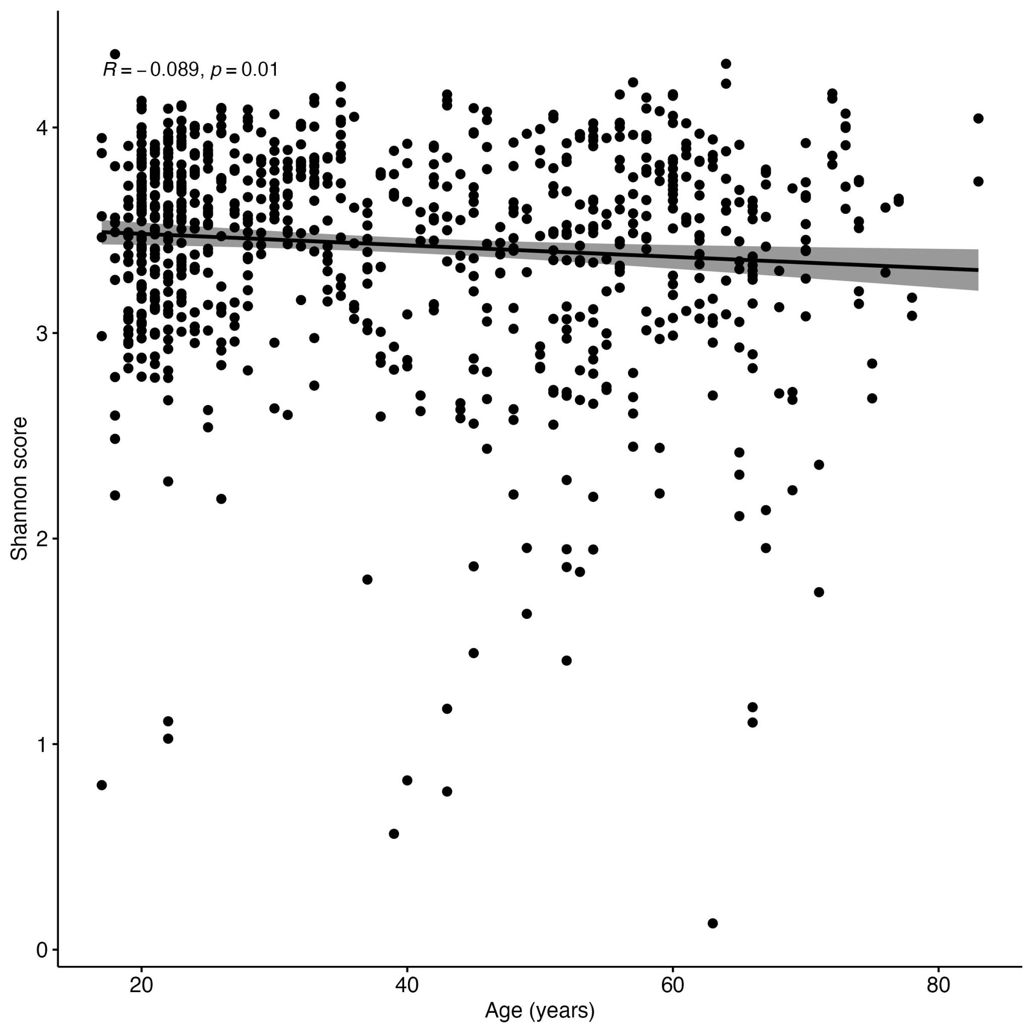

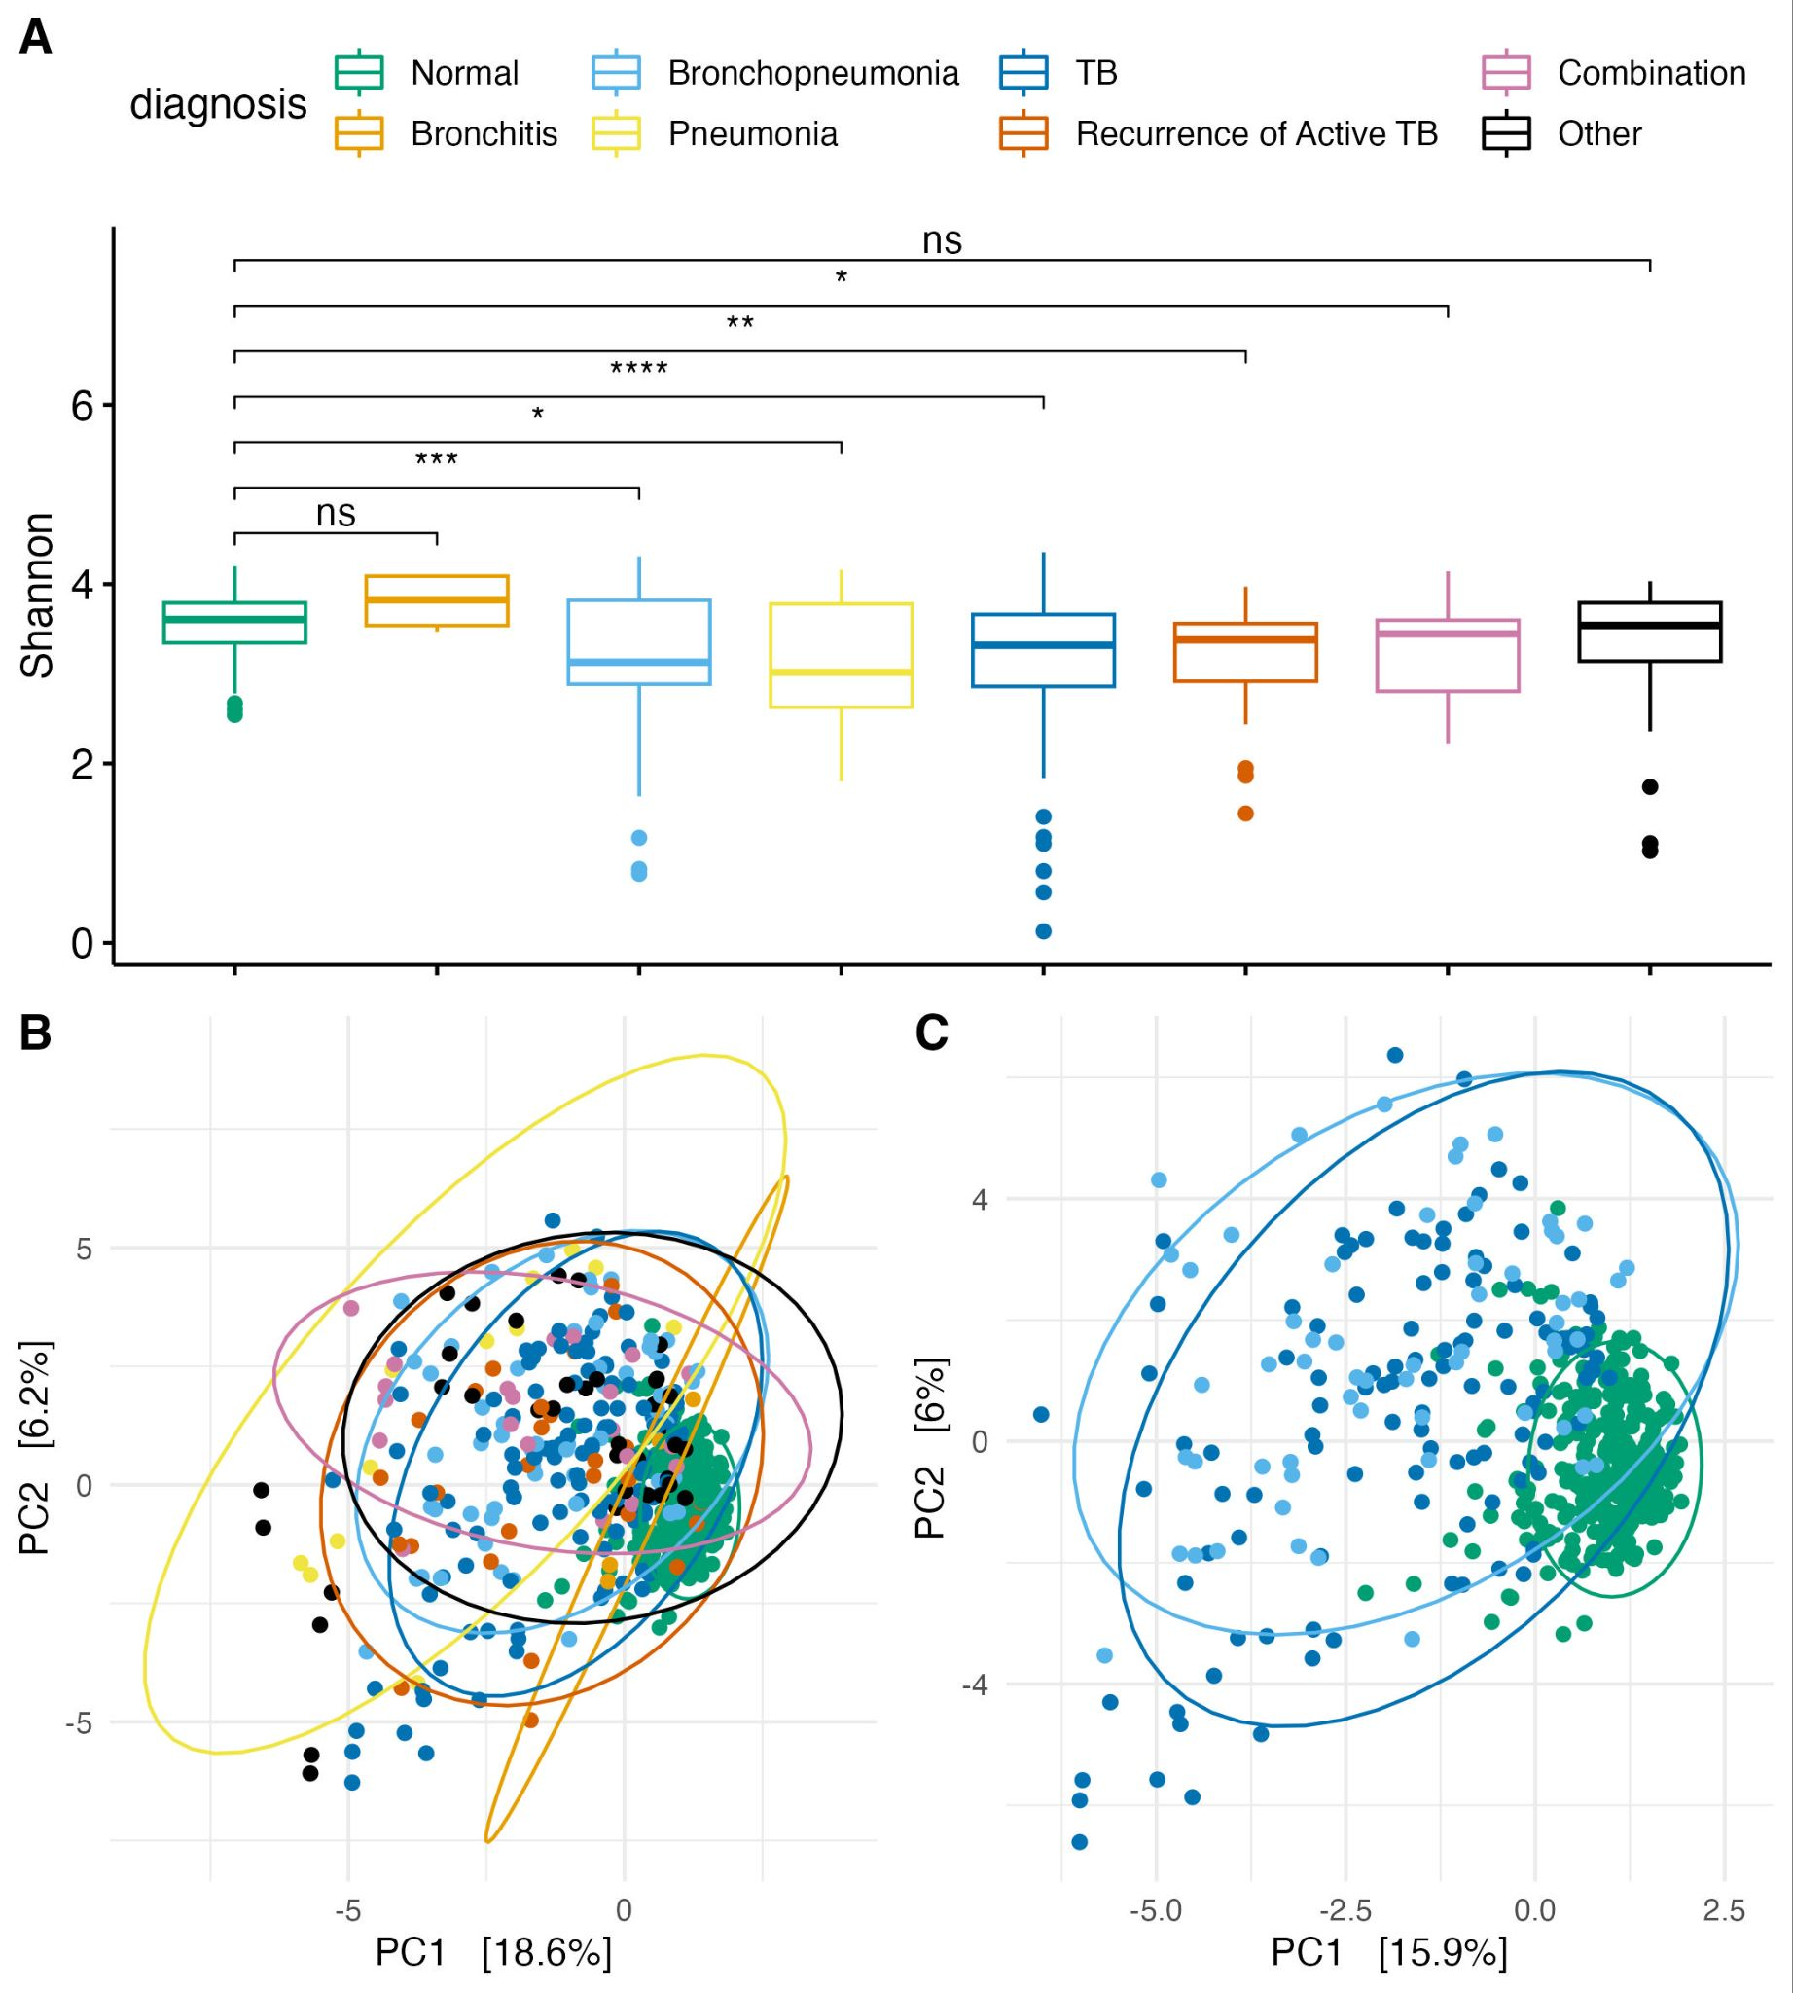
SUPPLEMENTARY 2. Overlaps between some diseased patients with healthy subjects highlight important of more data, such as disease onset and antibiotic consumption pattern. A Distribution of the alpha diversity score, showing significantly higher diversity of healthy samples compared to that of diseased patients, especially TB and bronchopneumonia. B PCA plot showing clusters between healthy samples to other diseased samples. C PCA plot revealed overlaps between several TB and Bronchopneumonia patients with healthy subjects.
SUPPLEMENTARY 3. While healthy samples showed higher abundance of oral microbiome commensals, chronic samples had higher abundance of pathogenic microbes.
