Lactarius crocogalum (sp.nov.): A new ectomycorrhizal species of Lactarius subgen. Lactarius from the peat swamp forest of Central Kalimantan, Indonesia

Khalid Hafazallah^{b,e}, Helbertª, Valeria Verrone^{b}, Atik Retnowati^{f}, Hizbullah Al Muzahiq^{g}, Teguh Willy Nugroho^{h}, Sanjay Swarup^{b,c,d}

First co-authorship: Khalid Hafazallah, Helbert, Valeria Verrone
Corresponding authors: Khalid Hafazallah, Helbert

Affiliations
ª Research Center for Ecology and Ethnobiology, National Research and Innovation Agency, Indonesia
^{b} NUS Environmental Research Institute, National University of Singapore, 117411, Singapore
^{c} Singapore Centre of Environmental Engineering and Life Sciences, National University of Singapore, Singapore
^{d} Department of Biological Sciences, National University of Singapore, Singapore 117558, Singapore
^{e} Generasi Biologi Indonesia (Genbinesia) Foundation, Gresik 61171, East Java, Indonesia
^{f} Research Center for Biosystematics and Evolution, National Research and Innovation Agency, Indonesia
^{g} Department of Silviculture, Faculty of Forestry and Environment, IPB University, Bogor 16680, Indonesia
^{h} Sebangau National Park, Ministry of Environment and Forestry, Palangkaraya, Central Kalimantan, Indonesia

Supplementary material

Table S1. Database of the available ITS and LSU regions belonging to Lactarius taxa used to support the phylogenetic trees in this study. Source: GenBank.

Species | Origin | Voucher Collection | GenBank Accession Number
 |  |  | ITS | LSU
L. subg. Lactarius
L. akahatsu | South Korea | SFC20131010-01 | MH984916 | MH985030.1
L. alboscrobiculatus | Thailand | LTH275 | EF141539
L. austrotorminosus | South Korea | HCCN19723 | MG551724 | MH985048.1
L. austrozonarius | Thailand | LTH129 | EF141535
L. crocogalum (sp. nov.) | Indonesia | BO 24733 | LC818854 | LC818856
L. crocogalum (sp. nov.) | Indonesia | BO 24733 | LC818855 | LC818857
L. deliciosus |  | TMES25 | MT262921 | MT261201.1
L. formosus | Thailand | EF141549 | EF141549
L. porninsis |  | J. Nuytinck 2001-082 | DQ922547
L. purpureus | China | N.K.Zeng2952 | MT822960 | MT829144.1
L. queticolor | Germany | ue141 | AF140269 | AF325282
L. repraesentaneus | Sweden | JN 2001-023 | AY331011
L. scrobiculatus |  | QHU20107 | OM970920 | OM942701.1
L. speciosus | USA | A. Verbeken04/206 | EF141547
L. tornimosus | Netherland | CBS:197.72 | MH860447 | MH872175.1
L. uvidus | China | HMAS:269338 | KX441140 | KX441387.1
 |  |  | ITS | LSU
L. subg. Plinthogalus
L. crassiusculus | Thailand | LTH369 | EF560684 | KF133303.1
L. friabilis | Thailand | FH12-103 | KF432961
L. fuliginosus | China | XHW2721 | MW669872 | MW669923.1
L. lignyotus | China | XHW2620 | MW669865 | MW669913.1
L. pterosporus |  | QHU20095 | OM970917 | OM942698.1
L. subg. Russularia
L. aquosus | Thailand | KW231 | KF432984
L. austrorostratus | Thailand | KW108 | KF433012
L. crenulatulus | Thailand | KW383 | KR025604
L. decipiens | Italy | AV2000-137 | KF432973
L. falcatus | Thailand | KVP08-038 | KF133274 | KF133307.1
L. fuscomaculatus | China | N.K.Zeng2445 | MT822959 | MT829143.1
L. glabrigracilis | Thailand | KW093 | KR025606
L. gracilis | Thailand | KW096 | KR025609
L. inconspicuus | Thailand | KW339 | KR025584
L. kesiyae | South Korea | SFC20150701-99 | MG551730 | MH985101.1
L. laccarioides | Thailand | KW336 | KF432991
L. pasohensis | Malaysia | DS06-245 | KF432986
L. perparvus | Thailand | KW320 | KJ458981
L. rubrobrunneus | Thailand | AV12-044 | KF432985
L. rubrocorrugatus | Thailand | KW384 | KR025590
L. subdulcis | Netherland | CBS:411.75 | MH860932 | MH872686.1

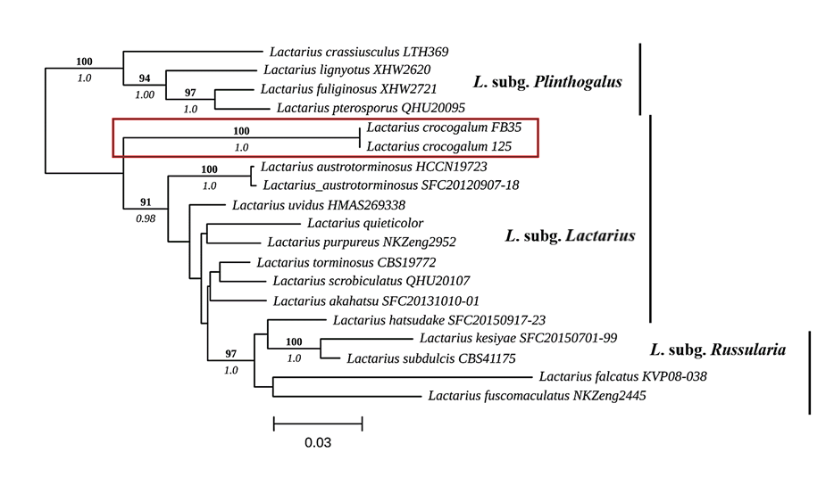

Fig. S1 Maximum Likelihood tree of the Lactarius crocogalum concatenated sequences, ITS and LSU. Maximum likelihood UFbootstrap support (UFbootstrap > 90%; SH-aLRT value > 80%) and posterior probability obtained from Bayesian inference are indicated above and below the branches, respectively. Branch lengths are scaled to the expected number of nucleotide substitutions per site. The species described as a novel species in this work and its clade are indicated in red box. Lactarius crocogalum FB35 indicates the sequence extracted from the fruit body, whereas Lactarius crocogalum 125 indicates the sequences extracted from the root tips collected in the field in the proximity of the fruit body.

