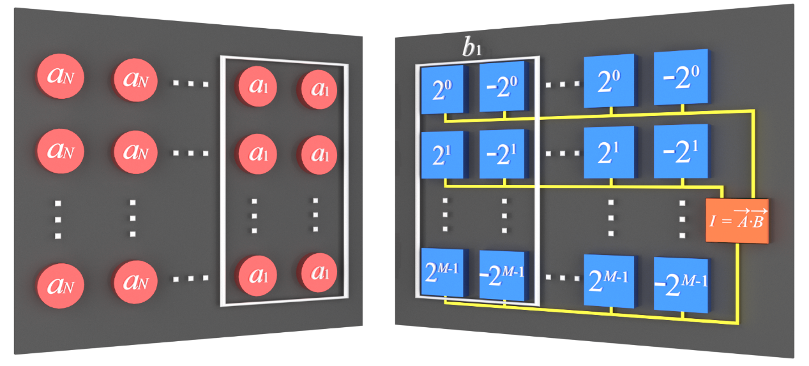
Extended Data Fig.1 | The mechanism to perform signed vector inner product A$\text{∙}$B with N sets of 2×M BEADs. The XOR operation of the sign bits of each multiplier a_{i} and b_{i} needs to be calculated in advance, which only takes a short amount of time to complete on traditional microelectronic processor. The on-off states of these 2×M BEADs in the ith set will be decided by the result of the XOR operation. If the result is zero, which means multiplier a_{i} and b_{i} have the same sign, then the M BEADs with positive bias voltage will be used to calculate the multiplication of multiplier a_{i} and b_{i} as mentioned above, and the other M BEADs with negative bias voltage will be at off state, and vice versa.

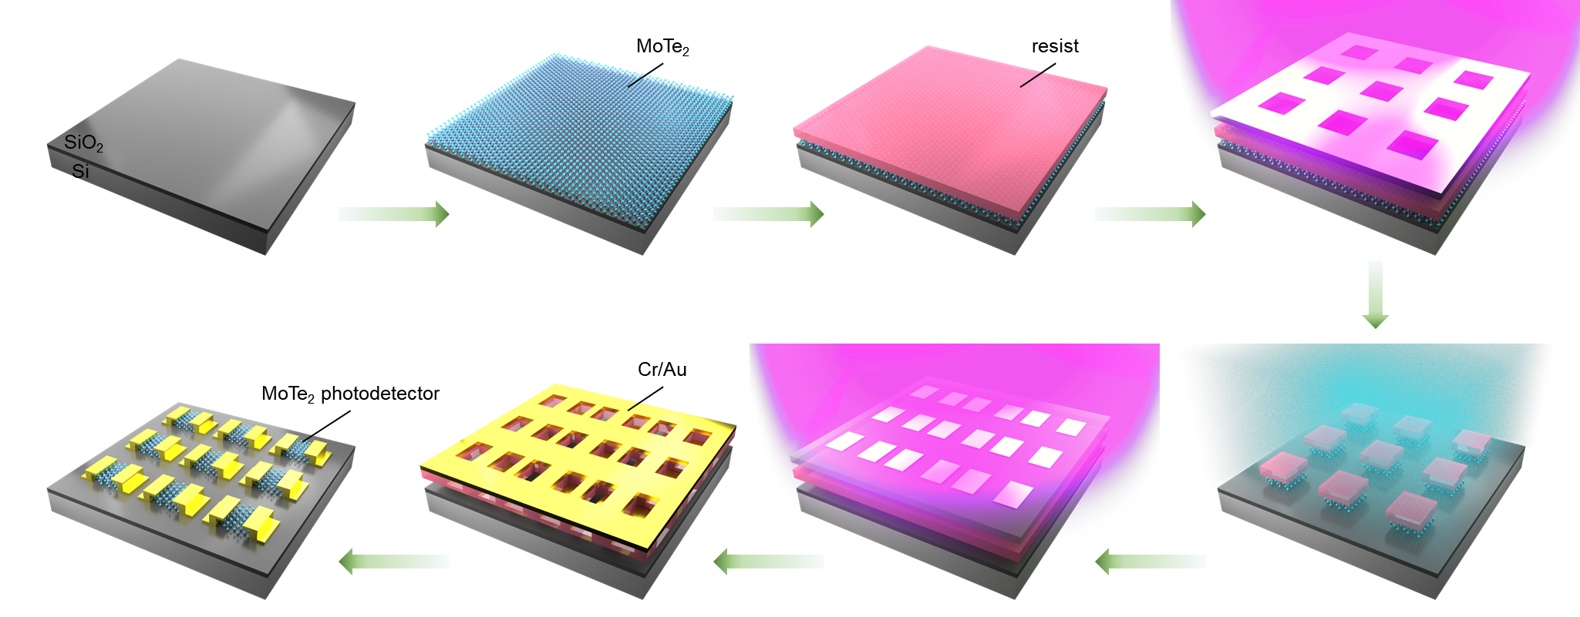
Extended Data Fig.2 | Schematic fabrication process of MoTe₂ PD array.

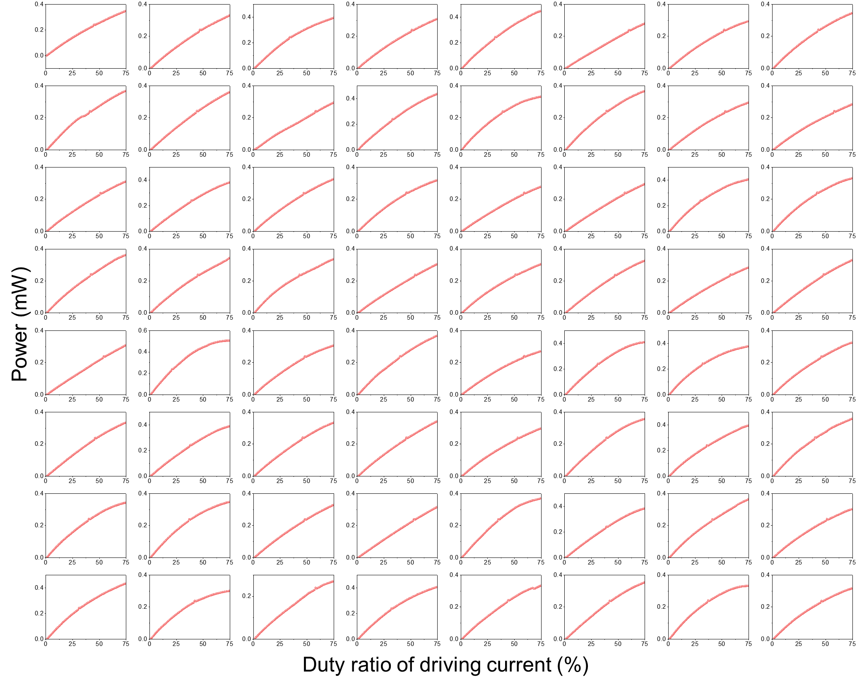
Extended Data Fig.3 | Output intensity of each VCSEL.

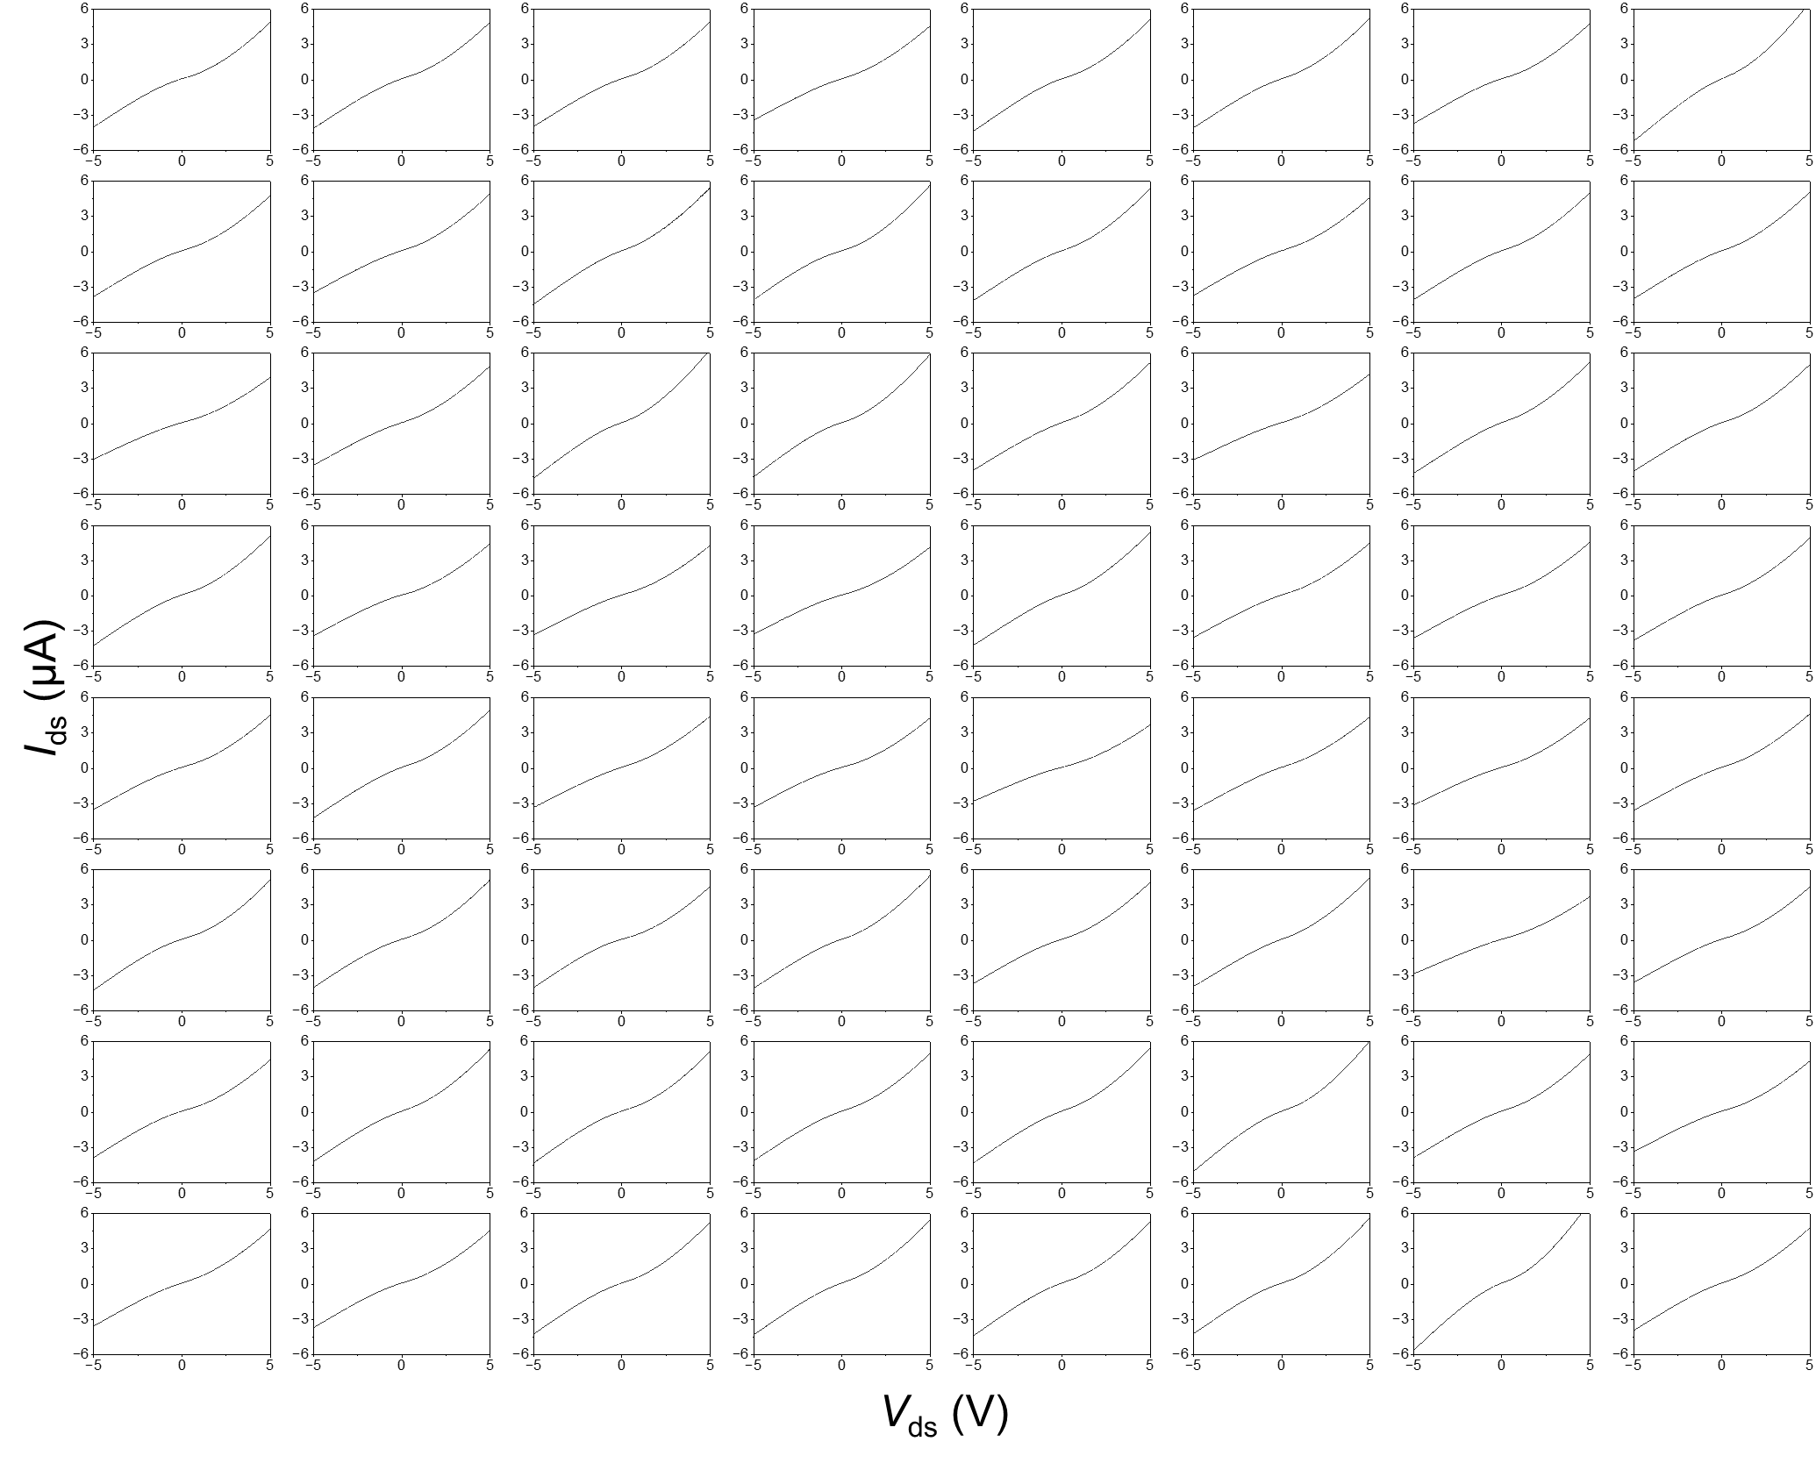
Extended Data Fig.4 | I-V curve of each MoTe₂ PD.

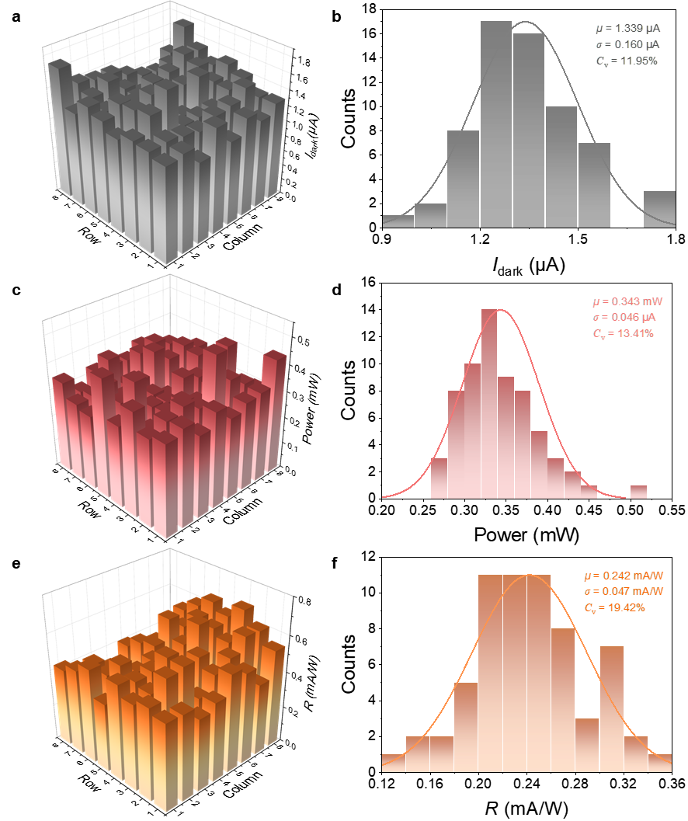
Extended Data Fig.5 | Statistical Uniformity of the VCSEL array and MoTe₂ PD array. a-b, The hold-state current mapping and statistical analysis of 8×8 MoTe₂ PD array without illumination at 2 V bias voltage. c-d, The hold-state output intensity mapping and statistical analysis of 8×8 VCSEL array at 75% duty ratio driving current. e-f, The hold-state responsivity mapping and statistical analysis of 8×8 MoTe₂ PD array at 2 V bias-voltage.

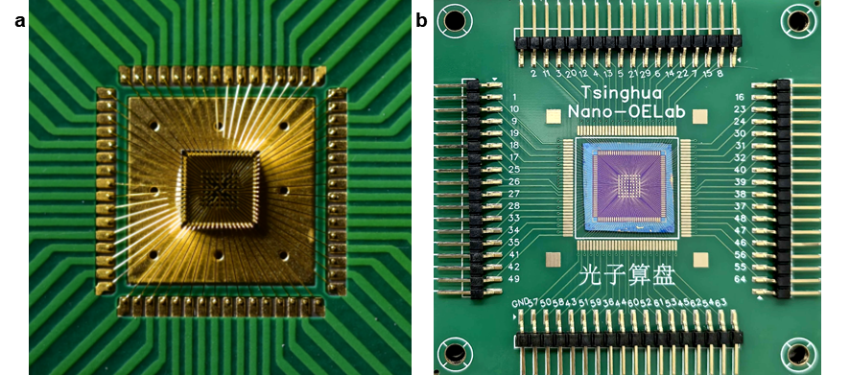
Extended Data Fig.6 | The VCSEL array (a) and MoTe₂ PD array (b) are connected to self-designed printed circuit boards using wire-bonding technology.

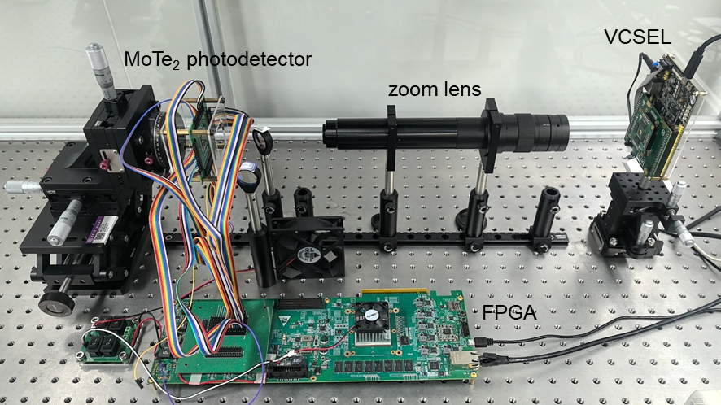
Extended Data Fig.7 | Optical image of the experimental setup.

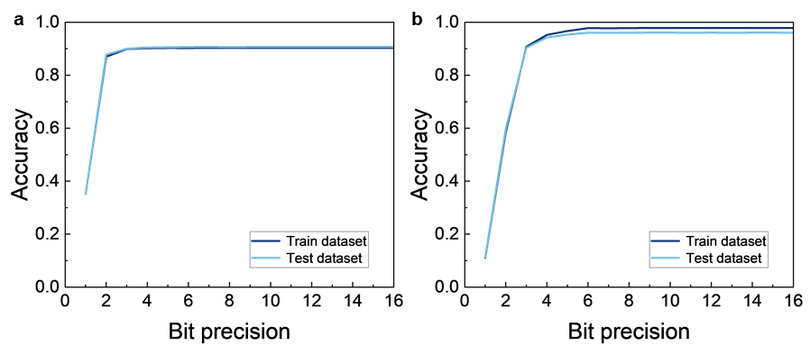
Extended Data Fig.8 | The quantization of ANN. a, The classification accuracies of single-layer ANN with various bit precisions. 4-bit precision is utilized in the experiment of single-layer ANN. b, The classification accuracies of double-layer ANN with various bit precisions. 6-bit precision is utilized in the experiment of double-layer ANN.

Extended Data Table1 | The parameters of Ising machine.
 | Initial temperature | Annealing rate | Iterations
30-dimensional Ising machine | 10 | 0.99 | 500
1024-dimensional Ising machine | 50 | 0.995 | 5000

