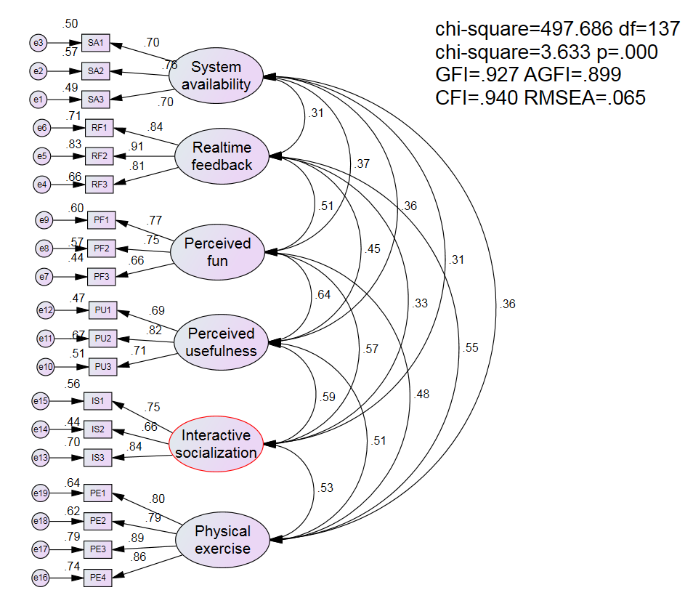

Standardized Regression Weights: (Group number 1 - Default model)
 |  |  | Estimate
SA3 | <--- | System_availability | .700
SA2 | <--- | System_availability | .758
SA1 | <--- | System_availability | .704
RF3 | <--- | Realtime_feedback | .810
RF2 | <--- | Realtime_feedback | .913
RF1 | <--- | Realtime_feedback | .843
PF3 | <--- | Perceived_fun | .660
PF2 | <--- | Perceived_fun | .752
PF1 | <--- | Perceived_fun | .773
PU3 | <--- | Perceived_usefulness | .712
PU2 | <--- | Perceived_usefulness | .818
PU1 | <--- | Perceived_usefulness | .688
IS3 | <--- | Interactive_socialization | .839
IS2 | <--- | Interactive_socialization | .662
IS1 | <--- | Interactive_socialization | .747
PE4 | <--- | Physical_exercise | .861
PE3 | <--- | Physical_exercise | .886
PE2 | <--- | Physical_exercise | .787
PE1 | <--- | Physical_exercise | .798

