Table 3: Major chemical compound identified from ME-CEF.
SL | Compounds | Formula | MW  g/mol | RT | % Area | Structure
01 | 3-Allyloxy-1,2 propanediol | C₆H₁₂O₃ | 132.16 | 3.536 | 0.41 | 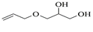
02 | Ethanamine, 1-(3, 4-dimethoxyphenyl)-N-methyl-N-[2-(4-morpholyl)ethyl] | C₁₇H₂₈N₂O₃ | 308.4 | 4.25 | 0.84 | 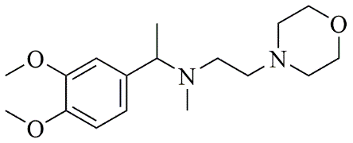
03 | 6-Oxa-bicyclo[3.1.0]hexan-3-one | C₅H₆O₂ | 98.10 | 4.898 | 4.3 | 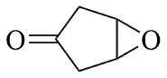
04 | Propane, 1,1-diethoxy-2-methyl | C₈H₁₈O₂ | 146.23 | 5.533 | 2.19 | 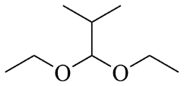
05 | 2-Propen-1-ol | C₃H₆O | 58.08 | 5.682 | 4.07 | 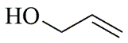
06 | Piperidine, 1-nitroso | C₅H₁₀N₂O | 114.15 | 6.224 | 0.71 | 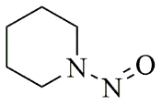
07 | d-Gala-l-ido-octonic amide | C₈H₁₇NO₈ | 255.22 | 7.153 | 0.24 | 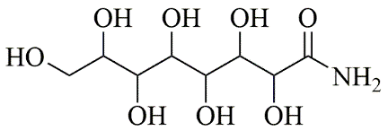
08 | 5-Methoxy-3-phenyl-1-pentanol | C₁₅H₂₆O₂Si | 194.27 | 7.485 | 2.11 | 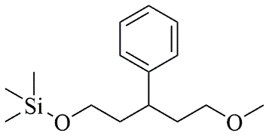
09 | Diethyl 1-methyl-3-hydroxy-5-phenylpyrrole-2,4-dicarboxylate | C₁₇H₁₉NO₅ | 317.34 | 7.786 | 0.94 | 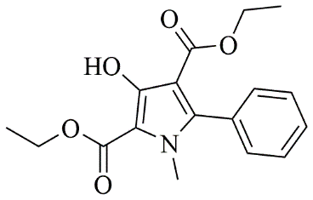
10 | 3,3'-Thiodipropanol | C₆H₁₄O₂S | 150.24 | 8.947 | 0.45 | 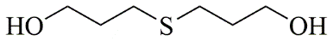
11 | Phenol, 2,6-dimethoxy | C₈H₁₀O₃ | 154.16 | 9.629 | 0.82 | 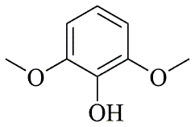
12 | 2-Furanmethanol, 5-ethenyltetrahydro-.alpha.,.alpha.,5-trimethyl | C₁₀H₁₈O₂ | 170.25 | 10.004 | 2.79 | 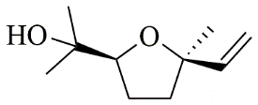
13 | 2-(Isobutoxymethyl)oxirane | C₇H₁₄O₂ | 130.18 | 10.579 | 8.65 | 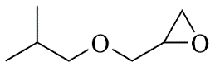
14 | 3,3-Dimethylpentanoic acid | C₇H₁₄O₂ | 130.18 | 11.051 | 0.85 | 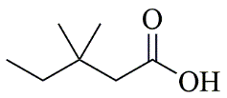
15 | Octyl-.beta.-D-glucopyranoside | C₁₄H₂₈O₆ | 292.37 | 11.76 | 0.33 | 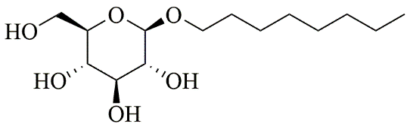
16 | 3-Deoxy-d-mannoic lactone | C₆H₁₀O₅ | 162.14 | 11.962 | 2.15 | 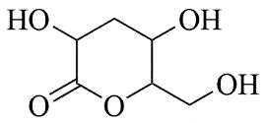
17 | Cyclohexane-1,2-diol, 4-(bicylo[2.2.1]hept-2-yl) | C₁₃H₂₂O₂ | 210.31 | 23.325 | 0.57 | 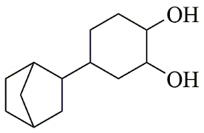
18 | 9-Octadecenamide | C₁₈H₃₅NO | 281.5 | 23.42 | 6.49 | 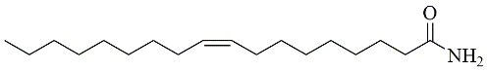
19 | Cyclohexanecarboxamide | C₇H₁₃NO | 127.18 | 23.52 | 0.97 | 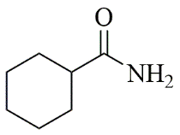
20 | Cyclodecanone, oxime | C₁₀H₁₉NO | 169.26 | 26.265 | 0.59 | 