Supplementary Information: Probing the Meissner effect in pressurized bilayer nickelate superconductors using diamond quantum sensors
Junyan Wen^{1,2†}, Yue Xu^{1,2†}, Gang Wang^{1,2†}, Ze-Xu He^{1,2}, Yang Chen¹, Ningning Wang^{1,2}, Tenglong Lu¹, Xiaoli Ma^{1,2}, Feng Jin^{1,2}, Liucheng Chen¹, Miao Liu¹, Jing-Wei Fan³, Xiaobing Liu⁴, Xin-Yu Pan^{1,2,5}, Gang-Qin Liu^{1,2,5*}, Jinguang Cheng^{1,2*}, Xiaohui Yu^{1,2*}

¹Beijing National Laboratory for Condensed Matter Physics and Institute of Physics, Chinese Academy of Sciences, Beijing 100190, China
²School of Physical Sciences, University of Chinese Academy of Sciences, Beijing 100190, China
³ Department of Physics, Hefei University of Technology, Hefei, Anhui 230009, China
⁴ Laboratory of High Pressure Physics and Material Science, School of Physics and Physical Engineering, Qufu Normal University, Qufu, Shandong 273165, China
⁵ CAS Center of Excellence in Topological Quantum Computation, Beijing 100190, China

† These authors contribute equally to this work.
*Corresponding authors: gqliu@iphy.ac.cn; jgcheng@iphy.ac.cn; yuxh@iphy.ac.cn

Supplementary notes:

- Alignment and calibration of the external magnetic field.
The external magnetic field is generated by a permanent magnet outside the cryostat chamber. The strength and orientation of the magnetic field are controlled by a translation stage and two rotation stages. The experiments are performed such that the magnetic field is perpendicular to the DAC culet, i.e. parallel to the quantization axis of a group of the shallow NV centers. As shown in Fig. S2, the ODMR of the reference point and the experimental points are measured at magnetic fields of different strengths. As the magnetic field increases, the ODMR spectra of the NV centers with [111] orientation split symmetrically (the center frequencies of the two dips remain unchanged). In contrast, the resonance dips of NV centers in other orientations do not show this property. The strength of the external magnetic field is calibrated with NV centers that are far away from the sample region.

- Calibration of pressures.
We use two methods to measure the pressures at the sample position. First, the Raman signals of the diamond culet above the sample are measured with a 532 nm laser to calibrate the pressure. The high-frequency edge of the Raman band, which corresponds to the Raman shift of the anvil culet due to the normal stress, is calculated by the pressure equation of state reformulated from the pressure-density relation of diamond¹.
$P (GPa) ≅ P_{0} \frac{∆v}{v_{0}} \left[1+\frac{1}{2} (K − 1) \frac{∆v}{v_{0}}\right]$ (S1)
where Δν and ν₀ correspond to the detected diamond frequency shift and the frequency at ambient pressure. P₀ and K are fitting parameters related to the pressure environment. The values of P₀ = 547 GPa and K = 3.75 can be found in reference 2. Using the analytical form of equation (S1) with the edge frequency ν₀ = 1330 cm⁻¹ measured at ambient pressure, we can obtain the pressure on the sample.
Another method is the use of NV centers as in-situ pressure sensors. After pressurizing or depressurizing the sample, the ODMR spectra of NV centers at the target position are measured. The resonance dips of the ODMR spectra, $f_{+1}$ and $f_{−1}$, are extracted, and the center frequency $f_{c}=(f_{+1}+f_{−1})/2$ is used to calculate the pressure $P$ according to the following formula³.
$P=\frac{f_{c}−f_{c0}}{α}$ (S2)
where $f_{c0}=2870 MHz$ is the zero-field splitting of NV centers at ambient temperature and pressure, and the slope $α=7.24 MHz/GPa$. The pressure at point A0 is summarized in Table S1.
Table S1 ODMR resonance dips and pressures at A0 of sample A
Experiment | $f_{−1}$/MHz | $f_{∓1}$/MHz | $$f_{c}/MHz$$ | $$P/GPa$$
1 | 3018.7 | 3030.3 | 3024.5 | 21.3
2 | 3048.6 | 3061.2 | 3054.9 | 25.5
3 | 2944.1 | 2954.9 | 2949.5 | 11.0
4 | 3083.1 | 3095.5 | 3089.3 | 30.3

- Decoupling of magnetic and stress information.
Magnetic fields and stress simultaneously influence the splitting of the ODMR spectra of NV centers. The total splitting of the ODMR spectra $∆$ can be expressed as follows: $∆ =\sqrt{∆_{magnetic}^{2}+∆_{stress}^{2}}$, where $∆_{magnetic}$ represents the splitting caused by the magnetic field, and $∆_{stress}$ represents the splitting caused by the differential stress (the symmetry-breaking stress that is not aligned along the NV axis). In our experiments, the ODMR spectra of the target region at zero field and 150 K (above T_{C} ) were measured to determine the contribution of local pressure. The distribution of stress-induced splitting in sample C (La₃Ni₂O_{7-δ} in silicon oil) is shown in Fig. 4c and Fig. 4d. It is clear that the stress-induced ODMR splitting changes slightly across the sample region. We performed linear interpolation to obtain a spatial distribution of non-magnetic splitting with higher resolution (Fig. S5c). By subtracting (in quadrature) the stressed component, we obtained the magnetic splitting shown in Fig. 4e.
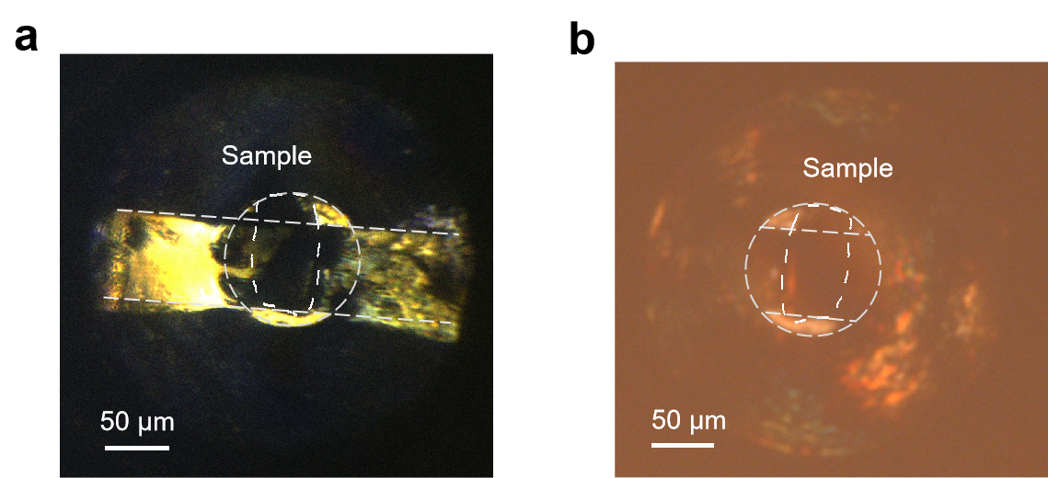
Fig. S1 Bright field image of sample A from the top view (a) and the bottom view (b). The sample, chamber and the wire are marked in the figure. The profile of the sample is determined from the bright field image from the bottom view and is marked with white dashed lines in the figure (a) and (b).

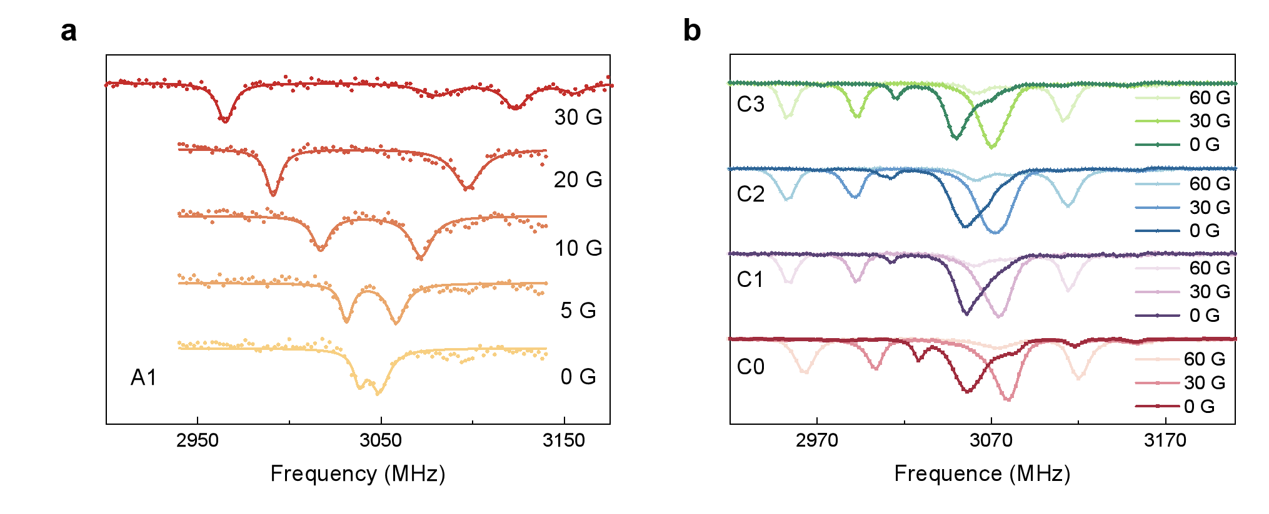
Fig. S2 ODMR spectra of sample A (La₂PrNi₂O₇ in silicon oil) and sample C (La₃Ni₂O_{7-δ} in silicon oil) at different magnetic fields. (a) Typical ODMR spectra of the NV centers at the diamagnetic point of sample A (A1) at different magnetic fields. (b) Typical ODMR spectra of the NV centers of points on sample C (C1, C2, C3) and far away from sample C (C0) at different magnetic fields.

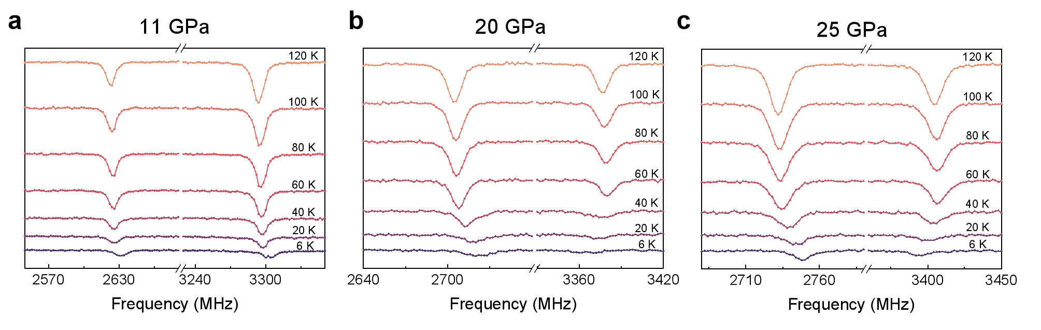
Fig. S3 Typical ODMR spectra during ZFC-FW measurements. The ODMR spectra are measured at point A1 of sample A (La₂PrNi₂O₇ in silicone oil) during the ZFC-FW process and at an external magnetic field of 120 G. The pressure is 11 GPa, 20 GPa and 25 GPa for (a), (b) and (c), respectively. At 11 GPa, the ODMR splitting remains constant from 6 K to 120 K, which means that the sample shows no diamagnetic response. In contrast, when the pressure is increased to 20 GPa, the ODMR splitting at low temperatures (T < T_{c} ~ 60 K) is lower than at high temperatures.

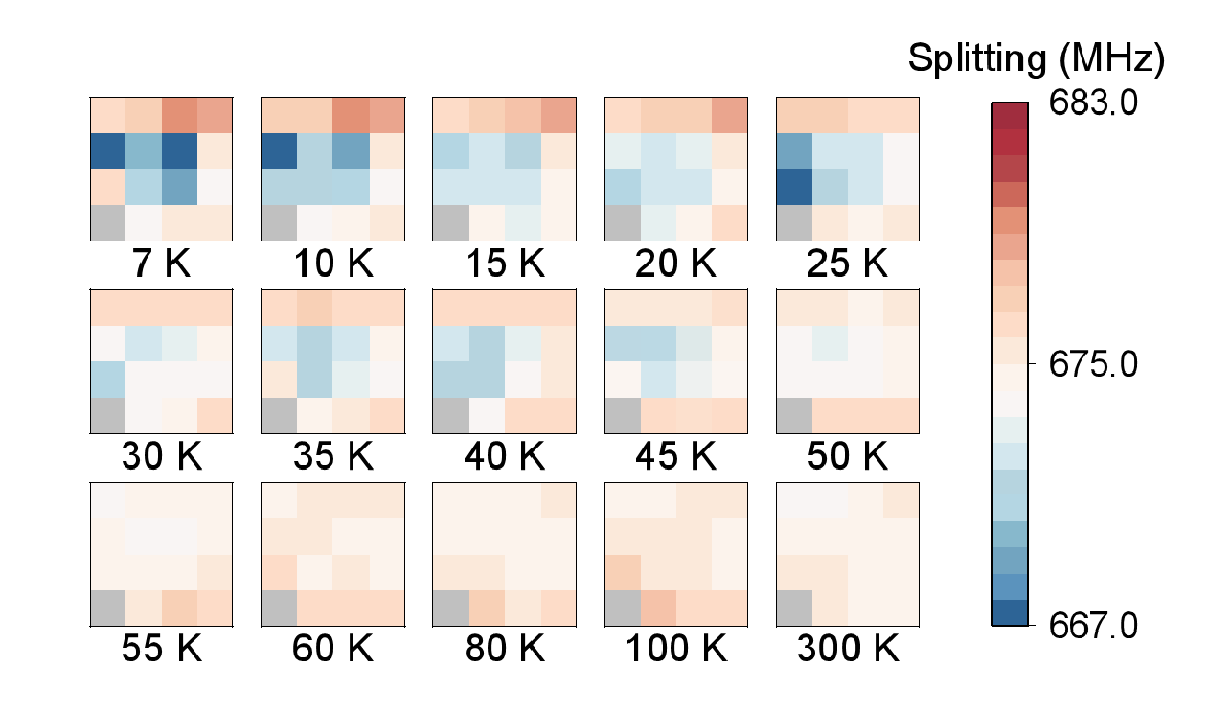
Fig. S4 Magnetic field image of sample B (La₂PrNi₂O₇ in KBr) during the FW process. Magnetic field image of a superconducting region on sample B (La₂PrNi₂O₇ in KBr) during the FW process. The exact position of the measured region is marked in Fig. 3b. The external magnetic field is 120 G. Part of the results are shown in Fig. 3(c) of the main text. The point shown in the gray square is not considered in the discussion because its ODMR contrast is too low.

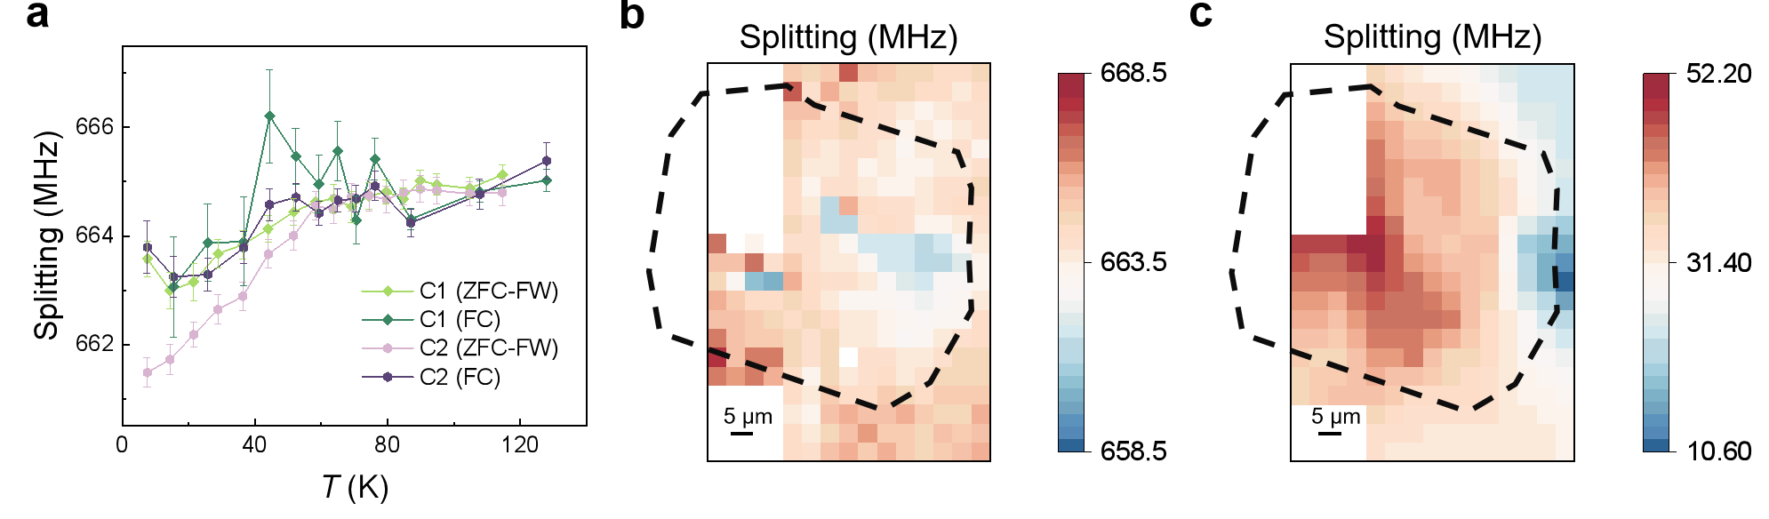
Fig. S5 Spatial distribution of the ODMR splitting in sample C (La₃Ni₂O_{7-δ} in silicon oil). (a) ODMR splitting of two points (C1 and C2) during the ZFC-FW and FC processes, with an external magnetic field of 120 G. The positions of the points are shown in Fig. 4a. (b) Spatial distribution of ODMR splitting at 120 G and 6 K. Both the diamagnetism and the local stress of sample C contribute to the ODMR splitting. (c) Spatial distribution of ODMR splitting at 150 K and 0 G. By combining (b) and (c), we can exclude the influence of the non-magnetic component of the splitting and obtain the purely magnetic distribution of sample C, as shown in Fig. 4e of the main text.

References
1 Eremets, M. I. Megabar high‐pressure cells for Raman measurements. J. Raman Spectrosc. 34, 515-518, (2003).
2 Akahama, Y. & Kawamura, H. Pressure calibration of diamond anvil Raman gauge to 310 GPa. J. Appl. Phys. 100, (2006).
3 Mengqi Wang et al. Imaging magnetism evolution of magnetite to megabar pressure range with quantum sensors in diamond anvil cell. Nat. Commun. 15, 1-8, (2024)

