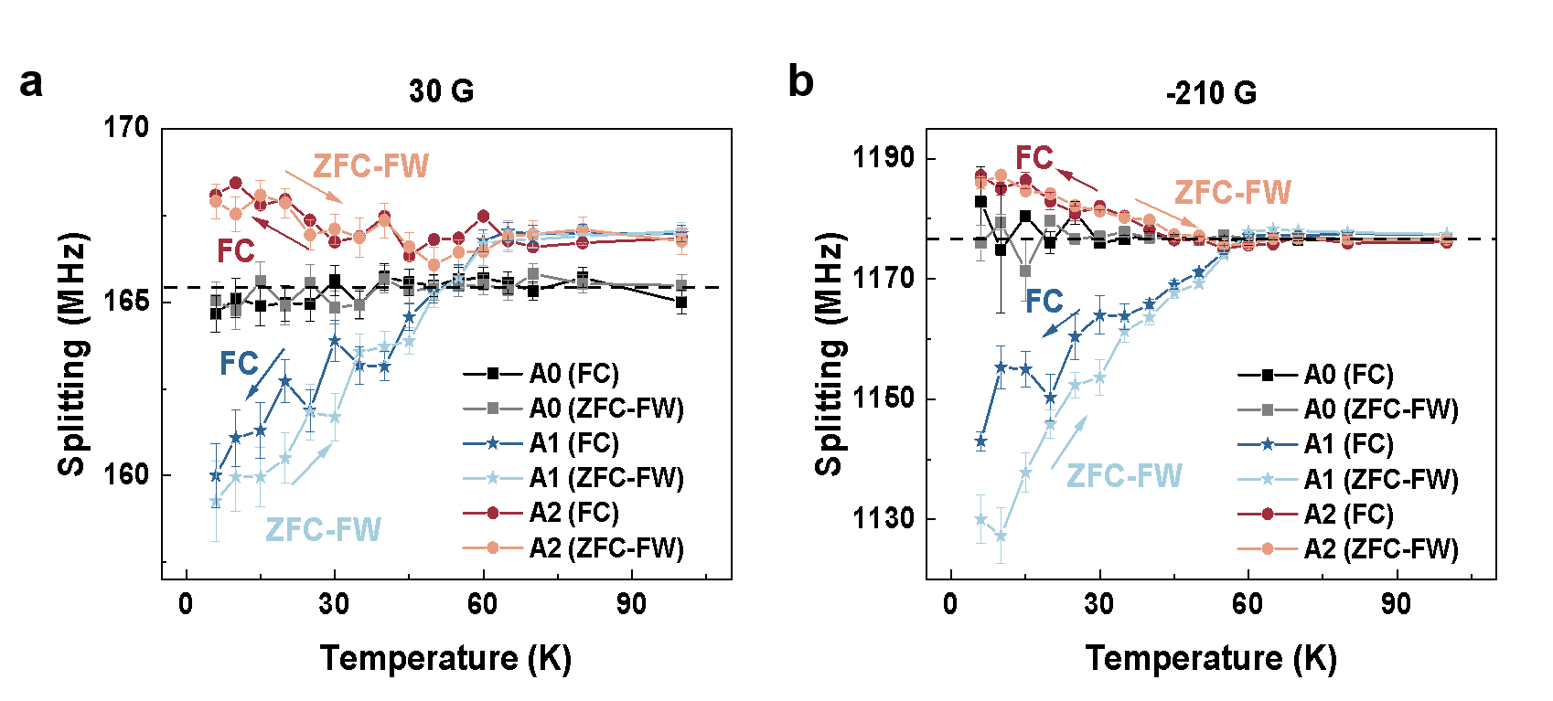Extended Data Fig. 1 Diamagnetism of sample A (La₂PrNi₂O₇ in silicon oil) under different external magnetic fields. ODMR splitting during the ZFC-FW and FC processes of sample A at 20 GPa and an external magnetic field of 30 G (a) and -210 G (b). The measured points (A0, A1 and A2) are marked in Fig. 2 (a) and the measurement protocol is shown in Fig. 2e. The ODMR splitting of FC is close to the splitting of ZFC-FW at 30 G, while the ODMR splitting of FC is smaller than that of ZFC-FW at -210 G. This agrees well with the magnetic behavior in superconductors with disorder pin: When the external magnetic field becomes larger, more magnetic flux can penetrate through the superconductor, which makes a difference between the diamagnetism during the FC process and the ZFC-FW processes. The larger the external magnetic field, the more magnetic flux can penetrate the superconductor.

Extended Data Fig. 2 Diamagnetism of sample A (La₂PrNi₂O₇ in silicon oil) at different pressures and T-P phase diagram. (a) ODMR splitting of point A1 at different pressures during the ZFC-FW measurement at 120 G. At a pressure of 11 GPa, sample A shows no diamagnetic effect. The sample shows maximum diamagnetism at 20 GPa and gradually decreases with increasing pressure. (b) The T-P phase diagram of La₂PrNi₂O_{7.} The purple star represents the T_{c} determined from the ODMR measurement. The rhomboid, pentagon and circle are the T_{c} values obtained in reference^{3,17}.

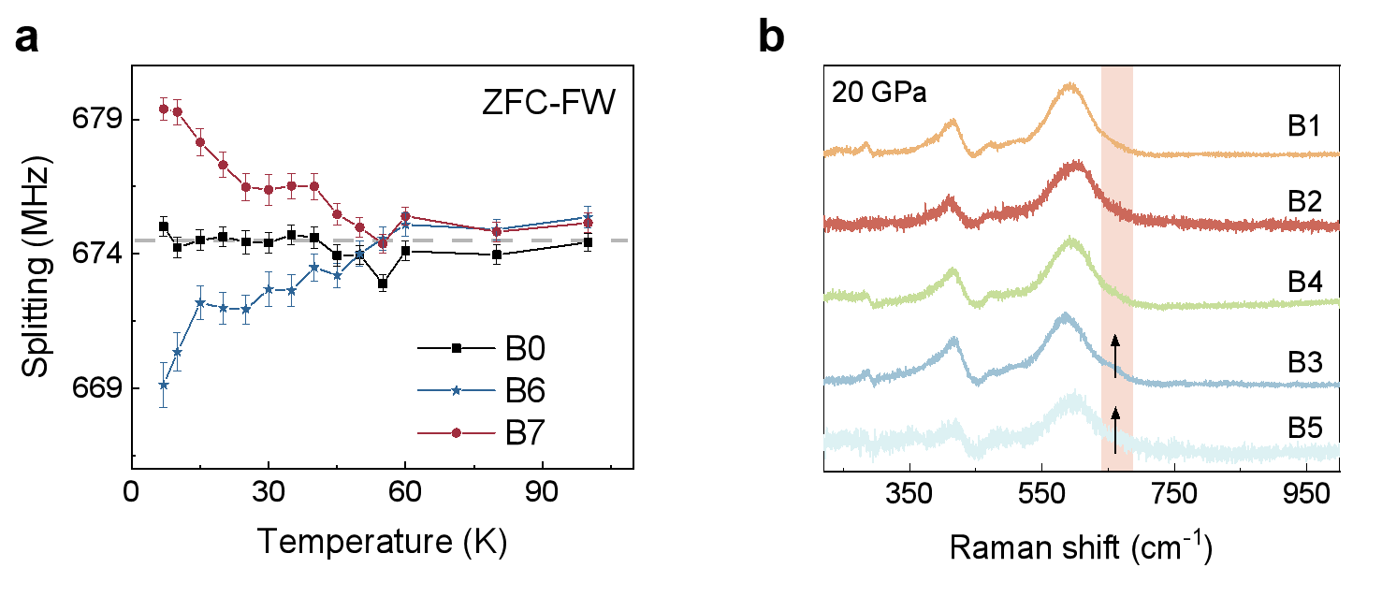
Extended Data Fig. 3 Diamagnetism and Raman spectra of sample B (La₂PrNi₂O₇ in KBr) (a) ODMR measurement at test points at 30 GPa during the ZFC-FW process. (b) Raman spectra measured at the test points of sample B at 20 GPa. The position of the test points is shown in Fig. 3b. Points B1, B2 and B4 are located in the superconducting region, B3 and B5 in the non-superconducting region. A satellite peak around 680 cm⁻¹ can be found in the Raman spectra of B3 and B5, while it is suppressed in the Raman spectra of B1, B2 and B4.

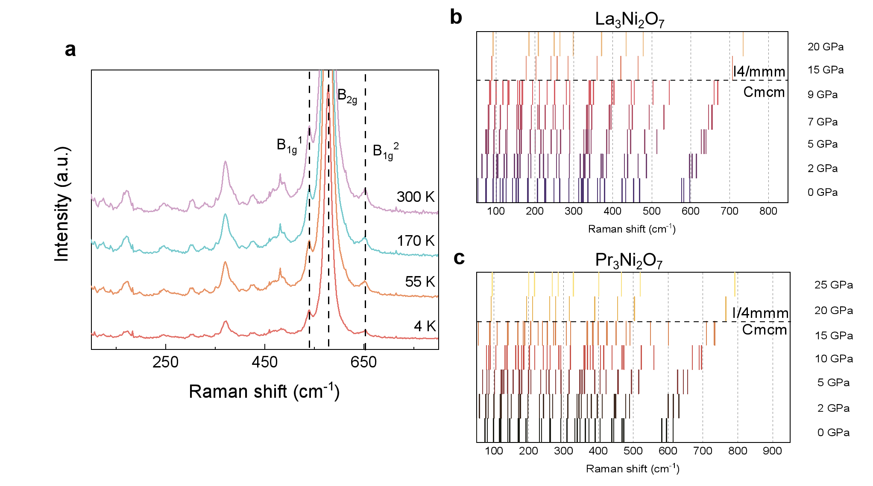
Extended Data Fig. 4 The Raman spectrum of La₂PrNi₂O₇ at ambient pressure and the DFPT calculations results. (a) Typical Raman spectrum measured with a 785 nm laser on the La₂PrNi₂O₇ at ambient pressure and temperatures from 4 K to 300 K. The Raman spectrum is evenly distributed over the sample. (b-c) The Raman-active modes with increasing pressure of La₃Ni₂O₇ (b) and Pr₃Ni₂O₇ (c) from DFPT calculations. The three highest Raman-active vibrational modes B_{1g}¹, B_{2g}, and B_{1g}² are correspondingly shown in (a). With increasing pressure, these three modes gradually shift to higher frequencies and the variance between the B_{2g} and B_{1g}² modes becomes negligible. In the high-pressure structure, there is only one Raman-active mode (E_{g}) above 600 cm⁻¹ , which is due to the degeneracy of the B_{2g} and B_{1g}² modes.

