Supplementary Material

Supplementary Figure 1 Mean RMSE over five periods in JPN for eight different models. The blue triangle indicates the minimum mean RMSE, achieved with the CNN-LSTM model using data from 20 countries.
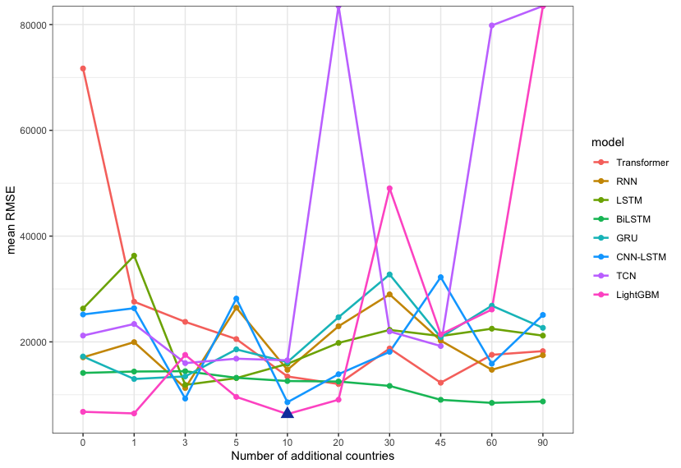
Supplementary Figure 2 Mean RMSE over five periods in RUS for eight different models. The blue triangle indicates the minimum mean RMSE, achieved with the lightgbm model using data from 10 countries.

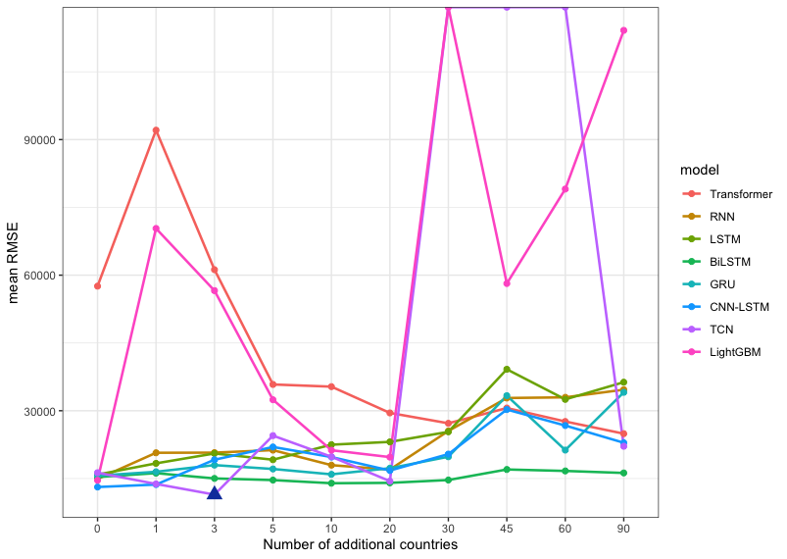
Supplementary Figure 3 Mean RMSE over five periods in ITA for eight different models. The blue triangle indicates the minimum mean RMSE, achieved with the TCN model using data from 3 countries.

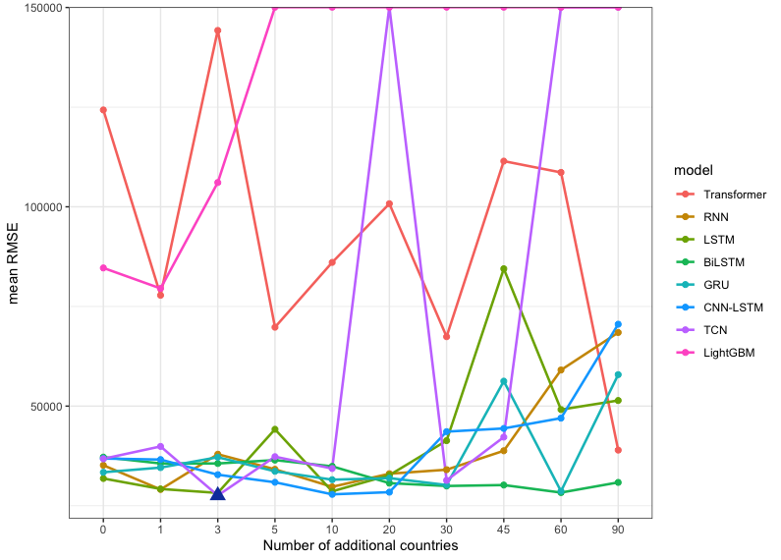
Supplementary Figure 4 Mean RMSE over five periods in USA for eight different models. The blue triangle indicates the minimum mean RMSE, achieved with the TCN model using data from 3 countries.

Supplementary Table 1 Hyperparameter tuning ranges for the transformer encoder with fully connected layer

Encoder Layers | Attention Heads | Embedding Dimension | Feedforward Dimension | Dropout  Rate | Learning Rate | Batch  Size
[2, 3,4, 5, 6] | [4, 8, 12] | [32, 64, 128] | [128, 256, 512] | [0.1, 0.2, 0.3, 0.4, 0.5] | [0.0001~0.001] | [4, 8, 16, 32, 64]
Supplementary Table 2. Hyperparameter Ranges for RNNs, LSTMs, BiLSTM, and GRU
hidden layers | hidden units per layer | dropout rate | Learning Rate | Batch Size
[1, 2, 4, 8] | [4, 8, 16, 32, 64, 128, 256] | [0.1, 0.2, 0.3, 0.4, 0.5] | [0.0001~0.001] | [4, 8, 16, 32]
Supplementary Table 3: Hyperparameter Ranges for CNN-LSTM
CNN layers | filters per CNN layer | kernel size | LSTM layers | Hidden units per LSTM layer | dropout rate | Learning Rate | Batch Size
[1, 2, 4, 8] | [8, 16, 32, 64] | [2, 3, 4, 5] | [1, 2, 4, 8] | [4, 8, 16, 32, 64, 128, 256] | [0.1, 0.2, 0.3, 0.4, 0.5] | [0.0001~0.001] | [4, 8, 16, 32]
Supplementary Table 4: Hyperparameter Ranges for TCN
Residual Blocks | Filters per Block | Kernel Size | Dropout  Rate | Learning  Rate | Batch  Size
[2, 3, 4] | [25, 50, 100] | [2, 3, 4, 5] | [0.1, 0.2, 0.3, 0.4, 0.5] | [0.0001~, 0.01] | [4, 8, 16, 32]

Supplementary Table 5: Hyperparameter Ranges for lightGBM
num_leaves | min_child_samples | num_iterations | max_depth | learning_rate | colsample_bytree | reg_alpha | reg_lambda | min_split_gain
[4,8,16,32,64] | [2,4,8] | [2000] | [5,7,8,16] | [0.01] | [0.7,0.8,0.9] | [0,0.1,0.3] | [0,0.1,0.3], | [0.001]

Supplementary Table 6: The five most informative countries for each target country based on DTW distance

Rank | Korea | Japan | Russia | Italy | USA
1 | China | Italy | India | Austria | France
2 | Austria | Korea | Vietnam | Brazil | Italy
3 | India | Turkey | China | France | Deutschland
4 | Brazil | Deutschland | Turkey | Deutschland | Brazil
5 | Russia | Austria | Austria | Korea | India
6 | Deutschland | France | Korea | China | Japan
7 | Vietnam | Brazil | Portugal | India | Austria
8 | Italy | Mexico | Netherlands | Japan | Korea
9 | France | India | India | Russia | UK
10 | Japan | China | Italy | Portugal | China

