Table S1 Some main signals of LC-MS/MS of L
Number | m | z | m/z | Symbol | Structure | Chemical formula
1 | 1207 | +1 | 1207 | A' | L | C₆₄H₆₄Cl₄N₁₂O₄
2 | 1110 | +1 | 1110 | B' | 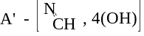 | C₆₃H₅₇Cl₄N₁₁
3 | 1098 | +1 | 1098 | C' | 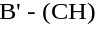 | C₆₂H₅₇Cl₄N₁₁
4 | 1064 | +1 | 1064 | D' | 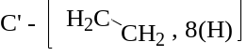 | C₆₀H₄₈Cl₄N₁₁
5 | 931 | +1 | 931 | E' | 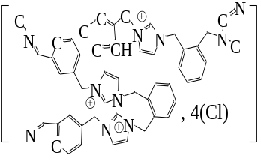 | C₅₁H₃₇Cl₄N₁₀
6 | 764 | +1 | 764 | F' | 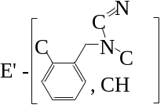 | C₄₀H₂₉Cl₄N₈
7 | 561 | +1 | 561 | G' | 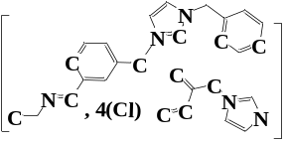 | C₂₈H₁₃Cl₄N₅
8 | 413 | +1 | 413 | H' | 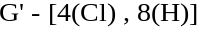 | C₂₈H₇N₅
9 | 305 | +1 | 305 | I' | 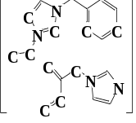 | C₂₀H₉N₄
10 | 292 | +1 | 292 | J' | 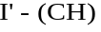 | C₁₉H₈N₄
11 | 239 | +1 | 239 | K' | 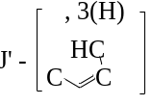 | C₁₅H₆N₄
12 | 171 | +1 | 171 | L' | 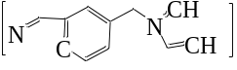 | C₁₁H₉N₂
13 | 117 | +1 | 117 | N' | 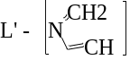 | C₃H₄N

