Supplementary information for Integrated photonic 3D tensor processing engine
Yue Wu^{1,3}, Ziheng Ni^{1,3}, Xin Li¹, Yuanxun Wang¹, Liangjun Lu^{1,2}, Jianping Chen^{1,2}, and Linjie Zhou^{1,2}

¹State Key Laboratory of Advanced Optical Communication Systems and Networks, Department of Electronic Engineering, Shanghai Jiao Tong University, Shanghai 200240, China,
²SJTU-Pinghu Institute of Intelligent Optoelectronics, Pinghu 314200, China
³These authors contributed equally: Yue Wu, Ziheng Ni
luliangjun@sjtu.edu.cn; ljzhou@sjtu.edu.cn

Supplementary note 1: All-optical 3D tensor processing engine 2
Supplementary note 2: Dual-coupled MRRs weighting element 4
Supplementary note 3: MNIST recognition task 7
Supplementary note 4: Design and test of the optical memory unit chip 9
Supplementary note 5: Signal synchronization between multi-channels 11
Supplementary note 6: Computing energy efficiency estimation 12
Supplementary note 7: Insertion loss of the 3D CNN 14
Supplementary note 8: Experimental setup for 3D convolution 15
Reference 16

Supplementary note 1: All-optical 3D tensor processing engine
In the main text, in order to avoid power perturbation induced by coherent interference between paths at identical wavelengths, photodetectors are used at the output ports of the optical tunable delay lines to convert optical signals to electrical signals, and signal accumulation is performed in the electrical domain with an electrical power combiner. Alternatively, signal accumulation across optical paths can occur directly in the optical domain by leveraging the rich resonance orders of the MRRs.
Suppl. Fig. 1a illustrates the working principle of the proposed all-optical 3D tensor processing engine (3D-TPE). To perform tensor convolution between two 3D matrices A and B, each with dimensions ($I,J,K)$ where $I×J≥K$, the input matrix A is sequentially encoded onto multi-wavelength carriers by a high-speed modulator with a symbol duration of $∆t$. The number of wavelengths is $I×J×K$, corresponding to the $K$ resonance orders of the MRR (from m^{th} to (m+K-1)^{th} orders), where each resonance order contains $I×J$ operating wavelengths, as shown in Suppl. Fig. 1b. The modulated optical carriers are then divided into $K$ paths using a WDM with channel spacing equal to the free spectral range (FSR) of the MRR. After passing through $K$ tunable delay lines with equal time intervals of $∆t$, the replicas enter the dual-coupled-MRRs crossbar optical computing unit (OCU). The OCU comprises $K$ rows and $I×J$ columns, with operating wavelengths configured such that different rows function at distinct resonance orders, while different columns in each row exhibit varying resonance wavelengths of the same order, as illustrated in Suppl. Fig. 1c. The weights of matrix B are deployed on the dual-coupled-MRRs crossbar circuit. Utilizing the filtering effect of MRRs, weighted replicas from different rows, with time intervals of $∆t$, combine into vertical bus waveguides and are transmitted into another array of optical tunable delay lines with time intervals of $K∆t$. After the second time delay, all signals are combined via an optical combiner. Consequently, the $I×J×K$ weighted replicas across multiple wavelengths have uniform delay time intervals of $∆t$ after traversing the $I×J×K$ weighting channels. Finally, a high-speed photodetector (PD) performed the summation. The 3D convolutional processing results are derived by sampling the PD output waveforms at a rate of $\frac{1}{(I×J×K)∆t}$. As the $I×J×K$ delayed signals operate at distinct wavelengths, they can be directly combined in the optical domain without concern for phase perturbation among different paths of identical wavelengths.
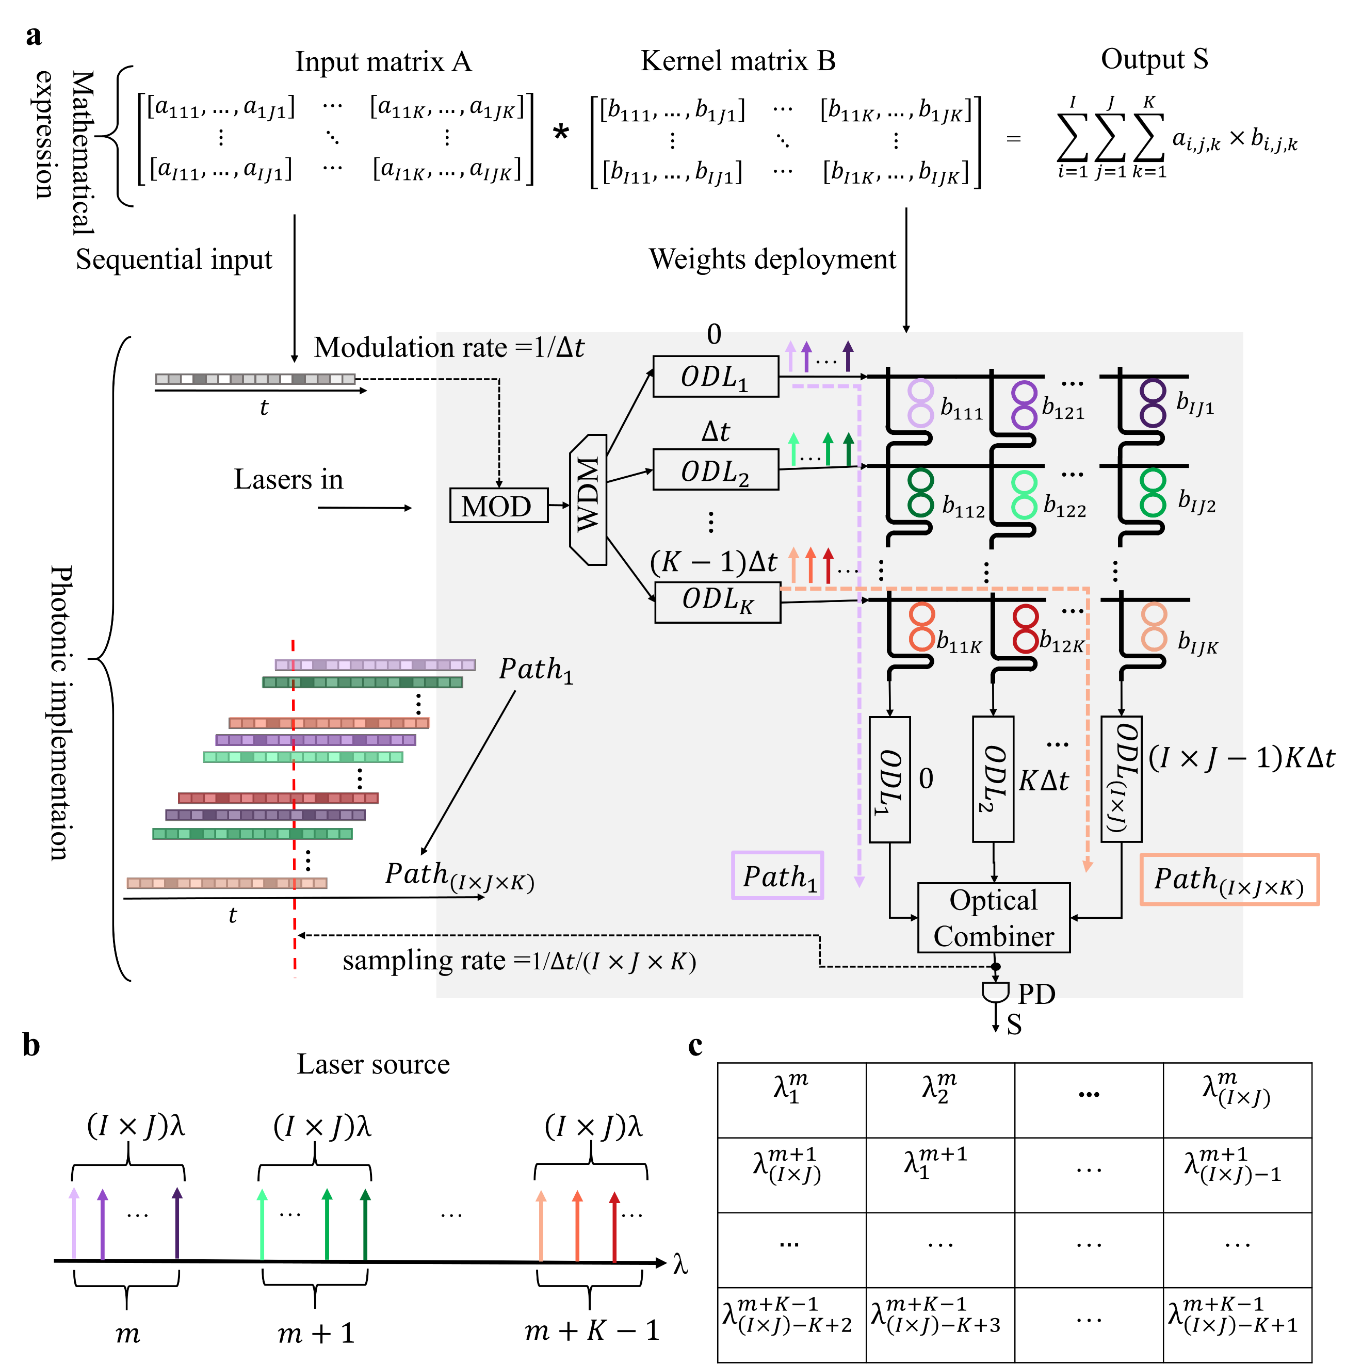
Suppl. Fig. 1 Processing flow of the all-optical 3D-TPE. a. The 3D matrix A, with a size of ($I,J,K)$, is encoded onto the amplitude of multi-wavelength carries by sequential modulation. The 3D kernel matrix B, with a size of ($I,J,K)$, is deployed on the dual-coupled-MRRs based crossbar circuit. The 3D tensor convolution operation is accomplished by controlling time delay intervals between channels and the coding process. b. The multi-wavelength laser source consists of $I×J×K$ wavelengths corresponding to the K resonance orders of the MRR, with each order containing $I×J$ operating wavelengths. c. Operating wavelength configuration of the crossbar OCU chip.

Supplementary note 2: Dual-coupled-MRRs weighting element
Suppl. Fig. 2 shows the schematic structure and the cross sections of the proposed dual-coupled-MRRs weighting element (WE). The dual-coupled MRRs were fabricated on a multilayer ${Si}_{3}N_{4}$-on-SOI platform, with two MRRs located in the middle ${Si}_{3}N_{4}$ layer. The MRR incorporates a 1-μm-long straight waveguide in each coupling region. In order to reduce bend-to-straight transition loss in the ring, four 90° bends are designed as Euler bends, thus decreasing insertion loss at the drop port. The FSR of the MRRs is 4.8 nm.
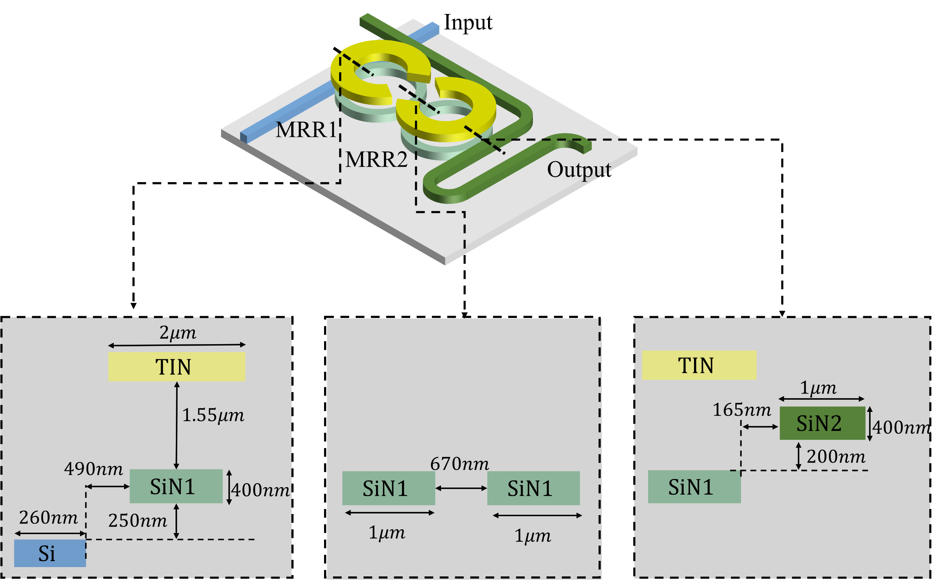
Suppl. Fig. 2 Structure of the dual-coupled-MRRs WE and cross-sectional views of the coupling regions with key dimensions indicated.
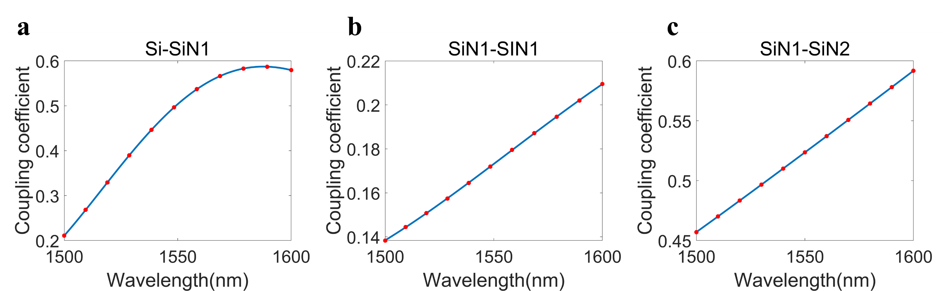
Suppl. Fig. 3 Simulated coupling coefficients of the three coupling regions in the dual-coupled-MRRs WE. a. Coupling between the Si bus waveguide and the middle ${Si}_{3}N_{4}$ MRR (marked as SiN1). b. Coupling between two MRRs in the middle ${Si}_{3}N_{4}$ layer. c. Coupling between the middle ${Si}_{3}N_{4}$ MRR and the top ${Si}_{3}N_{4}$ bus waveguide (marked as SiN2).
The simulation of the dual-coupled-MRRs WE focuses on three coupling regions, including the coupling region between the Si bus waveguide and the middle ${Si}_{3}N_{4}$ MRR, the coupling region between the two MRRs, and the coupling region between the middle ${Si}_{3}N_{4}$ MRR and the top ${Si}_{3}N_{4}$ bus waveguide. Suppl. Fig. 3 shows the simulated coupling coefficient of the three coupling regions using the FDTD method.
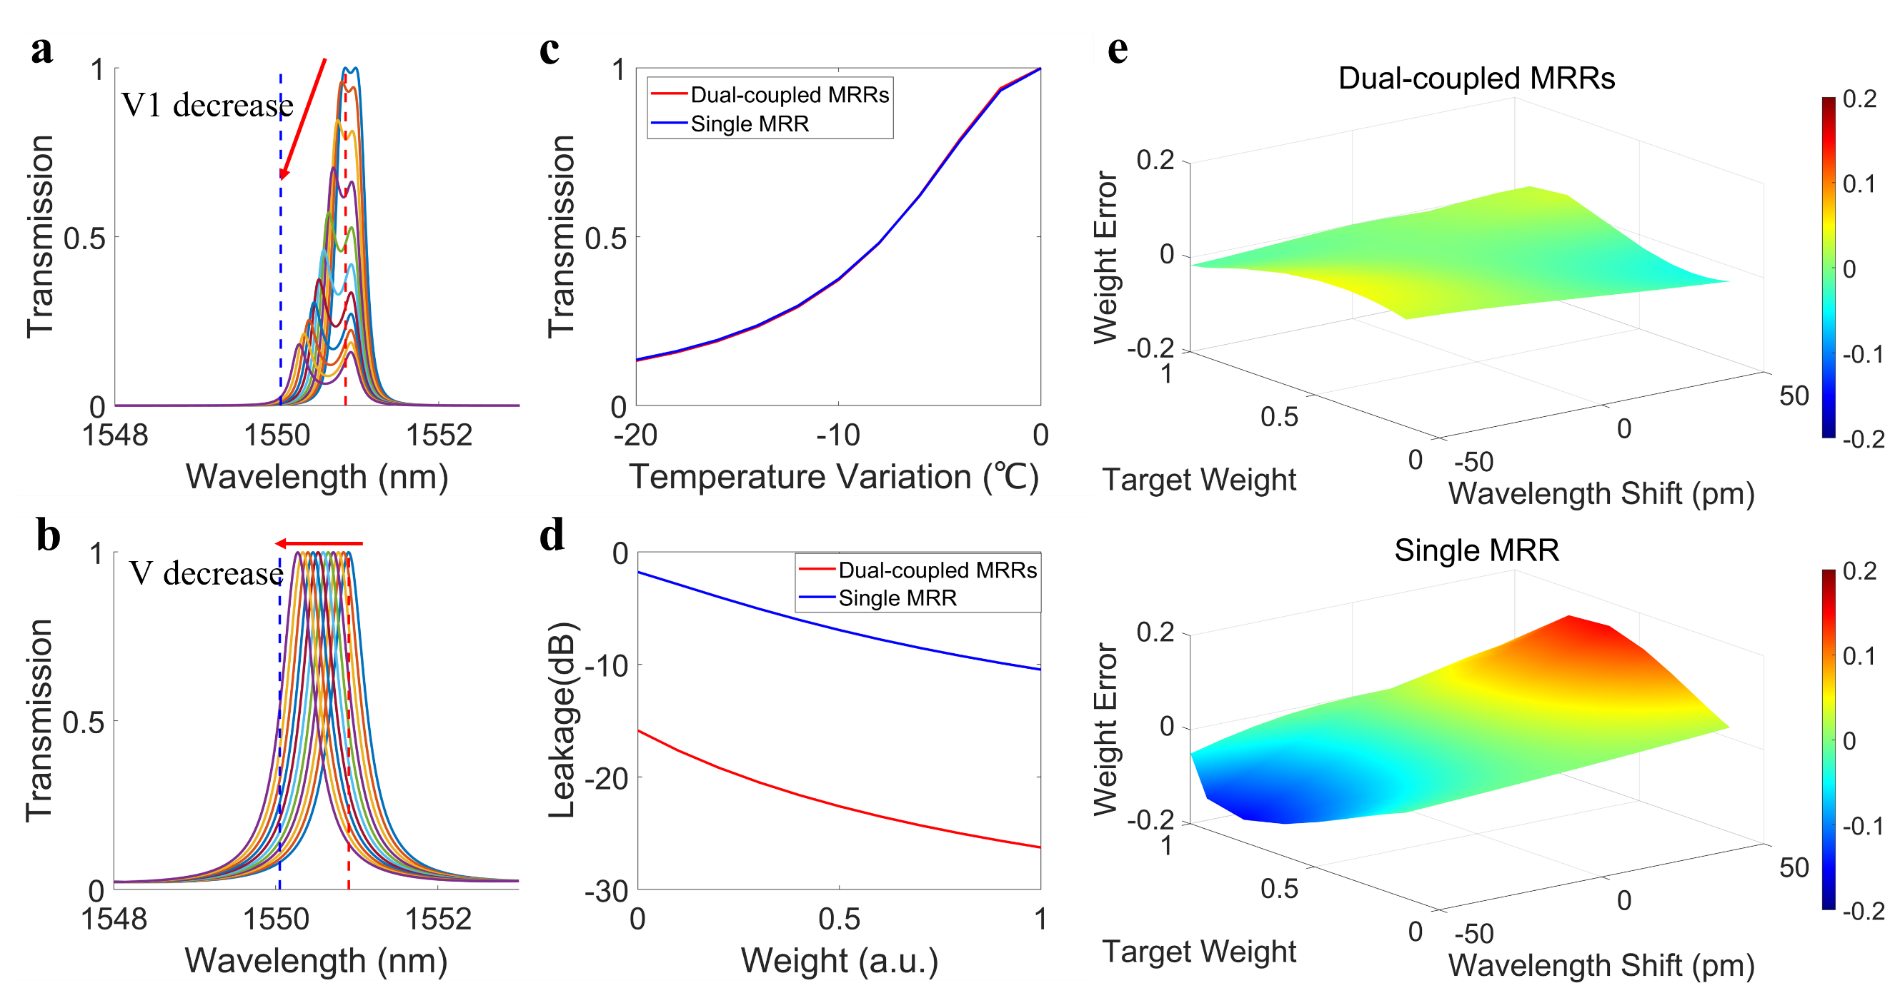
Suppl. Fig. 4 Comparison between the dual-coupled-MRRs WE and a single-MRR WE. a. Transmission spectra of the dual-coupled-MRRs WE were obtained by sweeping the voltages of MRR1. b. Transmission spectra of the single MRR. The red (blue) dotted lines in a and b illustrate the operating (adjacent) wavelengths for weighting. c. Weight tuning under different temperature variations for the dual-coupled MRR WE and the single MRR WE, respectively. The temperature variation at a weight value of 1 is marked as 0. d. Optical leakage from adjacent wavelength channels during the weight-tuning process. e. Weight errors upon the laser wavelength drift for the dual-coupled-MRRs WE (upper panel) and the single-MRR WE (bottom panel), respectively.
The transmission spectrum of the dual-coupled-MRRs WE was simulated using the transfer matrix method by importing the simulated coupling coefficients into the matrix. The spectrum shows a flat-top characteristic with a 3 dB bandwidth exceeding 50 GHz. Suppl. Fig. 4a illustrates the weight-tuning process of the dual-coupled-MRRs WE. Firstly, the voltages of the two MRRs were adjusted simultaneously to get a flat-top spectrum at the target operating wavelength. Secondly, the voltage of MRR1 was swept while maintaining the voltage of MRR2 fixed, and the output optical power at the operating wavelength was monitored. Suppl. Fig. 4b illustrates the weight-tuning process of a single MRR for comparison. Since the effective refractive index can be tuned by varying the temperature on the ring, utilizing temperature changes to simulate the voltage tuning process directly is feasible. The thermo-optic coefficient of the ${Si}_{3}N_{4}$ waveguide used here is $4.098×{10}^{-5}$. Suppl. Fig. 4c illustrates the relationship between optical transmission and temperature variations for both a dual-coupled-MRRs WE and a single-MRR WE, both exhibiting similar weight tuning efficiency. By normalizing the maximum and minimum output optical power, a dot product for positive real numbers ranging from 0 to 1 can be achieved. The normalization formula is expressed as follows:
$$w=\frac{(T-T_{min})}{(T_{max}-T_{min})}$$
where $T_{max}$ and $T_{min}$ are the maximum and minimum output optical power, respectively. Real-number computation can be further implemented by incorporating reference paths^{[1]}, balanced photodetectors^{[2]}, or decomposing a real number into two positive values ^{[3]}.
Due to the limited roll-off ratio of MRR-based WEs, optical leakage from adjacent wavelength channels will lead to unexpected optical power accumulation, thus degrading computing accuracy. Optical power leakage from an adjacent wavelength channel (indicated by the blue dotted lines in Suppl Figs. 4a and 4b) with a channel spacing of 100 GHz was observed while tuning the weights of the operating wavelength channel (as indicated by the red dashed lines in Suppl Figs. 4a and 4b), as shown in Suppl Fig. 4d. Weight tuning of the MRR-based WE results in the variations of optical leakage, which increases with the decrease of weight values. Nonetheless, optical leakage from adjacent channels in the dual-coupled-MRRs WE is significantly lower than in the single-MRR WE due to the faster roll-off, indicating smaller weight errors.
Given that laser emission wavelength drifts may occur due to temperature and pump current fluctuations, we monitored the output optical power under operating wavelength drifts ranging from ±50 pm and calculated the deviations from ideal optical power as weight errors. Suppl Fig. 4e shows the relationship between weight error and wavelength drift. For a single-MRR WE, the weight error increases rapidly with wavelength drift, with a 50 pm drift resulting in a maximum weight error of 0.152. In comparison, the impact of wavelength drift on weight error is significantly mitigated in the dual-coupled-MRRs WE, exhibiting smoother weighting characteristics and a maximum weight error of 0.067 for a 50 pm wavelength drift. The dual-coupled-MRRs WE shows larger weight errors at lower weight values due to the flatter spectral characteristics at higher weight values. Utilizing the weight pruning technique^{[4]}, which emphasizes higher weight values in neural network kernel weights, can minimize the impact of errors at smaller weight values.

Supplementary note 3: MNIST recognition task
To verify the parallel computational capability of the dual-coupled-MRRs based optical computing unit (OCU) chip, a 10-category handwritten digit recognition task based on the MINIST dataset was performed. The convolutional neural network (CNN) architecture is shown in Suppl. Fig. 5. The convolution layer consists of four $2×2$ convolution kernels constrained to positive values for extracting image features. The MVM operation within the convolution layer was executed optically on the OCU chip, while other operations were accomplished by a digital computer. Suppl. Fig. 6 illustrates the experimental setup. In the experiment, four modulators (ixblue MXAN-LN-20) were used to modulate four weighting channels in parallel. Synchronization between channels was done by the internal clock module of a high-speed arbitrary waveform generator (AWG, Keysight M8199A). After the training process, the trained kernel weights were deployed on the OCU chip according to the W-V relationships via a look-up-table method. The weight voltages were provided by a multi-channel voltage source. During image inference, images were initially patched according to the kernel dimensions and then modulated into the optical domain by the modulators and the AWG. MVM operation was completed as signals passed through the OCU chip. The accumulated optical signals were then converted into electrical signals by a high-speed photodetector (PD) equipped with a trans-impedance amplifier (TIA) (Finisar XPRV2021) and recorded by a real-time oscillograph (OSC) (Tektronix DPO75902SX). Suppl. Fig. 7 compares some randomly selected feature maps obtained from the optical implementation and a digital computer, revealing slight differences. These results demonstrate the promising potential of our OCU chip in parallel computing and image recognition applications.
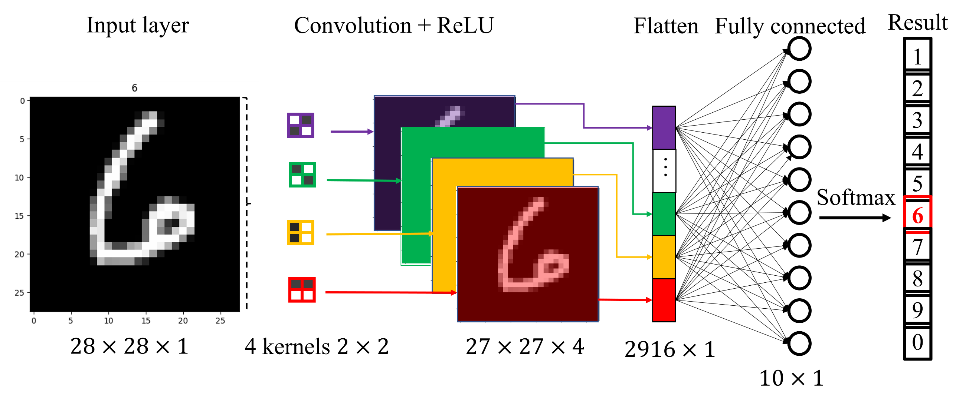
Suppl. Fig. 5 CNN architecture for 10-category MNIST handwritten digit recognition task.
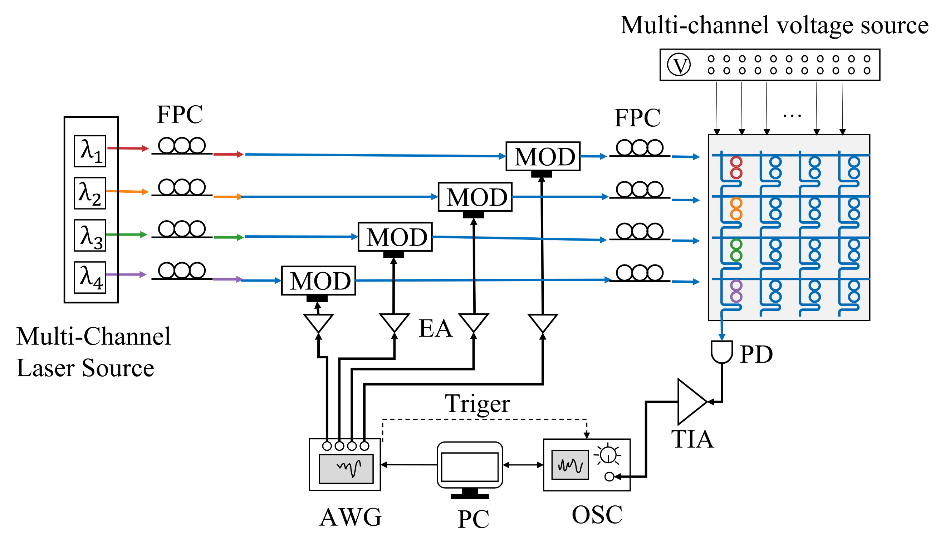
Suppl. Fig. 6 Experimental setup for 10-category MNIST handwritten digit recognition task. FPC: fiber polarization controller; MOD: modulator; AWG: arbitrary waveform generator; EA: electrical amplifier; PC: personal computer; OSC: oscilloscope; TIA: trans-impedance amplifier; PD: photodetector.
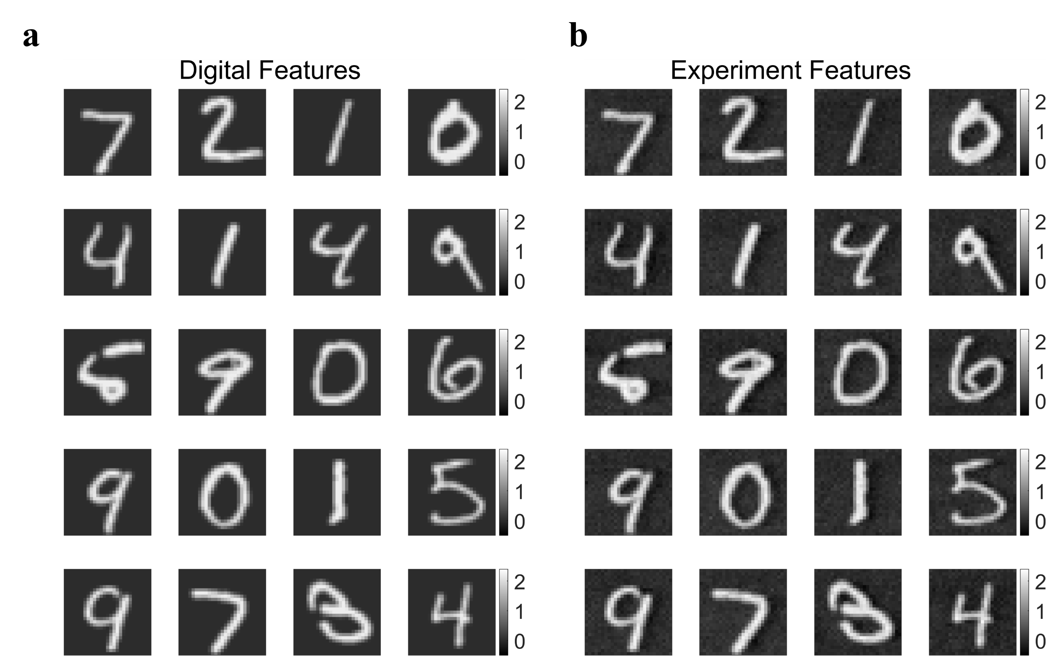
Suppl. Fig. 7 Comparison of the convolutional feature maps calculated by a. the digital computer and b. the optical computing chip.

Supplementary note 4: Design and test of the optical memory unit chip
The optical memory unit (OMU) chip consists of eight identical tunable optical true-time delay lines (OTTDLs). Suppl. Fig. 8a displays the schematic of the 6-bit switchable tunable delay line, which includes 7 MZI-based optical switches to digitally select delay paths with varied lengths to realize discrete delay tuning. The delay waveguide width is tapered from 0.5 μm to 2 μm to reduce transmission loss and delay errors induced by fabrication deviation. Suppl. Fig. 8b illustrates the cross-section of the 2-μm-wide ridge waveguide. Each optical switch consists of two 2×2 multimode interferometers (MMIs) and two waveguide arms. A TiN microheater is integrated on one of the arms for thermo-optic (TO) phase shift. Furthermore, we insert two VOAs based on PIN diodes following each pair of delay waveguides for delay state calibration^{[5]}. Suppl. Fig. 8c illustrates the cross-section of the VOA.
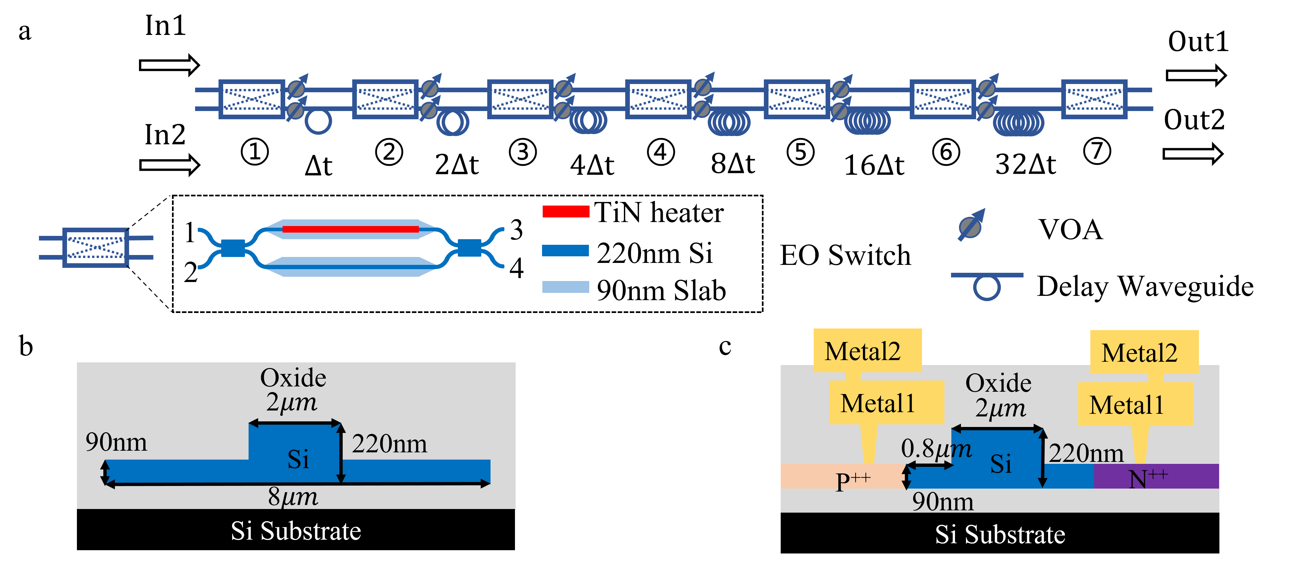
Suppl. Fig. 8 Design of the OTTDL. a. Schematic of the OTTDL. b. Cross sections of the 2-μm-wide ridge waveguide. c. PIN-diode-based VOA.
Suppl. Fig. 9a depicts the experimental setup for group delay measurement. A continuous wave (CW) laser (Agilent 8164A) was modulated by an electro-optic intensity modulator (iXblue MXAN-LN-20) biased at the quadrature point. The driving RF signals were generated from a vector network analyzer (VNA, Anritsu MS46522B). The modulated optical signal was then coupled into our delay line chip and subsequently amplified by an erbium-doped fiber amplifier (EDFA). The delayed optical signal was finally converted to an electrical signal by a photodetector (PD, Finisar XPDV3120R). The group delay responses were acquired by the VNA.
Suppl. Fig. 9b presents the measured group delay responses of all 64 delay states of the first channel OTTDL. Suppl. Fig. 9c shows the delay error statistics of all the 64 delay states across the 8-channel OTTDLs at the 43.5 GHz frequency. The delay error is defined as the difference between the measured and the target group delays. We achieved a delay error of less than 0.6 ps for all the states^{[5]}. The high delay accuracy of our OMU chip guarantees the computing accuracy of our 3D-TPE.
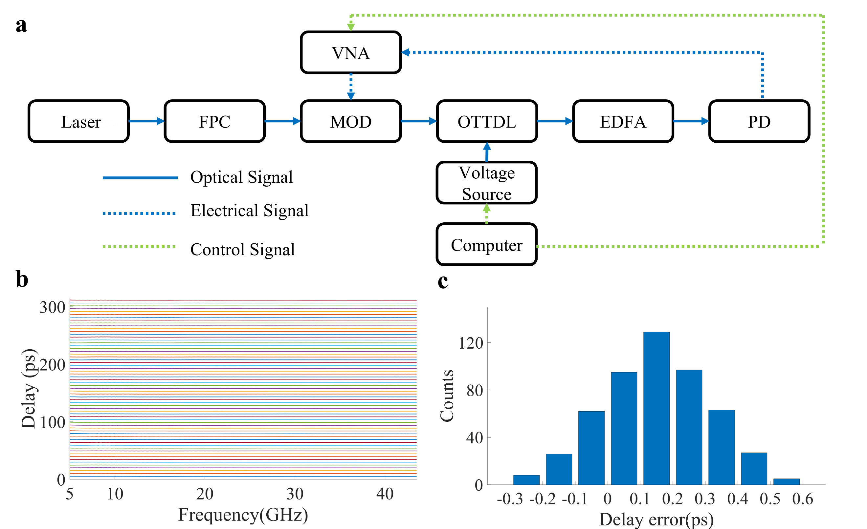
Suppl. Fig. 9 Group delay performance of the OMU chip. a. Experimental setup of the group delay measurement. b. Group delay responses of all the 64 delay states of the first OTTDL. c. Delay error statistics of all the delay states of the chip. FPC: fiber polarization controller; EDFA: erbium-doped fiber amplifier; PD: photodetector; VNA: vector network analyzer.

Supplementary note 5: Signal synchronization between multi-channels
Synchronous calibration across weighting channels is necessary before performing optical computing. Since the transmitted waveforms are identical for all channels, we only need to tune the relative delay between output waveforms of different channels without tuning the weights. A step signal was used to monitor the timestamp alignment between channels. The delay lines in the OMU chip were configured to the shortest paths, and the dual-coupled-MRRs WEs on the OCU chip were set to a weight value of 1 to ensure maximum output optical power. By controlling the laser source on or off in each corresponding channel, we recorded the output waveforms for each of the four channels individually, as shown in Suppl. Fig. 10a. Initial delay differences are randomly distributed due to the length differences of connecting fibers between the weighting channels. After the reconfiguration of the MZIs’ switching states in the delay lines to select proper optical paths, a uniform delay interval across four channels is obtained, as shown in Suppl. Fig. 10.
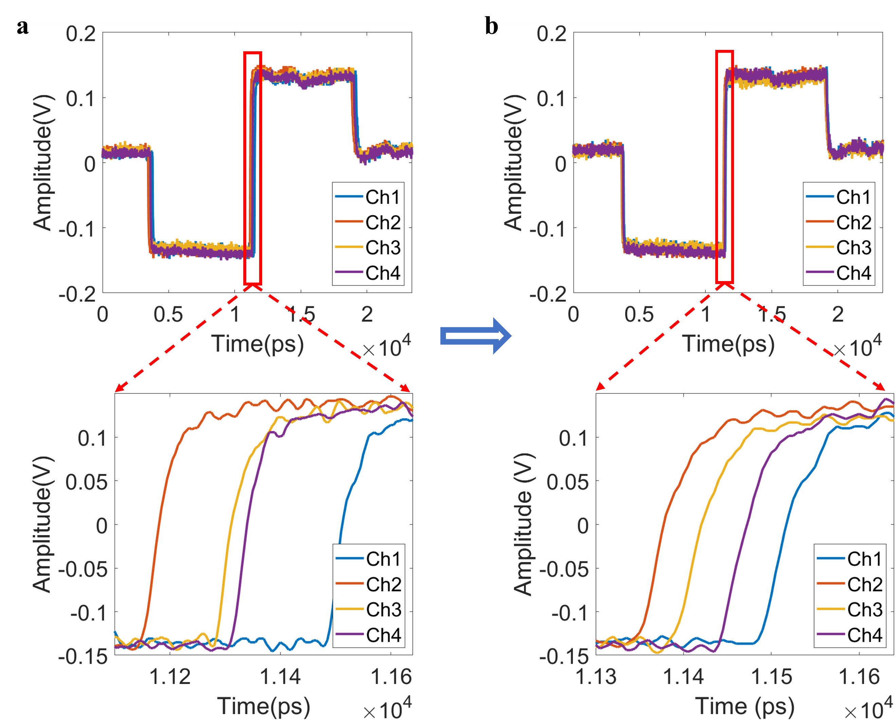
Suppl. Fig. 10 Weighting channel synchronization calibration. a. Before calibration, the delay intervals between different channels are randomly distributed. b. After calibration, there is a uniform time interval between channels.

Supplementary note 6: Computing energy efficiency estimation
In the 3D-TPE, power consumption mainly comes from the following parts: ⅰ. ADC/DAC; ⅱ. modulator and photodetector; ⅲ. dual-coupled-MRRs based OCU chip; ⅳ. tunable optical delay line-based OMU chip; ⅴ. laser source.
Benefiting from the rapid development of advanced CMOS processes, high-performance transceivers with integrated high-speed ADCs and DACs have reached bit rates exceeding 200 Gb/s, supporting high-speed analog-to-digital and digital-to-analog conversion. Suppl. Table 1 summarizes the performance of recent high-performance transceivers. For data rates above 200 Gb/s, a DAC-based transmitter (TX) has an average power efficiency of 1 pJ/b at PAM4 modulation, equating to 2 pJ/conversion, while an ADC-based receiver (RX) has a power efficiency of approximately 2.8 pJ/conversion (1.4 pJ/b).
Suppl. Table 1. State-of-the-art high-performance transceivers
Year | Process | Data rate (Gb/s) | Modulation format | TX APE (pJ/b) | RX APE (pJ/b) | Resolution  (bits)
2024^{[6]} | 3nm | 224 | PAM4 | 0.92 | / | 7
2024^{[7]} | 3nm | 224 | PAM4 | 1 | 2 | 7
2024^{[8]} | 5nm | 212 | PAM4 | 1.33 | 1.36 | 7
2024^{[9]} | 5nm | 200 | / | / | 2 | 8
2022^{[10]} | 5nm | 224 | PAM4 | / | 1.41 | 6
2021^{[11]} | 10nm | 224 | PAM4 | 1.88 | / | 7
2021^{[12]} | 7nm | 112 | PAM4 | 1.4pJ | / | 8
2021^{[13]} | 7nm | 112 | PAM4 | / | 3.18 | 7
^{APE: analog power efficiency}
For high-speed modulators and photodetectors, energy consumption mainly comes from high-speed linear drivers and TIAs, which are approximately 1.08 pJ/Sa (224 Gb/s PAM-4)^{[14]} and 0.84 pJ/Sa (112 Gb/s PAM-4)^{[15]}, respectively.
Power consumption for the OCU chip and the OMU chips is primarily dedicated to state maintenance. The average power consumption of a dual-coupled-MRRs WE is approximately $75.9 mW$. For the optical tunable delay line, the power consumption of thermal phase adjustment is approximately $10 mW$. For the 6-bit delay adjustment, a total of 7 switches are used, corresponding to a maximum power consumption of $10 mW×7=70 mW$.
The output power of a single-wavelength laser is considered to be $\sim 12 dBm$ ($15.8 mW$). The power consumption of the single-wavelength laser is about ~318mW if a 5% wall-plug efficiency is considered.
In summary, for a 3D-TPE at a size of $N×N$, operating at a clock frequency of $f_{s}$ (GHz), the expected power consumption $P$ and computing speed R are given by the following equations:
$$P(mW)= \left(2+2.8+1.08+0.84\right)×f_{s}+75.9×N^{2}+70×2×N+\left(318\right)×N$$
$$R(GHz)={2×N}^{2}×f_{s}$$
The power efficiency can be expressed as:
$$\frac{R}{P}=\frac{{2×N}^{2}×f_{s}}{6.72{×f}_{s}+75.9{×N}^{2}+458×N}$$
In our experiments, $f_{s}$= 30 GHz, $N=4$, the energy efficiency is calculated as 0.96 TOPS/3.248 W=0.30 TOPS/W. For $f_{s}$= 200 GHz, $N=9$, the energy efficiency is calculated as 32.4 TOPS/11.614 W=2.79 TOPS/W.
Combined with non-volatile phase-change materials (PCM)^{[16]}, zero static power consumption can be achieved to maintain phase states. Power consumption for the dual-coupled-MRRs based OCU chip and the optical tunable delay line-based OMU chip can be neglected, and the power efficiency can be further expressed as:
$$\frac{R}{P}=\frac{{2×N}^{2}×f_{s}}{6.72×f_{s}+318×N}$$
For $f_{s}$= 30 GHz, $N=4$, the energy efficiency is calculated as 0.96 TOPS/1.474 W=0.65 TOPS/W. And for $f_{s}$= 200 GHz, $N=9$, the energy efficiency is calculated as 32.4 TOPS/4.206 W=7.70 TOPS/W.
Suppl. Fig. 11 compares system power efficiency between the current volatile phase tuning schemes used in our experiment and those incorporating non-volatile PCMs versus channel size and clock frequency. The results indicate that phase tuning combined with PCMs exhibits a more rapid growth rate of system energy efficiency with increasing clock frequency and computational size, as compared to the current volatile phase tuning scheme.
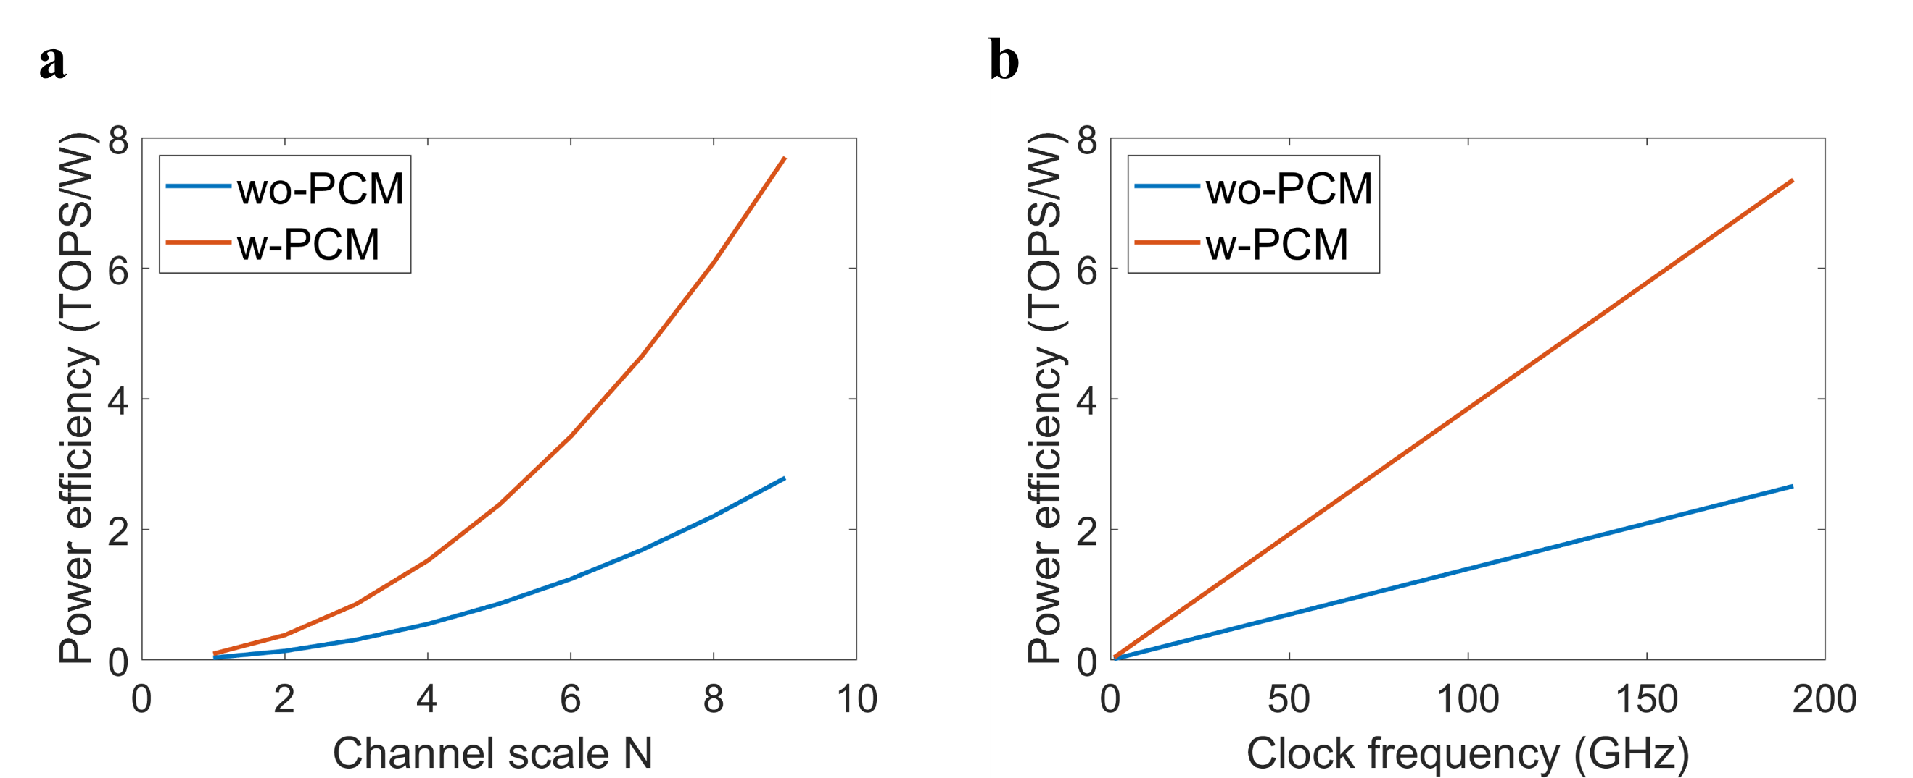
Suppl. Fig. 11 System power efficiency comparison between the current volatile phase tuning scheme and non-volatile scheme combined with PCMs. a. Fixed clock frequency of 200 GHz, scanning channel size. b. Fixed channel size 9×9, scanning clock frequency.

Supplementary note 7: Insertion loss of the 3D CNN
In the experiment architecture, insertion loss mainly comes from the following parts: ⅰ. dual-coupled-MRRs based OCU chip; ⅱ. optical tunable delay line-based OMU chip; ⅲ. high-speed modulator; ⅳ. WDM and wave-shaper; ⅴ. optical fibers and connectors, etc.
The dual-coupled-MRRs based OCU chip and the optical tunable delay line-based OMU chip were packaged with polarization-maintaining fiber arrays, with insertion losses of approximately 7 dB and 8 dB (including 2dB/facet of coupling loss), respectively. The high-speed modulator used in the experiment is a commercial modulator with a bandwidth of 40 GHz and an insertion loss of about 4 dB. The four-channel WDM has an insertion loss of about 1 dB, and the wave-shaper has an insertion loss of about 6 dB. To confirm the polarization state of the input optical signals, two fiber polarization couplers (FPCs) were used per channel, each with a loss of about 0.5 dB. Finally, the fiber connections between individual components contribute a total insertion loss of about 2 dB. The specific loss of each part is listed in the Suppl. Table 2. For a single computation channel, the total insertion loss is calculated to be $0.5×2+1+4+6+8+7+2=29dB$. To compensate for the link loss, an erbium-doped fiber amplifier (EDFA) was employed following the modulator. The non-uniformity of optical amplification across different wavelengths, and the amplified spontaneous emission (ASE) noise of the EDFA, deteriorate the signal-to-noise ratio and increase the computational errors. Since the majority of losses occur in the fiber-chip coupling and polarization controlling, through monolithic integration and further optimization of devices, the overall insertion loss can be reduced to below 15 dB in the future. It is anticipated that eliminating the EDFA is expected to further improve signal quality and reduce computational errors.
Suppl. Table 2. Insertion loss of the devices
Item | Insertion loss(dB)
FPC | $$0.5×2$$
WDM | 1
Modulator | 4
Wave-shaper | 6
OMU chip | 4(on-chip)+4(CL)
OCU chip | 3(on-chip)+4(CL)
Fiber connectors | 2
^{CL: coupling loss}

Supplementary note 8: Experimental setup for 3D convolution
The detailed experimental setup is shown in Suppl. Fig.12. The details of the experiment can be seen in the Method of the main text.
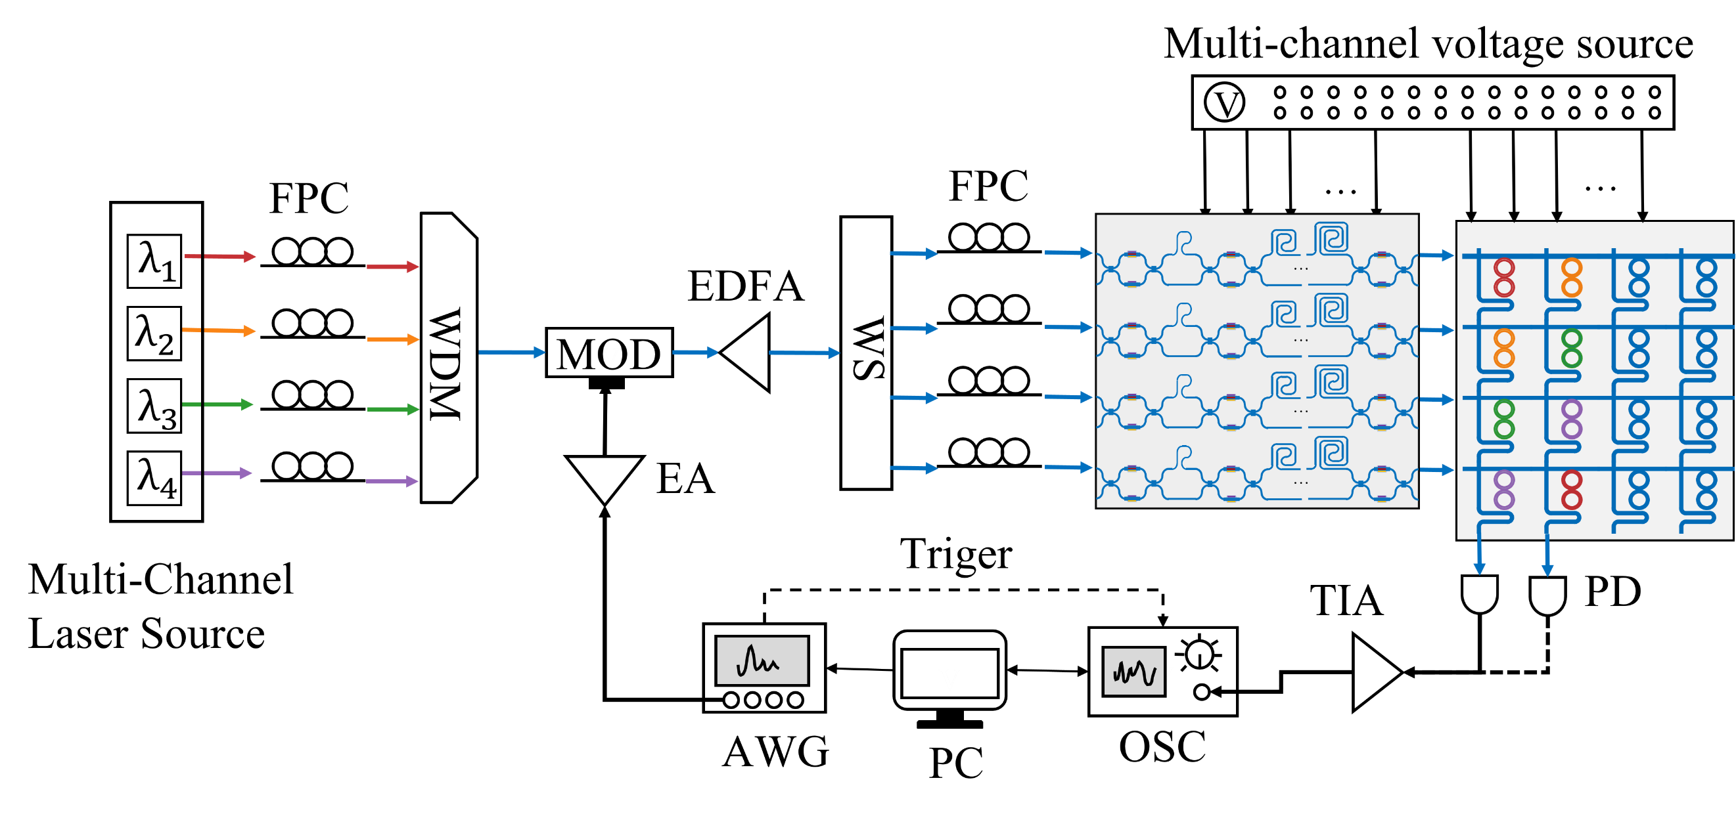
Suppl. Fig. 12 Experimental setup for the 3D convolution with the 3D-TPE. FPC: fiber polarization controller; WDM: wavelength division multiplexer; MOD: modulator; EA: electrical amplifier; EDFA: erbium-doped fiber amplifier; WS: wave-shaper; PC: personal computer; OSC: oscilloscope; PD: photodetector; TIA: trans-impedance amplifier.

Reference
[1] X. Xu, G. Ren, T. Feleppa, et al., “Self-calibrating programmable photonic integrated circuits.” Nature Photonics. vol. 16, no. 8, pp. 595–602, 2022. DOI:10.1038/s41566-022-01020-z.
[2] C. Huang, S. Fujisawa, T.F. De Lima, et al., “A silicon photonic–electronic neural network for fibre nonlinearity compensation.” Nature Electronics. vol. 4, no. 11, pp. 837–844, 2021. DOI:10.1038/s41928-021-00661-2.
[3] B. Bai, Q. Yang, H. Shu, et al., “Microcomb-based integrated photonic processing unit.” Nature Communications. vol. 14, no. 1, p. 66, 2023. DOI:10.1038/s41467-022-35506-9.
[4] T. Xu, W. Zhang, J. Zhang, et al., “Control-free and efficient integrated photonic neural networks via hardware-aware training and pruning.” Optica. vol. 11, no. 8, p. 1039, 2024. DOI:10.1364/OPTICA.523225.
[5] Z. Ni, L. Lu, Y. Liu, Y. Wang, J. Chen, and L. Zhou, “Silicon-Integrated 8-Channel 6-bit Tunable Optical True-Time Delay Lines with High Switching Speed and Low Loss.” In: 2023 International Topical Meeting on Microwave Photonics (MWP). pp. 1–5. IEEE, Nanjing, China (2023)DOI:10.1109/MWP58203.2023.10416568.
[6] M. Cusmai, N. Familia, E. Kuperberg, et al., “A 0.92-pJ/b PAM-4 and 0.61-pJ/b PAM-6 224-Gb/s DAC-Based Transmitter in 3-nm FinFET.” IEEE Journal of Solid-State Circuits. pp. 1–12, 2024. DOI:10.1109/JSSC.2024.3456672.
[7] D. Pfaff, M. Nummer, N. Hai, et al., “7.3 A 224Gb/s 3pJ/b 40dB Insertion Loss Transceiver in 3nm FinFET CMOS.” In: 2024 IEEE International Solid-State Circuits Conference (ISSCC). pp. 128–130. IEEE, San Francisco, CA, USA (2024)DOI:10.1109/ISSCC49657.2024.10454537.
[8] J.Q. Wang, A. Tan, A. Iyer, et al., “7.1 A 2.69pJ/b 212Gb/s DSP-Based PAM-4 Transceiver for Optical Direct-Detect Application in 5nm FinFET.” In: 2024 IEEE International Solid-State Circuits Conference (ISSCC). pp. 123–125. IEEE, San Francisco, CA, USA (2024)DOI:10.1109/ISSCC49657.2024.10454275.
[9] R.L. Nguyen, A. Mellati, A. Fernandez, et al., “18.4 A 200GS/s 8b 20fJ/c-s Receiver with >60GHz AFE Bandwidth for 800Gb/s Optical Coherent Communications in 5nm FinFET.” In: 2024 IEEE International Solid-State Circuits Conference (ISSCC). pp. 344–346. IEEE, San Francisco, CA, USA (2024)DOI:10.1109/ISSCC49657.2024.10454385.
[10] A. Khairi, Y. Krupnik, A. Laufer, et al., “A 1.41-pJ/b 224-Gb/s PAM4 6-bit ADC-Based SerDes Receiver With Hybrid AFE Capable of Supporting Long Reach Channels.” IEEE Journal of Solid-State Circuits. vol. 58, no. 1, pp. 8–18, 2023. DOI:10.1109/JSSC.2022.3211475.
[11] J. Kim, S. Kundu, A. Balankutty, et al., “8.1 A 224Gb/s DAC-Based PAM-4 Transmitter with 8-Tap FFE in 10nm CMOS.” In: 2021 IEEE International Solid- State Circuits Conference (ISSCC). pp. 126–128. IEEE, San Francisco, CA, USA (2021)DOI:10.1109/ISSCC42613.2021.9365840.
[12] M.A. Kossel, V. Khatri, M. Braendli, et al., “8.3 An 8b DAC-Based SST TX Using Metal Gate Resistors with 1.4pJ/b Efficiency at 112Gb/s PAM-4 and 8-Tap FFE in 7nm CMOS.” In: 2021 IEEE International Solid- State Circuits Conference (ISSCC). pp. 130–132. IEEE, San Francisco, CA, USA (2021)DOI:10.1109/ISSCC42613.2021.9365784.
[13] H. Lin, C. Boecker, M. Hossain, et al., “ADC-DSP-Based 10-to-112-Gb/s Multi-Standard Receiver in 7-nm FinFET.” IEEE Journal of Solid-State Circuits. vol. 56, no. 4, pp. 1265–1277, 2021. DOI:10.1109/JSSC.2021.3051109.
[14] K. Li, D.J. Thomson, S. Liu, et al., “An integrated CMOS–silicon photonics transmitter with a 112 gigabaud transmission and picojoule per bit energy efficiency.” Nature Electronics. vol. 6, no. 11, pp. 910–921, 2023. DOI:10.1038/s41928-023-01048-1.
[15] D. Patel, A. Sharif-Bakhtiar, and T.C. Carusone, “A 112-Gb/s —8.2-dBm Sensitivity 4-PAM Linear TIA in 16-nm CMOS With Co-Packaged Photodiodes.” IEEE Journal of Solid-State Circuits. vol. 58, no. 3, pp. 771–784, 2023. DOI:10.1109/JSSC.2022.3218558.
[16] X. Yang, L. Lu, Y. Li, et al., “Non‐Volatile Optical Switch Element Enabled by Low‐Loss Phase Change Material.” Advanced Functional Materials. p. 2304601, 2023. DOI:10.1002/adfm.202304601.

