In vivo targeted delivery of extracellular vesicle‒gold nanorod hybrids to metastatic melanoma lung tumors
Karen Bolaños,^{1,2,3} Daniela León,^{1,2,3} Pedro Jara,^{2,3} Pamela Contreras,¹ David Silva,³ Ana Riveros,^{2,3} Yanay Montano, ^{2,3} Damián Pérez,^{2,3} Eyleen Araya,⁴ Marcelo J. Kogan, ^{2,3*} Andrew F. G. Quest^{1,3*}
¹Laboratory of Cellular Communication, Center for Studies on Exercise, Metabolism and Cancer (CEMC), Program of Cell and Molecular Biology, Faculty of Medicine, Institute of Biomedical Sciences (ICBM), University of Chile, Santiago, Chile
² Departamento de Quimica Farmacologica y Toxicologica, Facultad de Ciencias Quimicas y Farmaceuticas, Universidad de Chile, Santiago, Chile
³ Advanced Center for Chronic Diseases (ACCDiS), Facultad de Medicina and Facultad de Ciencias Quimicas y Farmaceuticas, , Santiago, Chile
⁴ Departamento de Ciencias Quimicas, Facultad de Ciencias Exactas, Universidad Andres Bello, Santiago, Chile
*Corresponding authors

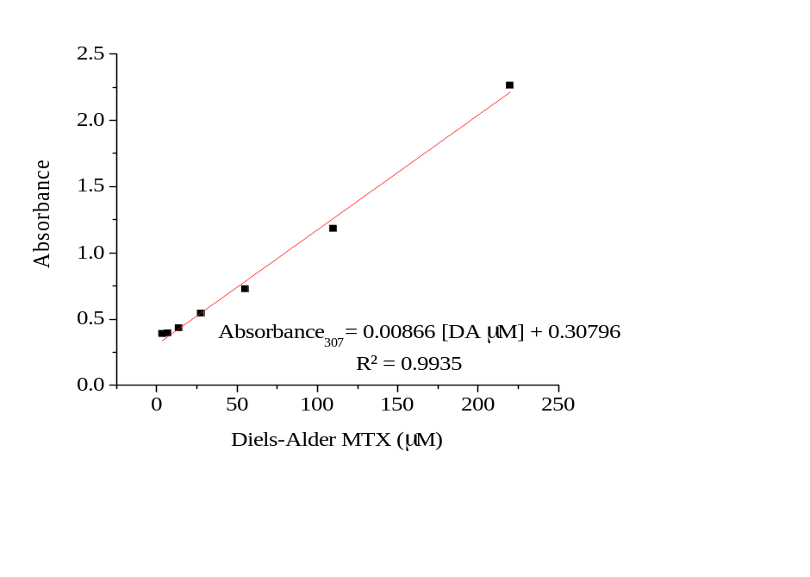
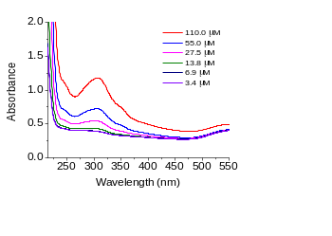

S1. Calibration curve DA adduct UV-VIS at 307 nm from 3.7 to 110 µM

S2. GFAAS parameters for gold quantification
Au standard solutions were prepared from a commercially available 1000 mg L⁻¹ of Au single-element standard (Merck, Darmstadt, Germany), by dilution with 0.5% HCl (analytical grade, Merck). All the samples of tissues were lyophilized and homogenized with an agata mortar before analysis. A graphite furnace solid atomic absorption spectrometer ContrAA 800G-Analytic Jena, was used for the determination of Au in the biological samples. The platform was loaded with an appropriate amount of sample, weighed in a microbalance and the platform containing the sample was then transferred to the graphite furnace. The operation conditions for graphite furnace atomic absorption spectrometry (GFAAS) are presented in table S2.

Table S2. Operation conditions for Au determination by GFAAS
Signal processing: Peak area; Read time: 5 s
Background correction: Zeeman-effect
Wavelength—242.80 nm
Slit—0.7 nm
Step | Temp (°C) | Ramp (°C/s) | Hold (s) | Time (s)
Drying | 80 | 6 | 20 | 27.5
Drying | 90 | 3 | 20 | 23.3
Drying | 110 | 5 | 10 | 14.0
Pyrolysis | 350 | 50 | 20 | 24.8
Pyrolysis | 500 | 300 | 10 | 10.5
Gas adaption | 500 | 0 | 5 | 5.0
Atomize | 2000 | 1500 | 3 | 4.0
Cleaning | 2450 | 500 | 4 | 4.9

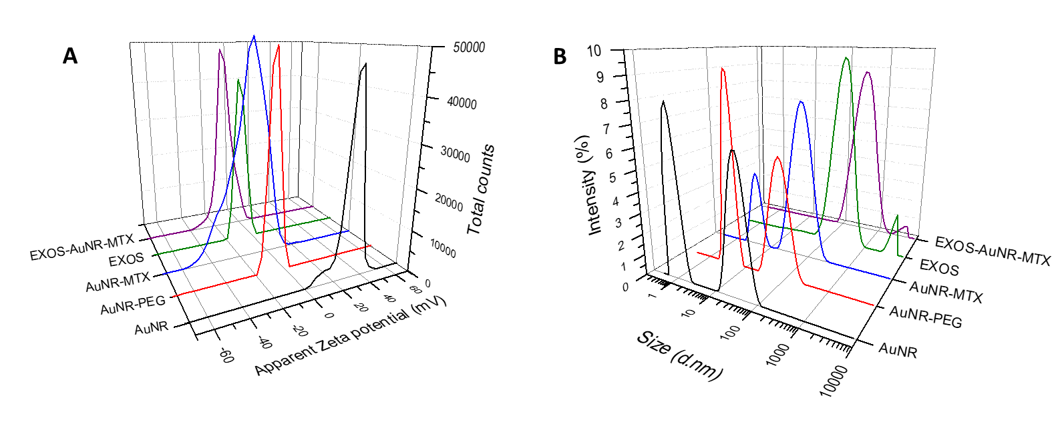
S3. Characterization of functionalized AuNRs and EXO-AuNRs hybrids showing the variations: (A) Apparent Z potential (mV), (B) Size distribution in DLS

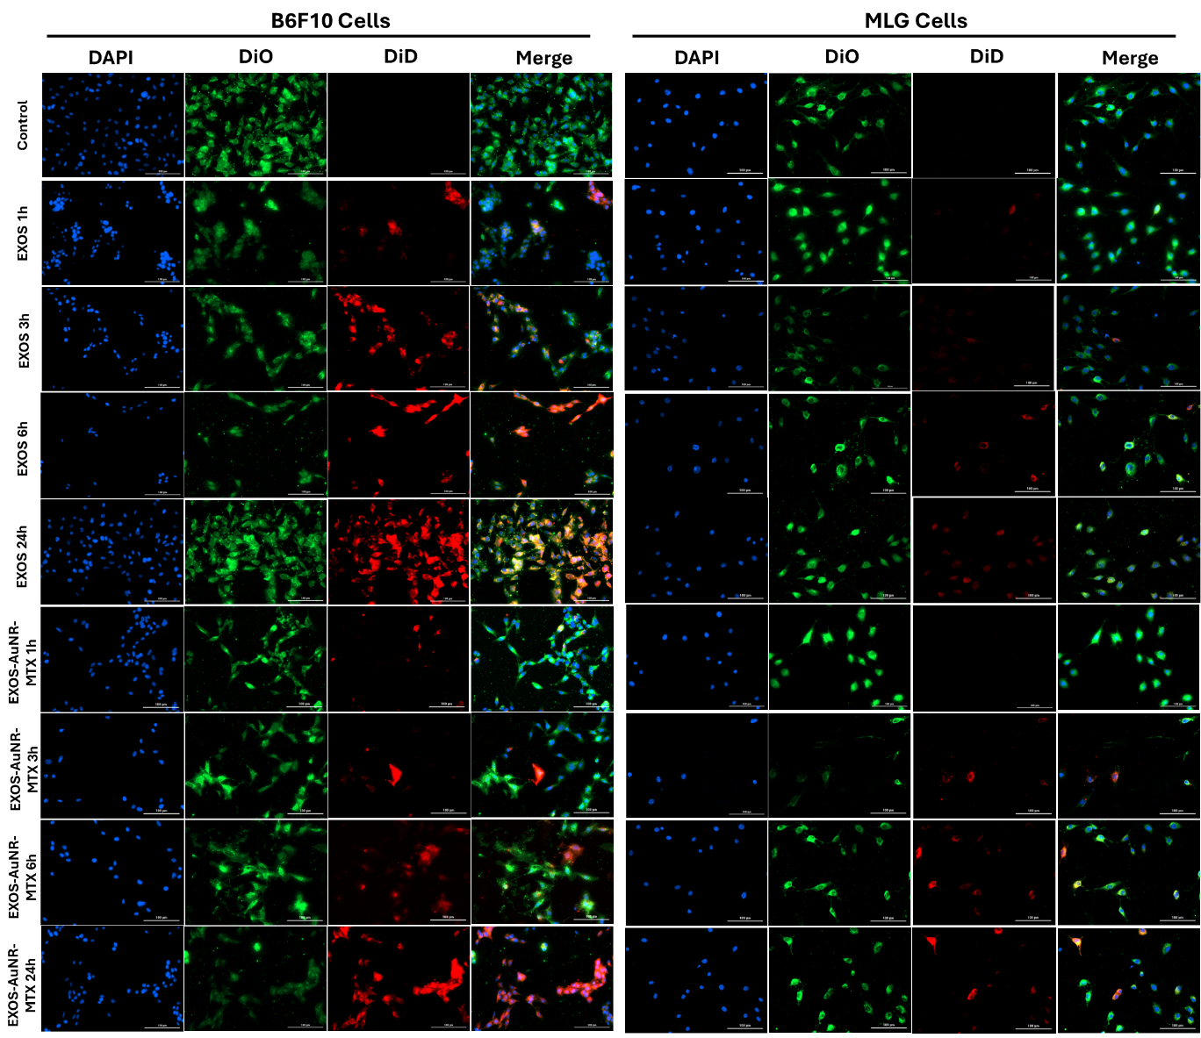
S4. Cell uptake of B16F10 EXOS and EXOS-AuNR-MTX, showing increased uptake in B16F10 cells compared to MLG cells. Cells were treated with DiD‑labeled treatments for 1, 3, 6 or 24 h and analyzed by fluorescence microscopy. DiD-labeled treatments are shown in red; membranes were stained with DiO in green and nuclei are shown in blue by HOESCHT staining. Microscopy images were acquired at 20X.

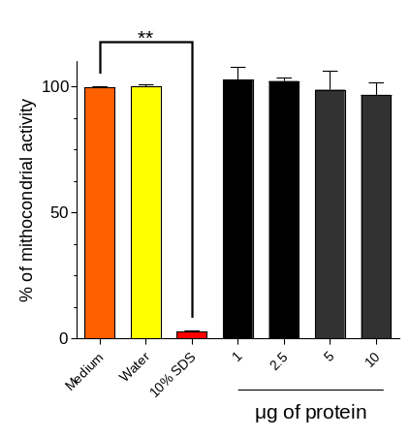
S5. MTS Cell viability assays of B16F10 cells after treatment with EXOS-AuNR-MTX for 24 h. Values averaged from n=4 experiments are presented with error bars representing the SEM. *Significant difference according to Kruskal-Walliss: **p ≤ 0.01 compared to medium control.
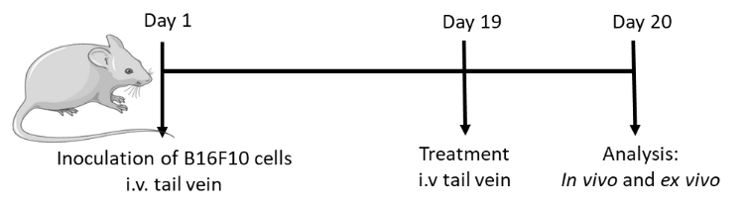
S6. Design of in vivo experiments in the B16F10 metastatic lung tumor model
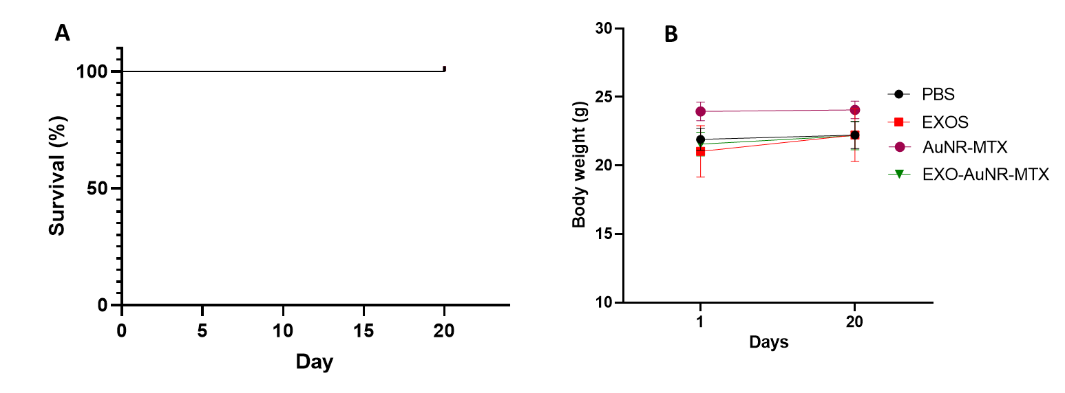
S7. Survival of the animals in the metastasis model days 1-20 (A); Body weight variations from day 1 to 20 (B). All animals survived after B16F10 cell inoculation (Day 1) and treatments (day 19). Body weight variations were not significantly different throughout the experiment.
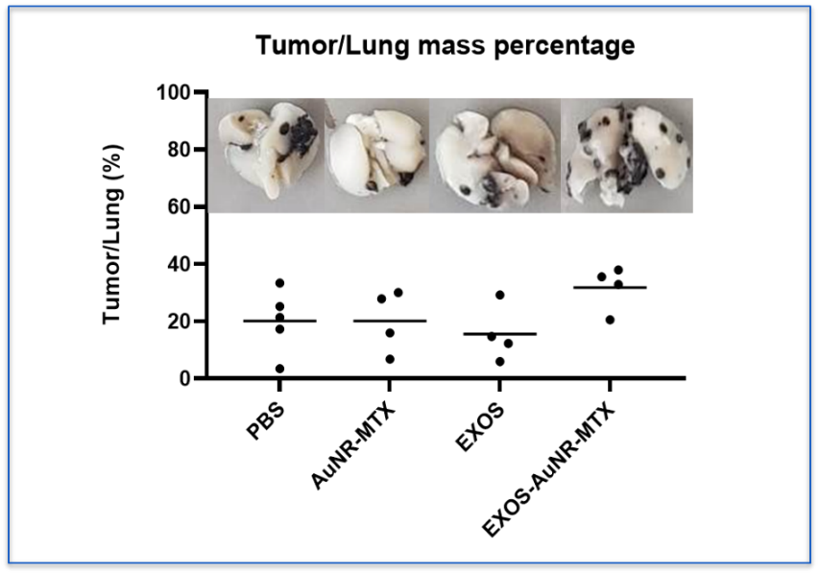
S8. Ex vivo tumor/lung mass percentage after treatments in the metastasis model. No significant differences were found compared to PBS according to the Kruskal-Wallis test. (Fixed with FEKETES and lyophilized organs)
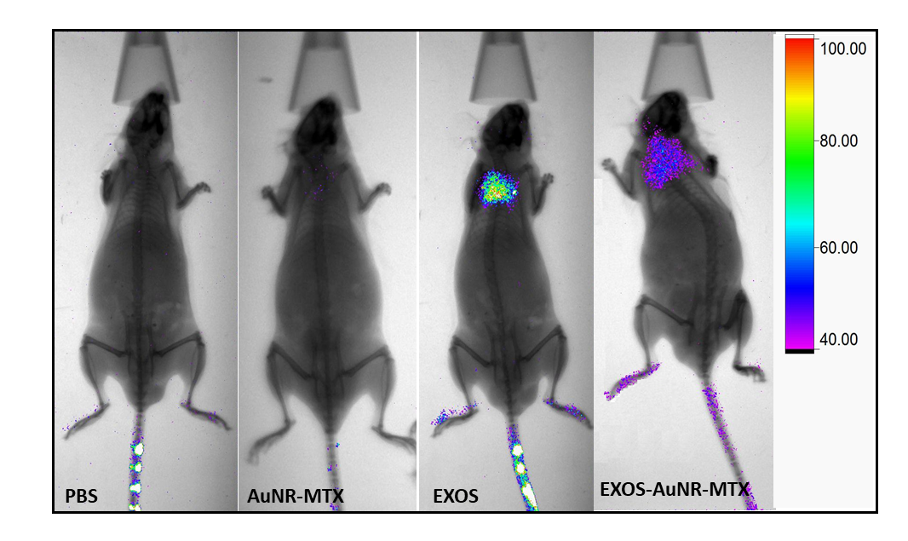
S9. In vivo fluorescence increases after treatment with DiR-labeled EXOS and EXOS-AuNR-MTX: Representative tracking of In vivo fluorescence in lungs, n=4, in the metastasis model (λ_{exc}=720 nm, λ_{em}=790 nm).
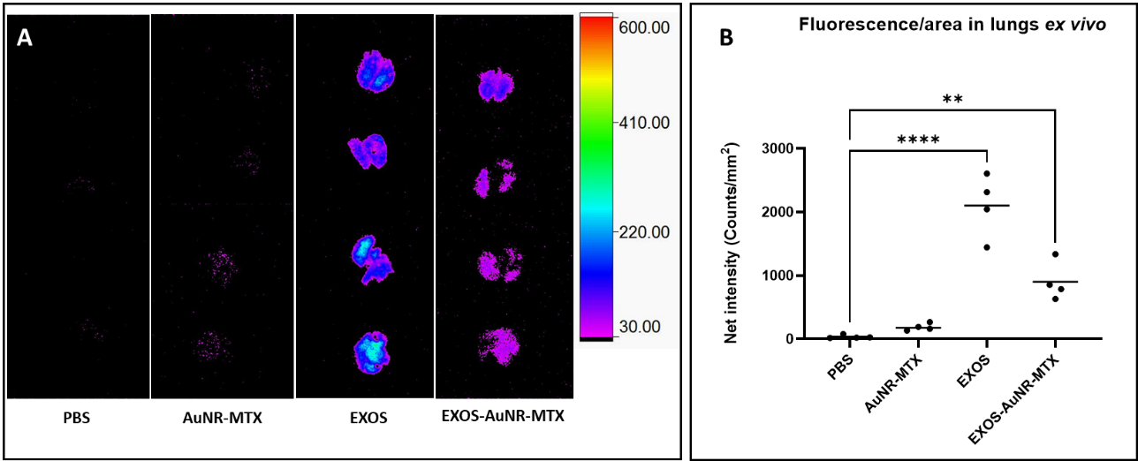
S10. Ex vivo fluorescence increases significantly after treatment with DiR-labeled EXOS and EXOS-AuNR-MTX: Ex vivo images (A) and fluorescence quantification (b) in lungs (λ_{exc}=720 nm, λ_{em}=790 nm). Significant differences according to ANOVA are indicated: **p ≤ 0.01, ****p ≤ 0.0001
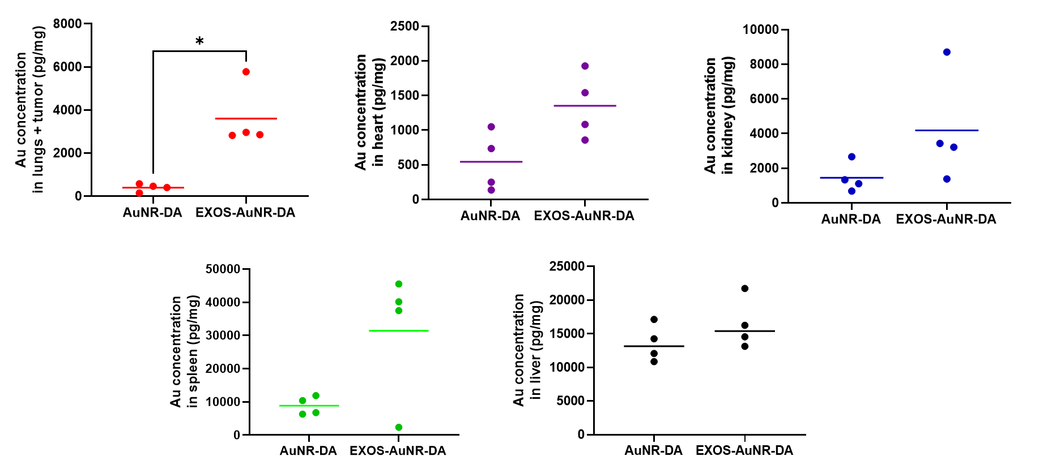
S11. Gold concentration (pg Au/mg organ) in the organs as determined by AAS graphite furnance measurements. Significant differences according to t-test are indicated: *p≤0.05, **p ≤ 0.01 Mann Whitney test

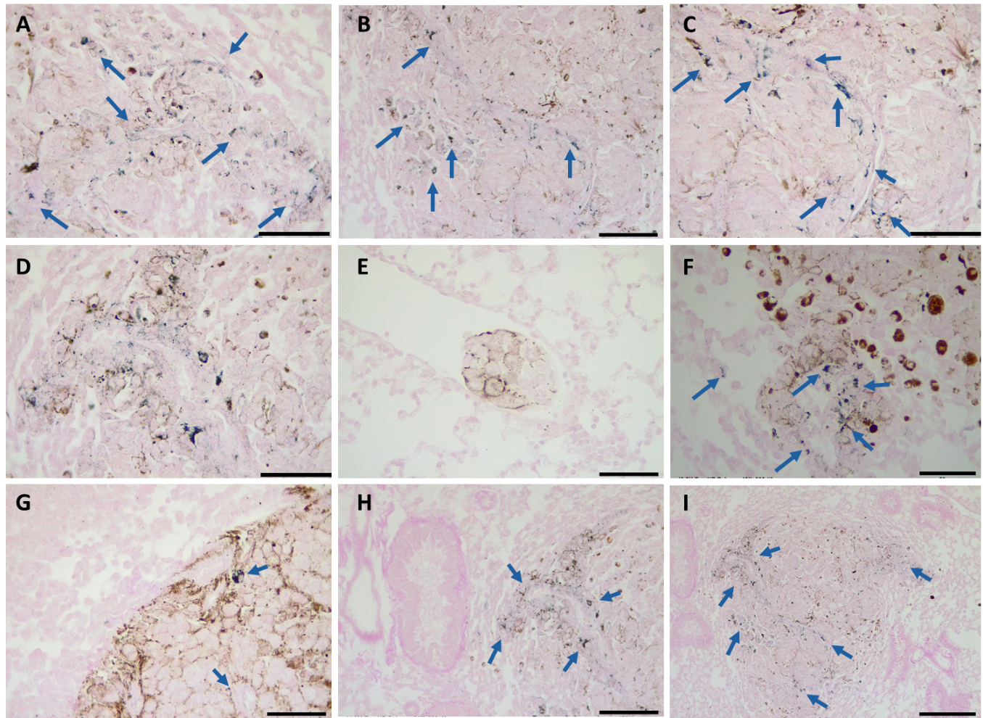
S12. Histological sections of lungs stained with Eosin (pink) and the gold enhancement kit (blue, indicated with blue arrows). Melanin of melanoma cells is visible as brown staining. Mice treated with EXOS-AuNR-MTX. Scalebar: A-G 50 µm, H 100 µm, I 200 µm. Injected dose 1 nM of AuNRs, 24 h treatment.
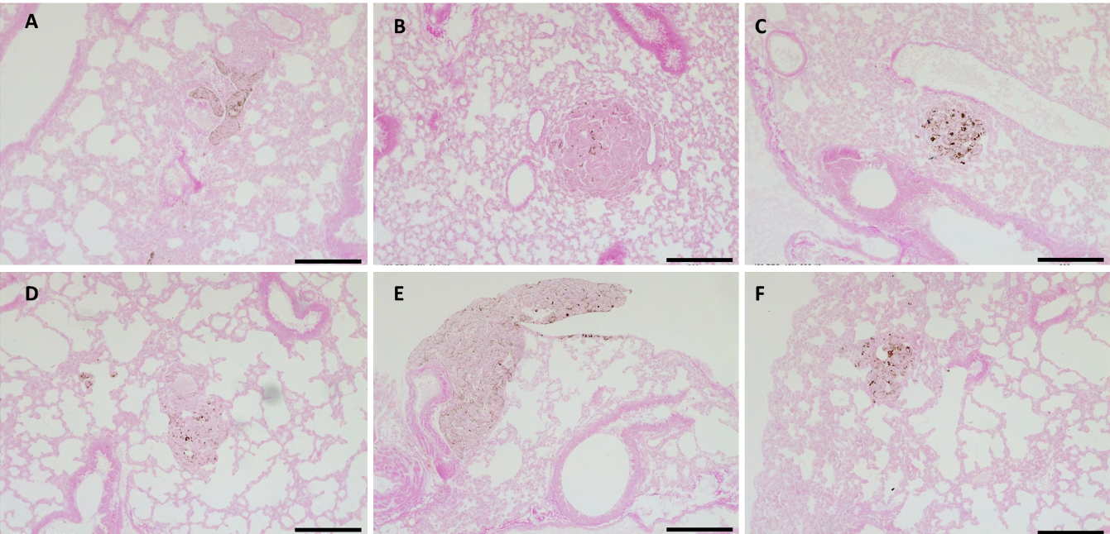
S13. Histological sections of lungs stained with Eosin (pink) and the gold enhancement kit (blue). Melanin of melanoma cells is visible as brown stains. Mice treated with PBS control. Scalebar 200 µm.

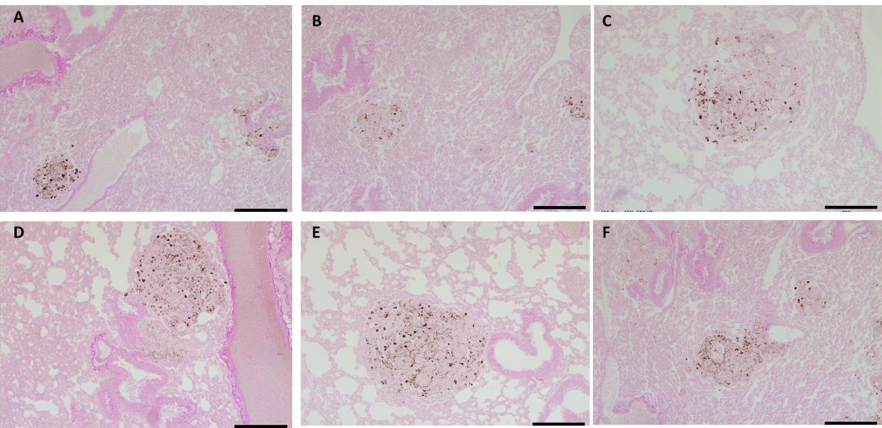
S14. Histological sections of lungs stained with Eosin (pink) and the gold enhancement kit (blue). Melanin of melanoma cells is visible as brown stains. Mice treated with EXOS. Scale bar 200 µm.
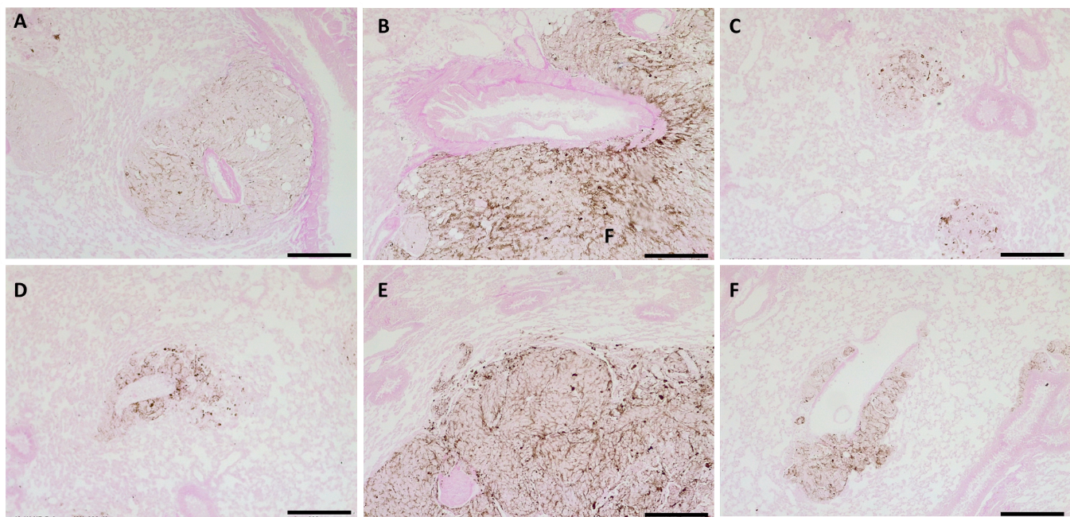
S15. Histological sections of lungs stained with Eosin (pink) and the gold enhancement kit (blue). Melanin of melanoma cells is visible as brown stains. Mice treated with AuNR-MTX. Scale bar 200 µm. Injected dose 1 nM of AuNRs, 24 h treatment.

