Supplementary Information

Insulating Effect of Alkyl Chains for Low-Power and High-Stability Organic Transistors and Circuits
Jiannan Qi#, Jialu Xue#, Xufan Li, Kai Tie, Zhongwu Wang, Yinan Huang, Yongxu Hu, Xiaosong Chen*, Liqiang Li* and Wenping Hu

Supplementary Note 1. The calculation of the alkyl chain length
X-ray diffraction technology describes the rules of a crystal in X-ray diffraction. The lattice spacing of the crystal satisfies the Bragg’s law (Equation S1).
$2dsinθ=nλ$ (1)
Here d represent the interplanar spacing, θ is the scattering angle, n represent positive integer and λ is the X-ray wavelength (Cu kα, λ=0.154 nm).
According to the XRD patterns of DNTT, C₆-DNTT, and C₁₀-DNTT films (Supplementary Fig. 3), the d(001) spacings were determined to be 1.58 nm, 2.80 nm, and 3.85 nm calculated by the Bragg’s law, respectively. Since all three OSCs exhibit a herringbone packing structure, the C₆ and C₁₀ alkyl chains lengths were calculated from the d(001) spacings of three OSCs to be 0.61 nm and 1.135 nm, respectively.
Based on a carbon-carbon single bond length (0.154 nm) and the bond angle of sp³-hybridized carbon in the alkyl chains (109.5°), the theoretical C₆ and C₁₀ alkyl chains lengths were calculated to be 0.67 nm and 1.20 nm, indicating a slight bending of the alkyl chains in C₆-DNTT and C₁₀-DNTT.

Supplementary Note 2. Trap DOS calculations using Grünewald’s method
Grünewald’s method properly considers the gate-induced band bending, enabling the transformation of a single linear transfer characteristic into the corresponding density of states function. The dependence of mobility on V_{GS} is indicative of the trap DOS near the valence band in FETs. Assuming a homogeneous OSC layer, it accounts for the initial band bending by calculating the gate-source voltage relative to the flat band voltage ($U_{G}={V_{G}-V}_{T}$). The relationship between the interface potential ($V_{0}$) and $U_{G}$ is provided in Equation S2.
$\exp\left(\frac{eV_{0}}{kT}\right)-\frac{eV_{0}}{kT}-1=\frac{e}{kT}\frac{ϵ_{i}d}{ϵ_{s}lσ_{0}}\left[U_{G}σ\left(U_{G}\right)-\int_{0}^{U_{G}}{σ(\tilde{U_{G}})d}\tilde{U_{G}}\right]$ (S2)
Here, $σ_{0}$represents the conductivity at the flat band. l and d are the thickness of the dielectric layer and OSC film. $ϵ_{i}$ and $ϵ_{s}$denote the relative permittivity of the dielectric layer and the semiconductor, respectively.
For each gate voltage, Equation S3 is numerically evaluated based on the field-effect conductivity ($σ$), which is derived from the transfer characteristics in the linear regime.
$σ\left(U_{G}\right)=\frac{L}{W}\frac{I_{D}}{V_{D}}$ (S3)
Eventually, we have the complete function $V_{0}=V_{0}(U_{G})$.
The hole density ($p$) is the convolution of the DOS with the Fermi function and hence a deconvolution of the hole density is required in order to evaluate the DOS function.
The$p(V_{0})$ can be calculated according to the Equation S4
$p(V_{0}) =\frac{ϵ_{0}{ϵ_{i}}^{2}}{ϵ_{s}l^{2}e}U_{G}{(\frac{dV_{0}}{dU_{G}})}^{-1}$ (S4)
where $ϵ_{0}$are the vacuum permittivity.
For a slowly varying density of states function, the difference between the trap DOS N(E) and $dp/edV$ is expected to be relatively small on a logarithmic scale (Equation S5).
$N(E)≈\frac{1}{e}\frac{dp(V_{0})}{dV_{0}}$ (S5)
Under the zero temperature approximation, the band shift at the interface ($eV_{0}$) corresponds to the energy of the traps relative to the Fermi energy E_{F} of the sample, i.e., $eV_{0}=E-E_{F}$. The trap DOS can be plotted as a function of the energy relative to the Fermi energy $E_{F}$

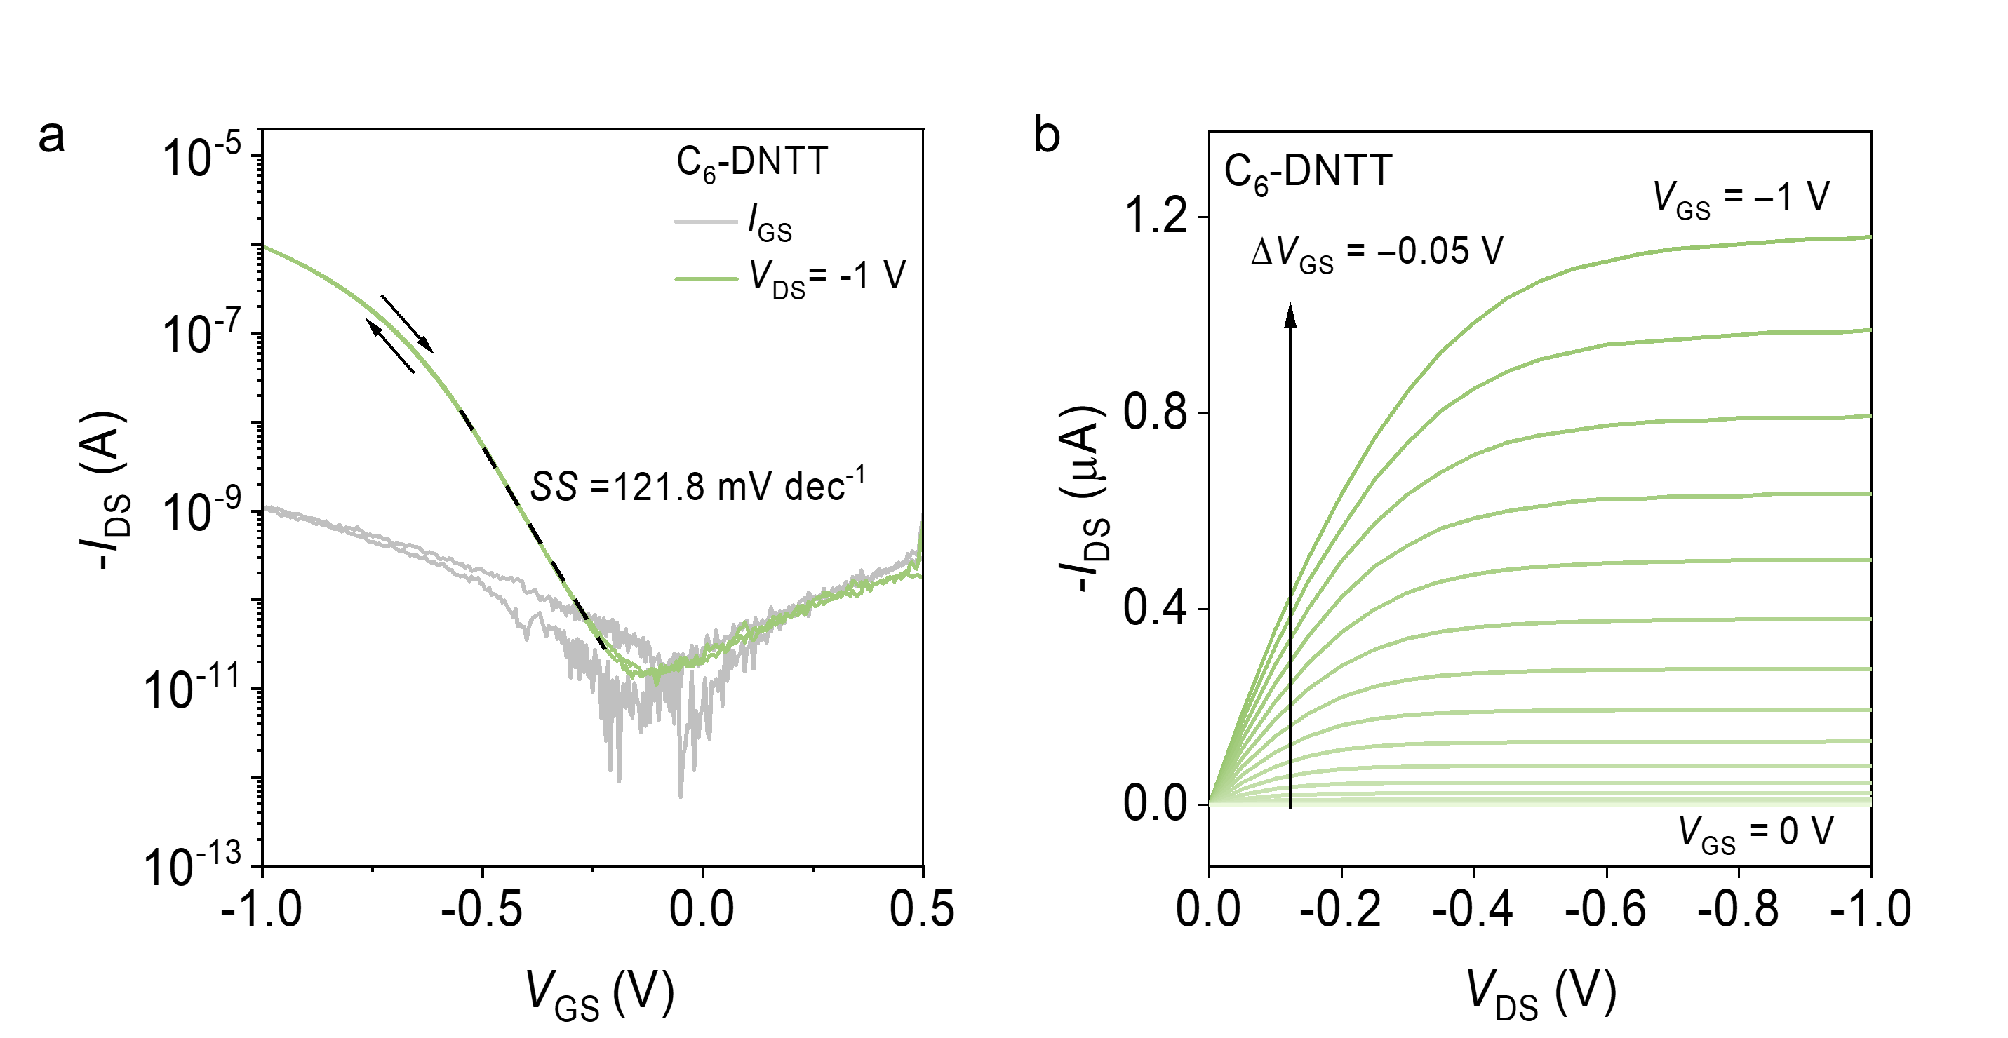
Supplementary Fig. 1 a Transfer characteristics of C₆-DNTT FETs. b Output characteristics of C₆-DNTT FETs. L = 200 μm, W = 1000 μm.

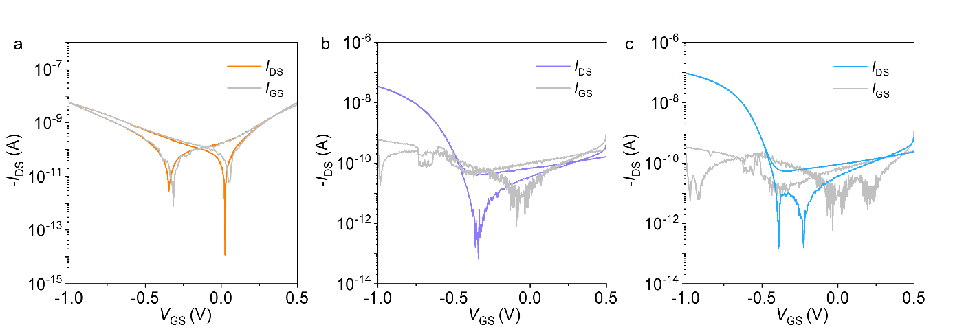
Supplementary Fig. 2 a-c Transfer characteristics of MTS-DNTT (a), MTS-C₆-DNTT (b) and MTS-C₁₀-DNTT FETs (c). L = 200 μm, W = 1000 μm, V_{DS} = −0.1 V

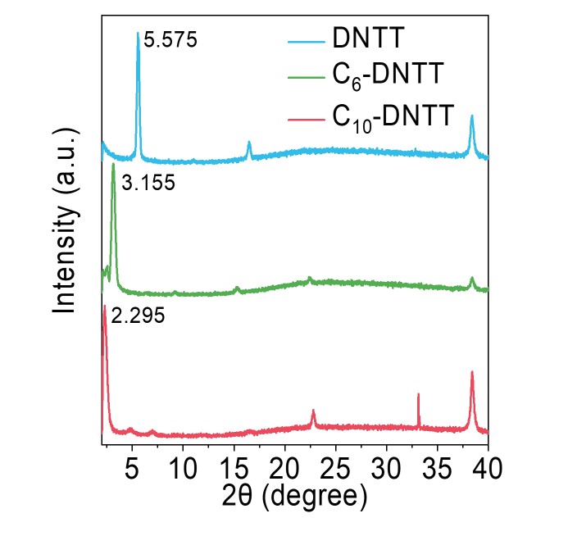
Supplementary Fig. 3 XRD pattern of DNTT, C₆-DNTT and C₁₀-DNTT film.

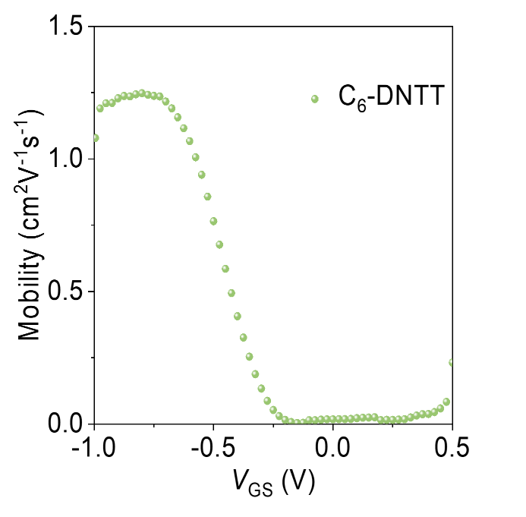
Supplementary Fig. 4 The extract mobility as a function of V_{GS} for C₆-DNTT FETs.

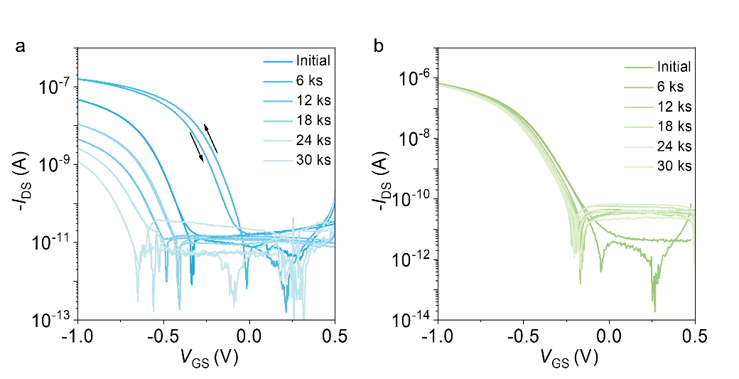
Supplementary Fig. 5 a, b Transfer characteristics of DNTT (a) and C₆-DNTT FETs (b) under different stress time. L = 200 μm, W = 1000 μm.

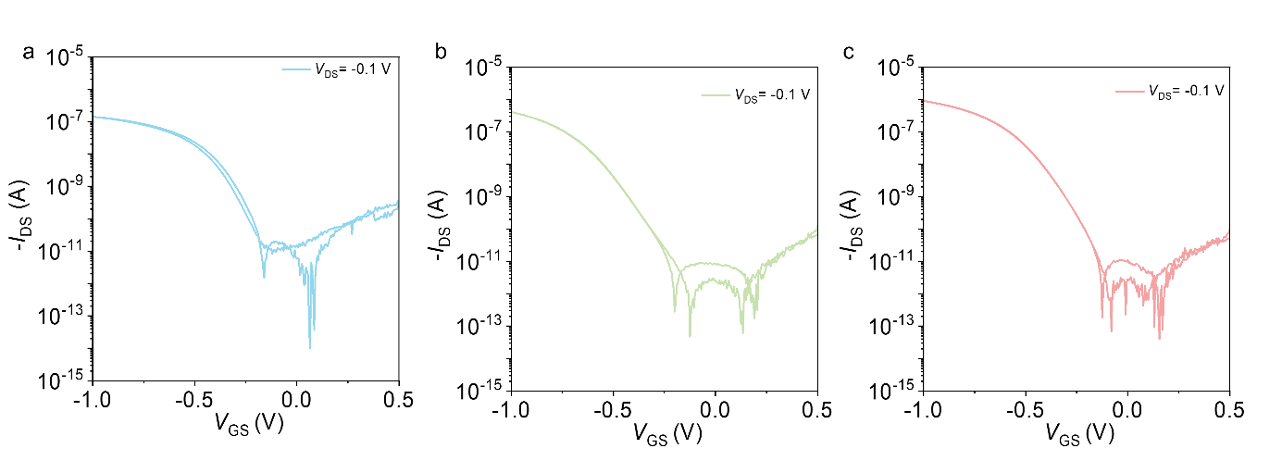
Supplementary Fig. 6 a-c Transfer characteristics of DNTT (a), C₆-DNTT (b) and C₁₀-DNTT FETs (c) in the linear region. L = 200 μm, W = 1000 μm, V_{DS} = −0.1 V.

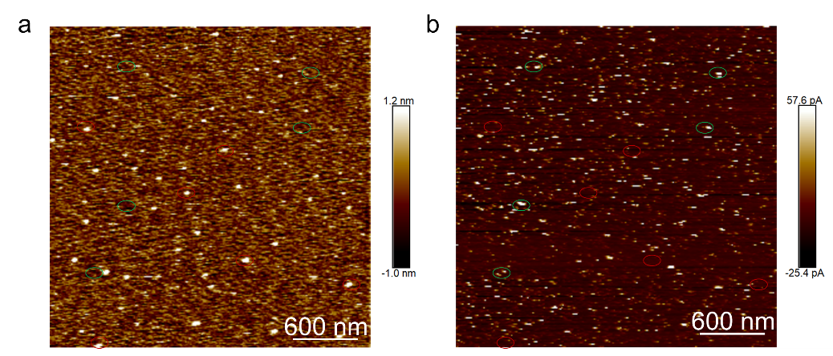
Supplementary Fig. 7 a, b C-AFM mapping of morphology (a) and current (b) at V_{sample} = − 3V of the OTS modified substrate. Regions with a thicker OTS layer typically exhibited lower leakage current (green circles), while leakage points were mostly located in areas of lower height (red circles), where the OTS layer may not have covered the substrate or where OTS molecules lay horizontally on the substrate.

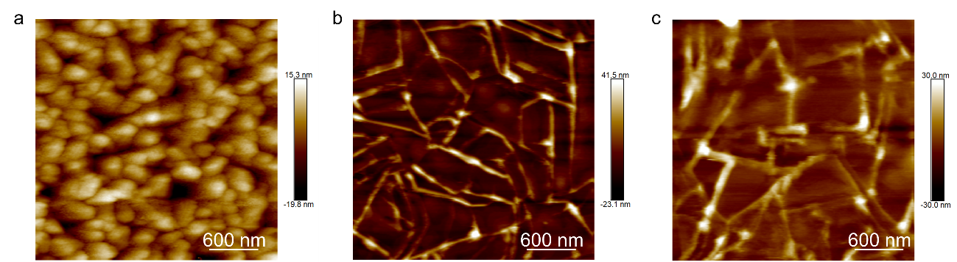
Supplementary Fig. 8 a-c C-AFM mapping of morphology for DNTT (a), C₆-DNTT (b) and C₁₀-DNTT films (c) corresponding to the Fig. 3a-c.
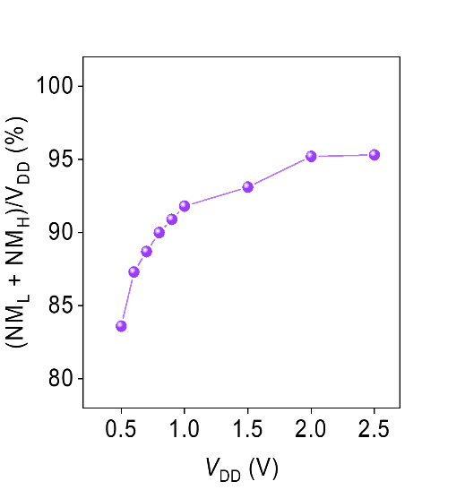
Supplementary Fig. 9 Total noise margin as a function of V_{DD}.

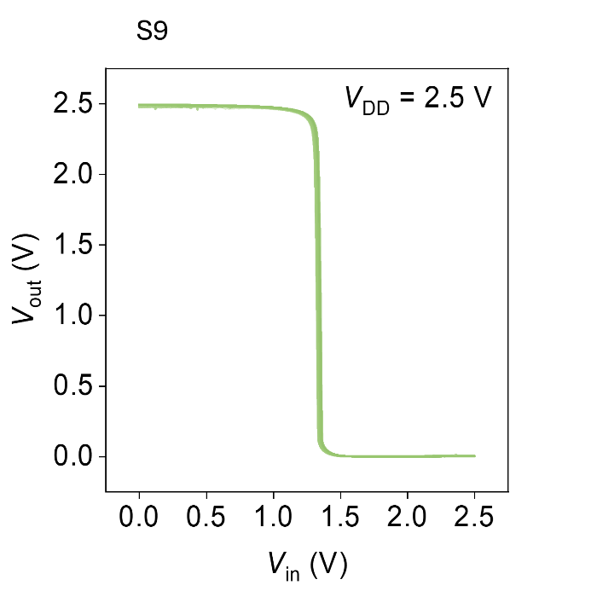
Supplementary Fig. 10 The 50-cycle input-output characteristics of the C₁₀-DNTT inverter at V_{DD} = 2.5 V.

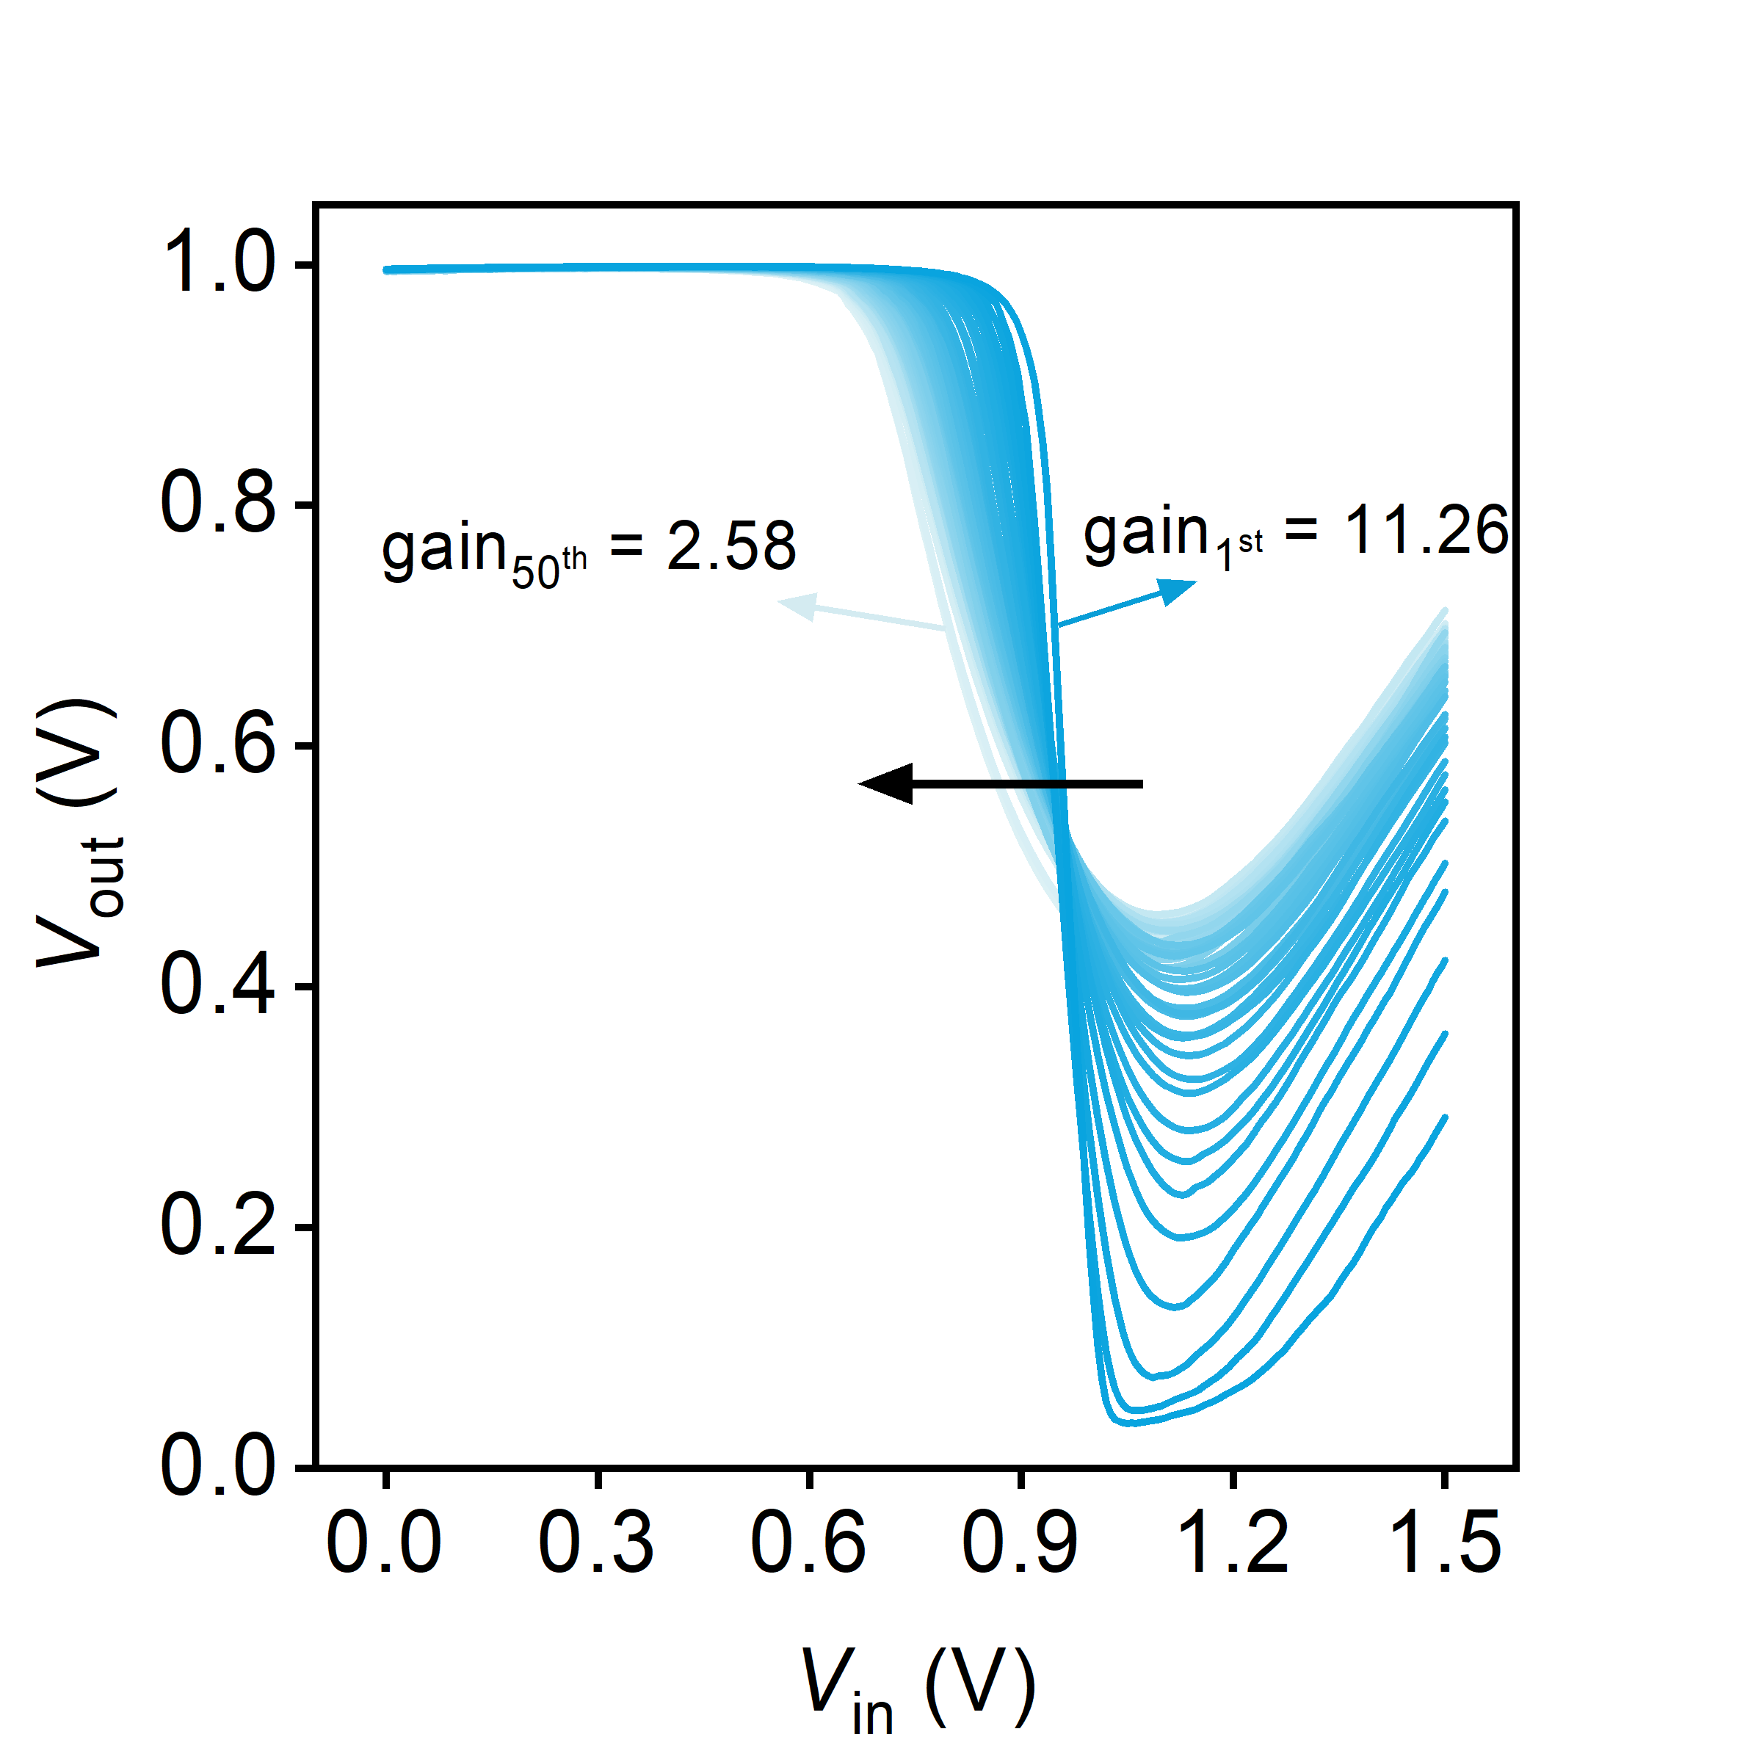
Supplementary Fig. 11 The 50-cycle input-output characteristics of the DNTT inverter at V_{DD} = 1 V.

Supplementary Table 1 The static and dynamic characteristics of inverters in the literatures.
Materials | Transistor  design | V_{DD} (V) | Gain | τ |  |  |  |  |  | Ref.
 |  |  |  | τ_{fall} | τ_{rise}
CNT | Zero-V_{GS} | 5 | 16 | - |  |  | - |  |  | ¹
MoS₂ | Zero-V_{GS} | 10 | 155 | - |  |  | - |  |  | ²
MoS₂ | Zero-V_{GS} | 5 | 60 | - |  |  | - |  |  | ³
IGZO | Zero-V_{GS} | 5/10/15 | 6/19/46 | - |  |  | - |  |  | ⁴
IGZO | Zero-V_{GS} | 1/2 | 25/39 | - |  |  | - |  |  | ⁵
P3HT | Zero-V_{GS} | 1 | 5.72 | - |  |  | - |  |  | ⁶
Pentacene | Zero-V_{GS} | 6/8/10 | 2/5.8/10.2 | - |  |  | - |  |  | ⁷
C8-BTBT | Zero-V_{GS} | 2 | 260 | - |  |  | - |  |  | ⁸
DPh-DNTT | Zero-V_{GS} | 1 | 3200 | 170 μs |  |  |  |  | 70 μs | ⁹
DPh-DNTT | Zero-V_{GS} | 1 | 5 | 560 ns |  |  | 14ns |  |  | ⁹
 |  |  |  | (V_{DD} = 3 V)
DPh-DNTT | Zero-V_{GS} | 2 | ~3 | 88ns |  |  | 23ns |  |  | ¹⁰
gDPP-g2T  (p-type)  Homo-gDPP (n-type) | Complementary | 0.7 | 150 | 366 μs |  |  |  | 45 μs |  | ¹¹
Merck lisicon S1200 | Zero-V_{GS} | 2/10 | 1/1.5 | 691ms |  | 427ms |  |  |  | ¹²
 |  |  |  | (V_{DD} = 10 V)
C₁₀-DNTT | Zero-V_{GS} | 1/2.5 | 46.2/127.5 | 50 μs |  |  | 50 μs |  |  | This work
 |  |  |  | (V_{DD} = 1 V)

Supplementary References
1 Sun, D.-m. et al. Flexible high-performance carbon nanotube integrated circuits. Nat. Nanotechnol. 6, 156-161 (2011).
2 Dai, Z., Wang, Z., He, X., Zhang, X. X. & Alshareef, H. N. Large‐Area Chemical Vapor Deposited MoS2 with Transparent Conducting Oxide Contacts toward Fully Transparent 2D Electronics. Adv. Funct. Mater. 27, 1703119 (2017).
3 Wachter, S., Polyushkin, D. K., Bethge, O. & Mueller, T. A microprocessor based on a two-dimensional semiconductor. Nat. Commun. 8, 14948 (2017).
4 Wang, M. et al. Threshold voltage tuning in a-IGZO TFTs with ultrathin SnO x capping layer and application to depletion-load inverter. IEEE Electr. Device. Lett. 37, 422-425 (2016).
5 Chi, L.-J., Yu, M.-J., Chang, Y.-H. & Hou, T.-H. 1-V full-swing depletion-load a-In–Ga–Zn–O inverters for back-end-of-line compatible 3D integration. IEEE Electr. Device. Lett. 37, 441-444 (2016).
6 Park, H. et al. Organic flexible electronics with closed-loop recycling for sustainable wearable technology. Nat. Electron. 7, 39-50 (2024).
7 Ji, D. et al. Copolymer dielectrics with balanced chain-packing density and surface polarity for high-performance flexible organic electronics. Nat. Commun. 9, 2339 (2018).
8 Jiang, C. et al. Printed subthreshold organic transistors operating at high gain and ultralow power. Science 363, 719-723 (2019).
9 Haldar, T. et al. High-gain, low-voltage unipolar logic circuits based on nanoscale flexible organic thin-film transistors with small signal delays. Sci. Adv. 9, eadd3669 (2023).
10 Borchert, J. W. et al. Flexible low-voltage high-frequency organic thin-film transistors. Sci. Adv. 6, eaaz5156 (2020).
11 Huang, W. et al. Vertical organic electrochemical transistors for complementary circuits. Nature 613, 496-502 (2023).
12 Fukuda, K. et al. Fully-printed high-performance organic thin-film transistors and circuitry on one-micron-thick polymer films. Nat. Commun. 5, 1-8 (2014).

