EXTENDED DATA FIGURES

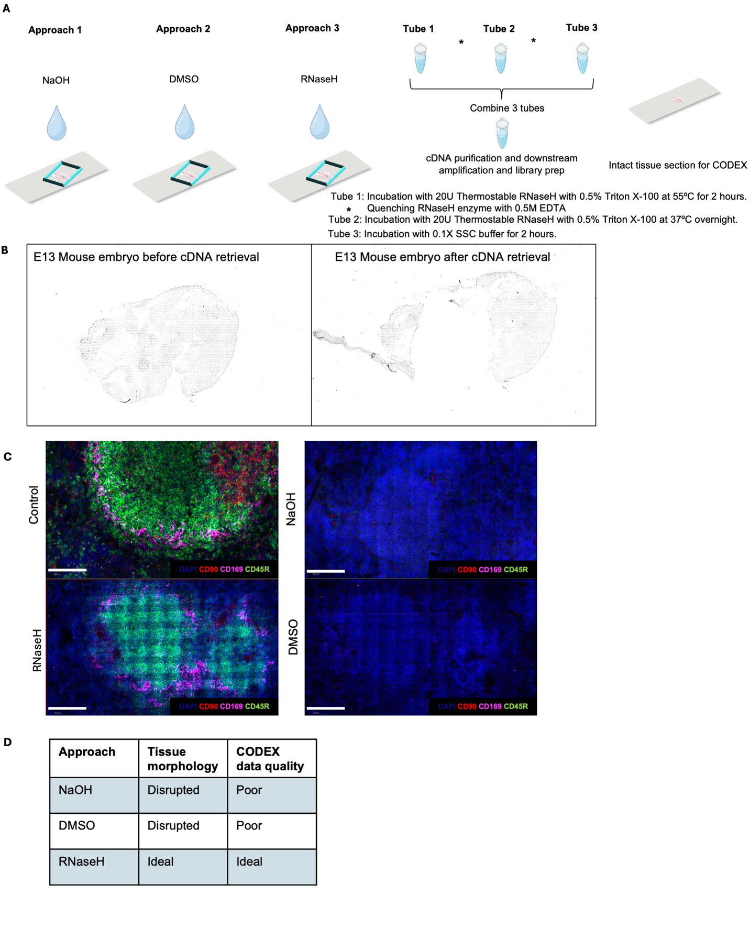

Extended Data Fig. 1. Exploration of different approaches for cDNA retrieval from FF and FFPE tissue sections. a Approaches for releasing cDNA from tissue section. Three approaches were tried – NaOH, DMSO (which can allow for the dissociation of cDNA followed by diffusion from the tissue section) and RNaseH enzyme (can selectively degrade mRNA in a DNA:RNA hybrid followed by diffusion from the tissue). Thermostable RNaseH allows for incubation at higher temperatures to facilitate diffusion. Three tubes are then pooled, cDNA purification and downstream amplification and library prep is done. The intact tissue section is then used for CODEX staining. b Brightfield images E11 mouse embryo FF section used in the DBiTplus workflow. Left panel shows barcoded tissue section after the DBiTplus workflow and right panel shows the barcoded tissue section after the cDNA retrieval. c Comparing the quality of CODEX imaging on FF mouse spleen after DBiTplus workflow. Mouse spleen sample with the retrieval method using RNaseH enzyme shows positive staining makers including CD45R (B cell lineage) and CD169 (macrophages) similar to control staining. Scale bar 50 μm. d QC analysis of parameters for selection of optimal approach for cDNA retrieval from the tissue section. RNaseH approach preserves tissue morphology and generates good quality CODEX data.

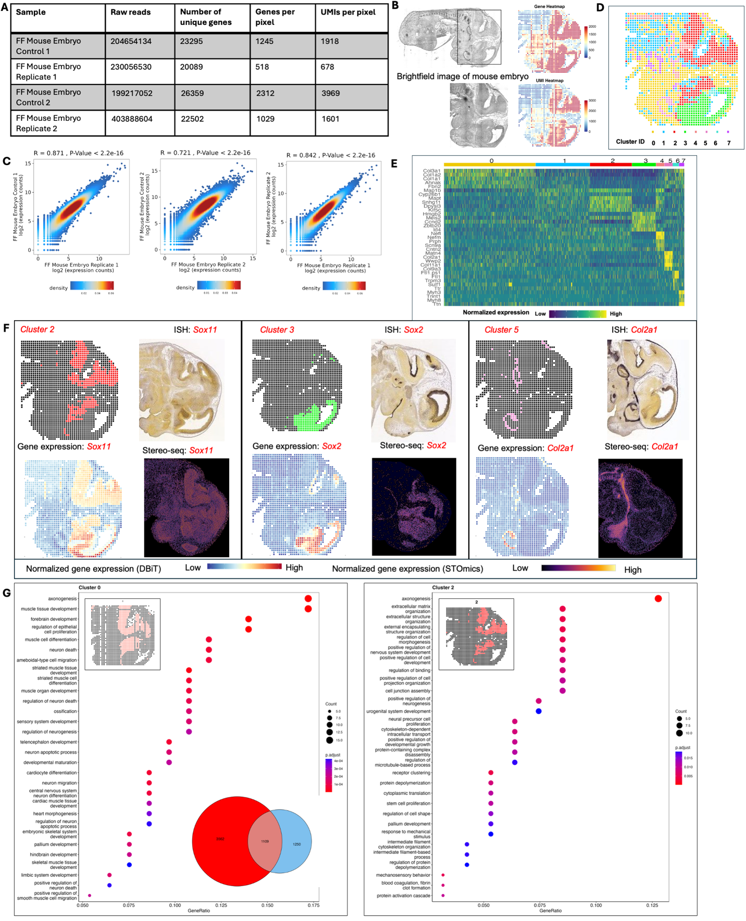

Extended Data Fig. 2. Spatial profiling of gene expression in FF mouse embryo. a Summary of raw reads, total number of unique genes, and genes and UMIs per 20 μm spot for FF mouse embryo experiments. b Brightfield image of E11 FF mouse embryo. Black box represents the DBiTplus workflow. Spatial mRNA and UMI count maps. An average of 1029 genes and 1601 UMIs detected per 20 μm spot. c Correlation analysis between replicates showing the reproducibility of the DBiTplus workflow with a Pearson correlation coefficient of 0.87 and 0.72 respectively. Pearson correlation between the two replicates is 0.84. d Spatial UMAP showing 8 distinct clusters of spots or spots that align with anatomical features of the E11 mouse embryo. e Heatmap showing the top 5 differentially expressed genes for each spatial cluster. f Spatial distribution of clusters 2, 3 and 5 alongside their principal defining genes. ISH staining image from the Allen Mouse Brain Atlas and gene expression from Stereo-seq data. g GO analysis showing the biological process associated with cluster 0 (E11 mouse embryo from the standard DBiTplus workflow) and cluster 2 (E11 mouse embryo from DBiTplus workflow) which are associated with the embryonic diencephalon. Venn diagram showing overlap of genes between cluster 0 and cluster 2.

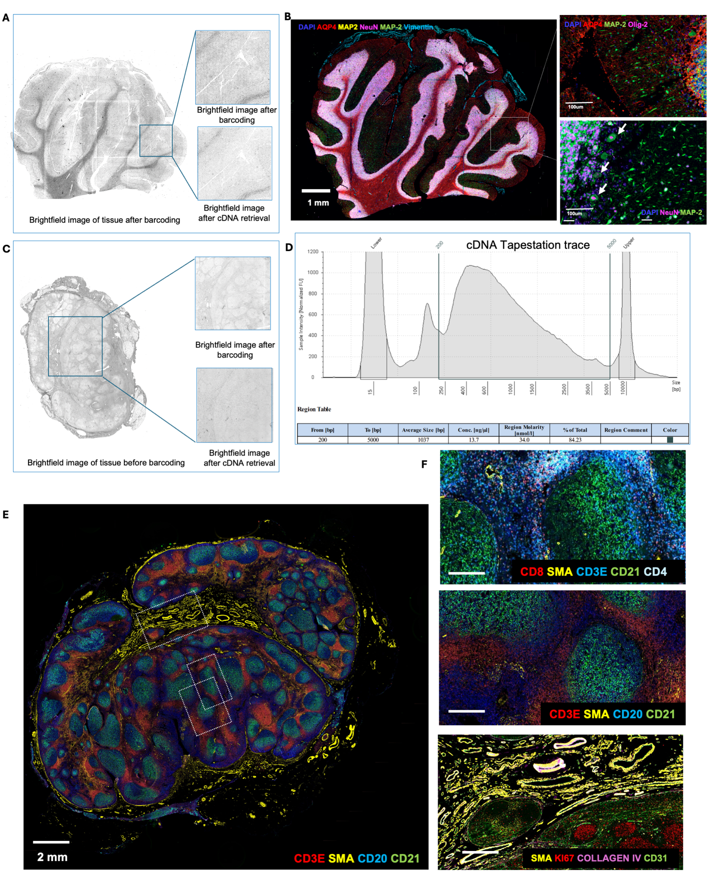
Extended Data Fig. 3. Optimization of CODEX staining on FFPE human cerebellum and lymph node following the DBiTplus workflow and cDNA retrieval using RNaseH. a Brightfield image of FFPE human cerebellum following barcoding in the DBiTplus workflow. Box represents the barcoded region. Brightfield image after cDNA retrieval shows the tissue morphology is preserved and is suitable for CODEX imaging. b The same tissue section from panel A is imaged with a 28-marker panel. Left: CODEX image showing AQP4 (Astrocytes), MAP2 (Synaptic neurons), NeuN (Neuronal nuclei and cell bodies) and Vimentin (Vasculature). Right top: Synaptic neurons marked by MAP2 in the molecular layer of the cerebellum. Right bottom: Large pear-shaped Purkinje cells, with their large cell bodies visualized in the Purkinje cell layer. c Brightfield image of FFPE of benign human lymph node. Box represents the barcoded region. Brightfield image after cDNA retrieval shows the tissue morphology is preserved and is suitable for CODEX imaging. d Size distribution from TapeStation traces of cDNA amplicon. e CODEX imaging on FFPE of human lymph node following the DBiTplus workflow. Three distinct regions are further analyzed for quality of CODEX staining. f Top: Region showing T cell subtypes: CD3ε (T cells), CD8 (Cytotoxic T cells), CD4 (Helper T cells) and SMA (Smooth muscles). Middle: CD3ε (T cells), SMA (Smooth muscles), CD20 (B cells) and CD21 (Follicular dendritic cells). Bottom: SMA (Smooth muscles), Ki67 (Proliferating germinal center B cells), Collagen IV (Blood vessels), CD31 (Vasculature).

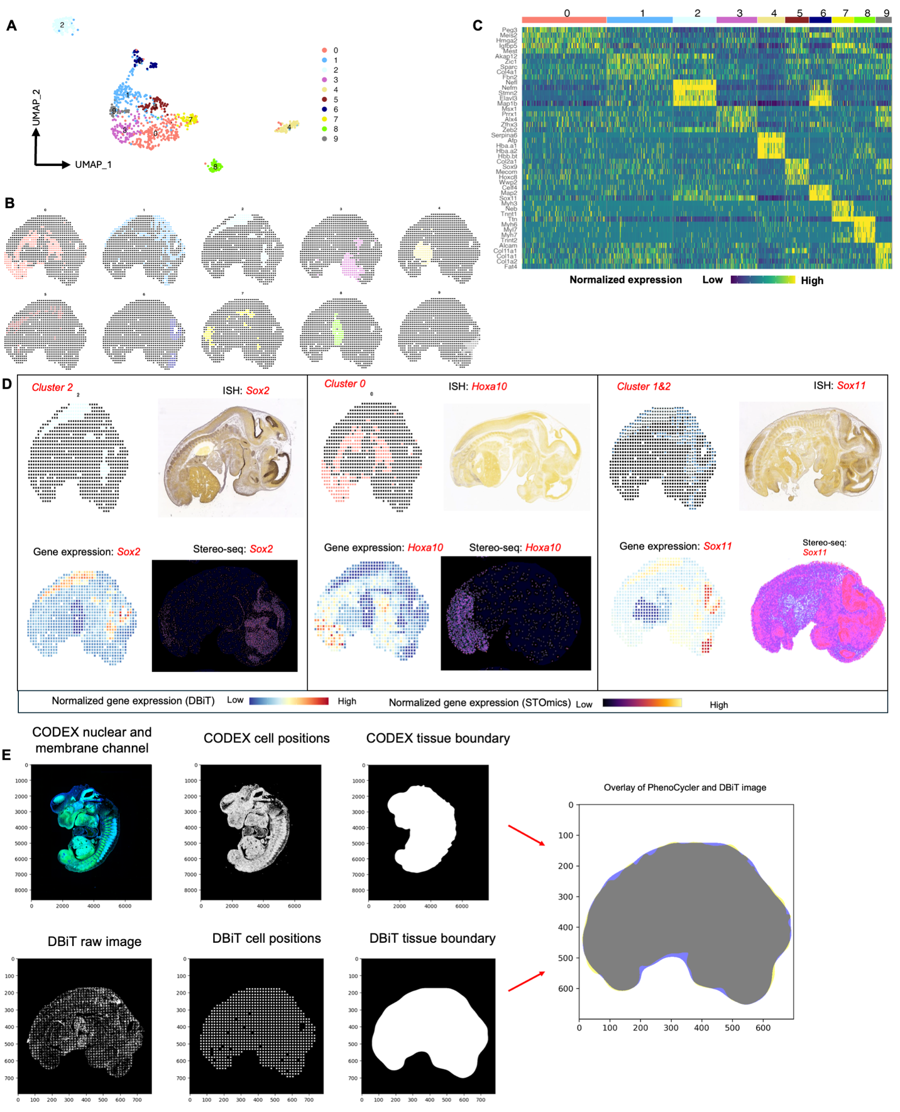

Extended Data Fig. 4. Workflow for the alignment of CODEX and DBiTplus images. a UMAP showing 10 distinct clusters of DBiTplus spots/spots. B Spatial distribution of the 10 clusters of DBiTplus spots. c Heatmap showing the top 5 differentially expressed genes for each spatial cluster. d Spatial distribution of clusters 0, 1, and 2 alongside their principal defining genes. ISH staining image from the Allen Mouse Brain Atlas and gene expression from Stereo-seq data. e CODEX-DBiTplus image alignment workflow. Top: Cell segmentation based on nuclear marker (DAPI) and two membrane markers, followed by determination of the coordinates of each cell in the CODEX dataset and tissue boundary detection. Bottom: Coordinates of the spots (spots) is extracted from the DBiTplus image, and the boundaries of the tissue section is detected. The CODEX image and the DBiTplus images are overlayed and registered in a common coordinate system.

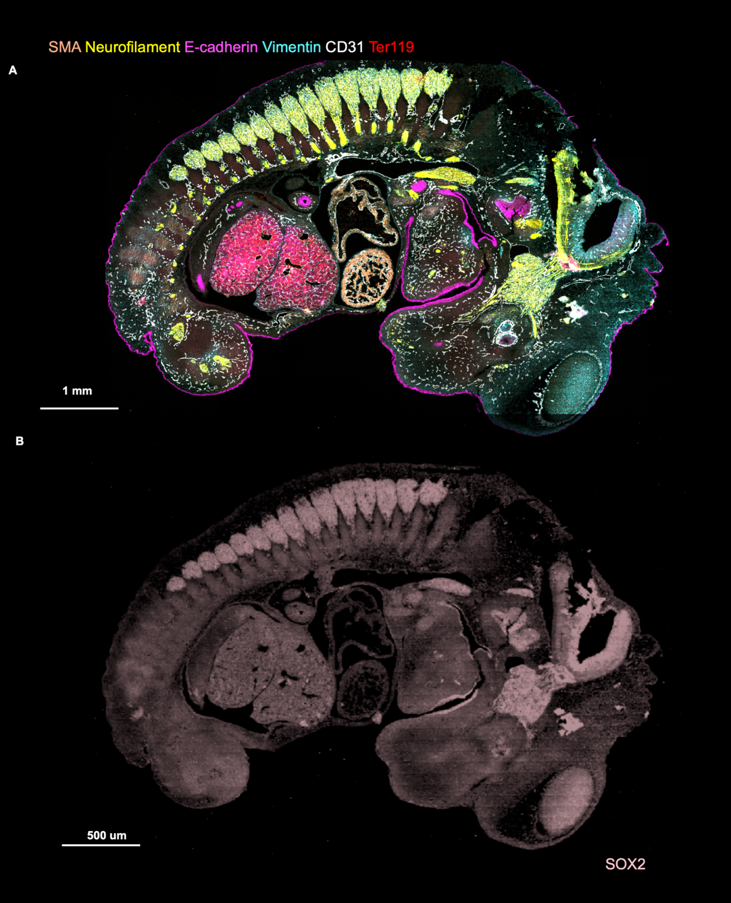

Extended Data Fig. 5. CODEX imaging of E13 FFPE mouse embryo. a Following the DBiTplus workflow, the intact tissue section is stained with a 21-marker panel. E-cadherin (Epithelia), CD31 (Vasculature), SMA (Smooth muscle), Ter119 (Erythroid cells), Vimentin (Mesenchyme and Endothelial cells) and Neurofilament (Nervous system). b Imprint of DBiTplus microfluidic channel on the tissue section observed in the SOX2 channel.

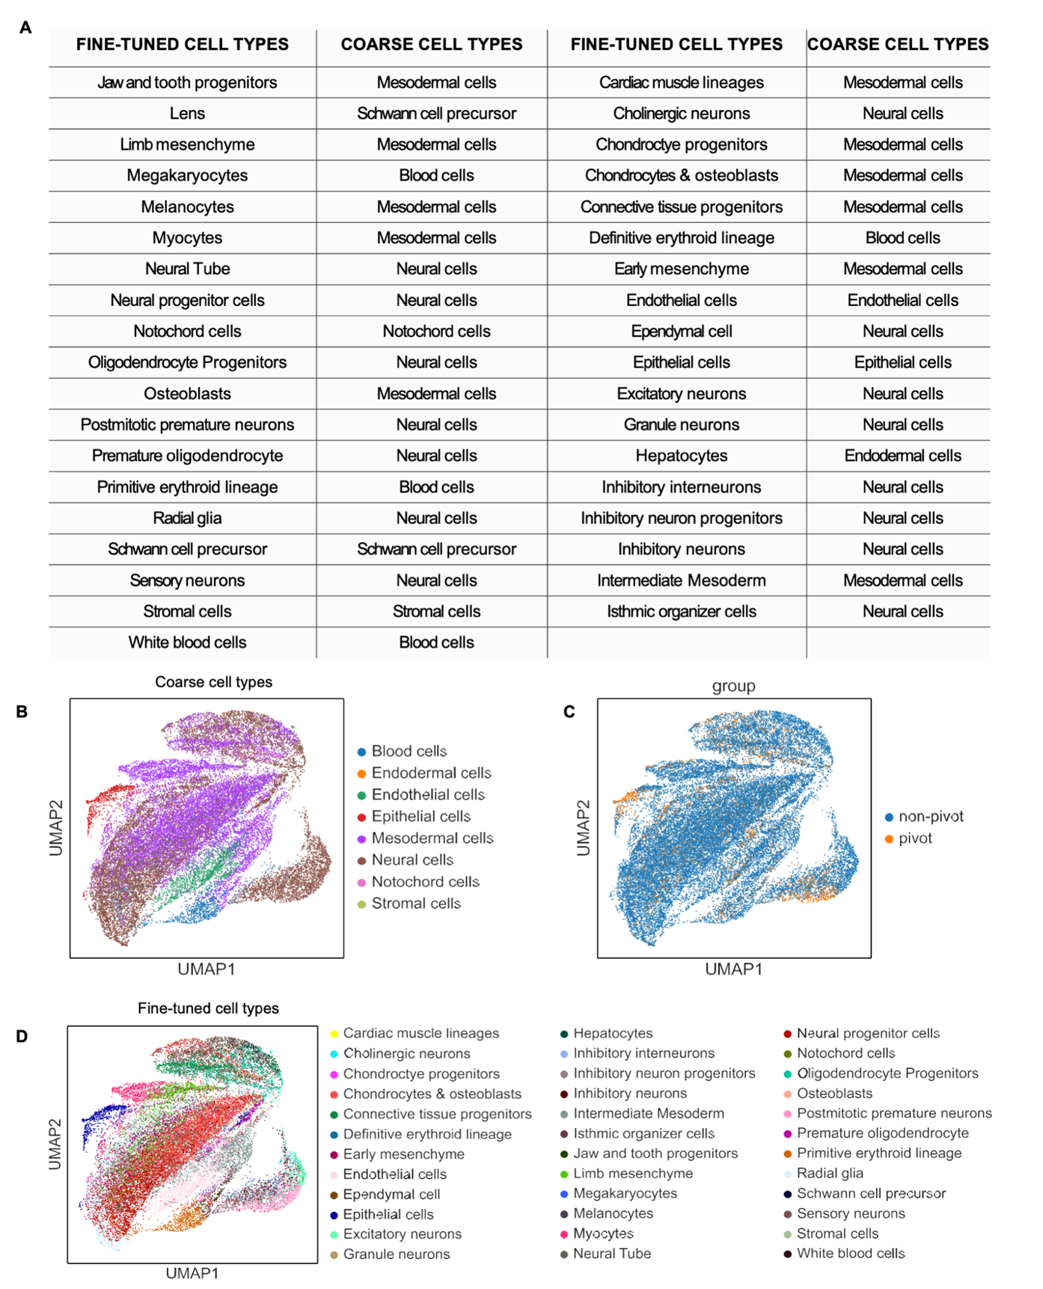

Extended Data Fig. 6. UMAP of integration of CODEX dataset and single cell RNA-seq reference dataset from E13 FFPE mouse embryo using MaxFuse. a Table showing the coarse and fine-tuned cell types from the single cell RNA-seq reference dataset. b UMAP showing major cell types from the integration of the single cell RNA-seq reference dataset and CODEX. c UMAP of the pivot and non-pivot cells in the MaxFuse integrated dataset. d UMAP of minor cell types in the integrated dataset.
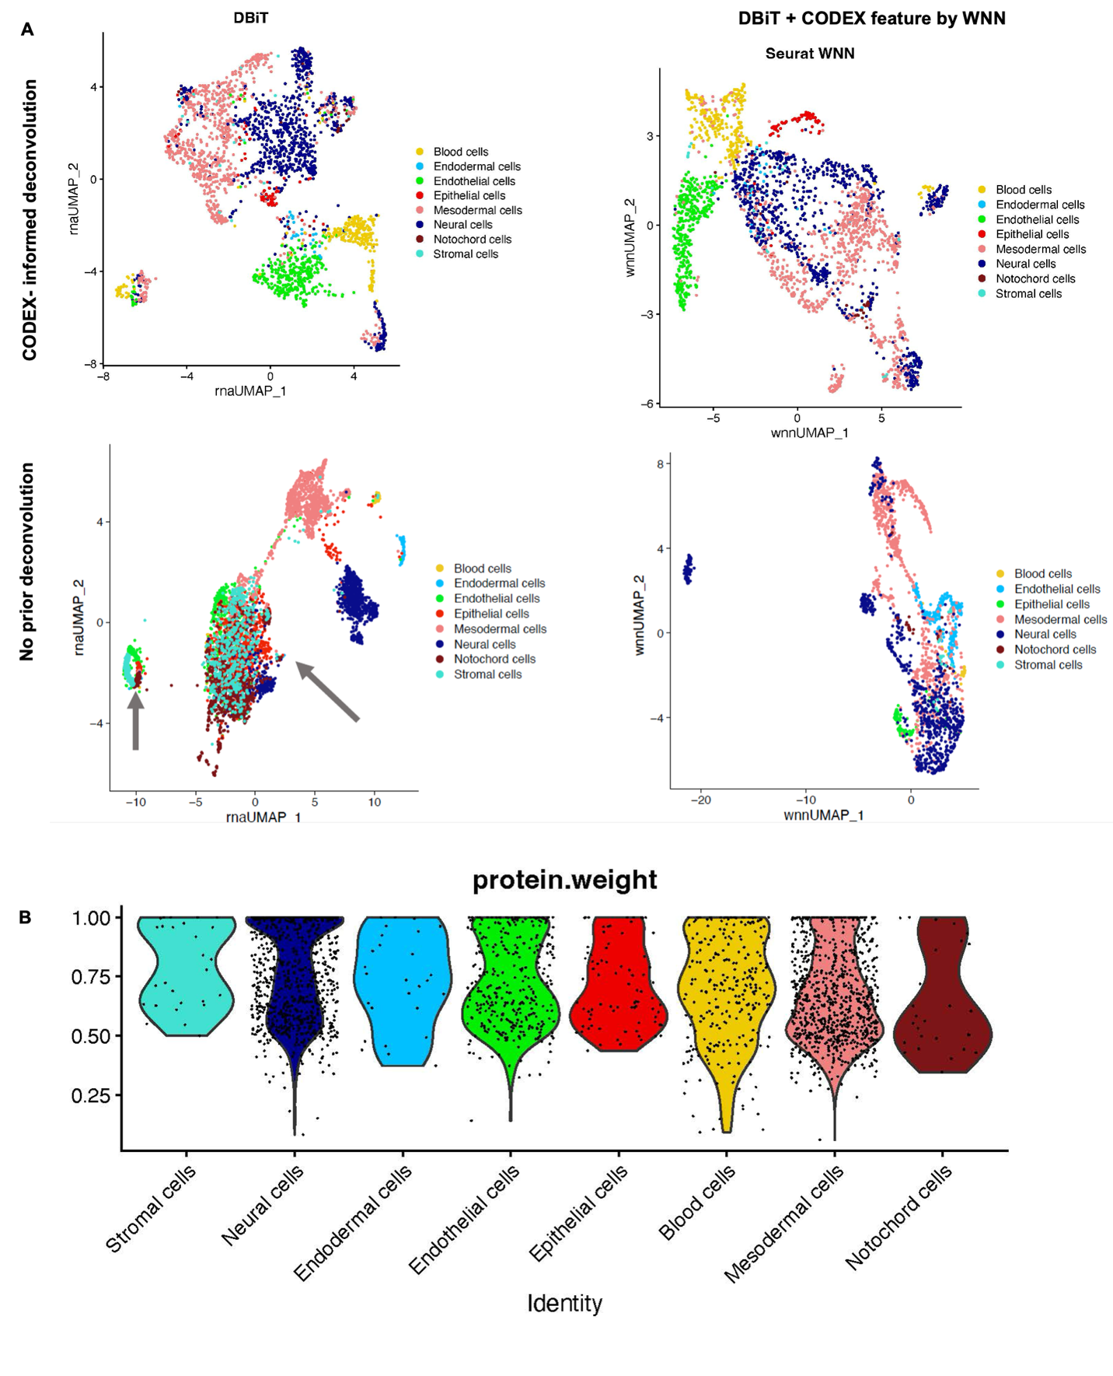
Extended Data Fig. 7. Integration of CODEX dataset and single cell RNA-seq reference dataset from E13 FFPE mouse embryo using MaxFuse. a Spatial plot of pivot cells and all cells from the matched single cell RNA-seq and CODEX datasets for major cell types. b Spatial plot of pivot cells and all cells from the matched single cell RNA-seq and CODEX datasets for minor cell types. c Spatial plot of pivot cells and all cells from the matched single cell RNA-seq and CODEX datasets for minor cell types belonging to neural cells. d Spatial plot of pivot cells and all cells from the matched single cell RNA-seq and CODEX datasets for minor cell types belonging to mesodermal cells.

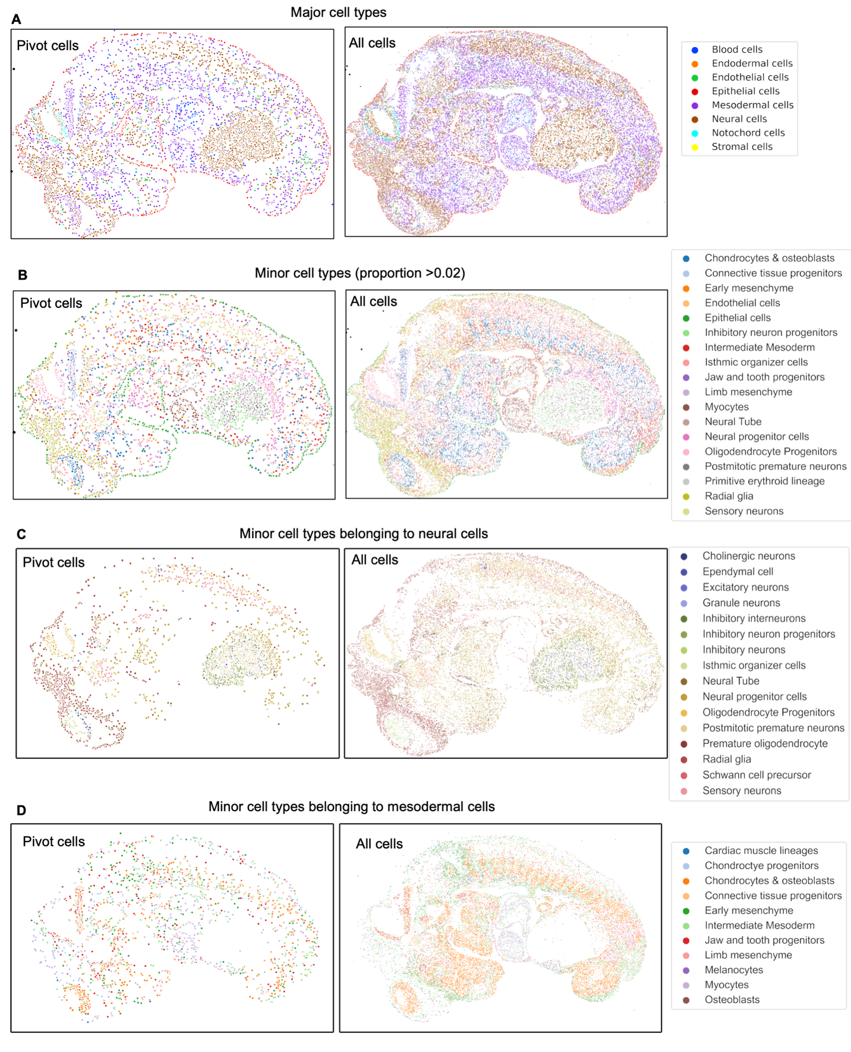
Extended Data Fig. 8. Deconvolution and WNN integration of DBiTplus datasets. a Top: UMAPs showing CODEX-informed deconvolution of DBiTplus feature only (Left) and a combination of DBiTplus and CODEX features (Right). Epithelial cells are better delineated when both deconvoluted DBiTplus and CODEX features are used via WNN integration. Bottom: No prior deconvolution with DBiTplus feature only (Left) and DBiTplus and CODEX feature (Right). The comparison with the top row demonstrates CODEX staining on the same tissue section markedly enhances the amount of information one gets from DBiTplus data. b Seurat WNN integration of DBiTplus+ and CODEX datasets. Weight of CODEX modality in Seurat WNN analysis. Strongest weights observed for T cell subtypes and lowest observed for B cell subtypes. These contributions are influenced by the composition of the CODEX marker panel.

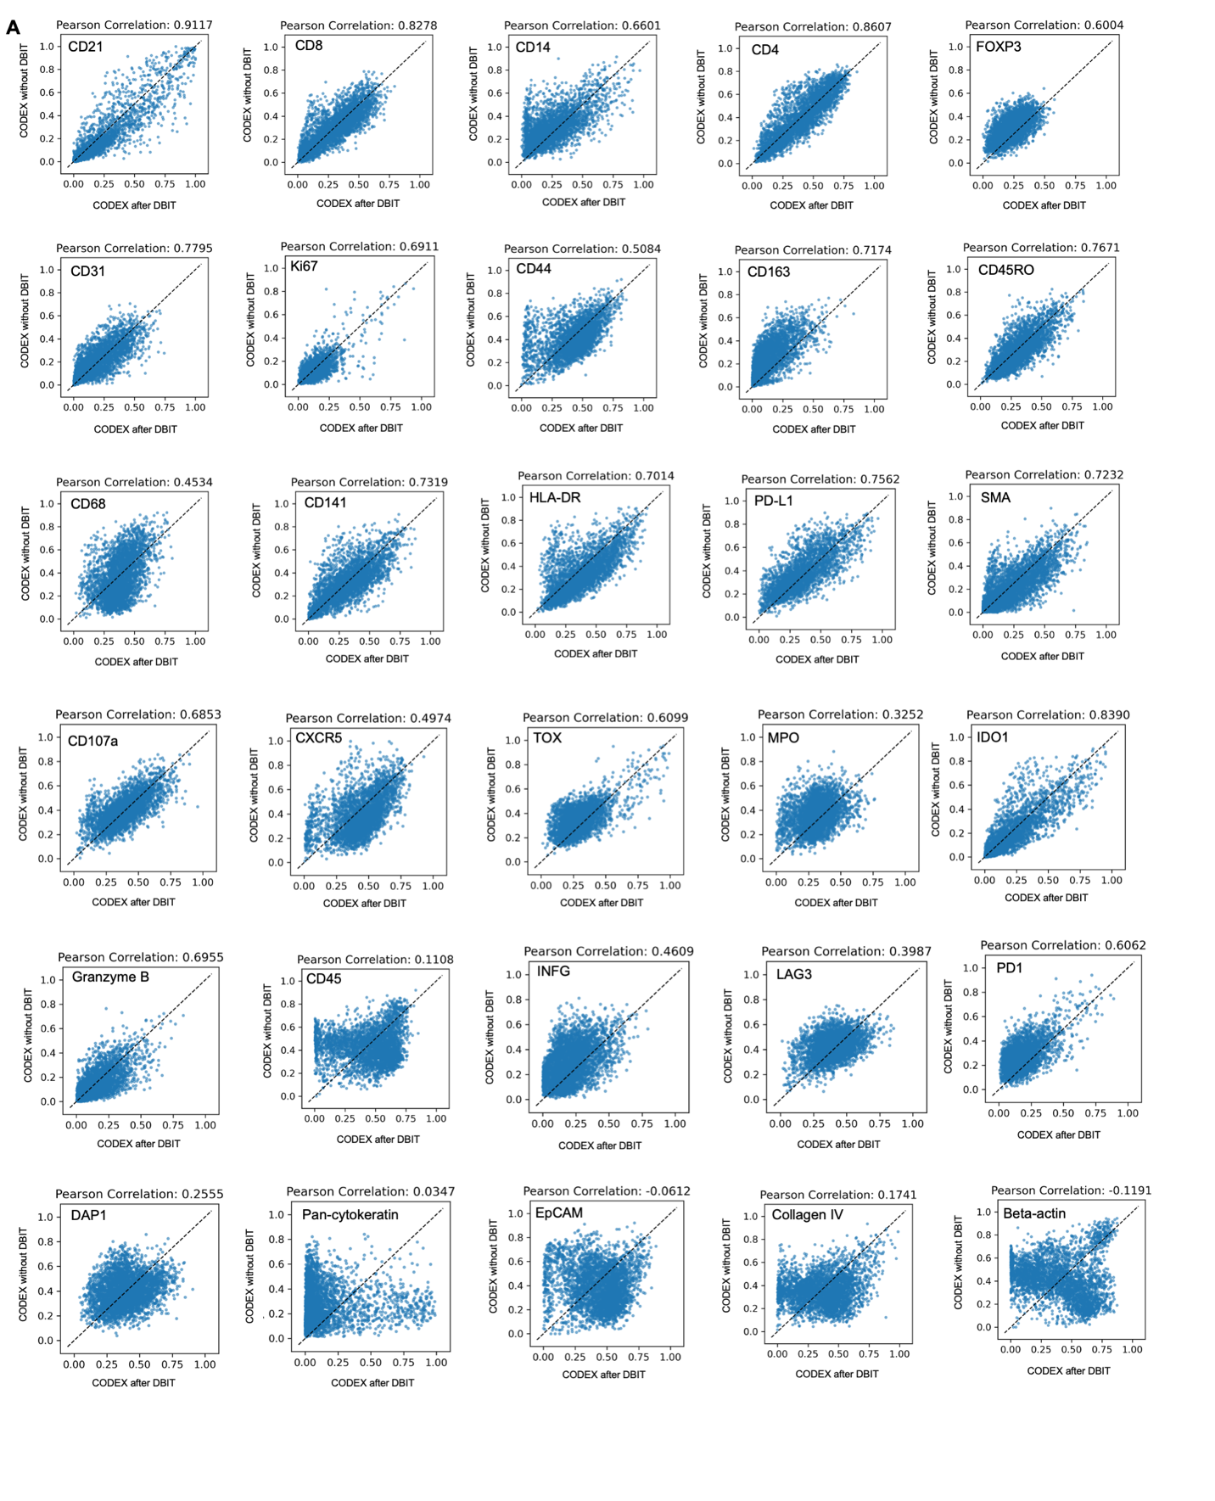
Extended Data Fig. 9. Assessing the quality of CODEX data from DBiTplus workflow. Correlation between tissue section stained via CODEX without prior DBiTplus and tissue section stained via CODEX after the DBiTplus workflow. Strong correlation is observed for most markers. Lowest correlations observed for markers such as Beta-actin and EpCAM.

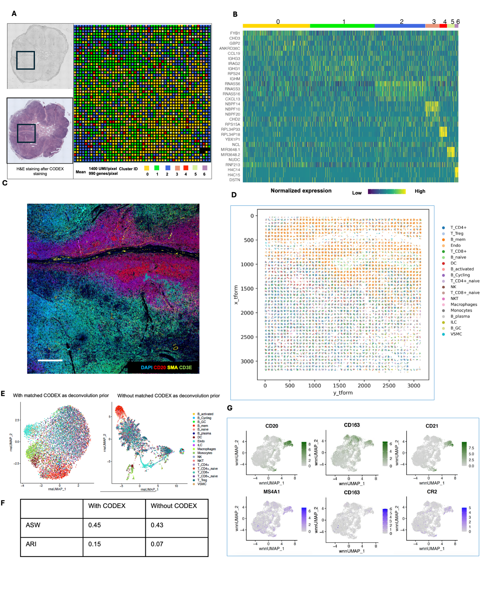

Extended Data Fig. 10. Spatial multi-omics profiling of FFPE human lymph node tissue section (25 μm resolution). a Spatial transcriptome distribution of FFPE human lymph node tissues barcoded using the microfluidic device with 25 μm resolution. Black box represents the DBiTplus ROI. Unsupervised clustering identified 7 distinct clusters whose spatial distribution closely matches the histological organization of human lymph nodes. B Heatmap showing the top 7 differentially expressed genes for each spatial cluster. c CODEX staining (panel of 35 markers) is performed on the same tissue section following the DBiTplus workflow. Scale bar 1mm. d Deconvolution of DBiTplus spots mapped by CODEX dataset. The identities of each cell within the DBiTplus spots can be directly inferred. e UMAPs of deconvoluted DBiTplus data: CODEX-informed deconvolution of DBiTplus feature (Left) and DBiTplus deconvolution without CODEX information (Right). f Higher ASW and ARI scores achieved by CODEX-informed deconvolution of DBiTplus spots suggesting better spot deconvolution quality. g Comparison of expression levels of protein features from CODEX (top) and corresponding RNA from DBiTplus after deconvolution (bottom).
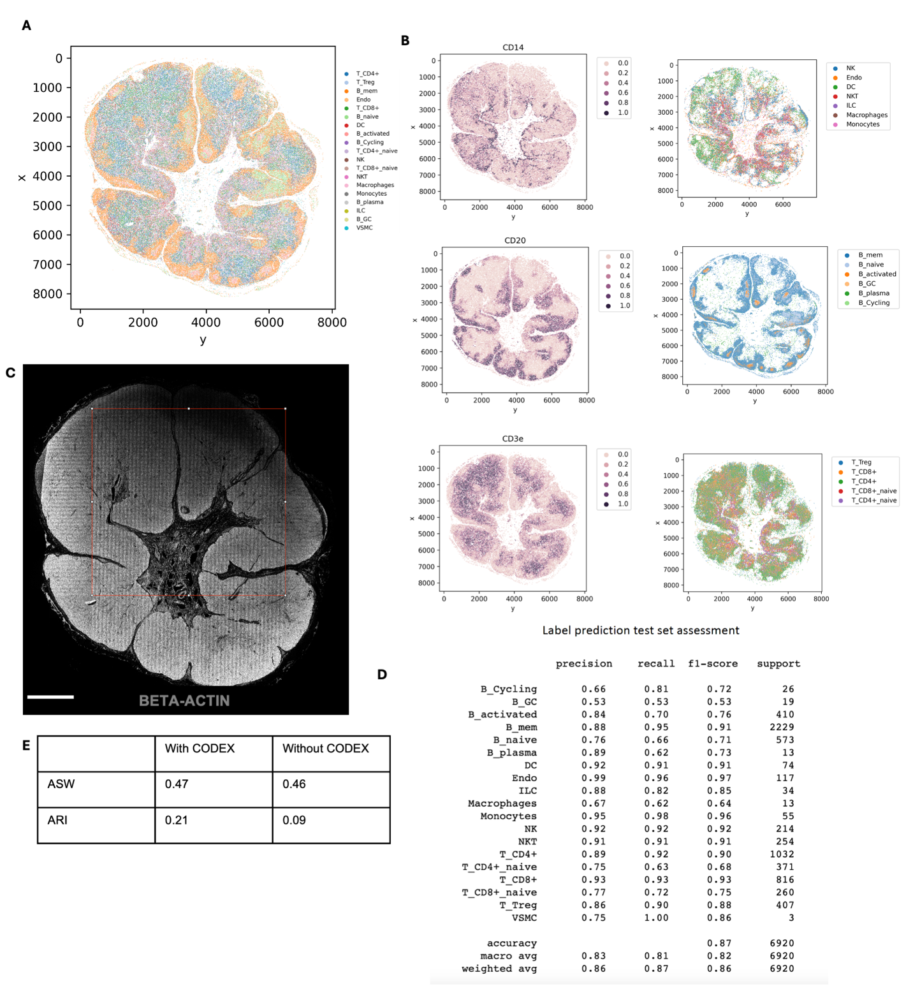

Extended Data Fig. 11. Spatial multi-omics profiling of FFPE of benign human lymph node tissue section (25 μm resolution). A Cell type annotation of whole CODEX dataset following integration with single cell RNA-seq reference dataset using MaxFuse. b Left: Spatial plots of different protein markers CD14 (Macrophages), CD20 (B cells) and CD3ε (T cells). Right: Plots of subtypes of the major cell types from the plots on the left. c Imprint of DBiTplus microfluidic channel on the tissue section observed in the Beta-actin channel. Scale bar 1mm. d Assessment of the label prediction test set. Highest f1-scores observed for endothelial cells, macrophages, dendritic cells and B cells. e Higher ASW and ARI scores for matched CODEX as deconvolution prior.

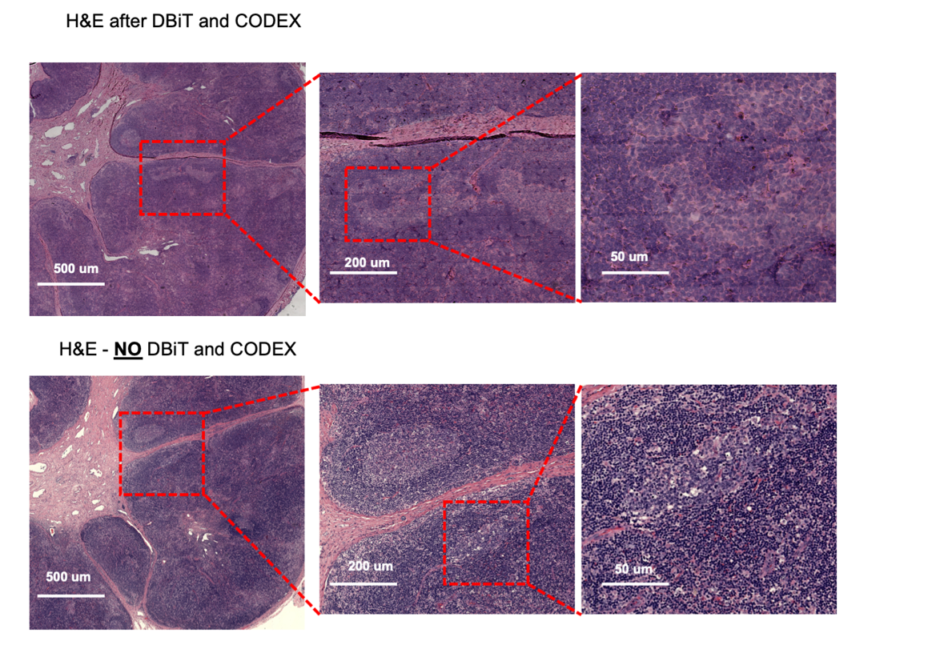

Extended Data Fig. 12. Comparison of H&E staining from FFPE of benign Human Lymph node sample after DBiTplus and CODEX workflows and an adjacent section without DBiTplus or CODEX. Identical regions from the adjacent sections undergo H&E staining. Comparable quality H&E is observed in both workflows.

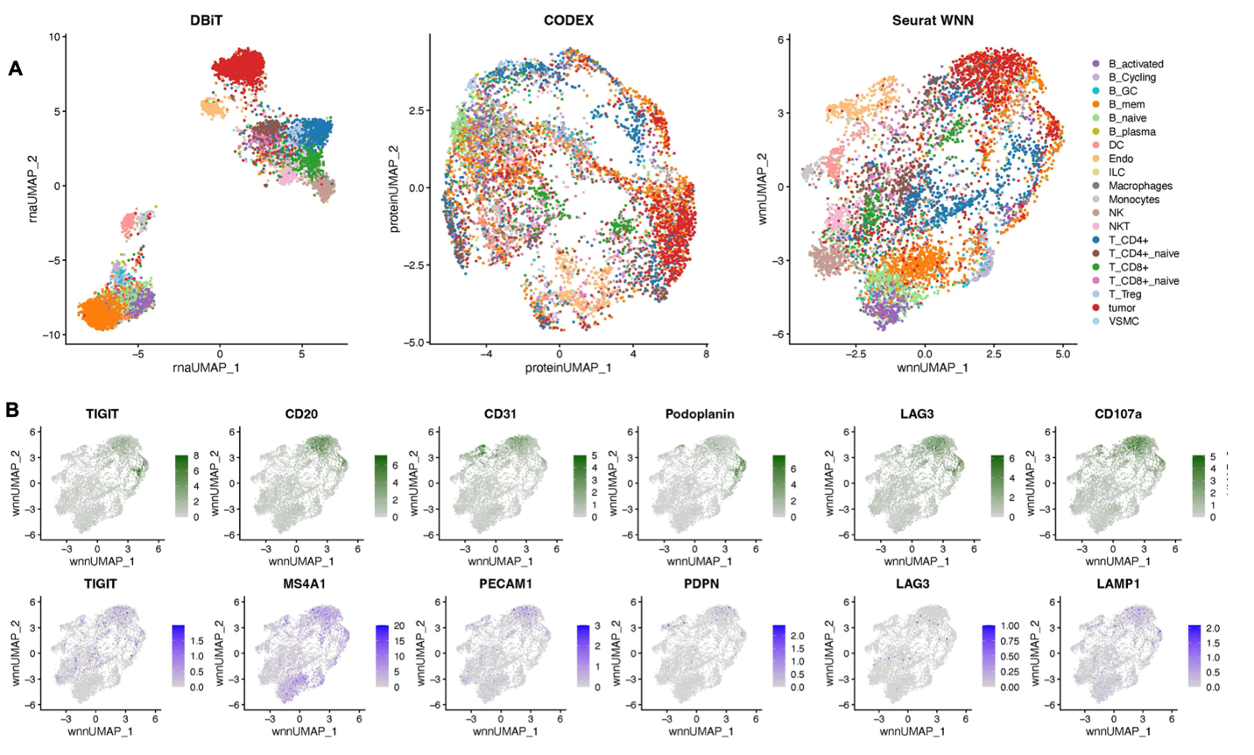

Extended Data Fig. 13. Integration of CODEX dataset and single cell RNA-seq reference dataset for DLBCL sample using MaxFuse (A) UMAP of the integration of the DBiTplus and CODEX dataset showing distinct cell types. Tumor cells were first labeled by codex markers only. MaxFuse then used for annotating non-tumor cells. (B) Comparison of expression levels of protein features from CODEX (top) and corresponding RNA from DBiTplus after deconvolution (bottom).

