Supporting Information
Shifting dynamics of Dengue in Ningbo City, China: Impacts of ENSO and Interventions before, during and after the COVID-19 pandemic

S1. Study site
Ningbo City, located along the Chinese coastline between 120°55' to 122°16' east longitude and 28°51' to 30°33' north latitude, lies on the southern side of the Yangtze River Delta with a population of 6.21 million in 2023 (Figures S1A and S1B). The topography of Ningbo slopes higher in the southwest and lower in the northeast. The urban area ranges from 4 to 5.8 meters above sea level, while suburban areas vary from 3.6 to 4 meters. The landform distribution in Ningbo is as follows: mountains cover 24.9%, hills 25.2%, basins 8.1%, plains 40.3%, and other terrains 1.5%. Ningbo City experiences a North Subtropical Monsoon Climate, characterized by mild and humid weather with distinct seasons. The city is divided into six districts: Haishu, Jiangbei, Zhenhai, Beilun, Yinzhou, and Fenghua, along with two counties, Ninghai and Xiangshan, and two county-level cities, Cixi and Yuyao (see Figure Figures S1C). The information mentioned above can be found in the Ningbo Statistical Yearbook (accessed at: http://tjj.ningbo.gov.cn/col/col1229042824/index.html) and the Ningbo Government Gazette (accessible at: https://www.ningbo.gov.cn/col/col1229099784/index.html).
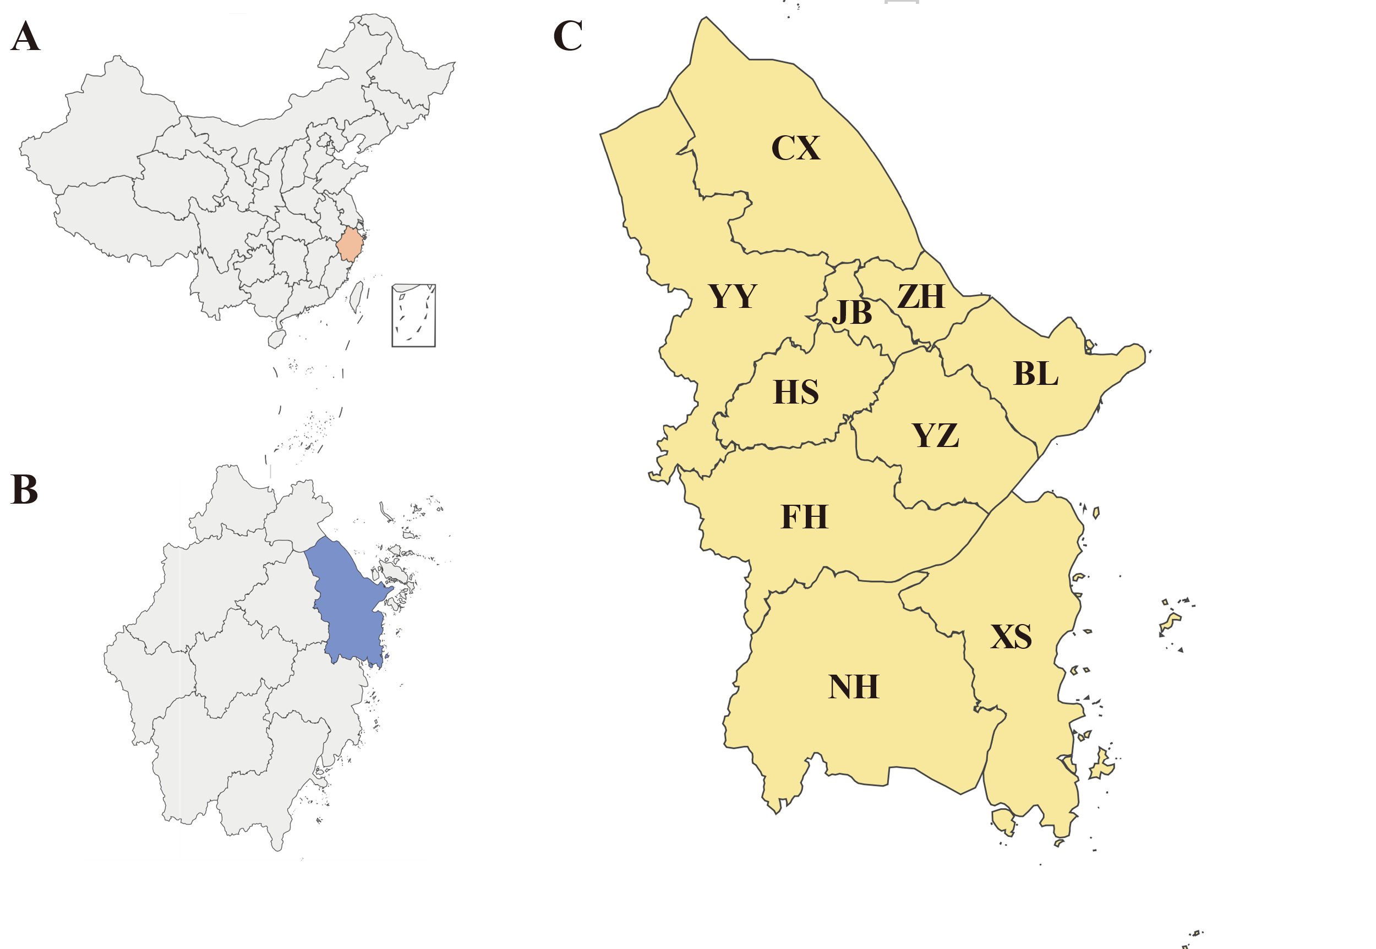

Figure S1. Location of Ningbo City. (A) Zhejiang Province (The light pink area on the map marks the geographical location of Zhejiang Province, located along the eastern coast of China, south of the Yangtze Delta). (B) Ningbo City (The blue area on the map depicts the geographical location of Ningbo City, situated in the northeastern region of Zhejiang Province). (C) Administrative subdivisions of Ningbo City. (in the south of China).
CX = Cixi City, YY = Yuyao City, JB = Jiangbei District, ZH = Zhenhai District, HS = Haishu District, BL = Beilun District, YZ = Yinzhou District, FH = Fenghua District, XS = Xiangshan County, NH = Ninghai County.

S2. The Evolution of Dengue Intervention Measures in Ningbo City

S2.1. Case definition
All dengue cases are diagnosed based on the criteria established by the National Health Commission of the People's Republic of China (WS216-2008) available at http://www.nhc.gov.cn/wjw/s9491/200802/38819.shtml.
- Suspected case: an individual has visited regions endemic to dengue and exhibited symptoms like fever, headache, eye pain, muscle and joint pain, extreme fatigue, along with facial, neck, and chest flushing, conjunctival congestion, and other general clinical manifestations within 14 days before the disease onset, or they have not been to dengue endemic areas but display symptoms like rash, bleeding tendency, and no confirmed diagnosis of other diseases within the same period before disease onset.
(b) Clinically diagnosed case: a suspected case presenting with leucopenia or thrombocytopenia, or a suspected case testing positive for serum-specific immunoglobulin IgG or IgM.
(c) Laboratory-confirmed case: a clinically diagnosed case has one or more of the following test results:
I. The dengue virus (DENV) is isolated from the serum, cerebrospinal fluid, blood cells, or tissues of patients during the acute phase.
II. DENV gene sequences are identified through RT-PCR or real-time quantitative PCR.
III. The DENV NS1 antigen is found in the serum of patients in the acute phase.
IV. Specific antibody titers in the serum during the recovery phase exhibit a fourfold or greater increase compared to the acute phase.
This study categorizes dengue cases into imported and indigenous cases based on the infection site. Imported cases are further classified into two groups: overseas imported cases and domestic imported cases. Overseas imported cases encompass individuals who have recently visited countries or regions with a documented prevalence of dengue within 14 days before symptom onset. In contrast, domestic imported cases involve individuals who have left their residences 14 days before onset and have visited areas within the country where dengue is prevalent. Indigenous cases refer to situations where. Individuals with dengue have not traveled outside in the 14 days leading up to symptom manifestation.

S2.2. China Information System for Disease Control and Prevention (CISDCP)
The CISDCP is a national web-based surveillance system that collects data on 40 notifiable infectious diseases and other health-related topics in China. According to the national law on infectious disease prevention and treatment, notifiable infectious diseases are categorized as A, B, or C. Category A diseases must be reported to CISDCP within 2 hours, while categories B and C necessitate reporting to CISDCP within 24 hours.
Dengue is categorized as a class B notifiable infectious disease. Healthcare workers (HCWs) across all healthcare institutions in Ningbo City are obliged to report suspected, clinically diagnosed, or laboratory-confirmed dengue cases to the CISDCP within 24 hours. Subsequently, the Ningbo Center for Disease Control and Prevention (CDC) conducts epidemiological investigations, confirms diagnoses, and updates or supplements the information in CISDCP by the Dengue Surveillance Guidelines provided by the Chinese Center for Disease Control and Prevention (CCDC) available at https://www.chinacdc.cn/jkzt/crb/zl/dgr/jszl_2235/ (Figure S2).

S2.3. Ningbo City Dengue Early Warning System (T+1)
As Ningbo City is not an endemic area for dengue, healthcare workers (HCWs) have limited knowledge of dengue-related information. The inadequate rate of inquiring about travel history, along with the non-specific symptoms of dengue during diagnosis, can result in missed or misdiagnosed dengue cases. This issue may hinder the prompt containment of the Imported-Acquired-Indigenous transmission Chains (IAICs) and contribute to indigenous dengue outbreaks, which pose a significant disease burden on Ningbo City.
To mitigate the risk of indigenous dengue outbreaks and break IAICs, a novel dengue surveillance system called T+1 was established and launched in 2022. The T+1 system gathers individual data imported from high-risk travel-related areas from various departments, including Customs, Immigration, and Tourism. Evaluate these high-risk travel-related areas based on historical CISDCP records. Additionally, T+1 compiles medical data from all healthcare institutions in Ningbo City, encompassing patients' demographic information, medical history, diagnoses, medical records, and laboratory test data. Suspected dengue cases encompass individuals from high-risk regions or those with non-dengue diagnoses showing symptoms like fever along with decreased platelets or white blood cell counts. The CDC performs laboratory diagnostics on suspected cases, conducts epidemiological investigations on confirmed cases, and submits confirmed case information to the CISDCP system within 24 hours. Confirmed dengue cases will be transported to healthcare institutions for treatment (Figure S2).
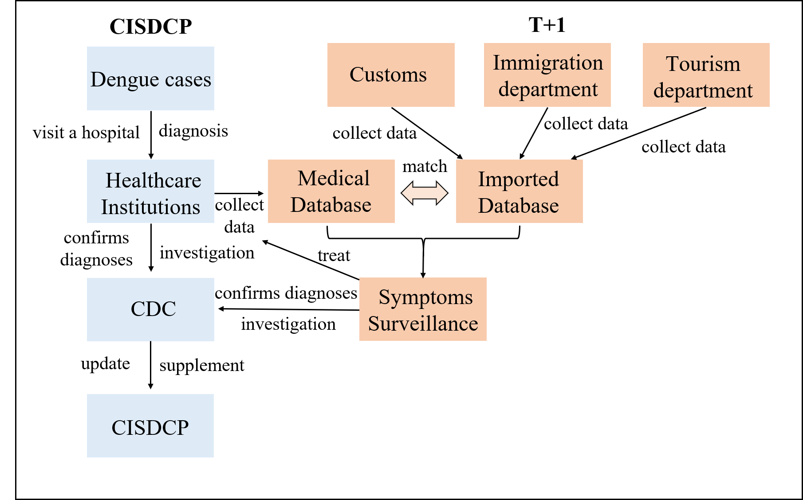

Figure S2. Flowchart of dengue surveillance system in Ningbo City. The blue square symbolizes the surveillance process of CISDCP, while the orange square signifies the surveillance process of T+1.
CISDCP = China Information System for Disease Control and Prevention, T+1 = Ningbo City Dengue Early Warning System, CDC = Ningbo Center for Disease Control and Prevention.

Table S1. High-risk locations for dengue identified by T+1.
Region | Type | Name*
Asia | Overseas | Cambodia
Asia | Overseas | Thailand
Asia | Overseas | Philippines
Asia | Overseas | Vietnam
Asia | Overseas | Burma
Asia | Overseas | India
Asia | Overseas | Singapore
Asia | Overseas | Malaysia
Asia | Overseas | Indonesia
Asia | Overseas | Bangladesh
Asia | Overseas | Nepal
Asia | Overseas | Maldives
Oceania | Overseas | Solomon Islands
Asia | Domestic | Xishuangbanna, Yunnan Province
Asia | Domestic | Fuzhou, Fujian Province
Asia | Domestic | Guangzhou City, Guangdong Province
Asia | Domestic | Yulin City, Guangxi Province
Asia | Domestic | Jiangxi Province
Asia | Domestic | Hangzhou City, Zhejiang Province
Asia | Domestic | Wenzhou, Zhejiang Province
* The above locations are derived solely from the system in 2023 and will be updated based on epidemiological investigations.

S2.4. Vector Surveillance and Control
China categorizes provinces based on the severity of historical dengue outbreaks and the distribution of Aedes mosquitoes. Class I areas are provinces where dengue outbreaks have been frequent in recent years. Class II areas are regions with recent indigenous cases or a higher risk of outbreaks due to the presence of Aedes mosquitoes. Class III areas have had reported imported cases in recent years, indicating a risk of dengue outbreaks associated with Aedes mosquito presence.
Ningbo City is a Class I area for mosquito population surveillance and Ae. albopictus is the only vector of dengue fever in Ningbo City. The city conducts Ae. albopictus surveillance and control in alignment with the guidelines issued by the CCDC available at https://www.chinacdc.cn/jkzt/crb/zl/dgr/jszl_2235/. Surveillance is conducted annually from April to November, with two fixed and two mobile surveillance points established in each county or district. Each surveillance point inspects residential areas in four communities or villages, covering various geographical directions, with at least 100 households surveyed for small water containers and larvae breeding inside and outside structures. Positive mosquito larvae samples are identified for species classification either on-site or in labs through rearing until adulthood. To prevent any bias in calculating mosquito density, subsequent surveys are conducted in different households. A household is defined as a family unit, two rooms in shared dormitories, offices, hotels, or every 30 square meters in markets, nurseries, outdoor spaces, indoor public areas, and similar locales. The Breteau Index (BI) is utilized for assessing monthly Ae. albopictus densities during surveillance, BI is calculated as the following formula:

$$BI = \frac{n_{p}}{N} *100$$
where $n_{p}$ is the number of positive water containers of Ae. albopictus, and $N$ is the number of households surveyed.
The measures implemented to control the mosquito population are as follows: Firstly, in coordination with CDC professionals, the community is mobilized to eliminate
stagnant water quantities in various high-risk locations (e.g., flowerpots, discarded tires, water tanks). Secondly, CDC employs insecticides for the swift eradication of adult mosquitoes. Outdoor mosquito management primarily entails ultra-low-volume spraying, complemented by residual spraying in mosquito habitats like livestock shelters and green areas. Conversely, indoor mosquito control emphasizes residual spraying, with specific locations requiring ultra-low-volume spraying. Thirdly, utilizing a variety of promotional platforms (e.g., brochures, newspapers, messaging, TV, and the Internet), CDC conducts health education on mosquito prevention and control. Moreover, social mobilization is undertaken to drive the Patriotic Health Campaign (PHC), motivating the population to actively participate in mosquito prevention and control measures. Last but not least, in surveillance regions where dengue fever cases are identified and the BI exceeds 5, or BI surpasses 20, CDC instigates emergency interventions against Ae. albopictus, encompassing eliminating stagnant water quantities in various high-risk locations and adult mosquitoes. Emergency measures cease when no new cases are documented within 25 days and the BI drops below 5.

S2.5. Patriotic Health Campaign (PHC)
PHC, initiated in the 1950s, is a government-organized health mobilization effort that entails coordination among various departments and the active participation of the entire population. It stands as the most enduring public health initiative in China. This campaign in Ningbo City involves, firstly, rallying the community to eradicate vectors such as mosquitoes, flies, cockroaches, and rats. Secondly, it encompasses environmental engineering initiatives aimed at enhancing environmental sanitation and providing both urban and rural areas with access to clean water and modern sanitation facilities to promote Water, Sanitation, and Hygiene (WASH). Thirdly, through health education programs, the population is instructed to embrace healthy hygiene practices such as handwashing and refraining from spitting, urinating, or defecating in public, as well as avoiding smoking and excessive drinking.
Between 2017 and 2019, the PHC was led primarily by the PHC Committee, with engagement from governmental entities such as the CDC, health supervision agencies, and primary health service centers. Subsequently, in response to the COVID-19 pandemic, there was a significant rise in public participation in PHC, with volunteers including students, workers, and community members actively joining in PHC activities. Notably, in 2021, the optimization of PHC regulations and the launch of a comprehensive plan to advance the PHC in Ningbo City further boosted the scale of mobilization and enthusiasm for public engagement in PHC.

S2.6. Other dengue intervention measures
Other dengue intervention measures include: the CDC has conducted numerous training sessions on dengue and other infectious disease prevention and control for HCWs and the general population. In February 2023, all healthcare institutions' information platforms implemented an intelligent diagnostic prompt to inquire about the travel history related to dengue. Additionally, since June 2023, all primary and higher-level healthcare institutions in the city can conduct rapid tests for DENV antigens and antibodies.
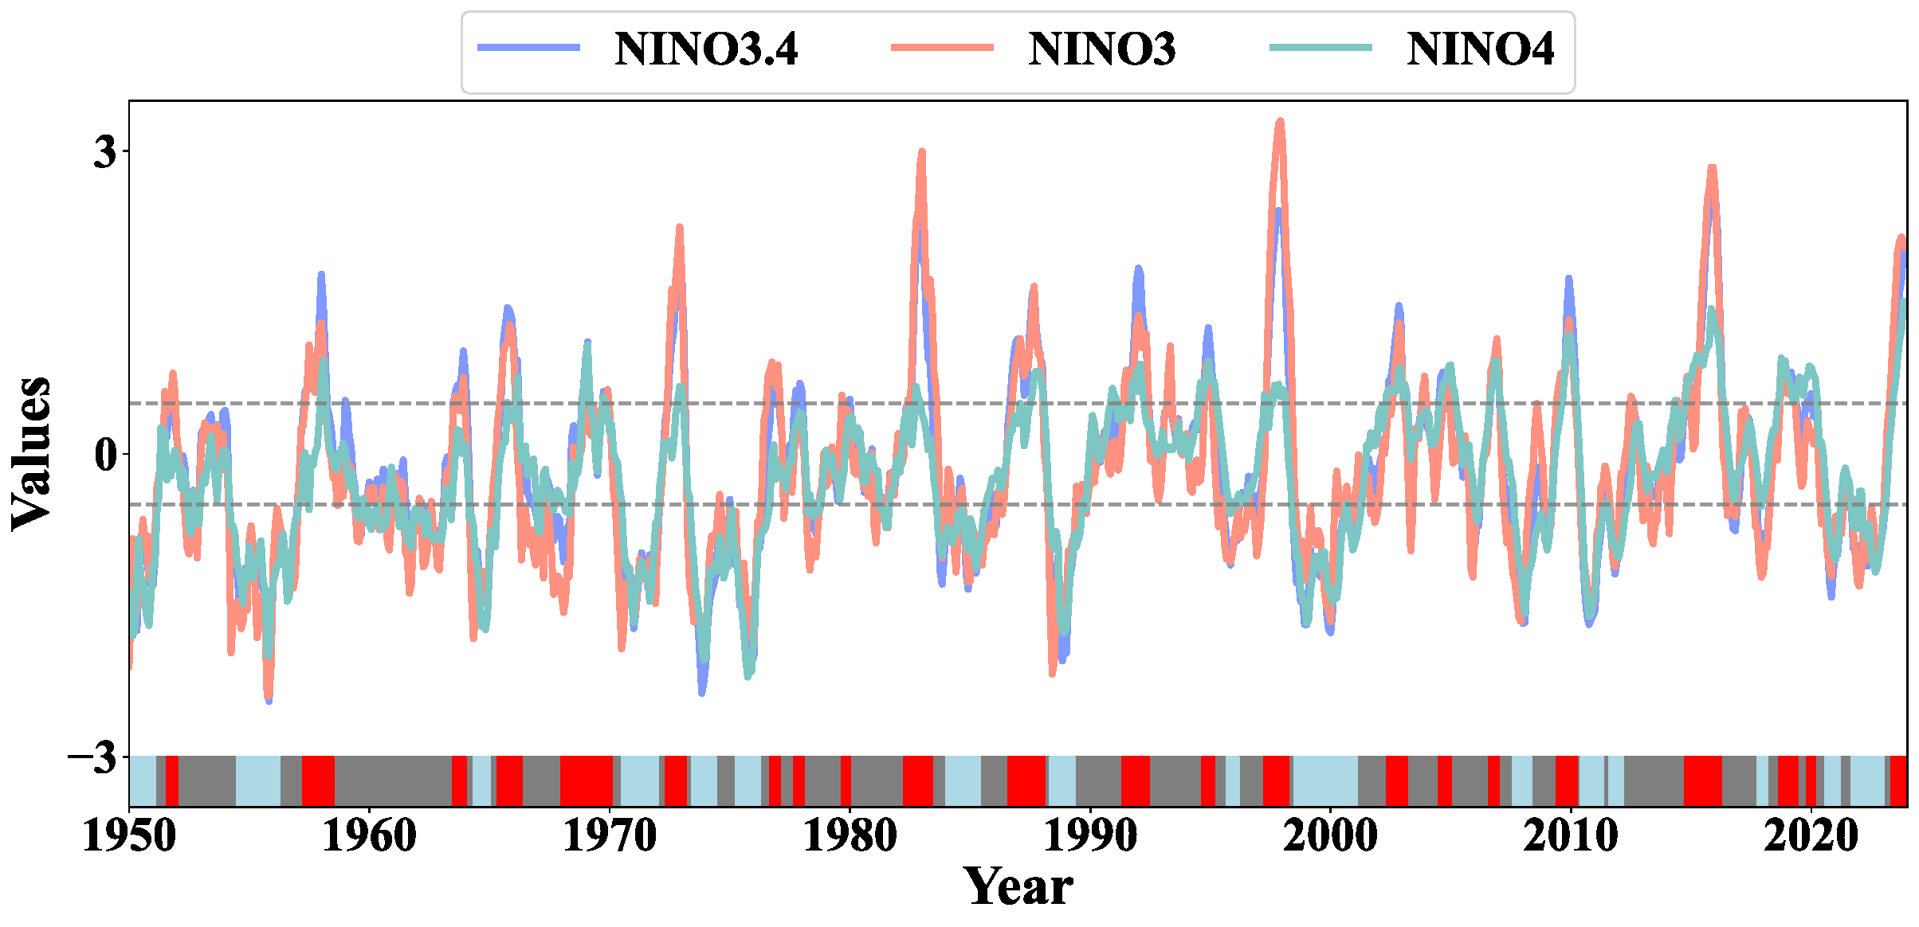

Figure S3. The ENSO variations from 1950 to 2023. The lower gray band signifies ENSO neutral conditions, red indicates the warm phase of El Niño, and light blue represents the cool phases of La Niña. The dashed line corresponds to the positive and negative values of 0.5, serving as the crucial threshold for identifying El Niño and La Niña events according to the GB/T 33666-2017.

S2.7. The characteristics of the study period
Phase I (2017-2019): The healthcare sector took the lead in dengue control and prevention efforts during this period. Prevention and control measures for dengue cases were mainly implemented in accordance with guidelines set forth by the CCDC. Epidemic investigations were conducted post active medical consultations, with reports being channeled through the CISDCP. Concurrently, the CDC undertook rounte survanliance and vector control activities. Furthermore, the healthcare sector organized health mobilization campaigns including the PHC initiative.
Phase II (2020-2022): During this period, Ningbo city's primary resources are dedicated to the prevention and control of the COVID-19 pandemic, given its classification as a Class A infectious disease. The city has implemented a series of stringent measures, including quarantine, contact tracing, mass nucleic acid testing, strict border controls, mandatory mask-wearing, and the enforcement of social distancing. The efforts to enhance the prevention and control of COVID-19 involve expanding healthcare capacity, increasing the number of healthcare workers, and boosting the availability of hospital beds. Simultaneously, there is active multi-agency collaboration involving departments such as the CDC, public security, customs, immigration management, and market supervision, working collectively on COVID-19 prevention and control. Additionally, there have been notable shifts in population behavior and an increasing awareness of infectious disease prevention and control, along with the a wide-ranging PHC. Of particular mention is the establishment and activation in 2022 of an early warning system for dengue (T+1).
Phase III (2023): One of the key features of this phase is the further enhancement of multi-agency collaboration and the deepening of PHC built upon the legacy of the zero-COVID-19 policy. There has been an expansion in collaborative departments, including the addition of departments such as Culture and Tourism. The scope of collaborative disease prevention and control has broadened to include diseases beyond COVID-19, such as dengue. PHC has intensified efforts in vector-borne disease control. Furthermore, there has been a significant improvement in dengue diagnostic capabilities, with all healthcare institutions now offering rapid dengue antigen and antibody testing services, and an enhancement in the automatic prompt reminder for epidemiological history in the healthcare diagnostic system.

S3. Incorporated variable features of linear regression model and generalized additive model (GAM)
Previous research suggests that the association between meteorological factors and dengue incidence in endemic areas is complex ^{[1, 2]}. In non-endemic regions, meteorological variables have a significant impact on mosquito populations due to the absence of indigenous dengue cases. The spread of dengue in non-endemic areas is attributed to IAICs.
Furthermore, earlier studies have indicated that temperature, humidity, wind speed, and precipitation exhibit varying degrees of correlation with mosquito populations^{[3]}. Temperature, humidity, and precipitation influence mosquito populations^{[4, 5]} [], with precipitation identified as a more reliable indicator ^{[4]}. However, these studies have not adequately clarified the relationship between meteorological factors and mosquito populations.
To achieve this goal, the most direct and simplest method that comes to mind initially is linear regression. However, considering the complex impact of meteorological factors, as discussed previously using the Generalized Additive Model (GAM) on how meteorology and vector density change the dynamics of Severe fever with thrombocytopenia syndrome (SFTS) transmission ^{[6]}, it is evident that linear regression alone may not suffice.
Therefore, we utilized a Linear regression model and a GAM with the BI as the dependent variable. It incorporated variables average temperature (T, °C), maximum temperature (Tx, °C), minimum temperature (Tn, °C), relative humidity (U, %), precipitation (RRR, mm), average wind speed (Ff, m/s), and average air pressure (P, mmHg) as independent variables. The objective was to elucidate the relationship between meteorological factors and mosquito populations in non-endemic areas.

S4. Dynamic model

S4.1. Model establish
In this study, a dynamics model based on IAICs and the natural history of dengue in Ningbo City. Within this model, the human population is segregated into distinct compartments: Imported infected individuals ($I_{i}$), susceptible individuals ($S_{p}$), exposed individuals ($E_{p}$), infectious individuals ($I_{p}$), asymptomatic individuals ($A_{p}$), and recovered/removed individuals $(R_{p})$. Meanwhile, mosquitoes population are categorized into susceptible mosquitoes ($S_{m}$), exposed mosquitoes ($E_{m}$), and infectious mosquitoes ($I_{m}$). Furthermore, the total number of indigenous human populations is composed of five compartments ($N_{p}$), while the total number of mosquitoes ($N_{m}$) is determined by combining three mosquito compartments.
The model is based on the following assumptions:
- Effective contact between imported dengue cases and indigenous mosquitoes is crucial in triggering IAICs, and the transmission rate from $I_{i}$ to $S_{m}$ denoted as $β_{i}$. while the transmission rates from $I_{m}$ to $S_{p}$ denoted as $β_{mp}$, the transmission rate from $I_{p}$ and $A_{p}$ to $S_{m}$ denoted as $β_{pm}$.
- The model incorporates the birth, death, and vertical transmission of DENV within mosquitoes ^{[7, 8]}, where the birth rate, death rate, and vertical transmission ratio of mosquitoes are denoted as $a$,$b$, and $n$, respectively. Moreover, Previous research has established the crucial influence of seasonality on the transmission of dengue and other vector-borne diseases ^{[9-11]}. To model this seasonality, we adopt a trigonometric function represented by $c$ ^{[12]}. The formula to compute $c$ is outlined below:
$$c = cos [\frac{2π (t - τ)}{T}]$$
Where $τ$ denotes the simulation delay of the initial time in the entire season, and $T$ represents the duration of the season.
- The model accounts for birth and death rates within the human population, represented as $b_{r}$ and ${ d}_{r}$ respectively. Additionally, the model assumes that among the infected human population, there exists a proportion of asymptomatic individuals, denoted as $q$. The incubation/latent period is indicated as $\frac{1}{ω_{p}}$ and $\frac{1}{ω_{m}}$ in the human and mosquito population, respectively. This suggests that the incubation period for infectious individuals and the latent period for asymptomatic individuals are assumed to be identical in this model. Furthermore, the model denotes the incubation period for infectious individuals as $γ_{I}$ and the recovery rate for both infectious and asymptomatic individuals as $γ_{A}$. In addition, the recovery rate for imported cases is denoted as $ε$. (Figure S4)
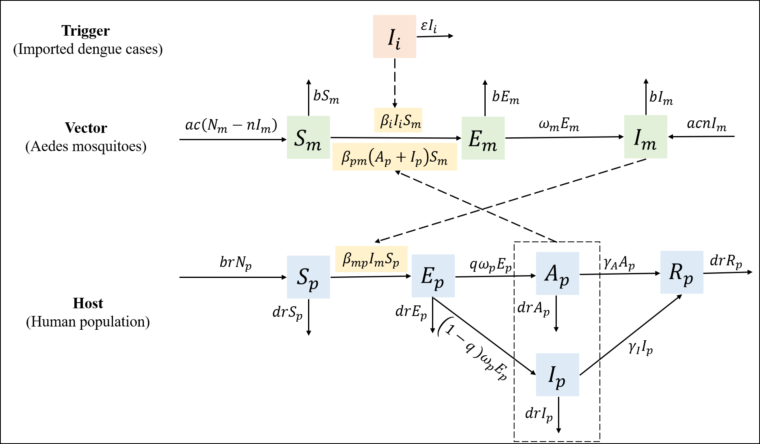

Figure S4. Flowchart of the dynamic model. The orange box symbolizes imported dengue cases, the green box represents the indigenous mosquito population, the blue box indicates the indigenous human population and the yellow box represents human-mosquito interaction or contact through bites.
The ordinary differential equation of the model is presented as follows:
$$\begin{aligned}\frac{dI_{i}}{dt}=-εI_{i}\#\left(1\right)\end{aligned} \\ \begin{aligned}\frac{dS_{m}}{dt}=ac\left(N_{m}-nI_{m}\right)-β_{i}I_{i}S_{m}-β_{pm}\left(A_{p}+I_{p}\right)S_{m}-bS_{m}\#\left(2\right)\end{aligned} \\ \begin{aligned}\frac{dE_{m}}{dt}=β_{i}I_{i}S_{m}+β_{pm}\left(A_{p}+I_{p}\right)S_{m}-ω_{m}E_{m}-bE_{m}\#\left(3\right)\end{aligned} \\ \begin{aligned}\frac{dI_{m}}{dt}=ω_{m}E_{m}+ acnI_{m}-bI_{m}\#(4)\#\end{aligned} \\ \begin{aligned}\frac{dS_{p}}{dt}=b_{r}N_{p}-β_{mp}I_{m}S_{p} -{ d}_{r}S_{p}\#\left(5\right)\end{aligned} \\ \begin{aligned}\frac{dE_{p}}{dt}=β_{mp}I_{m}S_{p}-{ ω}_{p}E_{p} {- d}_{r}E_{p}\#\left(6\right)\end{aligned} \\ \begin{aligned}\frac{dI_{p}}{dt}=(1-q{ )ω}_{p}E_{p} - γ_{I}I_{p}{- d}_{r}I_{p}\#\left(7\right)\end{aligned} \\ \begin{aligned}\frac{dA_{p}}{dt}=qω_{p}E_{p} - γ_{A}A_{p}{- d}_{r}A_{p}\#\left(8\right)\end{aligned} \\ \begin{aligned}\frac{dR_{p}}{dt}=γ_{A}A_{p}+ γ_{I}I_{p}{- d}_{r}R_{p}\#\left(9\right)\end{aligned} \\ \begin{aligned}N_{m}=S_{m}+E_{m}+I_{m}\#\left(10\right)\end{aligned} \\ \begin{aligned}N_{p}=S_{p}+E_{p}+I_{p} +A_{p} +R_{p}\#\left(11\right)\end{aligned}$$

S4.2. Parameter estimation
In this model, there are 11 variables and 17 parameters. The summary of the variables and parameters is provided in Table S2.

Table S2. Variables and parameter definitions and values of the model.
Variables /  Parameters | Description | Unit | Value | Range | Sources
$$I_{i}$$ | Imported infected individuals | Individuals | - | ≥0 | Actual data
$$S_{m}$$ | Susceptible mosquitoes | Individuals | - | ≥0 | Modeling
$$E_{m}$$ | Exposed mosquitoes | Individuals | - | ≥0 | Modeling
$$I_{m}$$ | Infectious mosquitoes | Individuals | - | ≥0 | Modeling
$$S_{p}$$ | Susceptible individuals | Individuals | - | ≥0 | Modeling
$$E_{p}$$ | Exposed individuals | Individuals | - | ≥0 | Modeling
$$I_{p}$$ | Infectious individuals | Individuals | - | ≥0 | Curve fitting / Modeling
$$A_{p}$$ | Asymptomatic individuals | Individuals | - | ≥0 | Modeling
$$R_{p}$$ | Recovered/removed individuals | Individuals | - | ≥0 | Modeling
$$N_{m}$$ | Total mosquito population size | Individuals | - | ≥0 | Actual data
$$N_{p}$$ | Total human population size | Individuals | - | ≥0 | Actual data
$$β_{i}$$ | Transmission rate from $I_{i}$ to $S_{m}$ | 1 | - | ≥0 | Curve fitting
$$β_{mp}$$ | Transmission rate from $I_{m}$ to $S_{p}$ | 1 | - | ≥0 | Curve fitting
$$β_{pm}$$ | Transmission rate  from $A_{p} and I_{p}$to $S_{m}$ | 1 | - | ≥0 | Curve fitting
$$a$$ | The birth rate of mosquitoes | Day-1 | 0.071 | 0-0.071 | ^{[13, 14]}
$$b$$ | The death rate of mosquitoes | Day-1 | 0.071 | 0-0.071 | ^{[13, 14]}
$$n$$ | Vertical transmission ratio  of the mosquitoes | 1 | 0.1 | 0.0140–0.174 | ^{[15]}
$$c$$ | Seasonality parameter  of the mosquitoes | 1 | - | 0–1 | Curve fitting
$$τ$$ | Simulation delay of the initial time in the entire season | Day | - | ≥0 | Curve fitting
𝑇 | Duration of the season | Day | - | ≥0 | Curve fitting
$$b_{r}$$ | The birth rate of  the human population | 1 | - | - | Actual data
$$d_{r}$$ | The death rate of  the human population | 1 | - | - | Actual data
$$q$$ | Proportion of human asymptomatic infection | 1 | 0.688 | 0-1 | ^{[16]}
$$ω_{m}$$ | The incubation rate of mosquitoes | Day-1 | 0.100 | 0.083 - 0.125 | ^{[13]}
$$ω_{p}$$ | The incubation rate of  the human population | Day-1 | 0.167 | 0.125 -0.250 | ^{[17]}
$$γ_{I}$$ | The recovery rate of  infectious individuals | Day-1 | 0.143 | 0.071 - 0.333 | ^{[13, 14]}
$$γ_{A}$$ | The recovery rate of asymptomatic individuals | Day-1 | 0.143 | 0.071 - 0.333 | ^{[13, 14]}
$$ε$$ | The recovery rate of  imported cases | Day-1 | - | 0.071 - 0.333 | Curve fitting

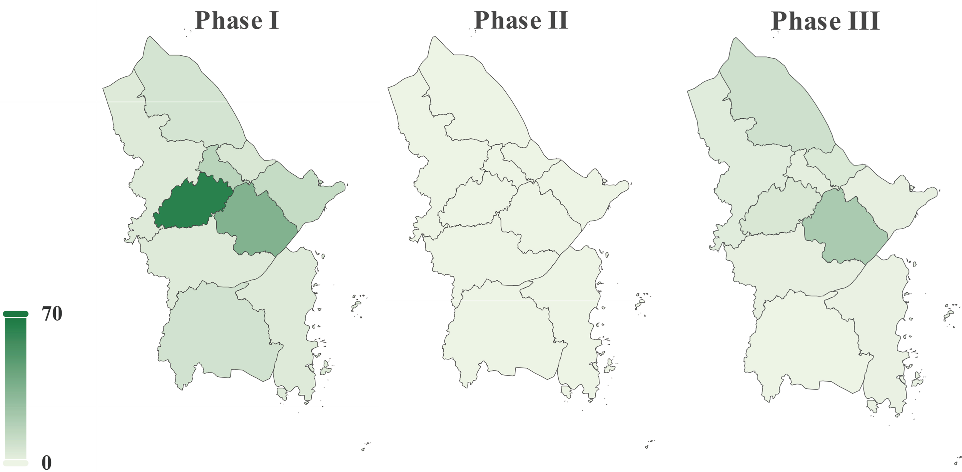

Figure S5. The spatial distribution of dengue cases across the three phases in Ningbo City.
.
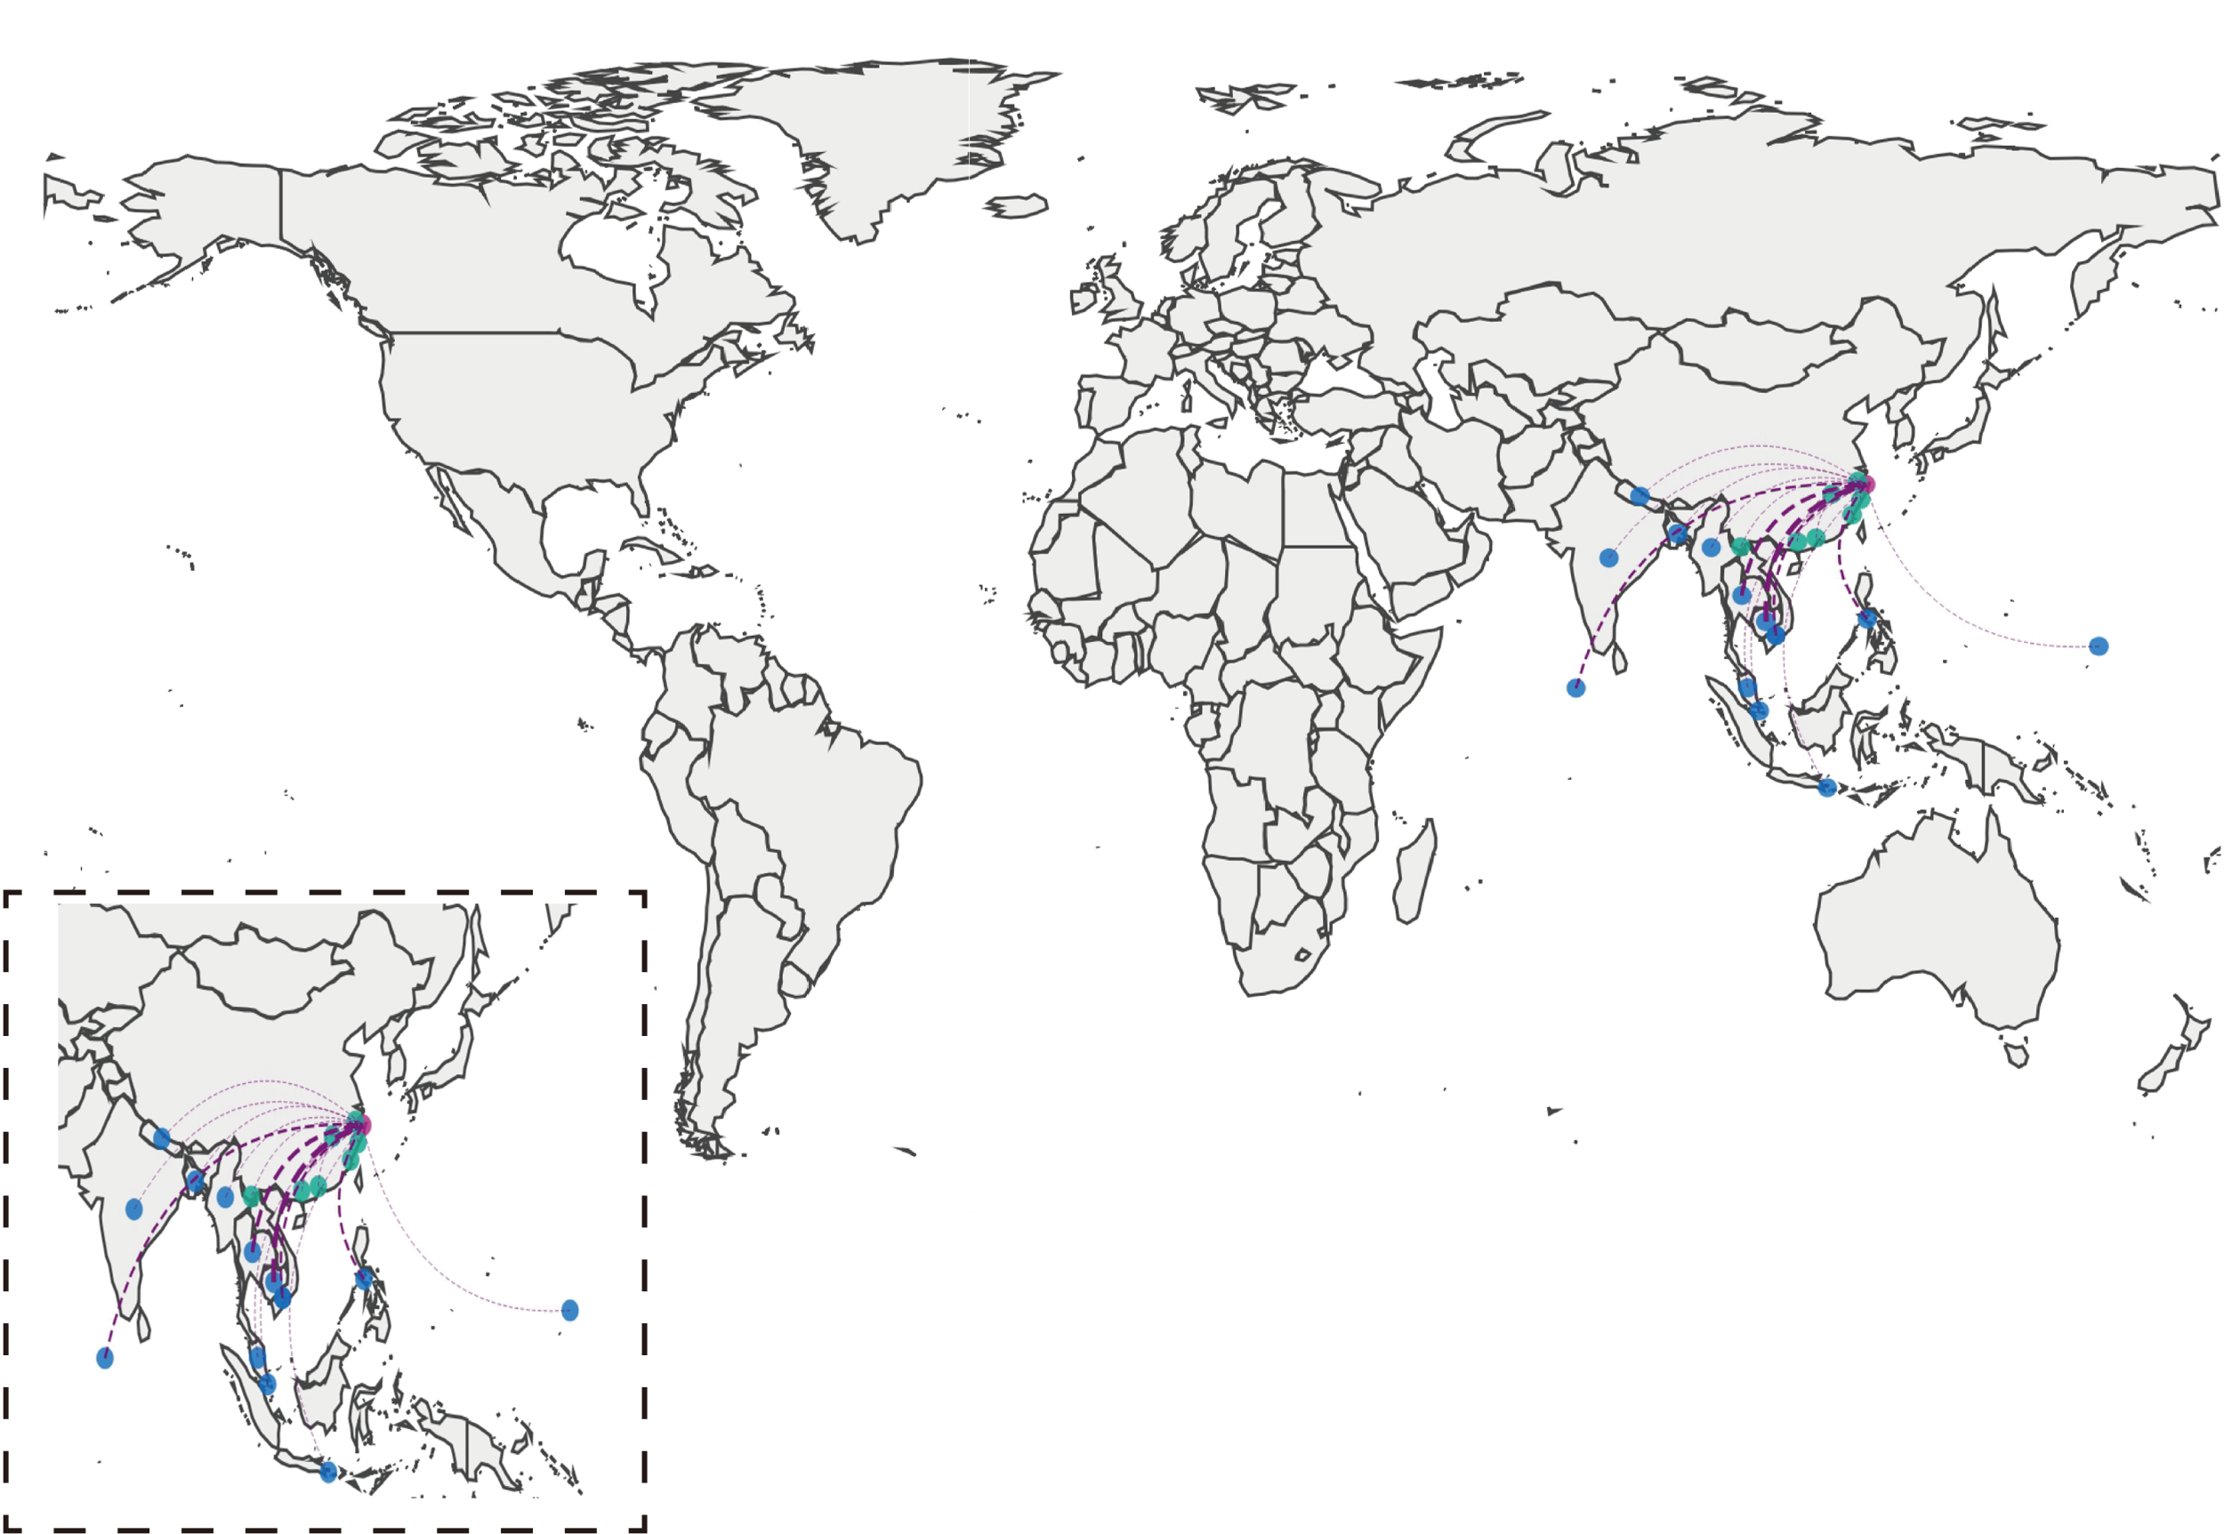

Figure S6. The Spatial Distribution of Imported Dengue Cases during Phase I in Ningbo City. The pink dot represents Ningbo City, the blue dot represents the overseas imported source, the green dot represents the domestic imported source, and the thickness of the dashed lines indicates the intensity of the imported, and the magnified map graphic is situated inside the dashed box at the bottom left corner.
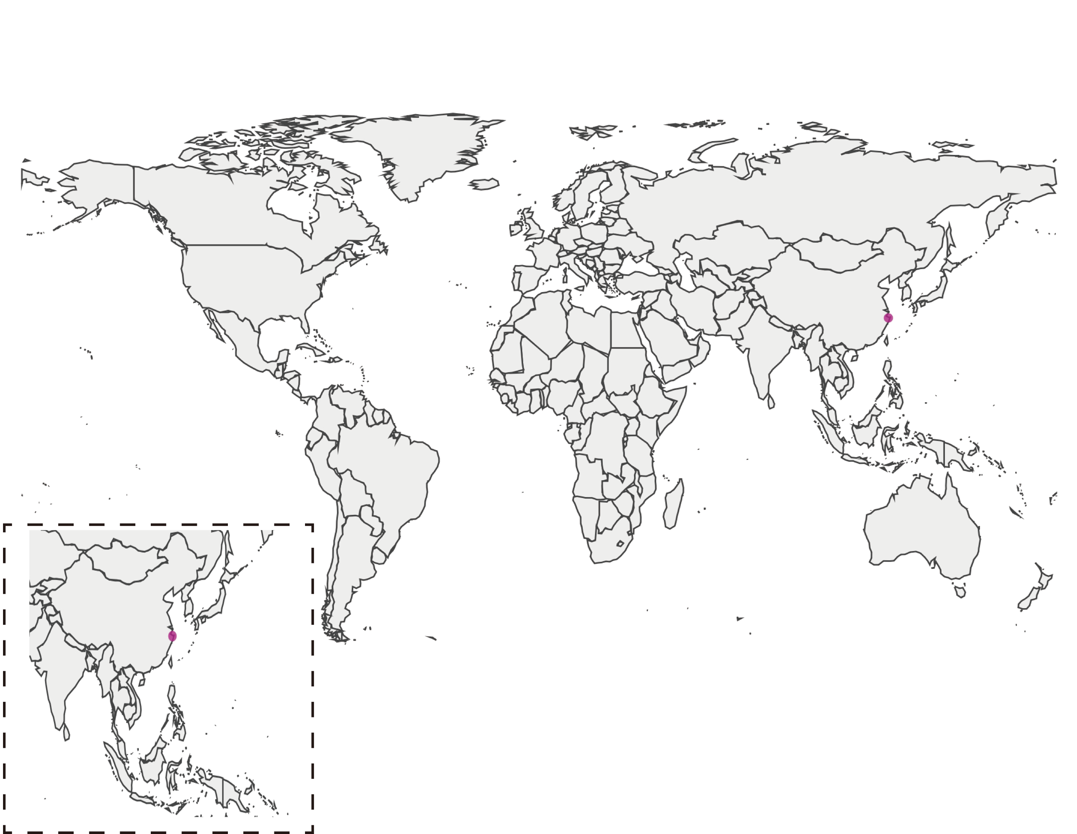

Figure S7. The Spatial Distribution of Imported Dengue Cases during Phase II in Ningbo City. The pink dot represents Ningbo City, the blue dot represents the overseas imported source, the green dot represents the domestic imported source, and the thickness of the dashed lines indicates the intensity of the imported, and the magnified map graphic is situated inside the dashed box at the bottom left corner.
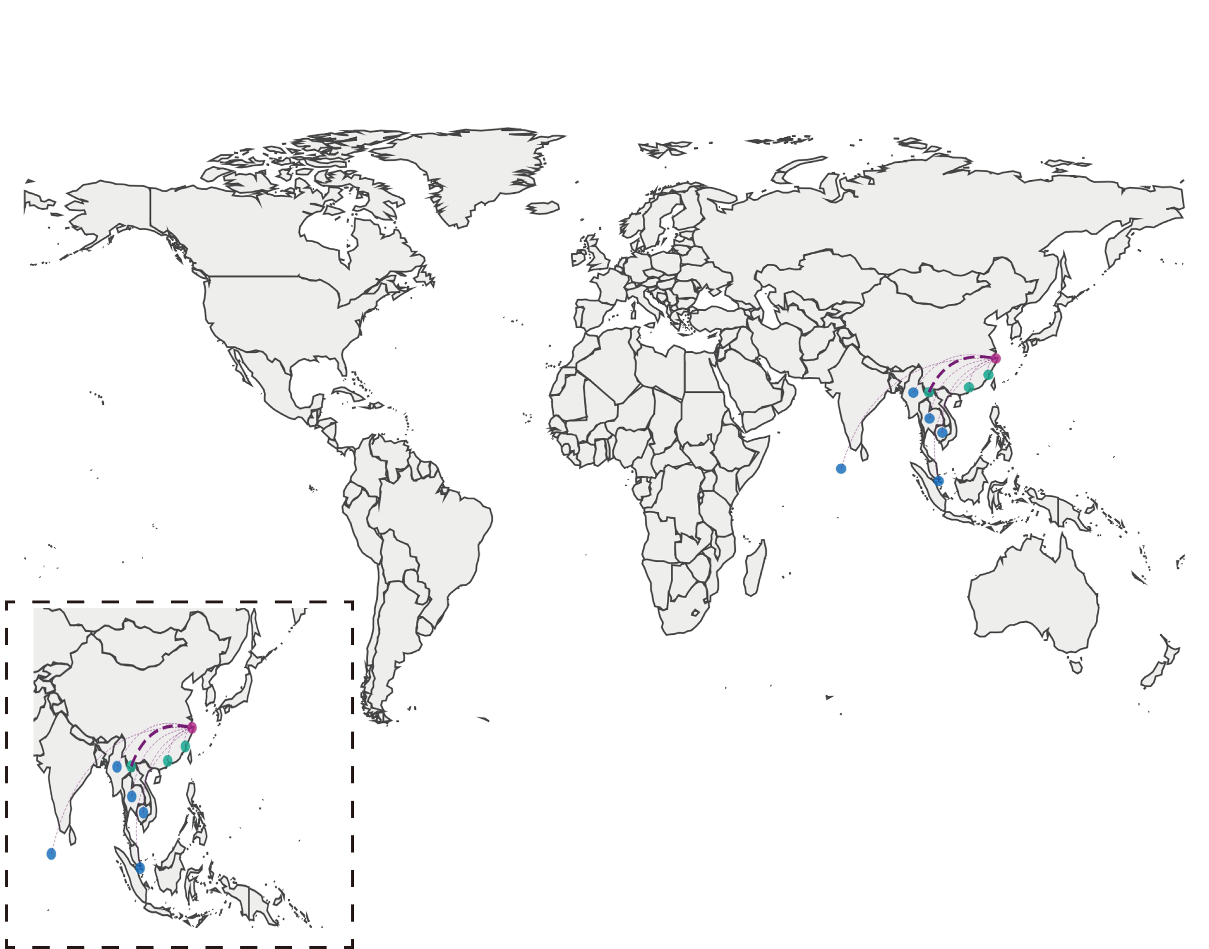

Figure S8. The Spatial Distribution of Imported Dengue Cases during Phase III in Ningbo City. The pink dot represents Ningbo City, the blue dot represents the overseas imported source, the green dot represents the domestic imported source, and the thickness of the dashed lines indicates the intensity of the imported, and the magnified map graphic is situated inside the dashed box at the bottom left corner.

Table S3. The monthly variations in selected meteorological variables in Ningbo City from 2017 to 2023.
Vari  ables | Month | Phase  I | Phase  II | Phase III | NT1 | NT2 | NT3 | VT | p | p12 | p13 | p23
T  (℃) | Jan | 7.26 (3.26) | 7.70 (3.51) | 7.27 (4.40) | 0.314 | 0.181 | 0.831 | 0.102 | 0.664 | - | - | -
T  (℃) | Feb | 7.06 (2.81) | 8.93 (3.29) | 7.26 (3.17) | 0.936 | 0.114 | 0.056 | 0.091 | 0.003* | 0.002* | 0.362 | 0.362
T  (℃) | Mar | 10.68 (4.15) | 11.8 (4.33) | 11.85 (2.84) | 0.095 | 0.005 | 0.214 | 0.862 | 0.045* | 0.042* | 0.546 | 0.546
T  (℃) | Apr | 16.18 (5.45) | 15.76 (2.93) | 16.01 (2.50) | 0.016 | 0.253 | 0.784 | 0.033 | 0.334 | - | - | -
T  (℃) | May | 20.56 (2.33) | 20.43 (2.21) | 20.28 (2.92) | 0.424 | 0.172 | 0.450 | 0.075 | 0.831 | - | - | -
T  (℃) | Jun | 22.96 (2.12) | 24.48 (2.35) | 24.45 (2.09) | 0.069 | 0.295 | 0.534 | 0.263 | <0.001* | <0.001* | 0.012* | 0.790
T  (℃) | Jul | 28.19 (1.93) | 27.73 (1.98) | 28.35 (1.07) | 0.000 | 0.122 | 0.655 | 0.026 | 0.425 | - | - | -
T  (℃) | Aug | 28.78 (1.26) | 28.83 (1.36) | 28.58 (1.38) | 0.000 | 0.126 | 0.000 | 0.817 | 0.086 | - | - | -
T  (℃) | Sep | 25.07 (2.14) | 24.83 (2.17) | 26.49 (1.43) | 0.440 | 0.516 | 0.502 | 0.033 | <0.001* | 0.508 | 0.001* | <0.001*
T  (℃) | Oct | 19.32 (3.01) | 19.20 (3.23) | 20.53 (1.80) | 0.025 | 0.000 | 0.402 | 0.016 | 0.074 | - | - | -
T  (℃) | Nov | 15.17 (2.60) | 15.71 (3.36) | 14.31 (4.50) | 0.230 | 0.347 | 0.010 | 0.039 | 0.206 | - | - | -
T  (℃) | Dec | 9.62 (3.44) | 9.14 (5.54) | 8.74 (5.21) | 0.146 | 0.007 | 0.870 | 0.009 | 0.326 | - | - | -
Tx (℃) | Jan | 10.10 (4.70) | 10.93 (4.03) | 11.67 (4.52) | 0.055 | 0.068 | 0.737 | 0.110 | 0.219 | - | - | -
Tx (℃) | Feb | 9.45 (4.80) | 12.18 (6.44) | 10.94 (3.80) | 0.097 | 0.003 | 0.026 | 0.071 | <0.001* | <0.001* | 0.979 | 0.007*
Tx (℃) | Mar | 14.60 (6.90) | 15.60 (5.91) | 16.15 (3.75) | 0.005 | 0.005 | 0.158 | 0.598 | 0.279 | - | - | -
Tx (℃) | Apr | 20.85 (4.21) | 20.27 (3.22) | 20.15 (2.75) | 0.400 | 0.803 | 0.693 | 0.020 | 0.361 | - | - | -
Tx (℃) | May | 24.86 (2.96) | 24.75 (2.88) | 24.43 (3.22) | 0.470 | 0.979 | 0.423 | 0.863 | 0.786 | - | - | -
Tx (℃) | Jun | 26.49 (2.80) | 28.00 (2.88) | 28.01 (2.59) | 0.294 | 0.618 | 0.615 | 0.907 | 0.001* | 0.053 | 0.863 | 0.287
Tx (℃) | Jul | 31.66 (3.12) | 31.46 (3.12) | 31.94 (1.89) | 0.536 | 0.804 | 0.443 | 0.033 | 0.681 | - | - | -
Tx (℃) | Aug | 32.60 (2.20) | 32.74 (2.13) | 32.10 (1.81) | 0.043 | 0.119 | 0.000 | 0.225 | 0.117 | - | - | -
Tx (℃) | Sep | 28.77 (2.76) | 29.02 (4.79) | 30.68 (1.90) | 0.543 | 0.016 | 0.000 | 0.004 | 0.012* | 0.004* | 0.256 | 0.001*
Tx (℃) | Oct | 23.00 (3.60) | 22.59 (4.42) | 25.19 (1.90) | 0.032 | 0.000 | 0.550 | 0.012 | 0.002* | 0.093 | 0.800 | 0.098
Tx (℃) | Nov | 19.70 (4.47) | 19.66 (3.35) | 19.95 (4.23) | 0.021 | 0.146 | 0.132 | 0.187 | 0.407 | - | - | -
Tx (℃) | Dec | 13.30 (3.74) | 12.25 (3.62) | 13.43 (5.81) | 0.251 | 0.348 | 0.296 | 0.001 | 0.139 | - | - | -
Tn (℃) | Jan | 4.96 (3.57) | 5.03 (3.97) | 4.03 (4.71) | 0.898 | 0.248 | 0.380 | 0.222 | 0.446 | - | - | -
Tn (℃) | Feb | 4.43 (3.24) | 5.98 (3.25) | 5.63 (2.33) | 0.805 | 0.178 | 0.586 | 0.164 | 0.005* | 0.040* | 0.003* | 0.040*
Tn (℃) | Mar | 8.11 (2.99) | 9.36 (2.99) | 8.54 (2.97) | 0.809 | 0.447 | 0.406 | 0.937 | 0.017* | 0.030* | 0.497 | 0.230
Tn (℃) | Apr | 12.91 (3.92) | 12.14 (3.44) | 12.90 (3.03) | 0.311 | 0.143 | 0.928 | 0.270 | 0.316 | - | - | -
Tn (℃) | May | 17.70 (5.00) | 17.55 (3.21) | 16.91 (3.74) | 0.081 | 0.051 | 0.487 | 0.009 | 0.789 | - | - | -
Tn (℃) | Jun | 20.68 (2.31) | 22.35 (3.66) | 21.62 (3.30) | 0.774 | 0.024 | 0.031 | 0.427 | <0.001* | <0.001* | 0.086 | 0.086
Tn (℃) | Jul | 25.70 (1.40) | 25.78 (1.77) | 25.93 (0.95) | 0.000 | 0.000 | 0.170 | 0.152 | 0.078 | - | - | -
Tn (℃) | Aug | 26.10 (2.00) | 26.31 (1.35) | 25.81 (1.57) | 0.000 | 0.014 | 0.006 | 0.188 | 0.126 | - | - | -
Tn (℃) | Sep | 22.52 (2.20) | 22.11 (2.26) | 23.89 (1.26) | 0.231 | 0.283 | 0.701 | 0.009 | <0.001* | 0.031* | 0.007* | 0.258
Tn (℃) | Oct | 17.50 (4.20) | 16.62 (4.00) | 17.40 (2.39) | 0.000 | 0.001 | 0.284 | 0.216 | 0.804 | - | - | -
Tn (℃) | Nov | 12.65 (2.79) | 13.08 (3.65) | 10.42 (6.30) | 0.801 | 0.646 | 0.036 | 0.112 | 0.101 | - | - | -
Tn (℃) | Dec | 7.07 (3.84) | 5.79 (3.56) | 5.50 (4.86) | 0.265 | 0.335 | 0.622 | 0.202 | 0.039* | 0.001* | 0.250 | 0.371
U  (%) | Jan | 81.25 (17.0) | 74.62 (19.75) | 68.98 (15.45) | 0.006 | 0.027 | 0.305 | 0.464 | 0.001* | 0.095 | 0.430 | 0.095
U  (%) | Feb | 81.62 (19.53) | 75.63 (12.28) | 77.36 (11.08) | 0.001 | 0.221 | 0.407 | 0.142 | 0.294 | - | - | -
U  (%) | Mar | 82.00 (17.5) | 79.50 (15.00) | 76.63 (9.93) | 0.006 | 0.008 | 0.777 | 0.270 | 0.177 | - | - | -
U  (%) | Apr | 81.62 (21.56) | 74.40 (11.72) | 77.73 (10.68) | 0.007 | 0.136 | 0.179 | 0.073 | 0.025* | 0.181 | 0.181 | 0.007*
U  (%) | May | 80.62 (19.50) | 82.50 (13.62) | 83.62 (18.50) | 0.001 | 0.002 | 0.012 | 0.266 | 0.537 | - | - | -
U  (%) | Jun | 89.69 (10.59) | 88.81 (9.53) | 86.62 (7.53) | 0.013 | 0.010 | 0.052 | 0.275 | 0.090 | - | - | -
U  (%) | Jul | 85.75 (8.36) | 84.95 (7.10) | 84.54 (5.60) | 0.041 | 0.196 | 0.231 | 0.227 | 0.294 | - | - | -
U  (%) | Aug | 84.47 (5.98) | 79.75 (8.88) | 81.88 (4.69) | 0.758 | 0.016 | 0.018 | 0.281 | <0.001* | 0.150 | 0.076 | 0.003*
U  (%) | Sep | 83.75 (15.09) | 79.92 (9.07) | 83.27 (5.36) | 0.042 | 0.331 | 0.763 | 0.000 | 0.063 | - | - | -
U  (%) | Oct | 78.09 (10.82) | 74.55 (10.31) | 76.10 (7.39) | 0.313 | 0.872 | 0.518 | 0.138 | 0.062 | - | - | -
U  (%) | Nov | 80.20 (11.23) | 76.25 (19.91) | 71.80 (13.12) | 0.107 | 0.038 | 0.254 | 0.533 | 0.004* | 0.004* | 0.190 | 0.863
U  (%) | Dec | 76.38 (24.12) | 69.59 (12.74) | 73.62 (27.62) | 0.002 | 0.539 | 0.061 | 0.134 | 0.002* | 0.013* | 0.770 | 0.381
RRR (mm) | Jan | 0.00 (3.00) | 0.00 (3.00) | 0.00 (3.00) | 0.000 | 0.000 | 0.000 | 0.077 | 0.915 | - | - | -
RRR (mm) | Feb | 0.00 (4.20) | 0.00  (4.20) | 0.00 (4.20) | 0.000 | 0.000 | 0.000 | 0.011 | 0.590 | - | - | -
RRR (mm) | Mar | 0.00 (5.00) | 0.00 (5.00) | 0.00 (5.00) | 0.000 | 0.000 | 0.000 | 0.000 | 0.001* | <0.001* | 0.638 | 0.090
RRR (mm) | Apr | 0.00 (1.980) | 0.00 (1.98) | 0.00 (1.98) | 0.000 | 0.000 | 0.000 | 0.047 | 0.120
RRR (mm) | May | 0.00 (2.00) | 0.00 (2.00) | 0.00 (2.00) | 0.000 | 0.000 | 0.000 | 0.000 | 0.001* | 0.001* | 0.739 | 0.107
RRR (mm) | Jun | 0.30 (5.85) | 0.30 (5.85) | 0.30 (5.85) | 0.000 | 0.000 | 0.000 | 0.003 | 0.021* | 0.021* | 0.226 | 0.680
RRR (mm) | Jul | 0.00 (0.70) | 0.00 (0.70) | 0.00 (0.70) | 0.000 | 0.000 | 0.000 | 0.007 | <0.001* | <0.001* | <0.001* | 0.694
RRR (mm) | Aug | 0.00 (4.00) | 0.00 (4.00) | 0.00 (4.00) | 0.000 | 0.000 | 0.000 | 0.208 | 0.182 | - | - | -
RRR (mm) | Sep | 0.00 (2.00) | 0.00 (2.00) | 0.00 (2.00) | 0.000 | 0.000 | 0.000 | 0.001 | 0.281 | - | - | -
RRR (mm) | Oct | 0.00 (0.40) | 0.00 (0.40) | 0.00 (0.40) | 0.000 | 0.000 | 0.000 | 0.640 | 0.502 | - | - | -
RRR (mm) | Nov | 0.00 (3.00) | 0.00 (3.00) | 0.00 (3.00) | 0.000 | 0.000 | 0.000 | 0.015 | 0.458 | - | - | -
RRR (mm) | Dec | 0.00 (5.90) | 0.00 (5.90) | 0.00 (5.90) | 0.000 | 0.000 | 0.000 | 0.932 | 0.094 | - | - | -
Ff (m/s) | Jan | 1.88 (0.88) | 1.88 (1.25) | 2.00 (0.94) | 0.000 | 0.001 | 0.003 | 0.474 | 0.903 | - | - | -
Ff (m/s) | Feb | 2.00 (0.88) | 2.00 (0.75) | 2.00 (0.91) | 0.001 | 0.000 | 0.035 | 0.732 | 0.715 | - | - | -
Ff (m/s) | Mar | 2.00 (1.00) | 2.04 (0.65) | 2.00 (0.88) | 0.023 | 0.239 | 0.052 | 0.859 | 0.295 | - | - | -
Ff (m/s) | Apr | 2.13 (0.68) | 2.00 (0.88) | 2.25 (0.72) | 0.271 | 0.001 | 0.093 | 0.693 | 0.615 | - | - | -
Ff (m/s) | May | 1.88 (1.00) | 1.75 (0.50) | 2.20 (0.76) | 0.000 | 0.001 | 0.348 | 0.014 | 0.032* | 0.001* | 0.030* | 1.000
Ff (m/s) | Jun | 1.68 (0.53) | 1.5 (0.50) | 1.74 (0.51) | 0.460 | 0.000 | 0.688 | 0.756 | 0.427 | - | - | -
Ff (m/s) | Jul | 2.00 (1.38) | 1.88 (1.12) | 1.88 (1.25) | 0.000 | 0.000 | 0.086 | 0.967 | 0.946 | - | - | -
Ff (m/s) | Aug | 2.12 (0.88) | 2.50 (1.00) | 1.88 (0.88) | 0.000 | 0.000 | 0.078 | 0.104 | 0.011* | 0.898 | 0.014* | 0.033*
Ff (m/s) | Sep | 1.88 (1.12) | 1.94 (1.12) | 1.87 (0.61) | 0.000 | 0.000 | 0.122 | 0.229 | 0.646 | - | - | -
Ff (m/s) | Oct | 1.88 (1.12) | 2.25 (1.12) | 1.50 (1.06) | 0.000 | 0.004 | 0.003 | 0.046 | 0.005* | 0.526 | 0.003* | 0.003*
Ff (m/s) | Nov | 1.62 (1.12) | 1.75 (1.00) | 1.91 (0.90) | 0.000 | 0.000 | 0.118 | 0.374 | 0.829 | - | - | -
Ff (m/s) | Dec | 2.00 (1.38) | 2.00 (1.38) | 1.50 (1.25) | 0.003 | 0.001 | 0.057 | 0.965 | 0.090 | - | - | -
P  (mm  Hg) | Jan | 769.92 (3.41) | 768.92 (2.86) | 770.22 (4.04) | 0.701 | 0.375 | 0.034 | 0.148 | 0.083 | - | - | -
P  (mm  Hg) | Feb | 768.94 (3.53) | 768.65 (5.89) | 769.38 (4.46) | 0.216 | 0.078 | 0.867 | 0.301 | 0.862 | - | - | -
P  (mm  Hg) | Mar | 765.25 (2.97) | 764.33 (3.82) | 765.73 (4.21) | 0.248 | 0.128 | 0.131 | 0.075 | 0.095 | - | - | -
P  (mm  Hg) | Apr | 761.45 (3.46) | 763.63 (3.85) | 761.30 (3.32) | 0.248 | 0.221 | 0.836 | 0.622 | <0.001* | 0.001* | 0.624 | 0.091
P  (mm  Hg) | May | 759.24 (2.91) | 758.45 (3.65) | 759.07 (3.25) | 0.503 | 0.095 | 0.552 | 0.500 | 0.135 | - | - | -
P  (mm  Hg) | Jun | 755.65 (2.60) | 754.74 (2.12) | 755.74 (3.51) | 0.551 | 0.291 | 0.079 | 0.142 | 0.048* | 0.001* | 0.739 | 0.107
P  (mm  Hg) | Jul | 754.78 (3.26) | 754.51 (3.34) | 754.98 (1.89) | 0.031 | 0.000 | 0.132 | 0.230 | 0.328 | - | - | -
P  (mm  Hg) | Aug | 754.40 (5.00) | 755.50 (2.58) | 753.55 (2.39) | 0.003 | 0.112 | 0.626 | 0.052 | <0.001* | 0.021* | 0.224 | 0.700
P  (mm  Hg) | Sep | 759.19 (3.08) | 759.08 (4.39) | 758.85 (1.67) | 0.805 | 0.000 | 0.410 | 0.018 | 0.505 | - | - | -
P  (mm  Hg) | Oct | 764.36 (3.09) | 765.95 (4.35) | 764.40 (2.13) | 0.001 | 0.002 | 0.951 | 0.442 | 0.043* | <0.001* | <0.001* | 0.694
P  (mm  Hg) | Nov | 767.10 (2.68) | 766.63 (3.32) | 767.33 (3.63) | 0.256 | 0.706 | 0.665 | 0.086 | 0.493 | - | - | -
P  (mm  Hg) | Dec | 770.06 (3.79) | 770.33 (3.42) | 769.93 (5.55) | 0.133 | 0.177 | 0.115 | 0.001 | 0.732 | - | - | -

Notes: *: p < 0.05, NT1 = The p-value of the normality test in Phase I, NT2 = The p-value of the normality test in Phase II, NT3 = The p-value of the normality test in Phase III, VT = The p-value of the homogeneity of variance test, p12 = The p-value adjusted for multiple comparisons between Phase I and Phase II, p13 = The p-value adjusted for multiple comparisons between Phase I and Phase III, p23 = The p-value adjusted for multiple comparisons between Phase II and Phase III, T = average temperature, Tx = maximum temperature, Tn = minimum temperature, U = relative humidity, RRR = precipitation, Ff = average wind speed, P = average air pressure.

S5. The relationship between BI and the selected meteorological factors
The correlation test results revealed a strong positive correlation (r > 0.98) between the average, maximum, and minimum temperatures. Conversely, air pressure exhibited a negative correlation with temperature, indicating a relatively high correlation value (r > 0.85) (Fig S9). The Variance Inflation Factors (VIF) test detected multicollinearity among temperature indicators with VIF values surpassing 10. Consequently, based on these findings, the study opted to exclude air pressure, maximum temperature, and minimum temperature variables (Tabel S4).
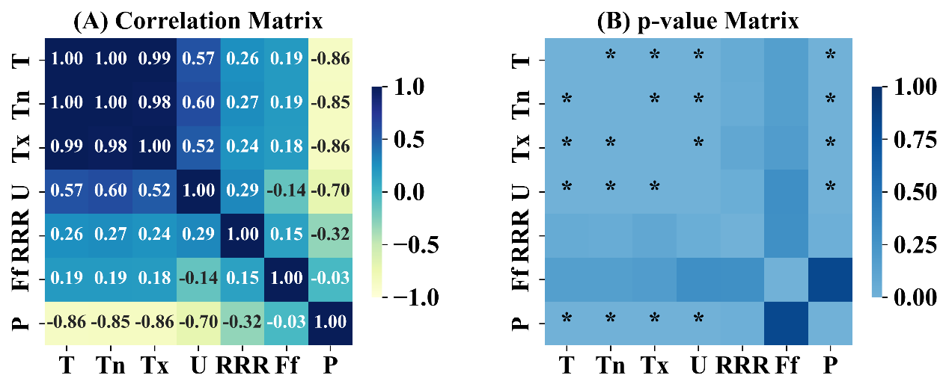

Figure S9. The correlation analysis between selected meteorological factors. The figure on the left illustrates the correlation coefficient matrix, while the figure on the right exhibits the statistical test matrix for the respective correlation coefficients with ‘*’ indicating p<0.05. T = average temperature, Tx = maximum temperature, Tn = minimum temperature, U = relative humidity, RRR = precipitation, Ff = average wind speed, P = average air pressure.

Table S4. The outcomes of the Variance Inflation Factors (VIF) test in selected meteorological variables.
Round | T | Tn | Tx | U | RRR | Ff | P
1 | 1401.42 | 516.38 | 290.33 | 4.22 | 1.19 | 1.29 | 8.12
2 | 270.86 | 254.30 | - | 4.18 | 1.19 | 1.25 | 7.89
3 | 147.58 | - | 147.58 | 3.47 | 1.18 | 1.29 | 6.08
4 | 4.38 | - | - | 2.14 | 1.16 | 1.21 | 5.49
5 | 1.67 | - | - | 1.72 | 1.14 | 1.18 | -
6 | 1.50 | - | - | 1.53 | 1.11 | - | -
7 | 1.66 | - | - | 1.64 | - | 1.15 | -
8 | 1.48 | - | - | 1.48 | - | - | -
9 | 1.07 | - | - | - | 1.07 | - | -
10 | - | - | - | 1.09 | 1.09 | - | -
Notes: T = average temperature, Tx = maximum temperature, Tn = minimum temperature, U = relative humidity, RRR = precipitation, Ff = average wind speed, P = average air pressure.

Based on the performance indicators presented in Table S5, Model 2 emerges as the optimal linear regression model, characterized by comparably lower AIC and BIC values, as well as relatively higher R-squared and Adjusted R-squared values. Furthermore, considering the performance indicators outlined in Table S6, Model 1 is identified as the GAM, distinguished by the lowest AIC and GCV values, as well as the highest R-squared values.

Table S5. The outcomes of the optimal linear regression model selection.
Models | Incorporated independent  variables | AIC | BIC | R-squared | Adjusted  R-squared
1 | T, U, RRR, Ff | 350.4 | 360.5 | 0.602 | 0.571
2 | T, U, RRR | 349.4 | 357.5 | 0.595 | 0.571
3 | T, U | 357.0 | 363.1 | 0.518 | 0.500
4 | T,RRR | 366.3 | 370.3 | 0.456 | 0.400
5 | U, RRR | 363.8 | 369.9 | 0.456 | 0.435
6 | T | 366.3 | 370.3 | 0.411 | 0.400
7 | U | 367.2 | 371.2 | 0.402 | 0.391
8 | RRR | 395.8 | 399.9 | 0.002 | -0.017
Notes: AIC = Akaike Information Criterion, BIC = Bayesian Information Criterion, T = average temperature, U = relative humidity, RRR = precipitation, Ff = average wind speed.

Table S6. The outcomes of the optimal Generalized Additive Model (GAM) selection.
Models | Incorporated independent variables | AIC | GCV | R-squared
1 | T, U, RRR, Ff | 211.6 | 0.1 | 0.999
2 | T, U, Ff | 496.5 | 34.3 | 0.551
3 | T, U, RRR | 468.2 | 27.4 | 0.676
4 | T, U | 500.8 | 35.6 | 0.547
5 | T,RRR | 488.2 | 33.3 | 0.619
6 | U, RRR | 512.4 | 40.8 | 0.512
7 | T | 511.7 | 38.8 | 0.483
8 | U | 524.3 | 39.8 | 0.407
9 | RRR | 580.5 | 71.8 | 0.004
10 | Ff | 580.1 | 71.4 | 0.017
Notes: AIC = Akaike Information Criterion, GCV = Generalized Cross-Validation, T = average temperature, U = relative humidity, RRR = precipitation, Ff = average wind speed.

Table S7. The curve fitting results of the Breteau Index (BI).
BI | AIC | BIC | R-squared | RMSE | MAE | MSE | 𝑇 | $$τ$$
ARIMA fit | - | - | 0.912 | 2.255 | 1.276 | 5.085 | - | -
Adjust BI | - | - | 0.965 | 1.422 | 0.793 | 2.021 | - | -
TF fit | - | - | 0.956 | 1.676 | 1.256 | 2.810 | - | -
TF fit  2017 | 18.6 | 18.8 | 0.887 | 2.199 | 1.969 | 4.837 | 19.46 | 7.60
TF fit  2018 | 14.0 | 14.3 | 0.947 | 1.653 | 1.278 | 2.731 | 19.89 | 7.02
TF fit  2019 | 13.6 | 13.8 | 0.966 | 1.609 | 1.081 | 2.588 | 17.39 | 7.44
TF fit  2020 | 13.7 | 13.9 | 0.934 | 1.616 | 1.222 | 2.611 | 17.58 | 7.22
TF fit  2021 | 13.3 | 13.5 | 0.890 | 1.577 | 1.266 | 2.486 | 18.45 | 7.36
TF fit  2022 | 16.9 | 17.1 | 0.775 | 1.977 | 1.364 | 3.910 | 18.86 | 7.06
TF fit  2023 | 0.6 | 0.8 | 0.973 | 0.712 | 0.612 | 0.506 | 17.09 | 7.43
TF fit for prediction | - | - | 0.952 | 1.841 | 1.356 | 3.388 | - | -
TF fit for  Prediction  2020 | 14.5 | 14.7 | 0.959 | 1.701 | 1.260 | 2.928 | 18.01 | 7.35
TF fit for  Prediction  2021 | 19.6 | 19.8 | 0.908 | 2.341 | 1.998 | 5.480 | 19.31 | 7.18
TF fit for  Prediction  2022 | 13.6 | 13.9 | 0.966 | 1.609 | 1.082 | 2.590 | 17.53 | 7.41
TF fit for  Prediction  2023 | 13.6 | 13.9 | 0.966 | 1.609 | 1.082 | 2.590 | 17.53 | 7.41
Notes: BI = Breteau Index, AIC = Akaike Information Criterion, BIC = Bayesian Information Criterion, RMSE = Root Mean Squared Error, MAE = Mean Absolute Error, MSE = Mean Squared Error.

Table S8. The curve fitting results of the dynamic model.
Year | AIC | BIC | R-squared | RMSE | MAE | MSE | $$ε$$ | $$β_{i}$$ | $$β_{mp}$$ | $$β_{pm}$$
Overall | - | - | 0.904 | 3.881 | 1.314 | 15.064 | - | - | -
2017 | -543.5 | -541.6 | 1.000 | 0.000 | 0.000 | 0.000 | 0.333 | 0.000 | 0.000 | 0.000
2018 | 62.9 | 64.9 | 0.849 | 9.865 | 7.078 | 97.321 | 0.333 | 0.000 | 0.000 | 0.000
2019 | 33.1 | 35.1 | 0.888 | 2.851 | 2.123 | 8.129 | 0.333 | 0.014 | 0.000 | 0.000
2020 | -6899.8 | -6897.8 | 1.000 | 0.000 | 0.000 | 0.000 | 0.143 | 0.000 | 0.000 | 0.000
2021 | -6899.8 | -6897.8 | 1.000 | 0.000 | 0.000 | 0.000 | 0.143 | 0.000 | 0.000 | 0.000
2022 | -6899.8 | -6897.8 | 1.000 | 0.000 | 0.000 | 0.000 | 0.143 | 0.000 | 0.000 | 0.000
2023 | -568.9 | -566.9 | 1.000 | 0.000 | 0.000 | 0.000 | 0.333 | 0.000 | 0.000 | 9.811
Notes: AIC = Akaike Information Criterion, BIC = Bayesian Information Criterion, RMSE = Root Mean Squared Error, MAE = Mean Absolute Error, MSE = Mean Squared Error.

S6. The escalating climate crisis in Ningbo City from 2017 to 2023.
During the study period, the most notable phenomenon was the escalating typhoon activity exacerbated by the El Niño phenomenon. In Phase I, the frequency of typhoon impacts on cities increased. However, cities were fortunate not to experience direct hits and most landfalls occurred along the southeast coast of mainland China, resulting in no significant loss of lives or economic damage to the cities. In Phases II and III, multiple typhoons made landfall in Zhejiang Province, leading to severe losses in terms of both lives and economic impact (Refer to Table S9 and Figure S10).
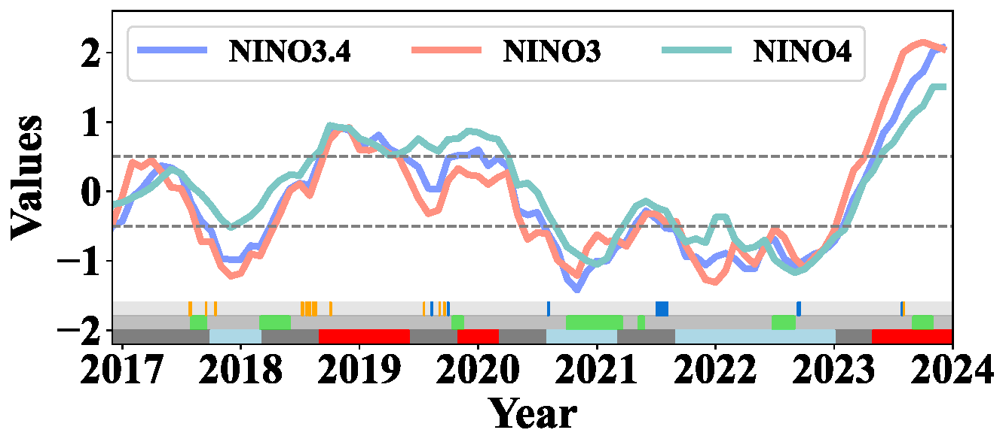

Figure S10. The ENSO variations from 2017 to 2023. The lower gray band signifies ENSO neutral conditions, red indicates the warm phase of El Niño, and light blue represents the cool phases of La Niña. The lower light gray band signifies the absence of drought impact, while green indicates drought occurrence. The upper light gray band represents the absence of typhoon impact, organge indicates a typhoon occurrence without any loss of life or economic damage, while the dark blue color demonstrates a typhoon event leading to loss of life and economic damage. The dashed line corresponds to the positive and negative values of 0.5, serving as the crucial threshold for identifying El Niño and La Niña events according to the GB/T 33666-2017.

Table S9. The typhoon activity in Ningbo City between 2017 and 2023.
Name | ID  * | Type  ** | D  *** | Affected time | Landfall  in China | Source
Nesat | 1709 | Typhoon | N | 2017/7/26  -7/30 | Yilan, Taiwan;  Fuqing, Fujian. | Philippines
Haitang | 1710 | Tropical Storm | N | 2017/7/31  -8/1 | Pingtung, Taiwan;  Fuqing, Fujian. | Central South China Sea,
Talim | 1718 | Super Typhoon | N | 2017/9/15  -9/16 | - | Northwest Pacific Ocean
Khanun | 1720 | Severe Typhoon | N | 2017/10/14  -10/16 | Guangdong. | Philippines
Maria | 1808 | Super Typhoon | N | 2018/7/8  -7/11 | Yilan, Taiwan;  Yellow Island Peninsula, Fujian. | Guam East Ocean
Ampil | 1810 | Severe Tropical Storm | N | 2018/7/22  -7/24 | Chongming Island, Shanghai. | Northwest Pacific
Jongdari | 1812 | Severe Typhoon | N | 2018/7/30  -8/3 | Jinshan District, Shanghai. | Northwest Pacific
Yagi | 1814 | Tropical Storm | N | 2018/8/11  -8/13 | Wenling, Zhejiang. | South-southeast of Hualien, Taiwan
Rumbia | 1818 | Severe Tropical Storm | N | 2018/8/17  -8/21 | Pudong New Area, Shanghai. | East China Sea
Kong-rey | 1825 | Super Typhoon | N | 2018/10/4  -10/5 | - | Northwest Pacific Ocean
Danas | 1905 | Tropical Storm | N | 2019/7/19 | - | Southeast of Guam
Lekima | 1909 | Super Typhoon | Y | 2019/8/10  -8/13 | Wenling, Zhejiang;  Qingdao, Shandong. | East of Luzon Island, Philippines
Lingling | 1913 | Super Typhoon | N | 2019/9/4  -9/5 | - | New Guinea Island
Tapah | 1917 | Typhoon | N | 2019/9/19  -9/20 | - | Southeast of Guam in the ocean
Mitag | 1918 | Typhoon | Y | 2019/9/30  -10/2 | Zhoushan, Zhejiang. | Northwest Pacific to the southeast of Guam
Hagupit | 2004 | Typhoon | Y | 2020/8/3 -8/6 | Leqing, Zhejiang. | East of Luzon Island
In-Fa | 2106 | Severe Typhoon | Y | 2021/7/3 -8/6 | Zhoushan, Zhejiang;  Pinghu, Zhejiang. | The eastern part of Luzon Island, Philippines
Muifa | 2212 | Severe Typhoon | Y | 2022/9/11  -9/17 | Zhoushan, Zhejiang;  Fengxian, Shanghai;  Qingdao, Shandong;  Dalian, Liaoning. | Northwest Pacific
Doksuri | 2305 | Super Typhoon | Y | 2023/7/28  -8/1 | Jinjiang, Fujian. | Northwest Pacific
Khanun | 2306 | Super Typhoon | N | 2023/8/2  -8/3 | Zhuanghe, Liaoning. | Southwest of Guam
Notes: *: The typhoon names and their corresponding identification numbers are obtained from the Typhoon Committee of the Economic and Social Commission for Asia and the Pacific (ESCAP/WMO). **: The categorization of tropical cyclone intensity follows the guidelines set forth by ESCAP/WMO (2022), available at http://www.nmc.cn/publish/typhoon/typhoon-name/index.html. ***: Whether the impact of the typhoon on Ningbo City includes the loss of life and economic damage.

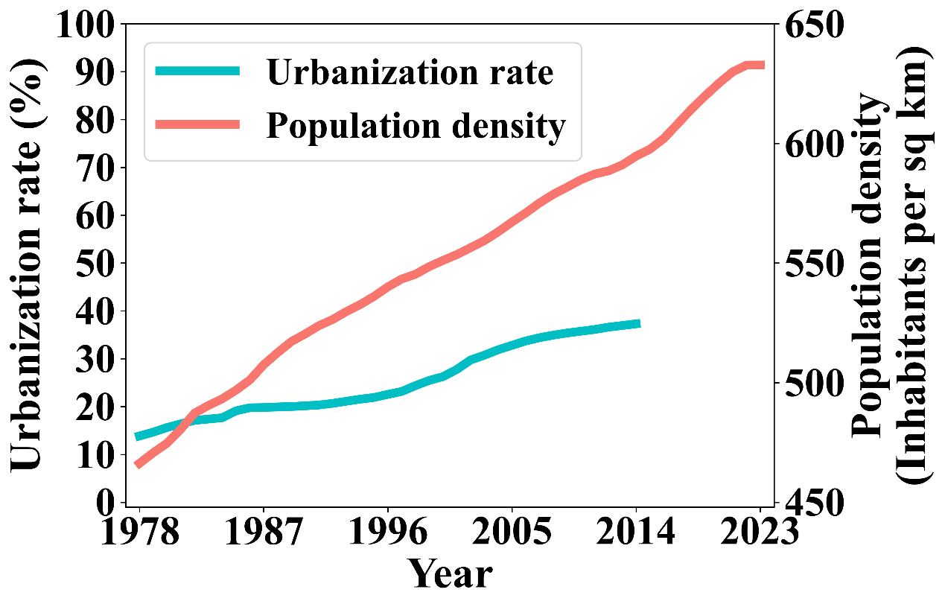

Figure S11. The changes in annual population density and urbanization rate in Ningbo City from 1978 to 2023.
Inhabitants per sq km = The number of inhabitants per square kilometer.

S7. The root prevention, underlying prevention, and proximal prevention of dengue
The study proposes root prevention, underlying prevention, and proximal prevention of dengue, as well as specific intervention measures, based on the public health practice of combating dengue in Ningbo City and the theoretical framework outlined in the textbook "Global Health 101" ^{[18]}(refer to Figure S12).
To achieve Root Prevention, three strategies can be employed: preserving the natural environment, tackling macro-level issues, and mitigating health inequalities. Preservation of the natural environment involves actions such as restoring and conserving natural habitats to enhance resilience to extreme weather events and changing climate patterns, developing early warning systems for forecasting ENSO events and their impacts, and fostering community resilience through education, capacity building, and infrastructure development to reduce vulnerability to ENSO-related risks. This can be facilitated by promoting the use of renewable energy sources like solar, wind, and hydroelectric power to decrease reliance on fossil fuels, as well as tree planting and forest restoration to absorb carbon dioxide from the atmosphere. In tackling macro-level issues, efforts can focus on enhancing government governance and capacity for mass mobilization, continually refining health policies, and promptly strengthening the resilience of public health systems. Regarding the mitigation of health inequalities, an essential first step involves conducting surveys to grasp the variability in dengue prevalence and evaluate the disease's transmission risks. Building upon this groundwork, the emphasis in high-risk regions should be on enhancing the accessibility and affordability of healthcare services, along with improving the surveillance and prevention of dengue cases and Aedes mosquitoes.
For Underlying Prevention, goals can be achieved by enhancing the built and social environments. Enhancing the built environment includes urban planning and construction measures to reduce mosquito breeding sites in densely populated areas and enhance urban hygiene through extensive health education and community engagement. Improvements to the social environment can be achieved through broad community mobilization initiatives like PHC, advancements in WASH, and systematic eradication of mosquito-friendly environments to decrease breeding sites. Additionally, strengthening multisectoral collaboration, surveillance population mobility dynamics, and promptly assessing dengue importation risks are crucial components.
For Proximal Prevention, three strategies can be employed: Addressing material conditions, Modifying behaviors, and Providing psychological support. Addressing material conditions involves initiatives to enhance living conditions, eliminate mosquito breeding sites, and promote personal protection measures such as installing mosquito screens in hospital wards, using mosquito nets, and installing screens at home. The use of mosquito coils, aerosols, and household insecticides can also aid in mosquito control. Modifying behaviors include promoting awareness through ongoing health education and PHC to reduce exposure to mosquito bites and address stagnant water sources promptly. Providing psychological support entails tailored health education for diverse groups, including training HCWs in dengue diagnosis and treatment. Schools can be targeted for dengue prevention and control education to eliminate discrimination and misconceptions related to the disease.
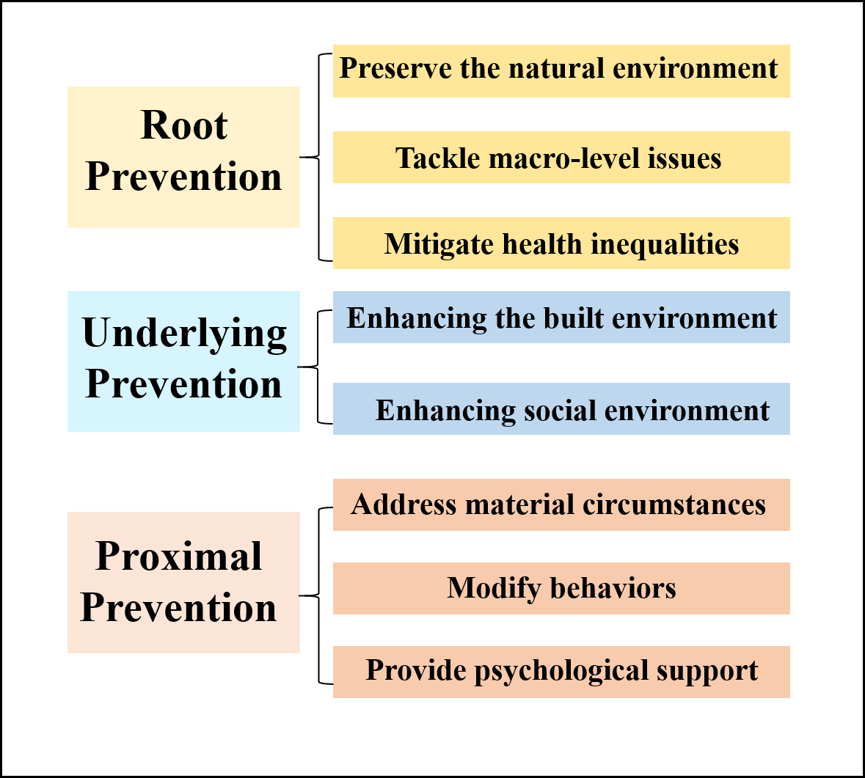

Figure S12. Flow chart of the root prevention, underlying prevention, and proximal prevention of dengue.

References
1. Liu K, Hou X, Wang Y, Sun J, Xiao J, Li R, Lu L, Xu L, Sang S, Hu J, Wu H, Song X, Zhao N, Yan D, Li J, Liu X, Liu Q. The driver of dengue fever incidence in two high-risk areas of China: A comparative study. Scientific Reports 2019, 9(1): 19510.
2. Colón-González FJ, Fezzi C, Lake IR, Hunter PR. The effects of weather and climate change on dengue. PLoS Negl Trop Dis 2013, 7(11): e2503.
3. Asgarian TS, Moosa-Kazemi SH, Sedaghat MM. Impact of meteorological parameters on mosquito population abundance and distribution in a former malaria endemic area, central Iran. Heliyon 2021, 7(12): e08477.
4. Liu Y, Wang X, Tang S, Cheke RA. The relative importance of key meteorological factors affecting numbers of mosquito vectors of dengue fever. PLoS Negl Trop Dis 2023, 17(4): e0011247.
5. Baril C, Pilling BG, Mikkelsen MJ, Sparrow JM, Duncan CAM, Koloski CW, LaZerte SE, Cassone BJ. The influence of weather on the population dynamics of common mosquito vector species in the Canadian Prairies. Parasites & Vectors 2023, 16(1): 153.
6. Deng B, Rui J, Liang SY, Li ZF, Li K, Lin S, Luo L, Xu J, Liu W, Huang J, Wei H, Yang T, Liu C, Li Z, Li P, Zhao Z, Wang Y, Yang M, Zhu Y, Liu X, Zhang N, Cheng XQ, Wang XC, Hu JL, Chen T. Meteorological factors and tick density affect the dynamics of SFTS in jiangsu province, China. PLoS Negl Trop Dis 2022, 16(5): e0010432.
7. Ferreira-de-Lima VH, Lima-Camara TN. Natural vertical transmission of dengue virus in Aedes aegypti and Aedes albopictus: a systematic review. Parasit Vectors 2018, 11(1): 77.
8. Goncalves DDS, Hue KDT, Thuy VT, Tuyet NV, Thi GN, Thi Thuy VH, Xuan THT, Thi DL, Vo LT, Le Anh Huy H, Van Thuy NT, Wills BA, Thanh PN, Simmons CP, Carrington LB. Assessing the vertical transmission potential of dengue virus in field-reared Aedes aegypti using patient-derived blood meals in Ho Chi Minh City, Vietnam. Parasit Vectors 2020, 13(1): 468.
9. Huber JH, Childs ML, Caldwell JM, Mordecai EA. Seasonal temperature variation influences climate suitability for dengue, chikungunya, and Zika transmission. PLoS Negl Trop Dis 2018, 12(5): e0006451.
10. Ewing DA, Purse BV, Cobbold CA, Schäfer SM, White SM. Uncovering mechanisms behind mosquito seasonality by integrating mathematical models and daily empirical population data: Culex pipiens in the UK. Parasit Vectors 2019, 12(1): 74.
11. Altizer S, Dobson A, Hosseini P, Hudson P, Pascual M, Rohani P. Seasonality and the dynamics of infectious diseases. Ecol Lett 2006, 9(4): 467-484.
12. Yi B, Chen Y, Ma X, Rui J, Cui JA, Wang H, Li J, Chan SF, Wang R, Ding K, Xie L, Zhang D, Jiao S, Lao X, Chiang YC, Su Y, Zhao B, Xu G, Chen T. Incidence dynamics and investigation of key interventions in a dengue outbreak in Ningbo City, China. PLoS Negl Trop Dis 2019, 13(8): e0007659.
13. Andraud M, Hens N, Marais C, Beutels P. Dynamic epidemiological models for dengue transmission: a systematic review of structural approaches. PLoS One 2012, 7(11): e49085.
14. Tang B, Xiao Y, Tang S, Wu J. Modelling weekly vector control against Dengue in the Guangdong Province of China. J Theor Biol 2016, 410: 65-76.
15. Bosio CF, Thomas RE, Grimstad PR, Rai KS. Variation in the efficiency of vertical transmission of dengue-1 virus by strains of Aedes albopictus (Diptera: Culicidae). J Med Entomol 1992, 29(6): 985-989.
16. Wang T, Wang M, Shu B, Chen XQ, Luo L, Wang JY, Cen YZ, Anderson BD, Merrill MM, Merrill HR, Lu JH. Evaluation of inapparent dengue infections during an outbreak in Southern China. PLoS Negl Trop Dis 2015, 9(3): e0003677.
17. Cheng Q, Jing Q, Spear RC, Marshall JM, Yang Z, Gong P. Climate and the Timing of Imported Cases as Determinants of the Dengue Outbreak in Guangzhou, 2014: Evidence from a Mathematical Model. PLoS Negl Trop Dis 2016, 10(2): e0004417.
18. SKOLNIK R. GLOBAL HEALTH 101, FOURTH EDITION, vol. 2. Jones & Bartlett Learning: Burlington, Massachusetts, 2020.

