Supplementary Figures

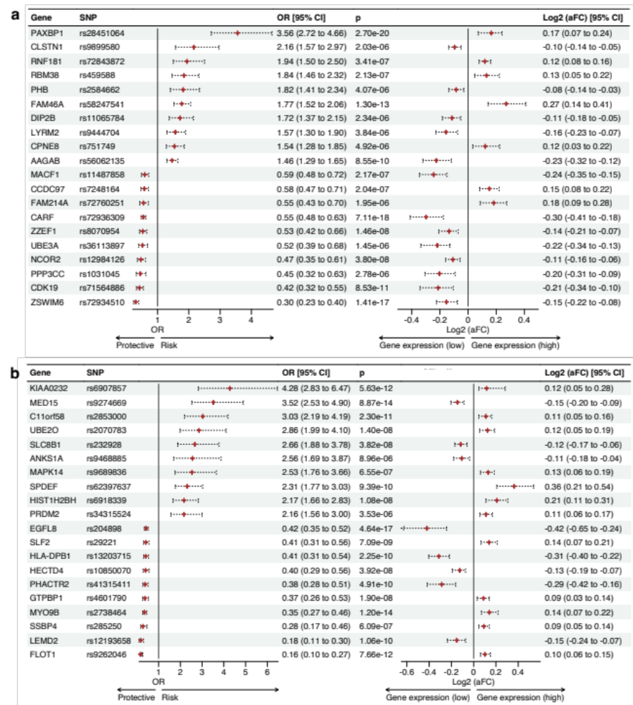

Supplementary Figure 1. Causal CAD genes from whole blood unique to East Asian and European ancestries.
The forest plot shows genes identified as having significant (p < 1 x 10⁻⁵) causal effects on CAD (from Figure 1a) that are ancestrally divergent within whole blood. The odds ratio (OR) of causal CAD genes per 1-SD change in gene expression within whole blood. The allele-specific gene expression changes (aFC) associated with the eQTLs across all tissues. 95% confidence intervals are represented by the horizontal dotted lines. Among the genes identified as being causal for CAD within whole blood, 101 genes were unique to the East Asian ancestry, and 60 were unique to the European ancestry (Figure 1b; Supplementary Table 1g). The top 10 risk genes and bottom 10 protective genes for CAD within blood tissue in Europeans (a) and East Asians (b) are shown.

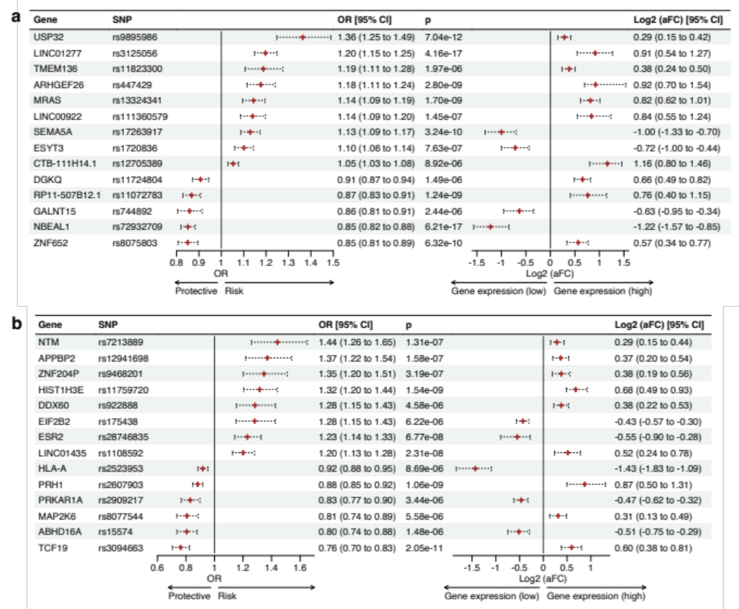
Supplementary Figure 2. Causal CAD genes from the coronary artery unique to East Asian and European ancestries.
Among the genes identified as being causal for CAD within the coronary artery, 14 (13 protein-coding, 1 non-coding) were unique to the East Asian ancestry (b), and 14 (10 protein-coding, 4 non-coding) were unique to the European ancestry (a). All 28 genes were instrumented with 28 IVs (sceQTLs) (Figure 1b; Supplementary Table 1g).

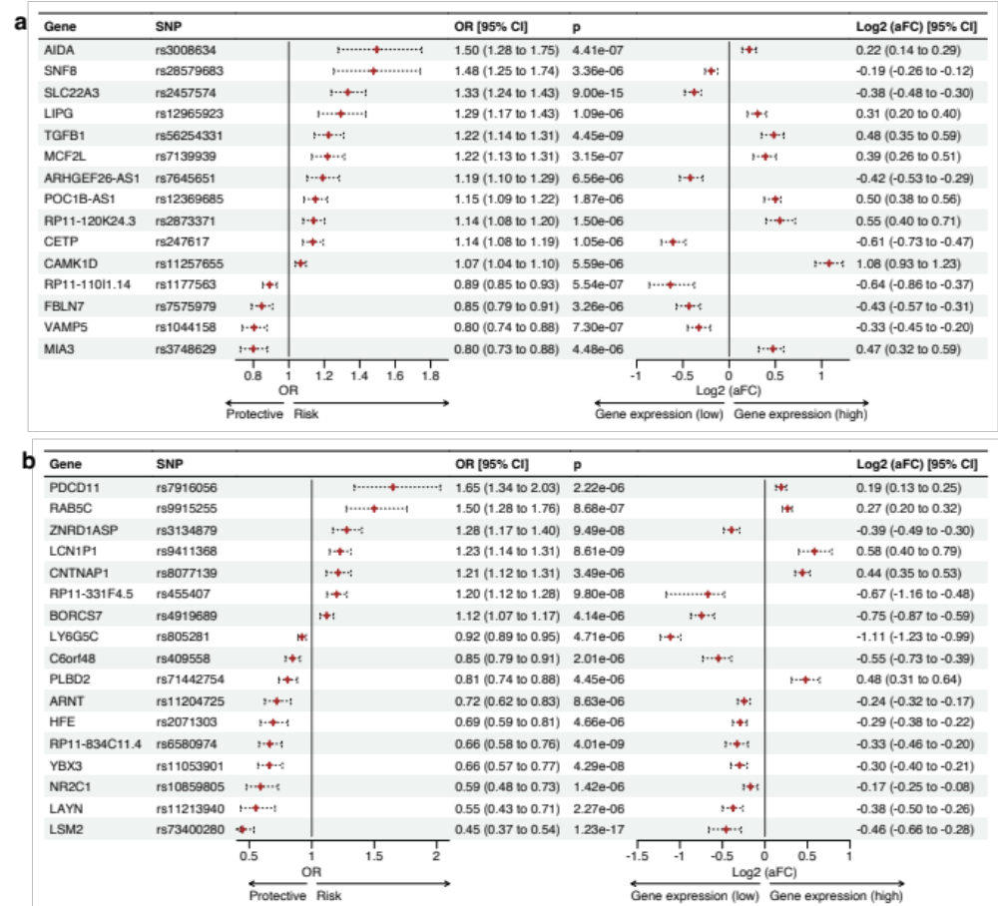

Supplementary Figure 3. Causal CAD genes from the lung unique to East Asian and European ancestries.
Among the genes identified as being causal for CAD within the coronary artery, 15 (12 protein-coding, 3 non-coding) were unique to the European ancestry (a), and 17 (14 protein-coding, 3 non-coding) were unique to the East Asian (b). All 21 genes were instrumented with 28 IVs (sceQTLs) (Figure 1b; Supplementary table 1g).

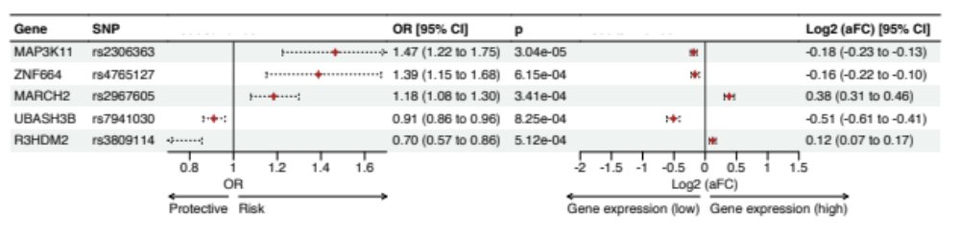
Supplementary Figure 4. HDL cholesterol genes causal for CAD via whole blood gene regulatory and protein interaction networks.
We identified an association between HDL cholesterol and CAD at level 2 of our previously described gene regulatory and protein interaction computational pipeline (Figure 1; methods). MR on the SNPs and genes associated with HDL cholesterol within whole blood was conducted. 5 genes instrumented by a single IV were found to be significant (p < 0.001).
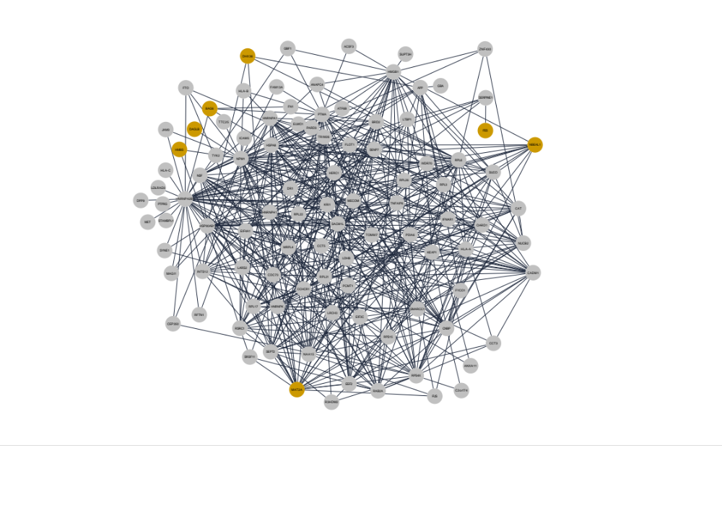
Supplementary Figure 5. Highly connected coronary artery SARS-CoV-2 / CAD protein interaction network.
The protein interaction network contains 7 causal CAD genes (yellow nodes) from the coronary artery MR analysis (Figure 2b; Supplementary table 8). This network is driven by 62 genes (Level 0) associated with both SARS-CoV-2 phenotypes, severe and hospitalised (Supplementary table 8). The protein interactions within this network have been experimentally validated in three cell types, endothelial cells, human embryonic kidney and T lymphocytes obtained from the PROPER-Seq tool⁴⁶.

