Unveiling Water Adsorption Dynamics on N and Br-Modified Anatase TiO₂ (101) Surfaces: A DFT Study
Asad Mahmood*
Shanghai Institute of Ceramics, Chinese Academy of Sciences, 1295 Dingxi Road, Shanghai 200050, China
Corresponding authors:
Asad Mahmood; E-mail: amkhan036@yahoo.com

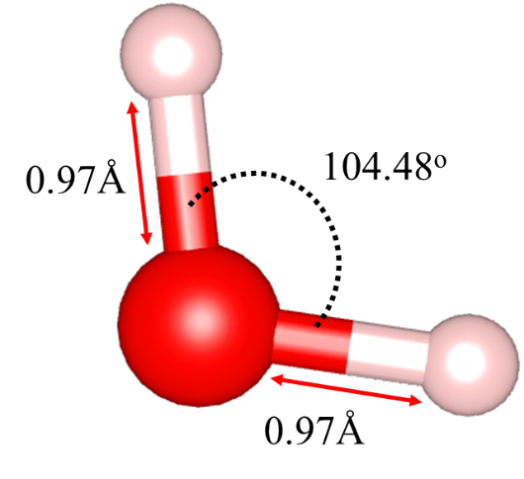
Fig. S1. Optimized geometry of a water molecule.

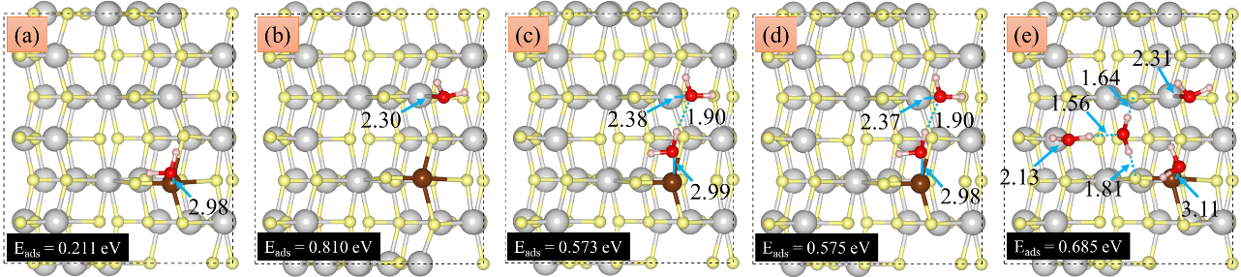
Fig. S2. Adsorption of a single water molecule on Br modified TiO₂ (101) surface (a, b), adsorption of two (c, d) and four (e) water molecules. The color scheme is as follows: Ti: gray, O: yellow, Br: brown, O_{water}: red, H: pink.

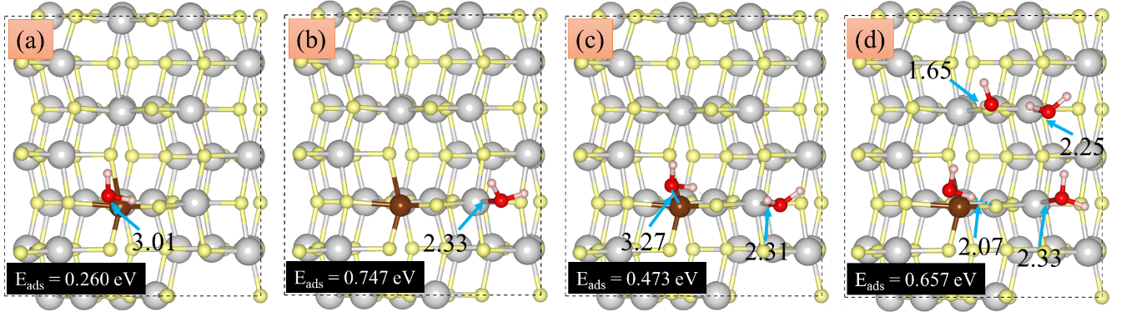
Fig. S3. Adsorption of a single water molecule on Br modified TiO₂ (101) surface (a, b), adsorption of two (c) and four (d) water molecules. The color scheme is as follows: Ti: gray, O: yellow, Br: brown, O_{water}: red, H: pink.

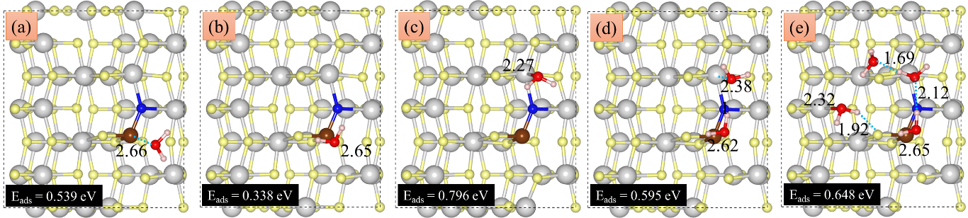
Fig. S4. Adsorption of a single water molecule on Br and N modified TiO₂ (101) surface (a, b, c), adsorption of two (d) and four (e) water molecules. The color scheme is as follows: Ti: gray, O: yellow, Br: brown, O_{water}: red, H: pink.

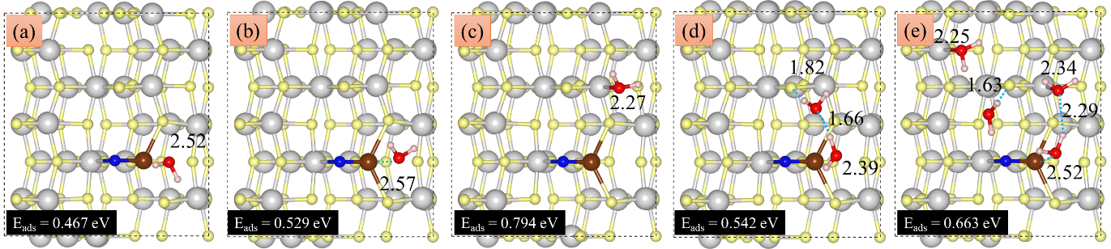
Fig. S5. Adsorption of a single water molecule on Br and N modified TiO₂ (101) surface (a, b, c), adsorption of two (d) and four (e) water molecules. The color scheme is as follows: Ti: gray, O: yellow, Br: brown, O_{water}: red, H: pink.

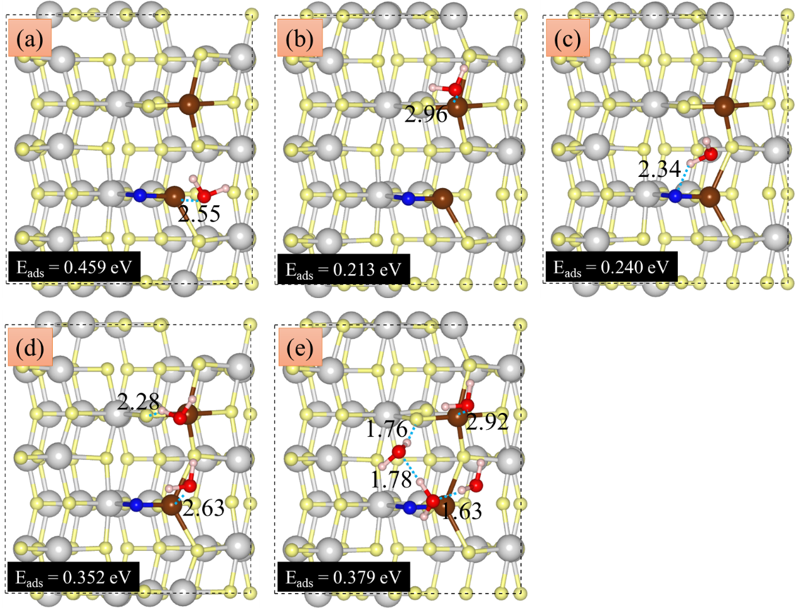
Fig. S6. Adsorption of a single water molecule on Br and N modified TiO₂ (101) surface (a, b, c), adsorption of two (d) and four (e) water molecules. The color scheme is as follows: Ti: gray, O: yellow, Br: brown, O_{water}: red, H: pink.

